**UNIT-I**

**INTRODUCTION TO MANAGERIAL ECONOMICS**

Imagine for a while that you have finished your studies and have joined as an engineer in a manufacturing organization. What do you do there? You plan to produce maximum quantity of goods of a given quality at a reasonable cost. On the other hand, if you are a sale manager, you have to sell a maximum amount of goods with minimum advertisement costs. In other words, you want to minimize your costs and maximize your returns and by doing so, you are practicing the principles of managerial economics.

Managers, in their day-to-day activities, are always confronted with several issues such as how much quantity is to be supplied; at what price; should the product be made internally; or whether it should be bought from outside; how much quantity is to be produced to make a given amount of profit and so on. Managerial economics provides us a basic insight into seeking solutions for managerial problems.

**INTRODUCTION TO MANAGERIAL ECONOMICS:**

Managerial economics, as the name itself implies, is an offshoot of two distinct disciplines: Economics and Management. In other words, it is necessary to understand what these disciplines are, at least in brief, to understand the nature and scope of managerial economics

**MANAGEMENT**

Management is the science and art of getting things done through people in formally organized groups. It is necessary that every organization be well managed to enable it to achieve its desired goals. Management includes a number of functions: *Planning, organizing, staffing, directing, and controlling*. The manager while directing the efforts of his staff *communicates* to them the goals, objectives, policies, and procedures; *coordinates* their efforts; *motivates* them to sustain their enthusiasm; and *leads* them to achieve the corporate goals.

**ECONOMICS**

Economics is a study of human activity both at individual and national level. The economists of early age treated economics merely as the science of wealth. The reason for this is clear.

Every one of us in involved in efforts aimed at earning money and spending this money to satisfy our wants such as food, Clothing, shelter, and others. Such activities of earning and spending money are called “Economic activities”.

It was only during the eighteenth century that Adam Smith, the Father of Economics, defined economics as the study of nature and uses of national wealth’.

Dr. Alfred Marshall, one of the greatest economists of the nineteenth century, writes “Economics is a study of man’s actions in the ordinary business of life: it enquires how he gets his income and how he uses it”. Thus, it is one side, a study of wealth; and on the other, and more important side; it is the study of man. As Marshall observed, the chief aim of economics is to promote ‘human welfare’, but not wealth.

Scarcity

How to produce?

What to produce?

Unlimited wants

When to produce?

Where to produce?

Limited resources

Why to produce?

All the above questions will lead to a business problem. The science which gives optimal solution for the above business problems is managerial economic

Business problem

Management/manager decision

Traditional economics

Managerial Economics

Optimal solution

***Meaning & Definition:***

Managerial Economics as a subject gained popularity in USA after the publication of the book “Managerial Economics” by Joel Dean in 1951.

Managerial Economics refers to the firm’s decision making process. It could be also interpreted as “Economics of Management” or “Economics of Management”. Managerial Economics is also called as “Industrial Economics” or “Business Economics”.

“Managerial Economics is the integration of economic theory with business practice for the purpose of facilitating decision making and forward planning by management”.

----------M. H. Spencer and Louis Siegelman

Managerial economics shows how economic analysis can be used in formulating police.

-------------- Joel Dean

Managerial economics is designed to provide a rigorous treatment of those aspects of economic theory and analysis that are most use for managerial decision analysis

------------ J. L. Pappas and E. F. Brigham.

**NATURE OF MANAGERIAL ECONOMICS**

Further, it is assumed that the firm or the buyer acts in a rational manner (which normally does not happen). The buyer is carried away by the advertisements, brand loyalties, incentives and so on, and, therefore, the natural behavior of the consumer will be rational is not a realistic assumption. Unfortunately, there are no other alternatives to understand the subject other than by making such assumptions. This is because the behavior of a firm or a consumer is a complex phenomenon.

The other features of managerial economics are explained as below:

1. **Close to microeconomics:**

Managerial economics is concerned with finding the solutions for different managerial problems of a particular firm. Thus, it is more close to microeconomics. The study of an individual consumer or a firm is called microeconomics (also called the *Theory of Firm*). Microeconomics deals with behavior and problems of single individual and of micro organization. Managerial economics has its roots in microeconomics and it deals with the micro or individual enterprises.

1. **Macroeconomics:**

The study of ‘aggregate’ or total level of economic activity in a country is called *macroeconomics*. It studies the flow of economics resources or factors of production (such as land, labour, capital, organization and technology) from the resource owner to the business firms and then from the business firms to the households. It deals with total aggregates, for instance, total national income total employment, output and total investment. It studies the interrelations among various aggregates and examines their nature and behaviour, their determination and causes of fluctuations in the.

1. ***Normative statements*:**

A normative statement usually includes or implies the words ‘ought’ or ‘should’. They reflect people’s moral attitudes and are expressions of what a team of people ought to do. For instance, it deals with statements such as ‘Government of India should open up the economy. Such statement are based on value judgments and express views of what is ‘good’ or ‘bad’, ‘right’ or ‘ wrong’. One problem with normative statements is that they cannot to verify by looking at the facts, because they mostly deal with the future. Disagreements about such statements are usually settled by voting on them.

1. ***Prescriptive actions*:**

Prescriptive action is goal oriented. Given a problem and the objectives of the firm, it suggests the course of action from the available alternatives for optimal solution. If does not merely mention the concept, it also explains whether the concept can be applied in a given context on not...

1. ***Offers scope to evaluate each alternative*:**

Managerial economics provides an opportunity to evaluate each alternative in terms of its costs and revenue. The managerial economist can decide which is the better alternative to maximize the profits for the firm.

1. ***Interdisciplinary:***

The contents, tools and techniques of managerial economics are drawn from different subjects such as economics, management, mathematics, finance, marketing statistics, accountancy, psychology, organizational behavior, sociology and etc.

1. **Managerial economic is descriptive**:

It is provides explanation description for the concepts of sales, profit ect… managerial economic provides brief description for the questions like how will be our sales, when can we reach breakeven and from what time we can get profits ect...

1. **Managerial economic is application oriented**:

*It is* helps the managers in solving problems of different application areas like production. Pricing, promotion demand analysis ect.

**SCOPE OF MANAGERIAL ECONOMICS:**

The scope of managerial economics refers to its area of study. Managerial economics refers to its area of study. Managerial economics is help to find out the optimal solution for different managerial problems such as *Production*, Capital Management Decisions, Pricing Decisions, Promotion Strategies, *Demand Analyses and Forecasting, Resource Allocation Profit analysis ,Capital or investment analyses,* Profit Expectation and Management

The production department, marketing and sales department and the finance department usually handle these five types of decisions.

*Production*

Capital Management Decisions

Pricing Decisions

Promotion Strategies

*Demand Analyses and Forecasting:*

*Resource Allocation:*

*Profit analysis:*

*Capital or investment analyses:*

Profit Expectation and Management

Optimum solution

Concepts of Managerial economics

**1. Production**

*It means inputs are transfer to output.* Production analysis is in physical terms. While the cost analysis is in monetary terms cost concepts and classifications, cost-out-put relationships, economies and diseconomies of scale and production functions are some of the points constituting cost and production analysis.

**2. Capital Management Decisions**

Capital management decision carries lot of weight age in the organization. It deals with various options of capital employment and respective returns with that investment. A manager has to select optimal investment decision among the available options with the use of managerial economics using discounted cash flow techniques and non discounted can flow techniques.

**3. Pricing Decisions**

Pricing plays a vital role in the success of product as well as the organization. Managerial Economics provides different types of prices for products. Managerial Economics has a close watch on the factors affecting the pricing. How the organization has to price the items, when to do changes in pricing like questions will be answered by managerial Economics. Pricing decisions have been always within the preview of managerial economics. Pricing policies are merely a subset of broader class of managerial economic problems. Price theory helps to explain how prices are determined under different types of market conditions.

**4. Promotion Strategies**

Whatever many be the quality of product, if it was not reached to final customer, it cannot get success. So, proper promotion has to be done in all products and services. Managerial Economics guides managers how to promote and what is the sector they need to concentrate more and what should be the advertisement budget etc.

***5.* Demand Analyses and Forecasting:**

A firm can survive only if it is able to the demand for its product at the right time, within the right quantity. Understanding the basic concepts of demand is essential for demand forecasting. Demand analysis should be a basic activity of the firm because many of the other activities of the firms depend upon the outcome of the demand forecast.

***4.* Resource Allocation:**

Managerial Economics is the traditional economic theory that is concerned with the problem of optimum allocation of scarce resources. Marginal analysis is applied to the problem of determining the level of output, which maximizes profit. In this respect linear programming techniques has been used to solve optimization problems. In fact lines programming is one of the most practical and powerful managerial decision making tools currently available.

***5.* Profit analysis*:***

Profit making is the major goal of firms. There are several constraints here an account of competition from other products, changing input prices and changing business environment hence in spite of careful planning, there is always certain risk involved.

Managerial economics deals with techniques of averting of minimizing risks. Profit theory guides in the measurement and management of profit, in calculating the pure return on capital, besides future profit planning.

***6.* Capital or investment analyses:**

Capital is the foundation of business. Lack of capital may result in small size of operations. Availability of capital from various sources like equity capital, institutional finance etc. may help to undertake large-scale operations. Hence efficient allocation and management of capital is one of the most important tasks of the managers. The major issues related to capital analysis are:

The choice of investment project

Evaluation of the efficiency of capital

Most efficient allocation of capital

Knowledge of capital theory can help very much in taking investment decisions. This involves, capital budgeting, feasibility studies, analysis of cost of capital etc.

**7. Profit Expectation and Management**

In addition to the all the above, sales of product takes place. Managerial economics tells us when can we reach the breakeven point and when can be we get profit. It also guides as in holders or reinvest in the same product.

These are the application areas where managerial economics can be used to take a decision.

**MANAGERIAL ECONOMICS RELATIONSHIP WITH OTHER DISCIPLINES:**

Many new subjects have evolved in recent years due to the interaction among basic disciplines. While there are many such new subjects in natural and social sciences, managerial economics can be taken as the best example of such a phenomenon among social sciences. Hence it is necessary to trace its roots and relationship with other disciplines.

*1****.* Relationship with economics:**

The relationship between managerial economics and economics theory may be viewed from the point of view of the two approaches to the subject Viz. Micro Economics and Marco Economics. Microeconomics is the study of the economic behavior of individuals, firms and other such micro organizations. Managerial economics is rooted in Micro Economic theory.

Managerial Economics makes use to several Micro Economic concepts such as marginal cost, marginal revenue, elasticity of demand as well as price theory and theories of market structure to name only a few. Macro theory on the other hand is the study of the economy as a whole. It deals with the analysis of national income, the level of employment, general price level, consumption and investment in the economy and even matters related to international trade, Money, public finance, etc.

*2****.* Management theory and accounting**:

Managerial economics has been influenced by the developments in management theory and accounting techniques. Accounting refers to the recording of pecuniary transactions of the firm in certain books. A proper knowledge of accounting techniques is very essential for the success of the firm because profit maximization is the major objective of the firm.

***3.* Managerial Economics and mathematics:**

The use of mathematics is significant for managerial economics in view of its profit maximization goal long with optional use of resources. The major problem of the firm is how to minimize cost, hoe to maximize profit or how to optimize sales. Mathematical concepts and techniques are widely used in economic logic to solve these problems. Also mathematical methods help to estimate and predict the economic factors for decision making and forward planning.

***4.* Managerial Economics and Statistics:**

Managerial Economics needs the tools of statistics in more than one way. A successful businessman must correctly estimate the demand for his product. He should be able to analyses the impact of variations in tastes. Fashion and changes in income on demand only then he can adjust his output. Statistical methods provide and sure base for decision-making. Thus statistical tools are used in collecting data and analyzing them to help in the decision making process.

*5****.* Managerial Economics and Operations Research:**

Taking effectives decisions is the major concern of both managerial economics and operations research. The development of techniques and concepts such as linear programming, inventory models and game theory is due to the development of this new subject of operations research in the postwar years. Operations research is concerned with the complex problems arising out of the management of men, machines, materials and money.

Operation research provides a scientific model of the system and it helps managerial economists in the field of product development, material management, and inventory control, quality control, marketing and demand analysis. The varied tools of operations Research are helpful to managerial economists in decision-making.

***6.* Managerial Economics and the theory of Decision- making:**

The Theory of decision-making is a new field of knowledge grown in the second half of this century. Most of the economic theories explain a single goal for the consumer i.e., Profit maximization for the firm. But the theory of decision-making is developed to explain multiplicity of goals and lot of uncertainty.

As such this new branch of knowledge is useful to business firms, which have to take quick decision in the case of multiple goals. Viewed this way the theory of decision making is more practical and application oriented than the economic theories.

**DEMAND ANALYSIS**

**INTRODUCTION & MEANING:**

|  |  |
| --- | --- |
| Price of Apple (In. Rs.) | Quantity Demanded |
| 10 | 1 |
| 8 | 2 |
| 6 | 3 |
| 4 | 4 |
| 2 | 5 |

Demand in common parlance means the desire for an object. But in economics demand is something more than this. According to Stonier and Hague, “Demand in economics means demand backed up by enough money to pay for the goods demanded”. This means that the demand becomes effective only it if is backed by the purchasing power in addition to this there must be willingness to buy a commodity.

Thus demand in economics means the desire backed by the willingness to buy a commodity and the purchasing power to pay. In the words of “Benham” “The demand for anything at a given price is the amount of it which will be bought per unit of time at that Price”. (Thus demand is always at a price for a definite quantity at a specified time.) Thus demand has three essentials – price, quantity demanded and time. Without these, demand has to significance in economics.

A product or services is said to have demand when tree conditions are satisfied:

**Desire + Ability to pay + Willingness to pay for it**

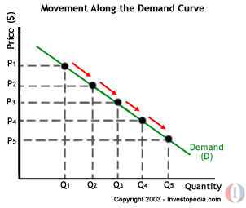

**FACTORS AFFECTING DEMAND:**

There are factors on which the demand for a commodity depends. These factors are economic, social as well as political factors. The effect of all the factors on the amount demanded for the commodity is called Demand Function.

These factors are as follows:

1. **Price of the Commodity:**

The most important factor-affecting amount demanded is the price of the commodity. The amount of a commodity demanded at a particular price is more properly called price demand. The relation between price and demand is called the Law of Demand. It is not only the existing price but also the expected changes in price, which affect demand

1. **Income of the Consumer:**

The second most important factor influencing demand is consumer income. In fact, we can establish a relation between the consumer income and the demand at different levels of income, price and other things remaining the same. The demand for a normal commodity goes up when income rises and falls down when income falls. But in case of Giffen goods the relationship is the opposite.

1. **Prices of related goods:**

The demand for a commodity is also affected by the changes in prices of the related goods also. Related goods can be of two types:

(I). Substitutes which can replace each other in use; for example, tea and coffee are substitutes. The change in price of a substitute has effect on a commodity’s demand in the same direction in which price changes. The rise in price of coffee shall raise the demand for tea;

(ii). Complementary foods are those which are jointly demanded, such as pen and ink. In such cases complementary goods have opposite relationship between price of one commodity and the amount demanded for the other. If the price of pens goes up, their demand is less as a result of which the demand for ink is also less.

The price anddemand go in opposite direction. The effect of changes in price of a commodity on amounts demanded of related commodities is called Cross Demand.

1. **Tastes of the Consumers:**

The amount demanded also depends on consumer’s taste. Tastes include fashion, habit, customs, etc. A consumer’s taste is also affected by advertisement. If the taste for a commodity goes up, its amount demanded is more even at the same price. This is called increase in demand. The opposite is called decrease in demand.

1. **Population:**

Increase in population increases demand for necessaries of life. The composition of population also affects demand. Composition of population means the proportion of young and old and children as well as the ratio of men to women. A change in composition of population has an effect on the nature of demand for different commodities.

1. **Expectations regarding the future:**

If consumers expect changes in price of commodity in future, they will change the demand at present even when the present price remains the same. Similarly, if consumers expect their incomes to rise in the near future they may increase the demand for a commodity just now.

1. **Advertisement expenditure:**

Advertisement promotes sales. Other factors remaining same, with every increase in the advertisement expense there will be an increase in sales.

1. **Demonstration effect:**

Demand for luxury item is always great among the rich. This naturally influences the less affluent or the lower income group in the neighborhood. They also begin to buy luxury item to imitate their rich neighbors even when they do not have any genuine need for them

1. ***Climate and weather:***

The climate of an area and the weather prevailing there has a decisive effect on consumer’s demand. In cold areas woolen cloth is demanded. During hot summer days, ice is very much in demand. On a rainy day, ice cream is not so much demanded.

**LAW OF DEMAND**

Law of demand shows the relation between price and quantity demanded of a commodity in the market. In the words of Marshall, “the amount demand increases with a fall in price and diminishes with a rise in price”.

Generally, a person demands more at a lower price and less at a higher price. The relation of price to demand or sales is known in Economics as the Law of Demand.

The Law of Demand states that “higher the price, lower the demand and vice versa, other things remaining the same”.

The demand curve slopes downward from left to rights showing that more quantities are demanded at lower prices. That is, demand responds to price in the reverse direction. The reasons for the inverse relation between price and quantity demanded are the following:

|  |  |
| --- | --- |
| Price of Apple (In. Rs.) | Quantity Demanded |
| 10 | 1 |
| 8 | 2 |
| 6 | 3 |
| 4 | 4 |
| 2 | 5 |

*Demand Schedule .*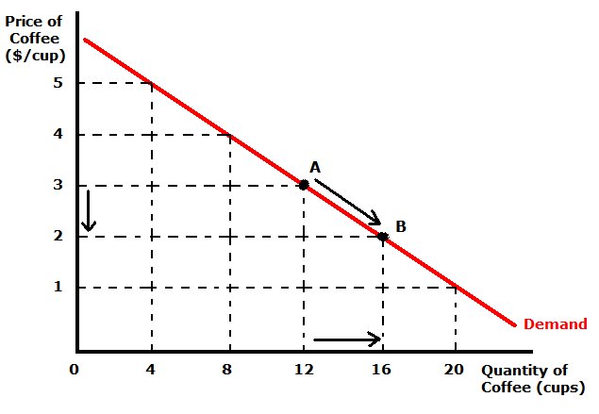

When the price falls from Rs. 10 to 8 quantity demand increases from 1 to 2. In the same way as price falls, quantity demand increases on the basis of the demand schedule we can draw the demand curve The demand curve DD shows the inverse relation between price and quantity demand of apple. It is downward sloping.

**Income Effect:**

A fall in price results in an increase in incomes of the consumer. As the price falls he can buy the same quantity as before with less amount of money. Thus he gains some money a part of which can be used for purchasing some more unit of the same commodity. This results in an increase in demand for that commodity. This results in an increase in demand for that commodity. When the price rises the consumers’ income is reduced. This causes fall in the purchasing power of the consumer. Now he can buy lesser quantity with the same amount. Hence, we can observe a decrease in demand o that commodity.

**Substitute Effect:**

When the price of a commodity rises, the consumer may substitute that relatively costly commodity with less costly one if the substitutes are available. When tea becomes cheaper some people may shift their consumption from coffee to tea. Similarly if the price rises consumers, to some extent, may substitute the costly commodity with a comparatively low priced commodity of a similar kind.

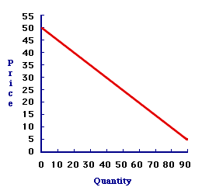

**Diminishing of Marginal Utility**:

If a person consumes more units of the same commodity, he will get less and less satisfaction from the additional units i.e., the utility from each additional units goes on diminishing. The consumer will be ready to buy the additional unit only if is available at a lower price. That is why consumers buy more at lower prices. He goes on buying till the marginal utility of the product is equal to its price.

***Assumptions:***

Law is demand is based on certain assumptions:

This is no change in consumers taste and preferences.

Income should remain constant.

Prices of other goods should not change.

There should be no substitute for the commodity

The commodity should not confer at any distinction

The demand for the commodity should be continuous

People should not expect any change in the price of the commodity

***EXCEPTIONAL DEMAND CURVE***

Sometimes the demand curve slopes upwards from left to right. In this case the demand curve has a positive slope.

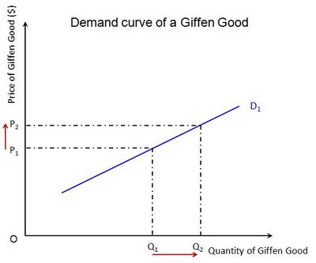

When price increases from OP to Op1 quantity demanded also increases from to OQ1 and vice versa. The reasons for exceptional demand curve are as follows.

***1. Giffen paradox:***

*Robert giffen has observed an effect of goods which has increase in demand even if price raised and goods demand decreases even if price decreased. He named above the goods as*

Superior goods

Inferior goods

Ex: if a person buy bread and meat daily, If the price of bread is decreased, he will not purchases more breads, for the balance of money he will purchases meat . Decrease in the price of an inferior goods does not increases its demand, dut increase the demand for superior goods

The Giffen good or inferior good is an exception to the law of demand. When the price of an inferior good falls, the poor will buy less and vice versa. For example, when the price of maize falls, the poor are willing to spend more on superior goods than on maize if the price of maize increases, he has to increase the quantity of money spent on it. Otherwise he will have to face starvation. Thus a fall in price is followed by reduction in quantity demanded and vice versa. “Giffen” first explained this and therefore it is called as Giffen’s paradox.

***2. Demonstration effect:***

‘Veblan’ has explained the exceptional demand curve through his doctrine of conspicuous consumption. Rich people buy certain good because it gives social distinction or prestige for example diamonds are bought by the richer class for the prestige it possess. It the price of diamonds falls poor also will buy is hence they will not give prestige. Therefore, rich people may stop buying this commodity.

***3. Ignorance:***

Sometimes, the quality of the commodity is Judge by its price. Consumers think that the product is superior if the price is high. As such they buy more at a higher price.

***4. Speculative effect:***

If the price of the commodity is increasing the consumers will buy more of it because of the fear that it increase still further, Thus, an increase in price may not be accomplished by a decrease in demand.

***5. Fear of shortage:***

During the times of emergency of war People may expect shortage of a commodity. At that time, they may buy more at a higher price to keep stocks for the future.

***6. Necessaries:***

In the case of necessaries like rice, vegetables etc. people buy more even at a higher price.

**7. Goods don’t have substitutes:**

As a general tendency, demand has to be decrease with increase in price, but if any goods don’t have substitutes, like salt and medicines, the demand will not get decreases. People will definitely buy as they don’t have other alternative

**8. Insignificant income spent on goods:**

If consumers spend a small amount for any goods the price changes will not influence the demand for that sort of goods, as they spent insignificant income or match boxes they might not reduce buying even if price rises

**9. Conspicuous consumption:**

Goods like diamonds, pearls ect ,are purchased by rich and wealthy section of the society because the price of such goods are so high that they are beyond the reach of a common man .most of these goods are demand when their price go up very high

**ELASTICITY OF DEMAND**

Elasticity of demand explains the relationship between a change in price and consequent change in amount demanded. “Marshall” introduced the concept of elasticity of demand. Elasticity of demand shows the extent of change in quantity demanded to a change in price.

In the words of “Marshall”, “The elasticity of demand in a market is great or small according as the amount demanded increases much or little for a given fall in the price and diminishes much or little for a given rise in Price”

**Elastic demand:** A small change in price may lead to a great change in quantity demanded. In this case, demand is elastic.

**In-elastic demand:** If a big change in price is followed by a small change in demanded then the demand in “inelastic”.

Proportionate change in the quantity demand of commodity

**Elasticity** = ------------------------------------------------------------------

Proportionate change in the factors of commodity

**MEASUREMENT OF ELASTICITY OF DEMAND**

* **Perfectly elastic demand**
* **Perfectly Inelastic Demand**
* **Relatively elastic demand**
* **Relatively in-elastic demand**
* **Unit elasticity of demand**

**A. PERFECTLY ELASTIC DEMAND:**

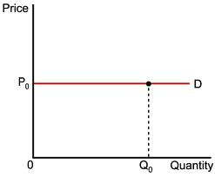When small change in price leads to an infinitely large change is quantity demand, it is called perfectly or infinitely elastic demand. In this case E=∞

The demand curve DD1 is horizontal straight line. It shows the at “OP” price any amount is demand and if price increases, the consumer will not purchase the commodity.

**B. PERFECTLY INELASTIC DEMAND**

In this case, even a large change in price fails to bring about a change in quantity demanded.

# http://courses.cit.cornell.edu/econ101-dl/images/l6fig2.gif

# When price increases from ‘OP’ to ‘OP’, the quantity demanded remains the same. In other words the response of demand to a change in Price is nil. In this case ‘E’=0.

**C. RELATIVELY ELASTIC DEMAND:**

Demand changes more than proportionately to a change in price. i.e. a small change in price loads to a very big change in the quantity demanded. In this caseE > 1. This demand curve will be flatter.

# http://1.bp.blogspot.com/_Fu8Af7ufmbU/SqYxe-NVwKI/AAAAAAAAAdA/u_q5-0iXPQc/s400/Relatively+Elastic+Curve.gif

When price falls from ‘OP’ to ‘OP1’, amount demanded increase from “OQ’ to “OQ1’ which is larger than the change in price.

**D. RELATIVELY IN-ELASTIC DEMAND.**

Quantity demanded changes less than proportional to a change in price. A large change in price leads to small change in amount demanded. Here E < 1. Demanded carve will be steeper.

# http://4.bp.blogspot.com/_Fu8Af7ufmbU/SqYxfWU67cI/AAAAAAAAAdI/m0_nDhUX9rE/s400/Relatively+Inelastic+Curve.gif

When price falls from “OP’ to ‘OP1 amount demanded increases from OQ to OQ1, which is smaller than the change in price.

**E. UNIT ELASTICITY OF DEMAND:**

The change in demand is exactly equal to the change in price. When both are equal E=1 and elasticity if said to be unitary.

# https://encrypted-tbn0.gstatic.com/images?q=tbn:ANd9GcQEsvcvxLQyWh7qjkB2YvPMd_N_ywcOndub0qZOtasAfRcLsOeXwA

When price falls from ‘OP’ to ‘OP1’ quantity demanded increases from ‘OP’ to ‘OP1’, quantity demanded increases from ‘OM’ to ‘OM1’. Thus a change in price has resulted in an equal change in quantity demanded so price elasticity of demand is equal to unity.

# http://www.transtutors.com/Uploadfile/CMS_Images/3116_elasticities-of-demands.JPG

**TYPES OF ELASTICITY OF DEMAND:**

There are three types of elasticity of demand:

1. Price elasticity of demand
2. Income elasticity of demand
3. Cross elasticity of demand
4. advertising elasticity of demand

**1. PRICE ELASTICITY OF DEMAND:**

Marshall was the first economist to define price elasticity of demand. Price elasticity of demand measures changes in quantity demand to a change in Price. It is the ratio of percentage change in quantity demanded to a percentage change in price.

Proportionate change in the quantity demand of commodity

**Price elasticity** = ------------------------------------------------------------------

Proportionate change in the price of commodity

There are three cases of price elasticity of demand

* Price elasticity greater than unity
* Price elasticity leas than unity
* Unit price elasticity
* **Price elasticity greater than unity:**

Demand changes more than proportionately to a change in price. i.e. a small change in price loads to a very big change in the quantity demanded. In this caseE > 1. This demand curve will be flatter.

# http://1.bp.blogspot.com/_Fu8Af7ufmbU/SqYxe-NVwKI/AAAAAAAAAdA/u_q5-0iXPQc/s400/Relatively+Elastic+Curve.gif

When price falls from ‘OP’ to ‘OP1’, amount demanded increase from “OQ’ to “OQ1’ which is larger than the change in price.

* **Price elasticity leas than unity:**

Quantity demanded changes less than proportional to a change in price. A large change in price leads to small change in amount demanded. Here E < 1. Demanded carve will be steeper.

# http://www.agmrc.org/media/cms/Graph2_E8477D0941263.jpg

When price falls from “OP1’ to ‘OP2 amount demanded increases from OQ1 to OQ2, which is smaller than the change in price.

* **unit price elasticity:**

The change in demand is exactly equal to the change in price. When both are equal E=1 and elasticity if said to be unitary.

# https://encrypted-tbn3.gstatic.com/images?q=tbn:ANd9GcQcLaoCF1wEFeGnNK7IdLQJsaFvsO3IiQeLuJbm8XKDLw9nOrHh

**2. INCOME ELASTICITY OF DEMAND:**

Income elasticity of demand shows the change in quantity demanded as a result of a change in income. Income elasticity of demand may be slated in the form of a formula.

Proportionate change in the quantity demand of commodity

**Income Elasticity** = ------------------------------------------------------------------

Proportionate change in the income of the people

Income elasticity of demand can be classified in to five types.

**A. Zero income elasticity:**

Quantity demanded remains the same, even though money income increases. Symbolically, it can be expressed as Ey=0. It can be depicted in the following way:

# https://encrypted-tbn3.gstatic.com/images?q=tbn:ANd9GcR3khXNwss1Gc56-Q1kYl20hXqKHvW4205NDbHDpigpAnm_EmDs

As income increases from OY to OY1, quantity demanded never changes.

**B. Negative Income elasticity:**

When income increases, quantity demanded falls. In this case, income elasticity of demand is negative. i.e., Ey< 0

# https://encrypted-tbn1.gstatic.com/images?q=tbn:ANd9GcRAiTMoxfDHZNh4xswi60gXt_t8Xo81zGhnXW4TXbD77fxog7sBUQ

When income increases from OY1 to OY2, demand falls from OQ1 to OQ2.

**c. Unit income elasticity:**

When an increase in income brings about a proportionate increase in quantity demanded, and then income elasticity of demand is equal to one. Ey = 1

# http://wikieducator.org/images/0/04/Income_2.jpeg

When income increases from OY1 to OY2, Quantity demanded also increases from OQ1 to OQ2.

**d. Income elasticitylees than unity:**

In this case, an increase in come brings about a more than proportionate increase in quantity demanded. Symbolically it can be written as Ey< 1.

# https://encrypted-tbn1.gstatic.com/images?q=tbn:ANd9GcTRqiRTvstE8oBiAv_u2DrqDKn2oCdfsGt5FKZPsuAROzzMD5LaMA

It shows high-income elasticity of demand. When income increases from OY to OY1, Quantity demanded increases from OQ to OQ1.

**E. Income elasticity greater than unity:**

When income increases quantity demanded also increases but less than proportionately. In this case E < 1.

# https://encrypted-tbn3.gstatic.com/images?q=tbn:ANd9GcQOyrvrjrkXGvGIKJZSuLCgm8xA2PpTT-YH4w_9XPAwU0Dg8fH4CQ

An increase in income from OY1 to OY2, brings what an increase in quantity demanded from OQ1 to OQ2, But the increase in quantity demanded is smaller than the increase in income. Hence, income elasticity of demand is less than one.

**3. CROSS ELASTICITY OF DEMAND:**

A change in the price of one commodity leads to a change in the quantity demanded of another commodity. This is called a cross elasticity of demand. The formula for cross elasticity of demand is:

Proportionate change in the quantity demand of commodity “**X”**

**Cross elasticity** = -----------------------------------------------------------------------

Proportionate change in the price of commodity “**Y”**

**A.In case of substitutes**, cross elasticity of demand is positive. Eg: Coffee and Tea. When the price of coffee increases, Quantity demanded of tea increases. Both are substitutes.

# https://lh4.googleusercontent.com/C9WCWKult828yd4Vw0YKFaPBx_k7NBWBcPm0Q-smU7G9bNkswqi53ju0fVok0wAJrSzOHyyxS8KMuv4s-cE3FCIuo4wHulnvYVIAFNCc8yZgTYGgE_E

**B.In case of compliments**, cross elasticity is negative. If increase in the price of one commodity leads to a decrease in the quantity demanded of another and vice versa.

# http://faculty.tamu-commerce.edu/dfunderburk/231/images/graph5.jpg

When price of car goes up from OP to OP! the quantity demanded of petrol decreases from OQ1 to OQ2. The cross-demanded curve has negative slope.

**4 ADVERTISING ELASTICITY OF DEMAND**

It refers to increase in the sale revenue because of changes in the advertising expenditure. In other words there is a direct relationship between the amount of money spent on advertising and its impact on sales. It is always positive

Proportionate change in the quantity demand of product “**X”**

**Advertising elasticity** = -----------------------------------------------------------------------

Proportionate change in the advertising cost

**Advertising elasticity greater than unity:**

In this case, an increase in come brings about a more than proportionate increase in quantity demanded. Symbolically it can be written as Ey> 1.

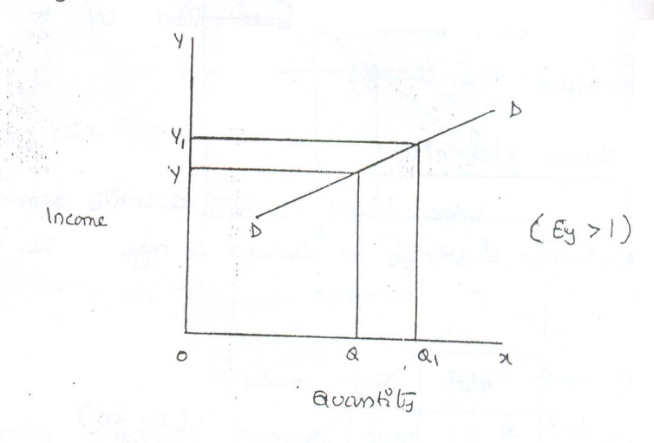

It shows high-income elasticity of demand. When income increases from OY to OY1, Quantity demanded increases from OQ to OQ1.

**Advertising elasticity leas than unity:**

When income increases quantity demanded also increases but less than proportionately. In this case E < 1.

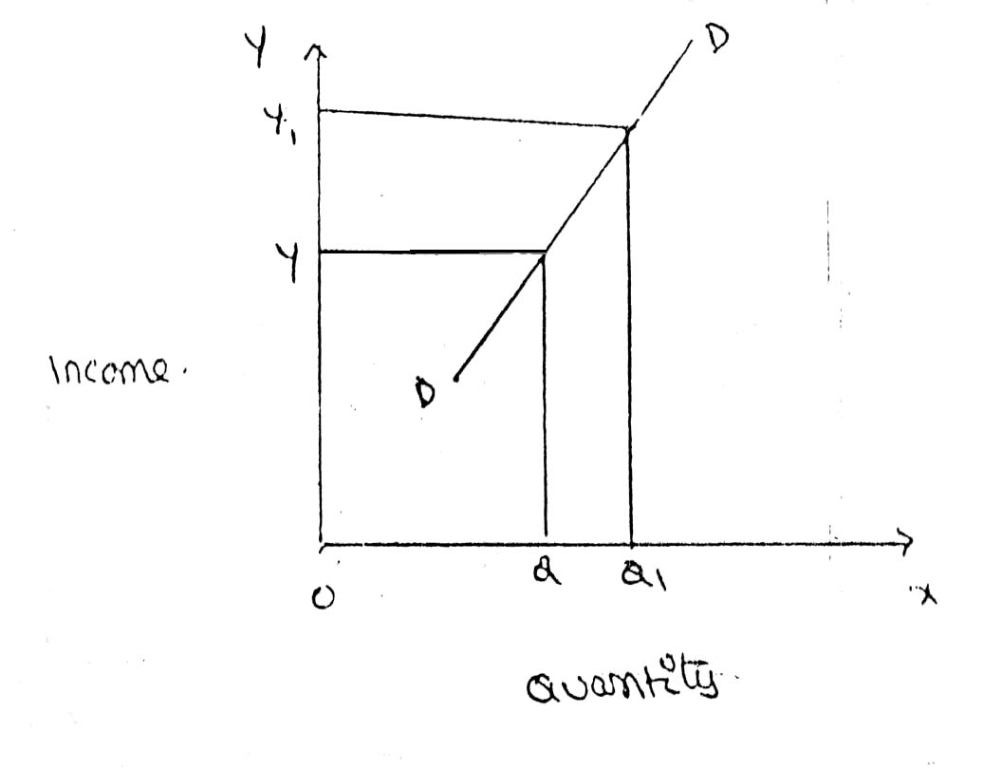

**Unit advertising elasticity:**

When an increase in income brings about a proportionate increase in quantity demanded, and then income elasticity of demand is equal to one. Eye = 1

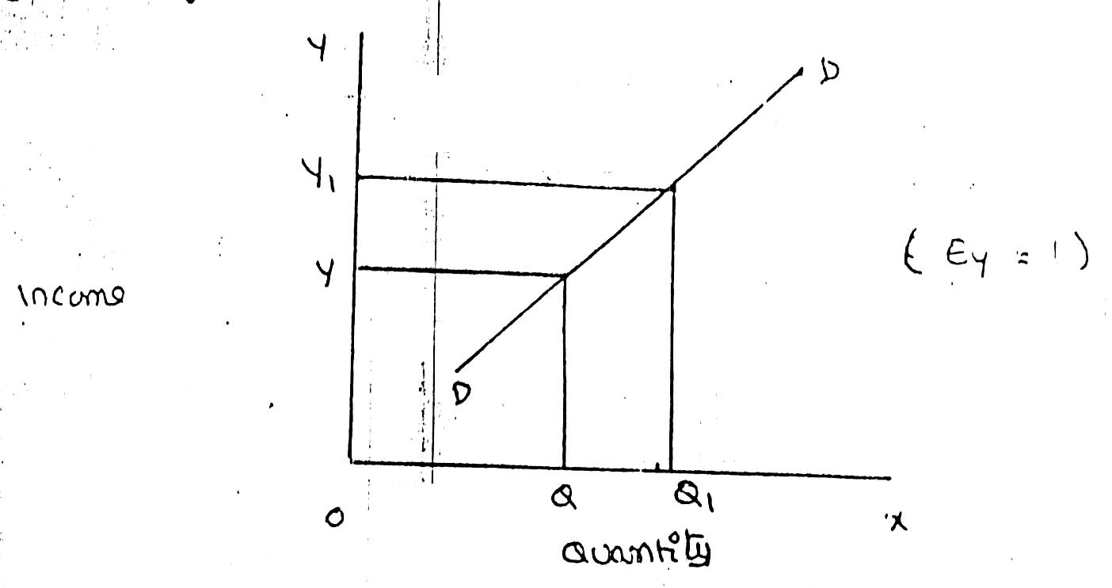

**FACTORS INFLUENCING THE ELASTICITY OF DEMAND**

Elasticity of demand depends on many factors.

***1. Nature of commodity:***

Elasticity or in-elasticity of demand depends on the nature of the commodity i.e. whether a commodity is a necessity, comfort or luxury, normally; the demand for Necessaries like salt, rice etc is inelastic. On the other band, the demand for comforts and luxuries is elastic.

***2. Availability of substitutes:***

Elasticity of demand depends on availability or non-availability of substitutes. In case of commodities, which have substitutes, demand is elastic, but in case of commodities, which have no substitutes, demand is in elastic.

***3. Variety of uses:***

If a commodity can be used for several purposes, than it will have elastic demand. i.e. electricity. On the other hand, demanded is inelastic for commodities, which can be put to only one use.

***4. Postponement of demand:***

If the consumption of a commodity can be postponed, than it will have elastic demand. On the contrary, if the demand for a commodity cannot be postpones, than demand is in elastic. The demand for rice or medicine cannot be postponed, while the demand for Cycle or umbrella can be postponed.

***5. Amount of money spent:***

Elasticity of demand depends on the amount of money spent on the commodity. If the consumer spends a smaller for example a consumer spends a little amount on salt and matchboxes. Even when price of salt or matchbox goes up, demanded will not fall. Therefore, demand is in case of clothing a consumer spends a large proportion of his income and an increase in price will reduce his demand for clothing. So the demand is elastic.

***6. Time:***

Elasticity of demand varies with time. Generally, demand is inelastic during short period and elastic during the long period. Demand is inelastic during short period because the consumers do not have enough time to know about the change is price. Even if they are aware of the price change, they may not immediately switch over to a new commodity, as they are accustomed to the old commodity.

***7. Range of Prices:***

Range of prices exerts an important influence on elasticity of demand. At a very high price, demand is inelastic because a slight fall in price will not induce the people buy more. Similarly at a low price also demand is inelastic. This is because at a low price all those who want to buy the commodity would have bought it and a further fall in price will not increase the demand. Therefore, elasticity is low at very him and very low prices.

**IMPORTANCE OF ELASTICITY OF DEMAND:**

The concept of elasticity of demand is of much practical importance.

***1. Price fixation:***

The manufacturer can decide the amount of price that can be fixed for his product based on the concept of elasticity. If there is no competition the manufacturer is free to fix his price. Where there is a competition it difficult to fix the price

***2. Production:***

Producers generally decide their production level on the basis of demand for the product. Hence elasticity of demand helps the producers to take correct decision regarding the level of cut put to be produced.

***3. Distribution:***

Elasticity of demand also helps in the determination of rewards for factors of production. For example, if the demand for labour is inelastic, trade unions will be successful in raising wages. It is applicable to other factors of production.

***4. International Trade:***

Elasticity of demand helps in finding out the terms of trade between two countries. Terms of trade refers to the rate at which domestic commodity is exchanged for foreign commodities. Terms of trade depends upon the elasticity of demand of the two countries for each other goods.

***5. Public Finance:***

Elasticity of demand helps the government in formulating tax policies. For example, for imposing tax on a commodity, the Finance Minister has to take into account the elasticity of demand.

***6. Nationalization:*** The concept of elasticity of demand enables the government to decide about nationalization of industries.

**7. Forecasting demand:**

Income elasticity is used to forecasting demand for product. The demand for the product can be forecasting a given level. Other words, the impact of changing income level on the demand of the product can be assessed with the help of income elasticity

**8. Planning the level of output and price:**

The knowing of price elasticity is very useful to producers. If the demand for the product is inelasticity, a little higher price may be to him to get huge profits

**9. Public utilities**:

The govt uses the concept of elasticity in fixing chargers for the public utility such as electricity, water ect

**Point elasticity and arc elasticity**

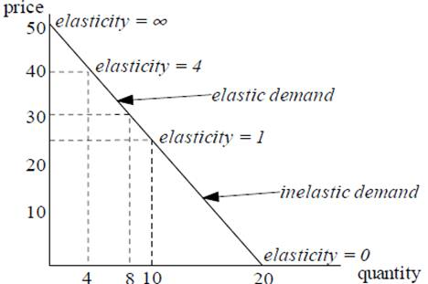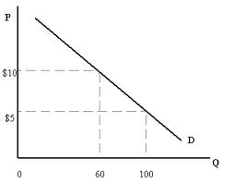

**DEMAND FORECASTING**

**INTRODUCTION:**

The information about the future is essential for both new firms and those planning to expand the scale of their production. Demand forecasting refers to an estimate of future demand for the product. Forecasting helps to assess the likely demand for products and services and to plan production accordingly

In recent times, forecasting plays an important role in business decision-making. Demand forecasting has an important influence on production planning. It is essential for a firm to produce the required quantities at the right time.

It is essential to distinguish between forecasts of demand and forecasts of sales. Sales forecast is important for estimating revenue cash requirements and expenses. Demand forecasts relate to production, inventory control, timing, reliability of forecast etc. However, there is not much difference between these two terms.

**THE NEED FOR DEMAND FORECASTING**

The importance of demand forecasting is paramount when either production or demand is uncertain. Where the supply is not in accordance with the demand, it results in the development of a black market or excessive prices.

Where there is a lot of competition, the entrepreneur has to estimate the demand for his production and services so that he can plan his material inputs, such as manpower, finances, advertising and other overheads.

**TYPES OF DEMAND FORECASTING:**

Based on the time span and planning requirements of business firms, demand forecasting can be classified in to

1. Short-term demand forecasting and

2. Long – term demand forecasting.

***1. Short-term demand forecasting:*** Short-term demand forecasting is limited to short periods, usually for one year. It relates to policies regarding sales, purchase, price and finances. It refers to existing production capacity of the firm. Short-term forecasting is essential for formulating is essential for formulating a suitable price policy. If the business people expect of rise in the prices of raw materials of shortages, they may buy early... Production may be undertaken based on expected sales and not on actual sales.

***2. Long – term forecasting:*** In long-term forecasting, the businessmen should now about the long-term demand for the product. Planning of a new plant or expansion of an existing unit depends on long-term demand. Similarly a multi product firm must take into account the demand for different items. When forecast are mode covering long periods, the probability of error is high. It is very difficult to forecast the production, the trend of prices and the nature of competition.

**FORECASTING LEVELS**

**INDUSTRY LEVEL**

**FIRM LEVEL**

**ECONOMIC LEVEL**

Economic forecasting is concerned with the economics, its covers whole economy. It based on levels of income saving of the customers.

Industrial level forecasting is used for inter-industry comparisons and is being supplied by trade association or chamber of commerce.

Firm level forecasting relates to individual firm. Estimate the demand for product and services offered by a single firm

**Functional nature o demand**

Higher volumes of sales can be realized with higher level of advertisements. However there could be some minimum value sales even when there are no advertisements on a large scale.

**Degree of orientation**

The fore casting is terms of total sales can be viewed as general forecasting where as product and service wise forecasting is a refers to specific forecasting.

**METHODS OF DEMANDFORECASTING**

1. SURVEY METHOD

(a) Census methods

(b) Sample method

2. STATISTICAL METHODS

1. Trend Projection Methods

A) Moving Average Method

B) Exponential Smoothing

2. Barometric Techniques

3. Correlation and Regression Methods

3.OTHERS METHODS

(a)Expert Opinion

(B)Test Marketing

(C)Controlled Experiments

(D)Judgmental Approach

1. **Survey method :**

It is the most useful source of information would be the buyers themselves. It is better to draw list of all potential buyers, approach each buyers to ask how much he plans to buy of the given product at a given point of time. The survey of buyers can be conducted either by covering the whole populations or by selecting a sample group of buyers. Suppose there are 10000 buyers for a particular product.

If the company wishes to elicit the opinion of all the buyers, this method is called census or total enumeration methods. This methods is not only time consuming but also costly. The firm can select a group of buyers who can represent the whole populations this methods is called the sample method.

The survey method is considered more advantages in the following situations.

(1) Where the product is new on the market for which no data previously exists

(2) When the buyers are few and they are accessible

(3) When the cost of reaching them is not significant

(4) When the consumers stick to their intentions

(5) When they are willing to disclose what they intend to do.

This method has certain disadvantages also. They are:

(1) SURVEYS MAY BE EXPENSIVE**;-**Quite often the value of information supplied by the customer is not worth the cost of gathering it.

(2) SAMPLE SIZE AND TIMING OF SURVEY**;-**Sample size should be large enough to yield meaningful results on the desired aspects of study. Also the sample should be selected in such a way that it represents the whole population under the study. This increase the cost and also the time needed to undertake the analysis. The forecast results can deeply be influenced by the timing of the survey. For example, the number of residents preferring to stay in multi-stored apartments soon after the news about an earthquake may drastically come down when compared to the normal times.

Where the surveys are conducted by a group of firms, these costs can be shared.

(3) METHODS OF SAMPLING**;-**The survey should be based on appropriate method of sampling. The method so selected should be capable of providing result with no bays. For instance, the surveys conducted on the internet will have a built-in bias towards those in the higher socio-economic groups who have access to interment.

(4) INCONSISTENT BUYING BEHAVIOUR**;-**The buyers also may not express their intentions freely. Even the buyers do no act upon the way they express. Most of the buyers are susceptible to the advertisement strategies and are emotional when it really comes to the question of buying the product or services.

**STATISTICAL METHODS**

For forecasting the demand for goods and services in the long-run, statistical and mathematical methods are used considering the past data.

**1. TREND PROJECTION METHODS;-**These are generally based on analysis of past sales patterns. These methods dispense with the need for costly market research because the necessary information is often already available in company files in terms of different time periods, that is, a time series data.

(b)**MOVING AVERAGE METHOD;-**This method considers that the average of past events determine the future events. In other words, this method provides consistent results when the past events are consistent and unaffected by wide changes. As the name itself suggest, under this method, the average keeps on moving depending up on the number of years selected. Selection of the number of years is the decisive factor in this method. Moving averages get updated as new information flows in.

(c)**EXPONENTIAL SMOOTIHING;-**This is a more popular technique used for short forecasts. This method is an improvement over moving averages method. Unlike in moving averages method, all time periods (ranging from the immediate past) here are given varying weights, that is, the values of the given variable in the recent time are given higher weights and the values of the given variable in the distant past are given relatively lower weights for further processing.

**2. BAROMETRIC TECHNIQUES;-**In other words, to forecast demand for a particular product or service, use some other relevant indicator (Which is known as a barometer) of future demand. How the statistical data relating to the economy comes handy for this purpose is explained in the following examples.

**3. CORRELATION AND REGRESSION METHODS;-**Correlation and regression methods are statistical techniques. When the two variables tend to change together, then they are said to be correlated. The extent to which they are correlated is measured by correlation coefficient. Of these two variables, one is a dependent variable and the other is an independent. If the high values of one variable are associated with the high values of another, they are said to be positively correlated. For example, if the advertisement are positively correlated. Similarly, if the high values of one variable are associated with the low values of another, then they are said to be negatively correlated. For example, if the price of a product has come down; and as result, there is increase in its demand; the demand and the price are negatively correlated.

**OTHERS METHODS**

**(a)EXPERT OPINION**: Well informed person are called experts. Experts constitute another source of information. These people are generally the outside experts and they do not have any vested in the result of particular survey

An expert is good at forecasting and analyzing the future trends in a given product or service at a given level of technology. The service of an expert could be advantageously used when a firm uses general economic forecast or special industry forecast prepared outside the firm. It may be easy to administer this method where there are parameters clearly defined to make forecast. This act as guidelines

This method has certain advantages and disadvantages.

* Result of this method would be more reliable as the expert is unbiased, has no direct involvement in its primary activities
* Independent demand forecast can be made relatively quickly and cheaply
* Where there is different point of view among different experts, consensus can be arrived through an objective analysis. These experts can be asked to explain the reasons why the forecasts are out of line with consensus. These can be taken into account before taking the final decisions. Sorting out difference in estimates in this way is called DELPHI TECNIQUE

**(b)TEST MAREKETING**: It is likely that opinions given by buyers, sales man or other experts may be, at times, misleading. This is the reason why of the manufacturers favor to test their product or service in a limited market as test –run before they launch their product nationwide. Based on the result of test marketing, valuable lessons can be learnt in how customer reacts to the given product and necessary changes can be introduced to gain wider acceptability. To forecast the sales of a new product or the likely sales of an established product in a new channel of distribution or territory, it is customary to find test marketing in practice.

Automobiles companies maintain a panel of consumers who give feedback on style and design and specification of the new models. Accordingly these companies make changes, if any, and launch the product in the wider markets

The advantages of test marketing are:

* The acceptability of the product can be judged in a limited market
* Before this is too late, the correction can be made to the product design, if necessary. Thus, major atrophy, in term of failure, can be avoided.
* The customer psychology is more focused in this method and the product and service are aligned or redesigned accordingly to gain more customer acceptance

The following are the disadvantages of this method:

* It reveals the quality of product to the competitors before it is launched in the wider markets. The competitors may bring about the similar product or often misuse the result of test marketing against the given company.
* It is not always easy to select a representative audience or market.
* It may also be difficult to extrapolate the feedback received from such a test market, particularly where the chosen market is not fully representative.

**(c)CONTROLLED EXPERIMENTS**: It refers to such exercises of the major determinants of demand are manipulated to suit to the customer with taste and preferences, income groups, and such other. It is further factors remain same in this method in this method the product is introduced in different packages, different prices in different markets or same markets.

This method is still in the infancy stage and not much tried because of the following reasons:

* It is costly and consuming
* It involves elaborate model of studying different markets and different permutations and combinations that can push the product aggressively
* It fails in one market, it may affect other market also

**(d)JUDGEMENTAL APPROACH**: When none of the above methods are directly related to the given product or service, the management has no alternative other than using its own judgment. Even when the above methods are used, the forecasting process is supplemented with the factor of judgment for the following reasons:

* Historical data for significantly long period is not available
* Turning points in terms of polices or procedure