UNIT-3 DIGITAL MODULATION TECHNIQUES
Basics:
Referring to Equation (2.1), if the information signal is digital and the amplitude (lV of the carrier is varied proportional to the information signal, a digitally modulated signal called amplitude shift keying (ASK) is produced.

If the frequency (f) is varied proportional to the information signal, frequency shift keying (FSK) is produced, and if the phase of the carrier (0) is varied proportional to the information signal, phase shift keying (PSK) is produced.

If both the amplitude and the phase are varied proportional to the information signal, quadrature amplitude modulation (QAM) results. ASK, FSK, PSK, and QAM are all forms of digital modulation:

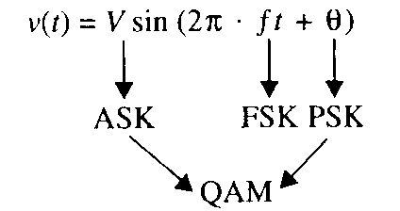
(2.1)

Figure 2-1 shows a simplified block diagram for a digital modulation system.
In the transmitter, the precoder performs level conversion and then encodes the incoming data into groups of bits that modulate an analog carrier.

The modulated carrier is shaped (filtered), amplified, and then transmitted through the transmission medium to the receiver.

The transmission medium can be a metallic cable, optical fiber cable, Earth's atmosphere, or a combination of two or more types of transmission systems.

In the receiver, the incoming signals are filtered, amplified, and then applied to the demodulator and decoder circuits, which extracts the original source information from the modulated carrier.

The clock and carrier recovery circuits recover the analog carrier and digital timing (clock) signals from the incoming modulated wave since they are necessary to perform the demodulation process.

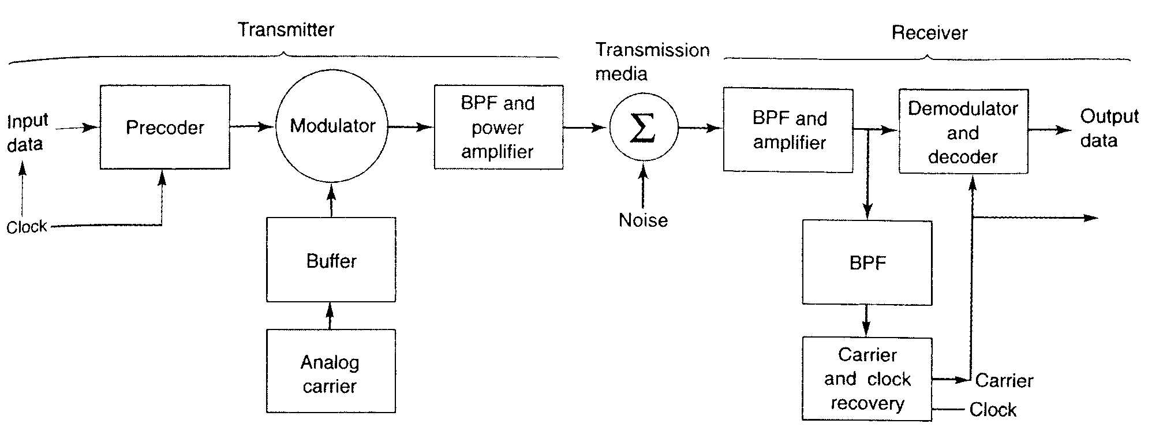
FIGURE 2-1 Simplified block diagram of a digital radio system.
INFORMATION CAPACITY, BITS, BIT RATE, BAUD, AND MARY ENCODING
Information Capacity, Bits, and Bit Rate

I $α$ B x t (2.2)

where I= information capacity (bits per second)
B = bandwidth (hertz)
t = transmission time (seconds)

From Equation 2-2, it can be seen that information capacity is a linear function of bandwidth and transmission time and is directly proportional to both.

If either the bandwidth or the transmission time changes, a directly proportional change occurs in the information capacity.

The higher the signal-to-noise ratio, the better the performance and the higher the information capacity.

Mathematically stated, the Shannon limit_for information capacity is
(2.3)
or
(2.4)
where I = information capacity (bps)
B = bandwidth (hertz)
$\frac{S}{N}$= signal-to-noise power ratio (unitless)

For a standard telephone circuit with a signal-to-noise power ratio of 1000 (30 dB) and a bandwidth of 2.7 kHz, the Shannon limit for information capacity is

I = (3.32)(2700) log₁₀ (1 + 1000) = 26.9 kbps

Shannon's formula is often misunderstood. The results of the preceding example indicate that 26.9 kbps can be propagated through a 2.7-kHz communications channel. This may be true, but it cannot be done with a binary system. To achieve an information transmission rate of 26.9 kbps through a 2.7-kHz channel, each symbol transmitted must contain more than one bit.

2-2-2 M-ary Encoding

M-ary is a term derived from the word binary.

M simply represents a digit that corresponds to the number of conditions, levels, or combinations possible for a given number of binary variables.

For example, a digital signal with four possible conditions (voltage levels, frequencies, phases, and so on) is an M-ary system where M = 4. If there are eight possible conditions, M = 8 and so forth.

The number of bits necessary to produce a given number of conditions is expressed mathematically as
$N={\text{log}}_{2}M$ (2.5)

where N = number of bits necessary
M = number of conditions, levels, or combinations possible with N bits

Equation 2-5 can be simplified and rearranged to express the number of conditions possible with N bits as

2^{N}=M (2.6)

For example, with one bit, only 2¹ = 2 conditions are possible. With two bits, 2² = 4 conditions are possible, with three bits, 2³ = 8 conditions are possible, and so on.

2-2-3 Baud and Minimum Bandwidth

Baud refers to the rate of change of a signal on the transmission medium after encoding and modulation have occurred.

Hence, baud is a unit of transmission rate, modulation rate, or symbol rate and, therefore, the terms symbols per second and baud are often used interchangeably.

Mathematically, baud is the reciprocal of the time of one output signaling element, and a signaling element may represent several information bits. Baud is expressed as

baud = $\frac{1}{t_{s}}$ (2.7)

where baud = symbol rate (baud per second)
t_{s} = time of one signaling element (seconds)

The minimum theoretical bandwidth necessary to propagate a signal is called the minimum Nyquist bandwidth or sometimes the minimum Nyquist frequency.

Thus, f_{b} = 2B, where f_{b} is the bit rate in bps and B is the ideal Nyquist bandwidth.

The relationship between bandwidth and bit rate also applies to the opposite situation. For a given bandwidth (B), the highest theoretical bit rate is 2B.

For example, a standard telephone circuit has a bandwidth of approximately 2700 Hz, which has the capacity to propagate 5400 bps through it. However, if more than two levels are used for signaling (higher-than-binary encoding), more than one bit may be transmitted at a time, and it is possible to propagate a bit rate that exceeds 2B.

Using multilevel signaling, the Nyquist formulation for channel capacity is

f_{b} = B log₂ M (2.8)

where f_{b} = channel capacity (bps)
B = minimum Nyquist bandwidth (hertz)
M = number of discrete signal or voltage levels

Equation 2.8 can be rearranged to solve for the minimum bandwidth necessary to pass M-ary digitally modulated carriers
B =$\left(\frac{f_{b}}{{\text{log}}_{2}M}\right)$ (2.9)
If N is substituted for log₂ M, Equation 2.9 reduces to
B =$\left(\frac{f_{b}}{N}\right)$ (2.10)
where N is the number of bits encoded into each signaling element.

In addition, since baud is the encoded rate of change, it also equals the bit rate divided by the number of bits encoded into one signaling element. Thus,

Baud = $\left(\frac{f_{b}}{N}\right)$ (2.11)

By comparing Equation 2.10 with Equation 2.11 the baud and the ideal minimum Nyquist bandwidth have the same value and are equal to the bit rate divided by the number of bits encoded.

2-3 AMPLITUDE-SHIFT KEYING

The simplest digital modulation technique is amplitude-shift keying (ASK), where a binary information signal directly modulates the amplitude of an analog carrier.

ASK is similar to standard amplitude modulation except there are only two output amplitudes possible. Amplitude-shift keying is sometimes called digital amplitude modulation (DAM).

Mathematically, amplitude-shift keying is

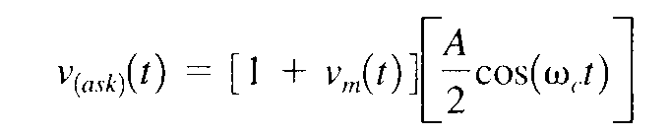
(2.12)

where
v_{ask}(t) = amplitude-shift keying wave
v_{m}(t) = digital information (modulating) signal (volts)
A/2 = unmodulated carrier amplitude (volts)
ω_{c} = analog carrier radian frequency (radians per second, 2πf_{c}t)

In Equation 2.12, the modulating signal [v_{m}(t)] is a normalized binary waveform, where + 1 V = logic 1 and -1 V = logic 0. Therefore, for a logic 1 input, v_{m}(t) = + 1 V, Equation 2.12 reduces to
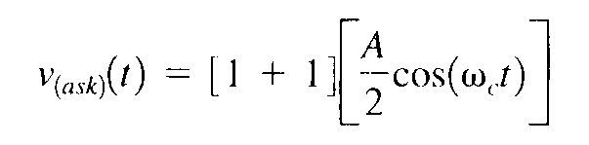

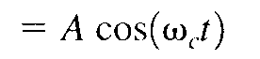

and for a logic 0 input, v_{m}(t) = -1 V, Equation 2.12 reduces to

Thus, the modulated wave v_{ask}(t), is either A cos(ω_{c} t) or 0. Hence, the carrier is either "on"or "off," which is why amplitude-shift keying is sometimes referred to as on-off keying(OOK).

Figure 2-2 shows the input and output waveforms from an ASK modulator.

From the figure, it can be seen that for every change in the input binary data stream, there is one change in the ASK waveform, and the time of one bit (t_{b}) equals the time of one analog signaling element (t,).

B = f_{b} /1 = f_{b} baud = f_{b} /1 = f_{b}
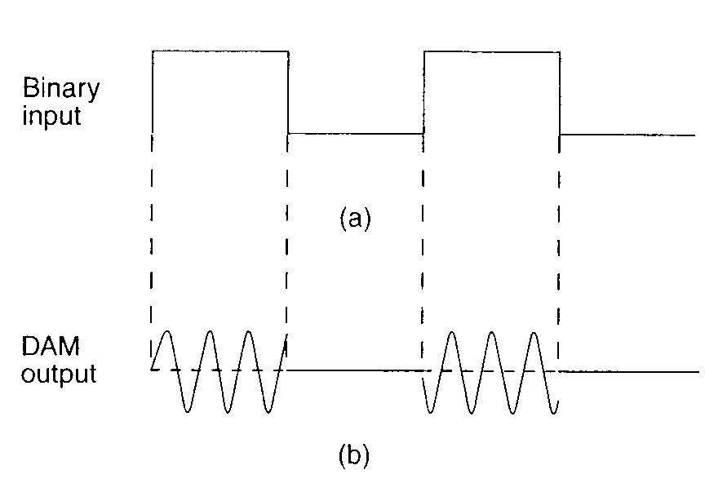
FIGURE 2-2 Digital amplitude modulation: (a) input binary; (b) output DAM waveform

The entire time the binary input is high, the output is a constant-amplitude, constant-frequency signal, and for the entire time the binary input is low, the carrier is off.

The rate of change of the ASK waveform (baud) is the same as the rate of change of the binary input (bps).

Example 2-1

Determine the baud and minimum bandwidth necessary to pass a 10 kbps binary signal using amplitude shift keying.
Solution

For ASK, N = 1, and the baud and minimum bandwidth are determined from Equations 2.11 and 2.10, respectively:

B = 10,000 / 1 = 10,000

baud = 10, 000 /1 = 10,000

The use of amplitude-modulated analog carriers to transport digital information is a relatively low-quality, low-cost type of digital modulation and, therefore, is seldom used except for very lowspeed telemetry circuits.

2-4 FREQUENCY-SHIFT KEYING
FSK is a form of constant-amplitude angle modulation similar to standard frequency modulation (FM) except the modulating signal is a binary signal that varies between two discrete voltage levels rather than a continuously changing analog waveform.

Consequently, FSK is sometimes called binary FSK (BFSK). The general expression for FSK is

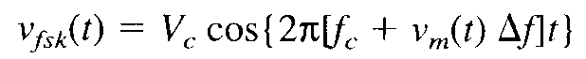
(2.13)

where

v_{fsk}(t) = binary FSK waveform
V_{c} = peak analog carrier amplitude (volts)
f_{c} = analog carrier center frequency (hertz)
Δf = peak change (shift) in the analog carrier frequency (hertz)
v_{m}(t) = binary input (modulating) signal (volts)

From Equation 2.13, it can be seen that the peak shift in the carrier frequency (Δf) is proportional to the amplitude of the binary input signal (v_{m}[t]), and the direction of the shift is determined by the polarity.

The modulating signal is a normalized binary waveform where a logic 1 = + 1 V and a logic 0 = -1 V. Thus, for a logic l input, v_{m}(t) = + 1, Equation 2.13 can be rewritten as

For a logic 0 input, v_{m}(t) = -1, Equation 2.13 becomes

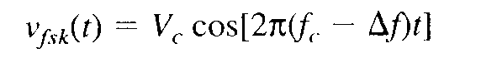

With binary FSK, the carrier center frequency (f_{c}) is shifted (deviated) up and down in the frequency domain by the binary input signal as shown in Figure 2-3.

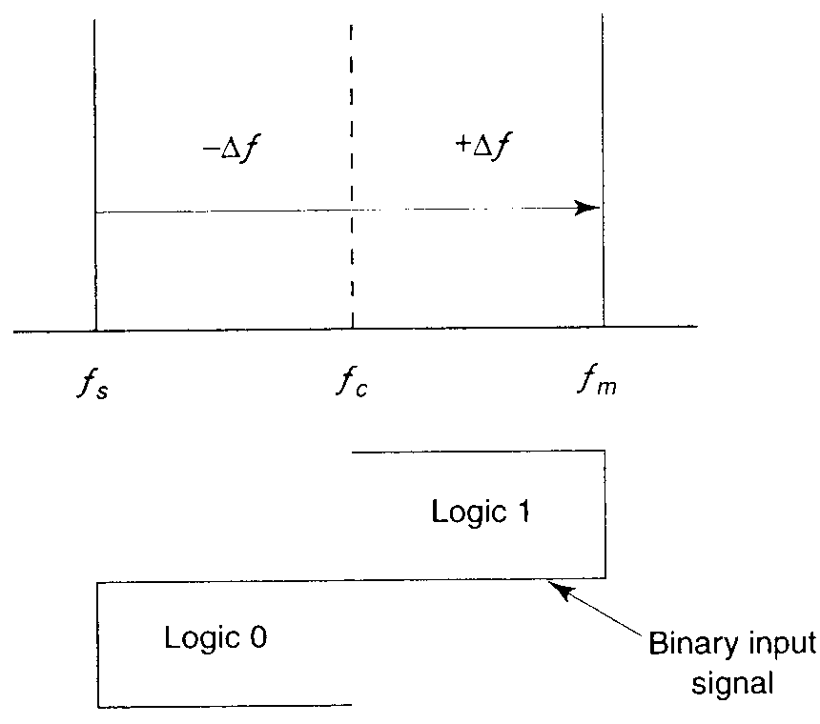

FIGURE 2-3 FSK in the frequency domain
As the binary input signal changes from a logic 0 to a logic 1 and vice versa, the output frequency shifts between two frequencies: a mark, or logic 1 frequency (f_{m}), and a space, or logic 0 frequency (f_{s}). The mark and space frequencies are separated from the carrier frequency by the peak frequency deviation (Δf) and from each other by 2 Δf.

Frequency deviation is illustrated in Figure 2-3 and expressed mathematically as

Δf = |f_{m} – f_{s}| / 2 (2.14)

where Δf = frequency deviation (hertz)
|f_{m} – f_{s}| = absolute difference between the mark and space frequencies (hertz)

Figure 2-4a shows in the time domain the binary input to an FSK modulator and the corresponding FSK output.

When the binary input (f_{b}) changes from a logic 1 to a logic 0 and vice versa, the FSK output frequency shifts from a mark ( f_{m}) to a space (f_{s}) frequency and vice versa.

In Figure 2-4a, the mark frequency is the higher frequency (f_{c} + Δf) and the space frequency is the lower frequency (f_{c} - Δf), although this relationship could be just the opposite.

Figure 2-4b shows the truth table for a binary FSK modulator. The truth table shows the input and output possibilities for a given digital modulation scheme.

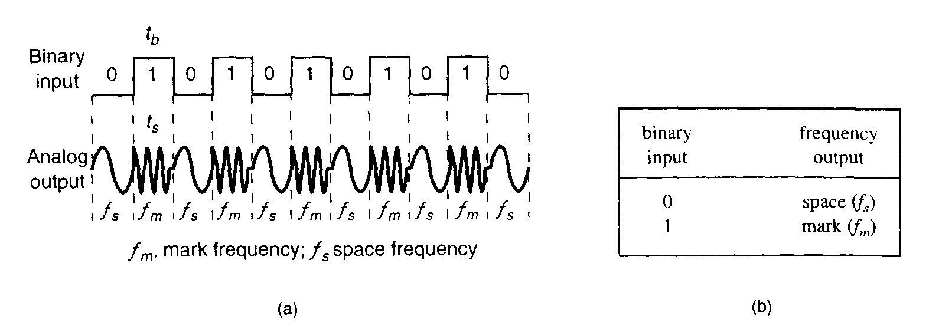
FIGURE 2-4 FSK in the time domain: (a) waveform: (b) truth table

2-4-1 FSK Bit Rate, Baud, and Bandwidth

In Figure 2-4a, it can be seen that the time of one bit (t_{b}) is the same as the time the FSK output is a mark of space frequency (t_{s}). Thus, the bit time equals the time of an FSK signaling element, and the bit rate equals the baud.

The baud for binary FSK can also be determined by substituting N = 1 in Equation 2.11:

baud = f_{b} / 1 = f_{b}

The minimum bandwidth for FSK is given as

B = |(f_{s} – f_{b}) – (f_{m} – f_{b})|
= |(f_{s}– f_{m})| + 2f_{b}

and since |(f_{s}– f_{m})| equals 2Δf, the minimum bandwidth can be approximated as
B = 2(Δf + f_{b}) (2.15)

where

B= minimum Nyquist bandwidth (hertz)
Δf= frequency deviation |(f_{m}– f_{s})| (hertz)
f_{b} = input bit rate (bps)

Example 2-2

Determine (a) the peak frequency deviation, (b) minimum bandwidth, and (c) baud for a binary FSK signal with a mark frequency of 49 kHz, a space frequency of 51 kHz, and an input bit rate of 2 kbps.

Solution

a. The peak frequency deviation is determined from Equation 2.14:

Δf = |149kHz - 51 kHz| / 2 =1 kHz

b. The minimum bandwidth is determined from Equation 2.15:
B = 2(1000 + 2000)
= 6 kHz
c. For FSK, N = 1, and the baud is determined from Equation 2.11 as

baud = 2000 / 1 = 2000

Bessel functions can also be used to determine the approximate bandwidth for an FSK wave. As shown in Figure 2-5, the fastest rate of change (highest fundamental frequency) in a non-return-to-zero (NRZ) binary signal occurs when alternating 1s and 0s are occurring (i.e., a square wave).

FIGURE 9-5 FSK modulator, t_{b}, time of one bit = 1/f_{b}; f_{m} mark frequency; f_{s}, space frequency; T₁, period of shortest cycle; 1/T₁, fundamental frequency of binary square wave; f_{b}, input bit rate (bps)

Since it takes a high and a low to produce a cycle, the highest fundamental frequency present in a square wave equals the repetition rate of the square wave, which with a binary signal is equal to half the bit rate. Therefore,

f_{a} = f_{b} / 2 (2.16)
where
f_{a} = highest fundamental frequency of the binary input signal (hertz)
f_{b} = input bit rate (bps)
The formula used for modulation index in FM is also valid for FSK; thus,
h = Δf / f_{a} (unitless) (2.17)
where
h = FM modulation index called the h-factor in FSK
f_{o} = fundamental frequency of the binary modulating signal (hertz)
Δf = peak frequency deviation (hertz)

The peak frequency deviation in FSK is constant and always at its maximum value, and the highest fundamental frequency is equal to half the incoming bit rate. Thus,

$h=\frac{\frac{|f_{m}−f_{s}|}{2}}{\frac{f_{b}}{2}}$
or
$h=\frac{|f_{m}−f_{s}|}{f_{b}}$ (2.18)

where
h = h-factor (unitless)
f_{m} = mark frequency (hertz)
f_{s} = space frequency (hertz)
f_{b} = bit rate (bits per second)
2-4-2 FSK Transmitter

Figure 2-6 shows a simplified binary FSK modulator, which is very similar to a conventional FM modulator and is very often a voltage-controlled oscillator (VCO).

The center frequency (f_{c}) is chosen such that it falls halfway between the mark and space frequencies.

FIGURE 2-6 FSK modulator

A logic 1 input shifts the VCO output to the mark frequency, and a logic 0 input shifts the VCO output to the space frequency.

Consequently, as the binary input signal changes back and forth between logic 1 and logic 0 conditions, the VCO output shifts or deviates back and forth between the mark and space frequencies.

FIGURE 2-6 FSK modulator

A VCO-FSK modulator can be operated in the sweep mode where the peak frequency deviation is simply the product of the binary input voltage and the deviation sensitivity of the VCO.

With the sweep mode of modulation, the frequency deviation is expressed mathematically as

Δf = v_{m}(t)k_{l} (2-19)

v_{m}(t) = peak binary modulating-signal voltage (volts)
k_{l} = deviation sensitivity (hertz per volt).

2-4-3 FSK Receiver

FSK demodulation is quite simple with a circuit such as the one shown in Figure 2-7.

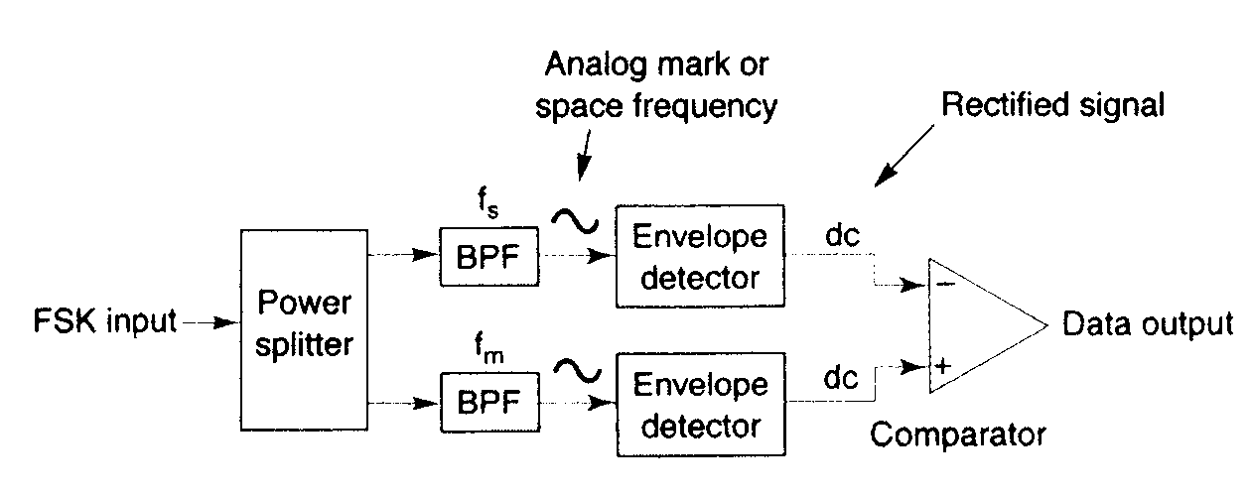
FIGURE 2-7 Noncoherent FSK demodulator

The FSK input signal is simultaneously applied to the inputs of both bandpass filters (BPFs) through a power splitter.

The respective filter passes only the mark or only the space frequency on to its respective envelope detector.

The envelope detectors, in turn, indicate the total power in each passband, and the comparator responds to the largest of the two powers.

This type of FSK detection is referred to as noncoherent detection.

The incoming FSK signal is multiplied by a recovered carrier signal that has the exact same frequency and phase as the transmitter reference.

However, the two transmitted frequencies (the mark and space frequencies) are not generally continuous; it is not practical to reproduce a local reference that is coherent with both of them. Consequently, coherent FSK detection is seldom used.

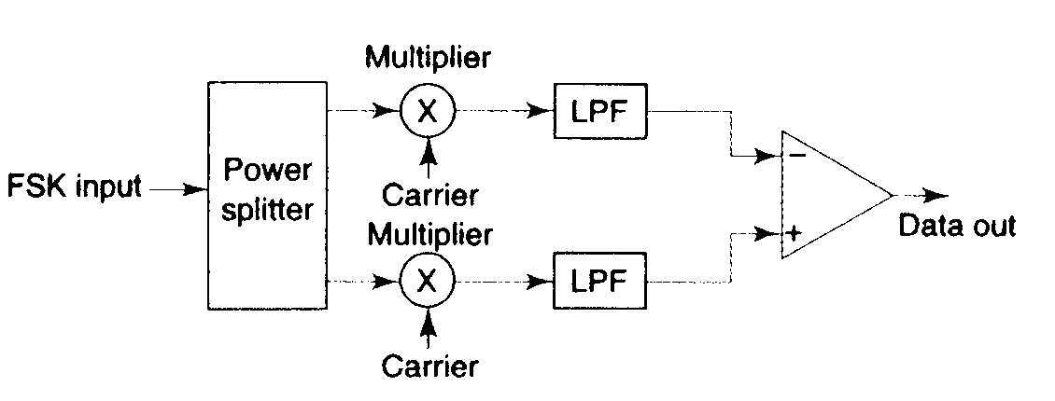
FIGURE 2-8 Coherent FSK demodulator

The most common circuit used for demodulating binary FSK signals is the phaselocked loop (PLL), which is shown in block diagram form in Figure 2-9.
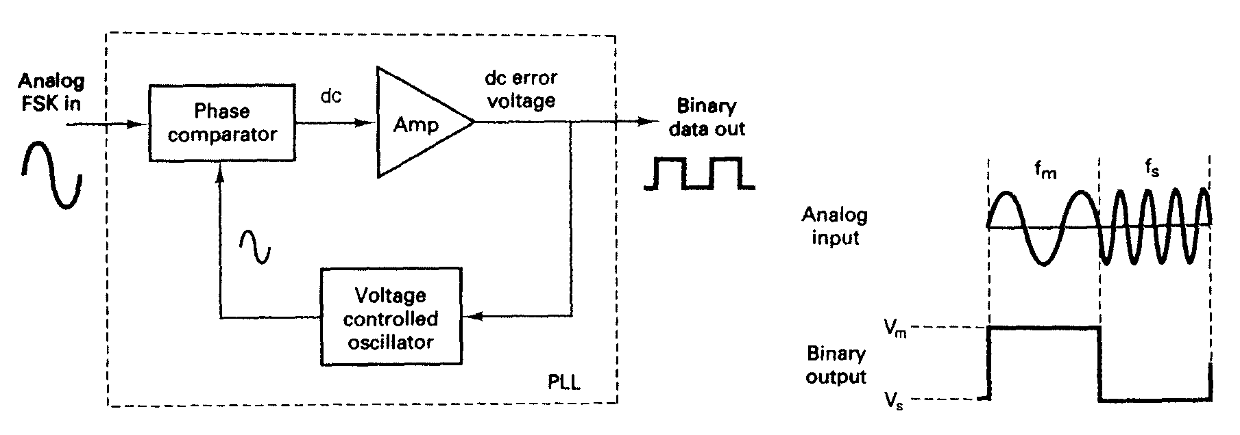
FIGURE 2-9 PLL-FSK demodulator

As the input to the PLL shifts between the mark and space frequencies, the dc error voltage at the output of the phase comparator follows the frequency shift.

Because there are only two input frequencies (mark and space), there are also only two output error voltages. One represents a logic 1 and the other a logic 0.

Binary FSK has a poorer error performance than PSK or QAM and, consequently, is seldom used for high-performance digital radio systems.

Its use is restricted to low-performance, low-cost, asynchronous data modems that are used for data communications over analog, voice-band telephone lines.

2-4-4 Continuous-Phase Frequency-Shift Keying

Continuous-phase frequency-shift keying (CP-FSK) is binary FSK except the mark and space frequencies are synchronized with the input binary bit rate.

With CP-FSK, the mark and space frequencies are selected such that they are separated from the center frequency by an exact multiple of one-half the bit rate (f_{m} and f_{s} = n[f_{b} / 2]), where n = any integer).

This ensures a smooth phase transition in the analog output signal when it changes from a mark to a space frequency or vice versa.

Figure 2-10 shows a noncontinuous FSK waveform. It can be seen that when the input changes from a logic 1 to a logic 0 and vice versa, there is an abrupt phase discontinuity in the analog signal. When this occurs, the demodulator has trouble following the frequency shift; consequently, an error may occur.

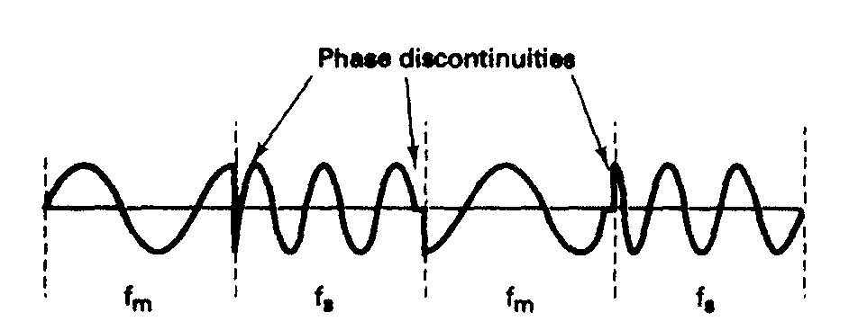
FIGURE 2-10 Noncontinuous FSK waveform

Figure 2-11 shows a continuous phase FSK waveform.

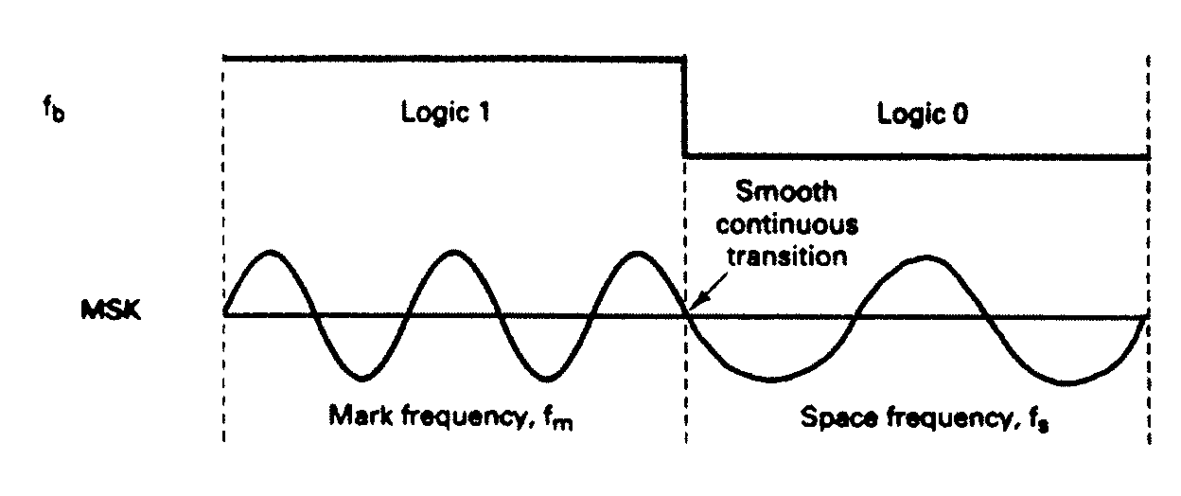
FIGURE 2-11 Continuous-phase MSK waveform

Notice that when the output frequency changes, it is a smooth, continuous transition. Consequently, there are no phase discontinuities.

CP-FSK has a better bit-error performance than conventional binary FSK for a given signal-to-noise ratio.

The disadvantage of CP-FSK is that it requires synchronization circuits and is, therefore, more expensive to implement.

2-5 PHASE-SHIFT KEYING

Phase-shift keying (PSK) is another form of angle-modulated, constant-amplitude digital modulation.

2-5-1 Binary Phase-Shift Keying
The simplest form of PSK is binary phase-shift keying (BPSK), where N = 1 and M = 2.

Therefore, with BPSK, two phases (2¹ = 2) are possible for the carrier.

One phase represents a logic 1, and the other phase represents a logic 0. As the input digital signal changes state (i.e., from a 1 to a 0 or from a 0 to a 1), the phase of the output carrier shifts between two angles that are separated by 180°.

Hence, other names for BPSK are phase reversal keying (PRK) and biphase modulation. BPSK is a form of square-wave modulation of a continuous wave (CW) signal.

FIGURE 2-12 BPSK transmitter
2-5-1-1 BPSK transmitter.
Figure 2-12 shows a simplified block diagram of a BPSK transmitter.
The balanced modulator acts as a phase reversing switch. Depending on the logic condition of the digital input, the carrier is transferred to the output either in phase or 180° out of phase with the reference carrier oscillator.
Figure 2-13 shows the schematic diagram of a balanced ring modulator.

The balanced modulator has two inputs: a carrier that is in phase with the reference oscillator and the binary digital data.

For the balanced modulator to operate properly, the digital input voltage must be much greater than the peak carrier voltage.

This ensures that the digital input controls the on/off state of diodes D1 to D4. If the binary input is a logic 1(positive voltage), diodes D 1 and D2 are forward biased and on, while diodes D3 and D4 are reverse biased and off (Figure 2-13b). With the polarities shown, the carrier voltage is developed across transformer T2 in phase with the carrier voltage across T 1. Consequently, the output signal is in phase with the reference oscillator.

If the binary input is a logic 0 (negative voltage), diodes Dl and D2 are reverse biased and off, while diodes D3 and D4 are forward biased and on (Figure 9-13c). As a result, the carrier voltage is developed across transformer T2 180° out of phase with the carrier voltage across T 1.

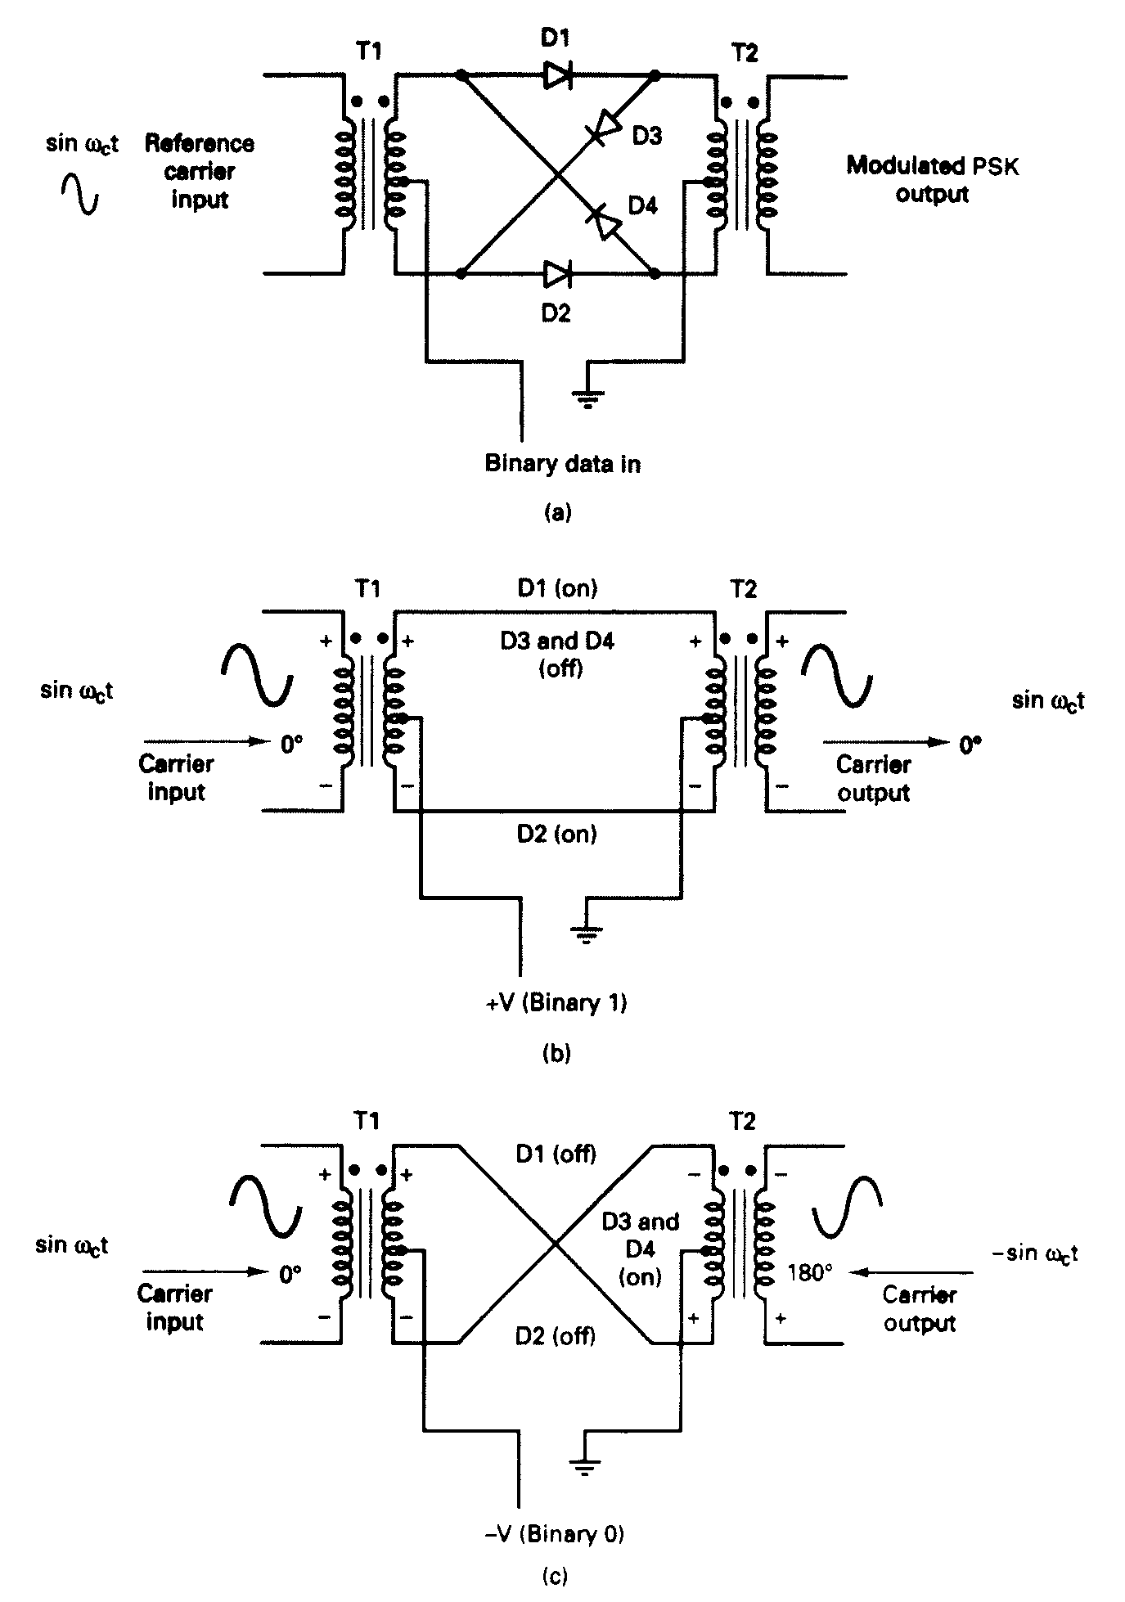

FIGURE 9-13 (a) Balanced ring modulator; (b) logic 1 input; (c) logic 0 input
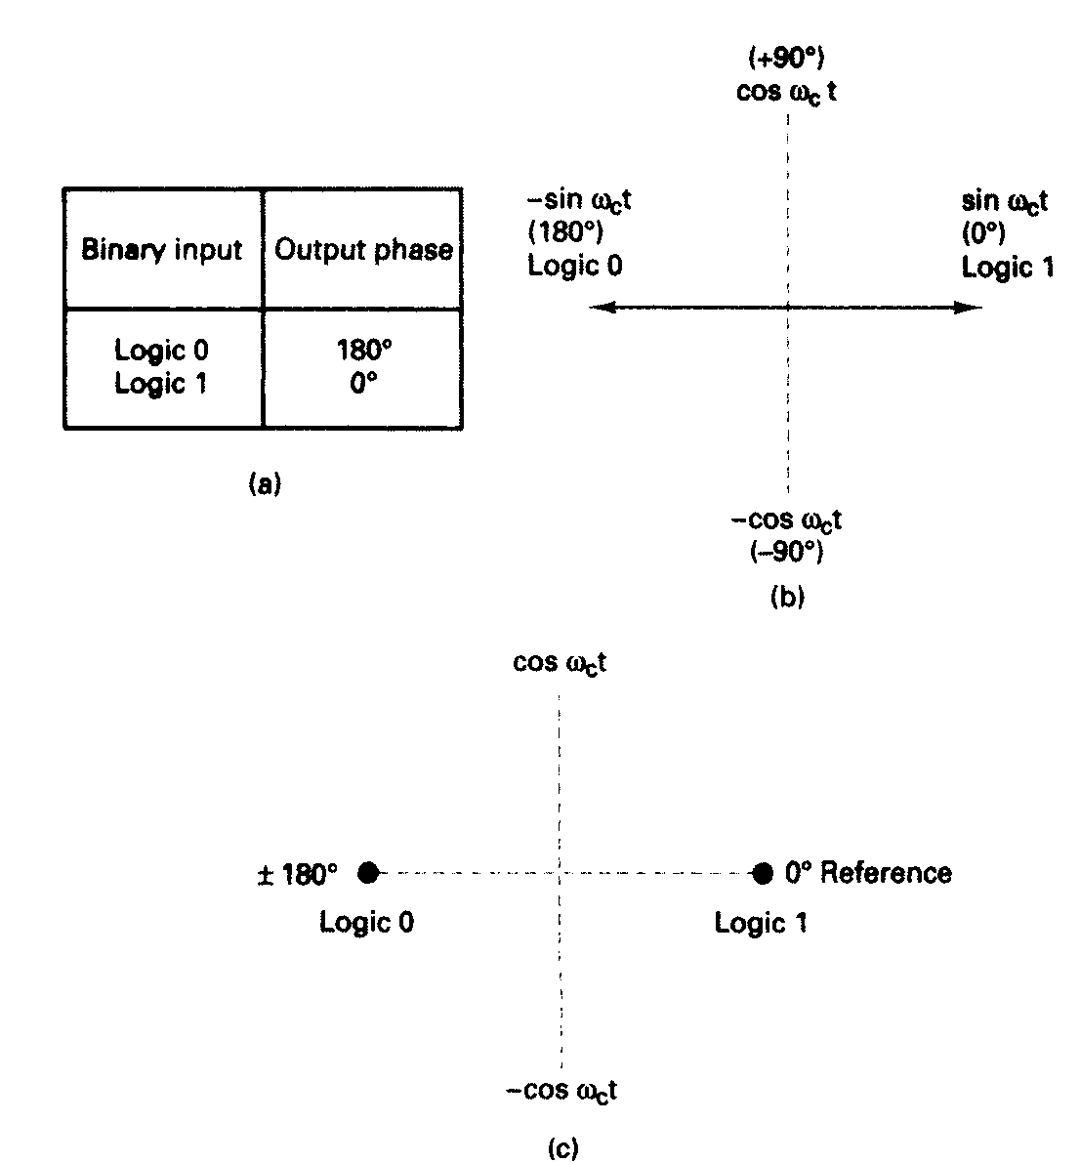

FIGURE 2-14 BPSK modulator: (a) truth table; (b) phasor diagram; (c) constellation diagram

2-5-1-2 Bandwidth considerations of BPSK.

In a BPSK modulator. the carrier input signal is multiplied by the binary data.

If + 1 V is assigned to a logic 1 and -1 V is assigned to a logic 0, the input carrier (sin ω_{c}t) is multiplied by either a + or - 1 .

The output signal is either + 1 sin ω_{c}t or -1 sin ω_{c}t the first represents a signal that is in phase with the reference oscillator, the latter a signal that is 180° out of phase with the reference oscillator.

Each time the input logic condition changes, the output phase changes.

Mathematically, the output of a BPSK modulator is proportional to

BPSK output = [sin (2πf_{a}t)] x [sin (2πf_{c}t)] (2.20)

where
f_{a} = maximum fundamental frequency of binary input (hertz)
f_{c} = reference carrier frequency (hertz)

Solving for the trig identity for the product of two sine functions,
0.5cos[2π(f_{c} – f_{a})t] – 0.5cos[2π(f_{c} + f_{a})t]
Thus, the minimum double-sided Nyquist bandwidth (B) is

f_{c} + f_{a} f_{c} + f_{a}
-(f_{c} + f_{a}) or -f_{c} + f_{a}
2f_{a}

and because f_{a =} f_{b} / 2, where f_{b} = input bit rate,
where B is the minimum double-sided Nyquist bandwidth.

Figure 2-15 shows the output phase-versus-time relationship for a BPSK waveform.

Logic 1 input produces an analog output signal with a 0° phase angle, and a logic 0 input produces an analog output signal with a 180° phase angle.

As the binary input shifts between a logic 1 and a logic 0 condition and vice versa, the phase of the BPSK waveform shifts between 0° and 180°, respectively.

BPSK signaling element (t_{s}) is equal to the time of one information bit (t_{b}), which indicates that the bit rate equals the baud.

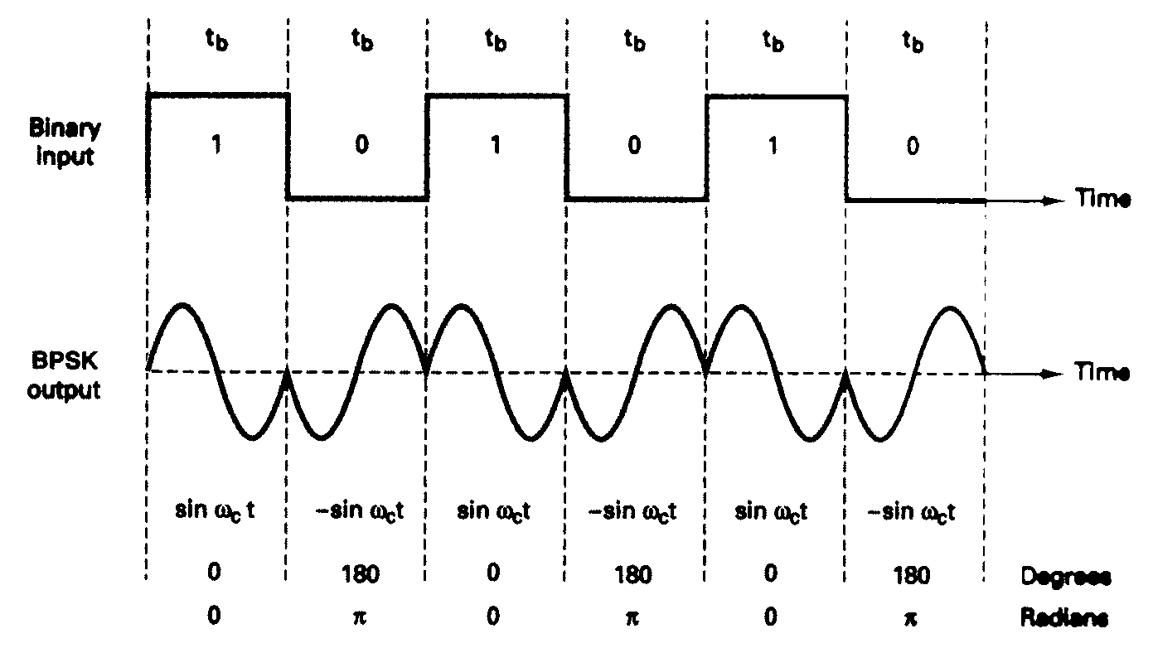
FIGURE 2-15 Output phase-versus-time relationship for a BPSK modulator

Example 2-4

For a BPSK modulator with a carrier frequency of 70 MHz and an input bit rate of 10 Mbps, determine the maximum and minimum upper and lower side frequencies, draw the output spectrum, determine the minimum Nyquist bandwidth, and calculate the baud..

Solution
Substituting into Equation 2-20 yields

output = [sin (2πf_{a}t)] x [sin (2πf_{c}t)] ; f_{a =} f_{b} / 2 = 5 MHz

= [sin 2π(5MHz)t)] x [sin 2π(70MHz)t)]

= 0.5cos[2π(70MHz – 5MHz)t] – 0.5cos[2π(70MHz + 5MHz)t]
lower side frequency upper side frequency

Minimum lower side frequency (LSF):

LSF=70MHz - 5MHz = 65MHz

Maximum upper side frequency (USF):

USF = 70 MHz + 5 MHz = 75 MHz

Therefore, the output spectrum for the worst-case binary input conditions is as follows: The minimum Nyquist bandwidth (B) is

B = 75 MHz - 65 MHz = 10 MHz

and the baud = f_{b} or 10 megabaud.

2-5-1-3 BPSK receiver.

Figure 2-16 shows the block diagram of a BPSK receiver.
The input signal maybe + sin ω_{c}t or - sin ω_{c}t .
The coherent carrier recovery circuit detects and regenerates a carrier signal that is both frequency and phase coherent with the original transmit carrier.

The balanced modulator is a product detector; the output is the product d the two inputs (the BPSK signal and the recovered carrier).

The low-pass filter (LPF) operates the recovered binary data from the complex demodulated signal.
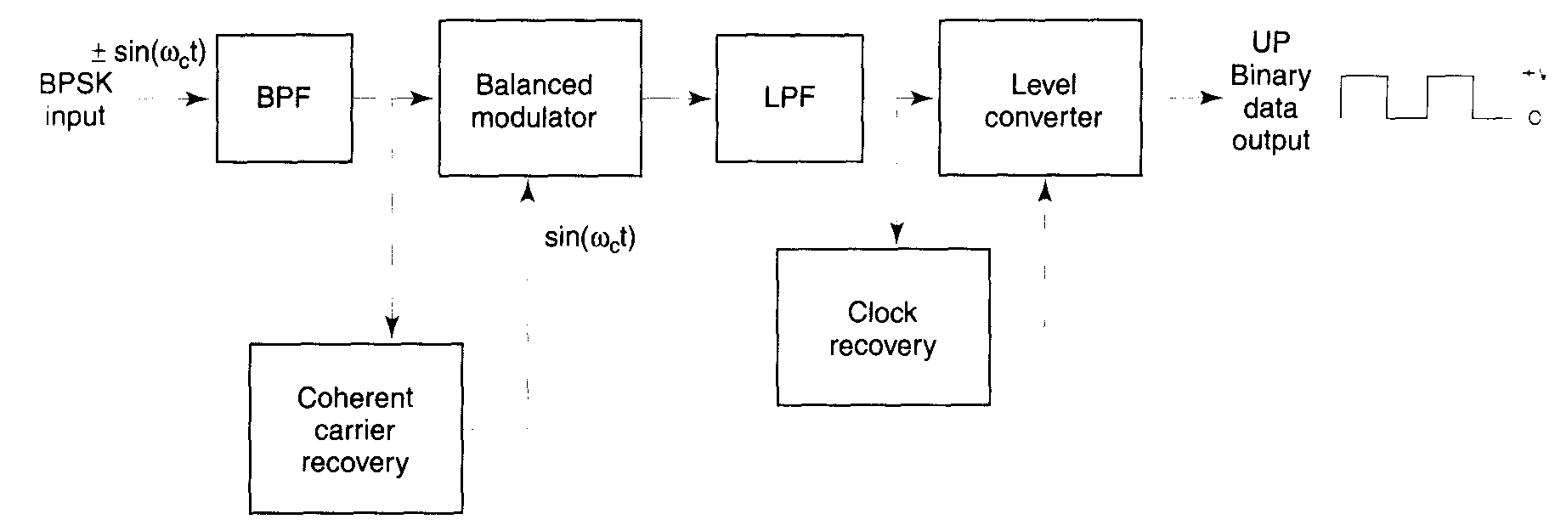
FIGURE 2-16 Block diagram of a BPSK receiver

Mathematically, the demodulation process is as follows.

For a BPSK input signal of + sin ω_{c}t (logic 1), the output of the balanced modulator is

output = (sin ω_{c}t )(sin ω_{c}t) = sin²ω_{c}t (2.21)
or

sin²ω_{c}t = 0.5(1 – cos 2ω_{c}t) = 0.5 - 0.5cos 2ω_{c}t

filtered out

leaving
output = + 0.5 V = logic 1

It can be seen that the output of the balanced modulator contains a positive voltage (+[1/2]V) and a cosine wave at twice the carrier frequency (2 ω_{c}t ).

The LPF has a cutoff frequency much lower than 2 ω_{c}t, and, thus, blocks the second harmonic of the carrier and passes only the positive constant component. A positive voltage represents a demodulated logic 1.

For a BPSK input signal of -sin ω_{c}t (logic 0), the output of the balanced modulator is

output = (-sin ω_{c}t )(sin ω_{c}t) = sin²ω_{c}t
or

sin²ω_{c}t = -0.5(1 – cos 2ω_{c}t) = 0.5 + 0.5cos 2ω_{c}t

filtered out

leaving
output = - 0.5 V = logic 0

The output of the balanced modulator contains a negative voltage (-[l/2]V) and a cosine wave at twice the carrier frequency (2ω_{c}t).

Again, the LPF blocks the second harmonic of the carrier and passes only the negative constant component. A negative voltage represents a demodulated logic 0.
QPSK transmitter.
A block diagram of a QPSK modulator is shown in Figure 2-17. Two bits (a dibit) are clocked into the bit splitter. After both bits have been serially inputted, they are simultaneously parallel outputted.

The I bit modulates a carrier that is in phase with the reference oscillator (hence the name "I" for "in phase" channel), and the Q bit modulate, a carrier that is 90° out of phase.

For a logic 1 = + 1 V and a logic 0= - 1 V, two phases are possible at the output of the I balanced modulator (+sin ω_{c}t and - sin ω_{c}t), and two phases are possible at the output of the Q balanced modulator (+cos ω_{c}t), and (-cos ω_{c}t).

When the linear summer combines the two quadrature (90° out of phase) signals, there are four possible resultant phasors given by these expressions: + sin ω_{c}t + cos ω_{c}t, + sin ω_{c}t - cos ω_{c}t, -sin ω_{c}t + cos ω_{c}t, and -sin ω_{c}t - cos ω_{c}t.

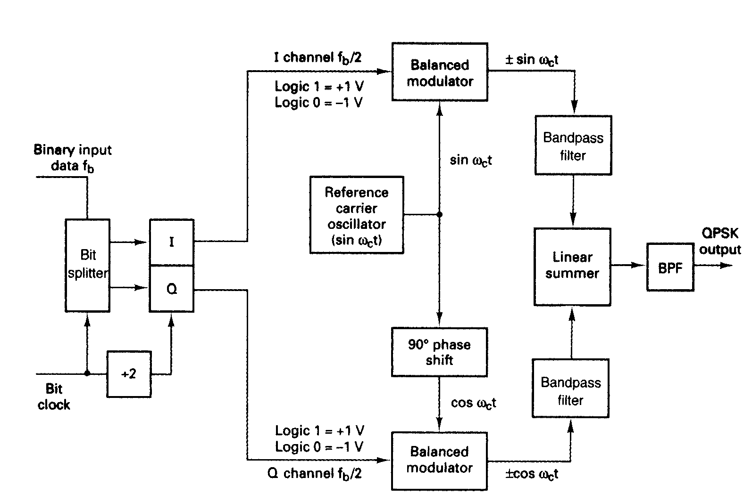
FIGURE 2-17 QPSK modulator

Example 2-5
For the QPSK modulator shown in Figure 2-17, construct the truth table, phasor diagram, and constellation diagram.
Solution

For a binary data input of Q = O and I= 0, the two inputs to the I balanced modulator are -1 and sin ω_{c}t, and the two inputs to the Q balanced modulator are -1 and cos ω_{c}t.

Consequently, the outputs are

I balanced modulator =(-1)(sin ω_{c}t) = -1 sin ω_{c}t
Q balanced modulator =(-1)(cos ω_{c}t) = -1 cos ω_{c}t and the output of the linear summer is

-1 cos ω_{c}t - 1 sin ω_{c}t = 1.414 sin(ω_{c}t - 135°)

For the remaining dibit codes (01, 10, and 11), the procedure is the same. The results are shown in Figure 2-18a.

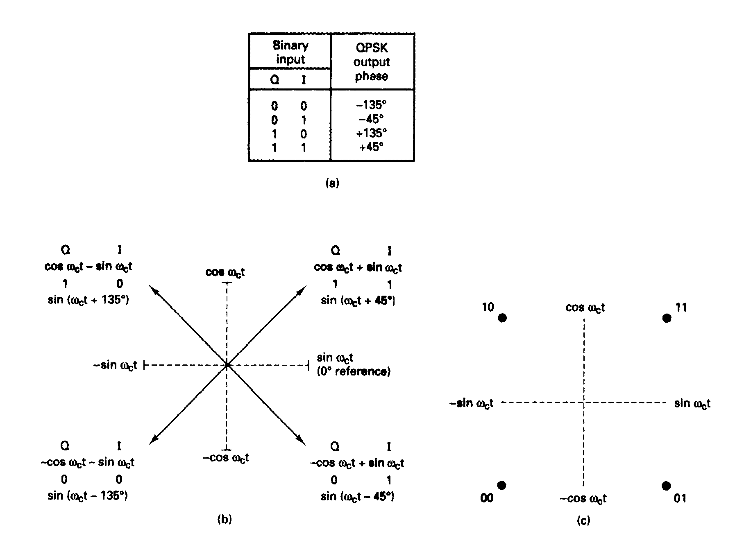
FIGURE 2-18 QPSK modulator: (a) truth table; (b) phasor diagram; (c) constellation diagram
In Figures 2-18b and c, it can be seen that with QPSK each of the four possible output phasors has exactly the same amplitude. Therefore, the binary information must be encoded entirely in the phase of the output signal.

Figure 2-18b, it can be seen that the angular separation between any two adjacent phasors in QPSK is 90°.

Therefore, a QPSK signal can undergo almost a+45° or -45° shift in phase during transmission and still retain the correct encoded information when demodulated at the receiver.

Figure 2-19 shows the output phase-versus-time relationship for a QPSK modulator.

FIGURE 2-19 Output phase-versus-time relationship for a PSK modulator.
2-5-2-2 Bandwidth considerations of QPSK
With QPSK, because the input data are divided into two channels, the bit rate in either the I or the Q channel is equal to one-half of the input data rate (f_{b}/2) (one-half of f_{b}/2 = f_{b}/4).

This relationship is shown in Figure 2-20.

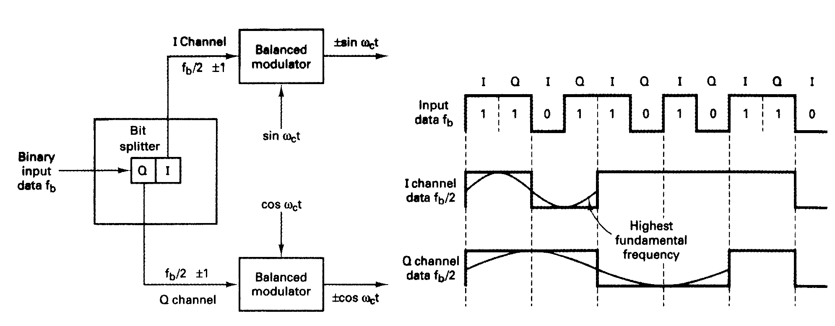
FIGURE 2-20 Bandwidth considerations of a QPSK modulator

In Figure 2-20, it can be seen that the worse-case input condition to the I or Q balanced modulator is an alternative 1/0 pattern, which occurs when the binary input data have a 1100 repetitive pattern. One cycle of the fastest binary transition (a 1/0 sequence in the I or Q channel takes the same time as four input data bits.

Consequently, the highest fundamental frequency at the input and fastest rate of change at the output of the balance.: modulators is equal to one-fourth of the binary input bit rate.

The output of the balanced modulators can be expressed mathematically as

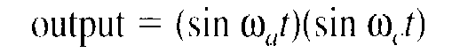 (2.22)
where

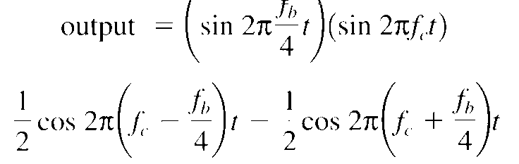

The output frequency spectrum extends from f'_{c} + f_{b} / 4 to f'_{c} - f_{b} / 4 and the minimum bandwidth (f_{N}) is

Example 2-6

For a QPSK modulator with an input data rate (f_{b}) equal to 10 Mbps and a carrier frequency 70 MHz, determine the minimum double-sided Nyquist bandwidth (f_{N}) and the baud. Also, compare the results with those achieved with the BPSK modulator in Example 2-4. Use the QPSK block diagram shown in Figure 2-17 as the modulator model.

Solution
The bit rate in both the I and Q channels is equal to one-half of the transmission bit rate, or

f_{bQ} = f_{b1} = f_{b} / 2 = 10 Mbps / 2 = 5 Mbps
The highest fundamental frequency presented to either balanced modulator is
f_{a}= f_{bQ} / 2 = 5 Mbps / 2 = 2.5 MHz

The output wave from each balanced modulator is
(sin 2πf_{a}t)(sin 2πf_{c}t)

0.5 cos 2π(f_{c} – f_{a})t – 0.5 cos 2π(f_{c} + f_{a})t

0.5 cos 2π[(70 – 2.5)MHz]t – 0.5 cos 2π[(70 – 2.5)MHz]t

0.5 cos 2π(67.5MHz)t - 0.5 cos 2π(72.5MHz)t

The minimum Nyquist bandwidth is

B=(72.5-67.5)MHz = 5MHz

The symbol rate equals the bandwidth: thus,

symbol rate = 5 megabaud

The output spectrum is as follows:
It can be seen that for the same input bit rate the minimum bandwidth required to pass the output of the QPSK modulator is equal to one-half of that required for the BPSK modulator in Example 2-4. Also, the baud rate for the QPSK modulator is one-half that of the BPSK modulator.
The minimum bandwidth for the QPSK system described in Example 2-6 can also be determined by simply substituting into Equation 2-10:
B = 10 Mbps / 2 = 5 MHz
2-5-2-3 (QPSK receiver).
The block diagram of a QPSK receiver is shown in Figure 2-21. The power splitter directs the input QPSK signal to the I and Q product detectors and the carrier recovery circuit. The carrier recovery circuit reproduces the original transmit carrier oscillator signal. The recovered carrier must be frequency and phase coherent with the transmit reference carrier. The QPSK signal is demodulated in the I and Q product detectors, which generate the original I and Q data bits. The outputs of the product detectors are fed to the bit combining circuit, where they are converted from parallel I and Q data channels to a single binary output data stream.
The incoming QPSK signal may be any one of the four possible output phases shown in Figure 2-18. To illustrate the demodulation process, let the incoming QPSK signal be -sin ω_{c}t + cos ω_{c}t. Mathematically, the demodulation process is as follows.
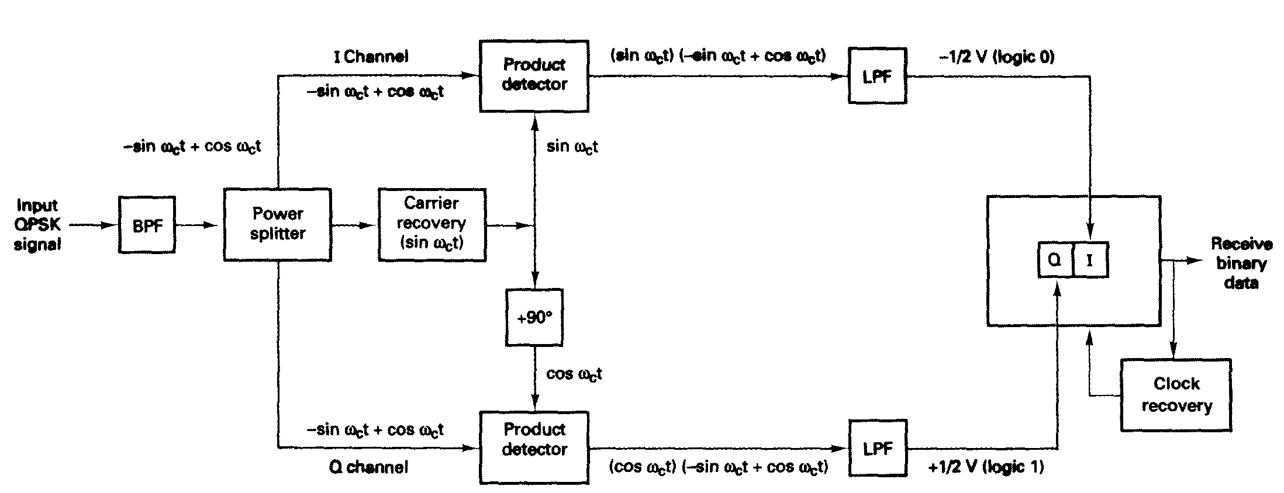
FIGURE 2-21 QPSK receiver
The receive QPSK signal (-sin ω_{c}t + cos ω_{c}t) is one of the inputs to the I product detector. The other input is the recovered carrier (sin ω_{c}t). The output of the I product detector is
(2.23)

Again, the receive QPSK signal (-sin ω_{c}t + cos ω_{c}t) is one of the inputs to the Q product detector. The other input is the recovered carrier shifted 90° in phase (cos ω_{c}t). The output of the Q product detector is

(2.24)

The demodulated I and Q bits (0 and 1, respectively) correspond to the constellation diagram and truth table for the QPSK modulator shown in Figure 2-18.
2-5-2-4 Offset QPSK.
Offset QPSK (OQPSK) is a modified form of QPSK where the bit waveforms on the I and Q channels are offset or shifted in phase from each other by one-half of a bit time.

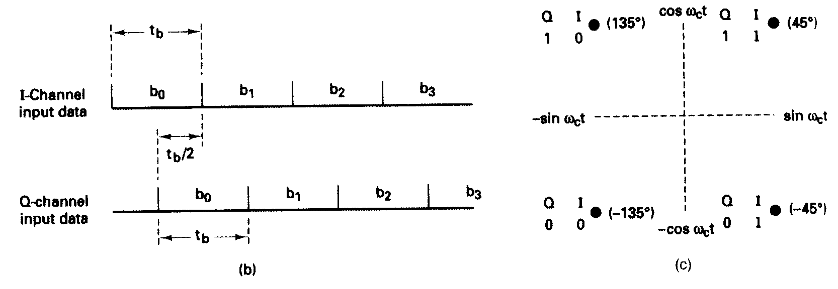
FIGURE 2-22 Offset keyed (OQPSK): (a) block diagram; (b) bit alignment; (c) constellation diagram
Because changes in the I channel occur at the midpoints of the Q channel bits and vice versa, there is never more than a single bit change in the dibit code and, therefore, there is never more than a 90° shift in the output phase. In conventional QPSK, a change in the input dibit from 00 to 11 or 01 to 10 causes a corresponding 180° shift in the output phase.
Therefore, an advantage of OQPSK is the limited phase shift that must be imparted during modulation.
A disadvantage of OQPSK is that changes in the output phase occur at twice the data rate in either the I or Q channel".
Consequently, with OQPSK the baud and minimum bandwidth are twice that of conventional QPSK for a given transmission bit rate. OQPSK is sometimes called OKQPSK (offset-keyed QPSK).
2-7 BANDWIDTH EFFICIENCY

Bandwidth efficiency (sometimes called information density or spectral efficiency, often used to compare the performance of one digital modulation technique to another.

Mathematical bandwidth efficiency is

$Bη=\frac{\text{transmission} \text{bit} \text{rate} (\text{bps})}{\text{min}\text{imum} \text{bandwidth} (\text{Hz})}=\frac{{\text{bits}}/s}{\text{Hertz}}$ (2.27)

Where B$η$ = bandwidth efficiency

DIFFERENTIAL PHASE-SHIFT KEYING

Differential phase-shift keying (DPSK) is an alternative form of digital modulation where the binary input information is contained in the difference between two successive signaling elements rather than the absolute phase.

2-8-1 Differential BPSK

2-8-1-I DBPSK transmitter.

Figure 2-37a shows a simplified block diagram of a differential binary phase-shift keying (DBPSK) transmitter. An incoming information bit is XNORed with the preceding bit prior to entering the BPSK modulator (balanced modulator).

For the first data bit, there is no preceding bit with which to compare it. Therefore, an initial reference bit is assumed. Figure 2-37b shows the relationship between the input data, the XNOR output data, and the phase at the output of the balanced modulator. If the initial reference bit is assumed a logic 1, the output from the XNOR circuit is simply the complement of that shown.

In Figure 2-37b, the first data bit is XNORed with the reference bit. If they are the same, the XNOR output is a logic 1; if they are different, the XNOR output is a logic 0. The balanced modulator operates the same as a conventional BPSK modulator; a logic I produces +sin ω_{c}t at the output, and a logic 0 produces -sin ω_{c}t at the output.
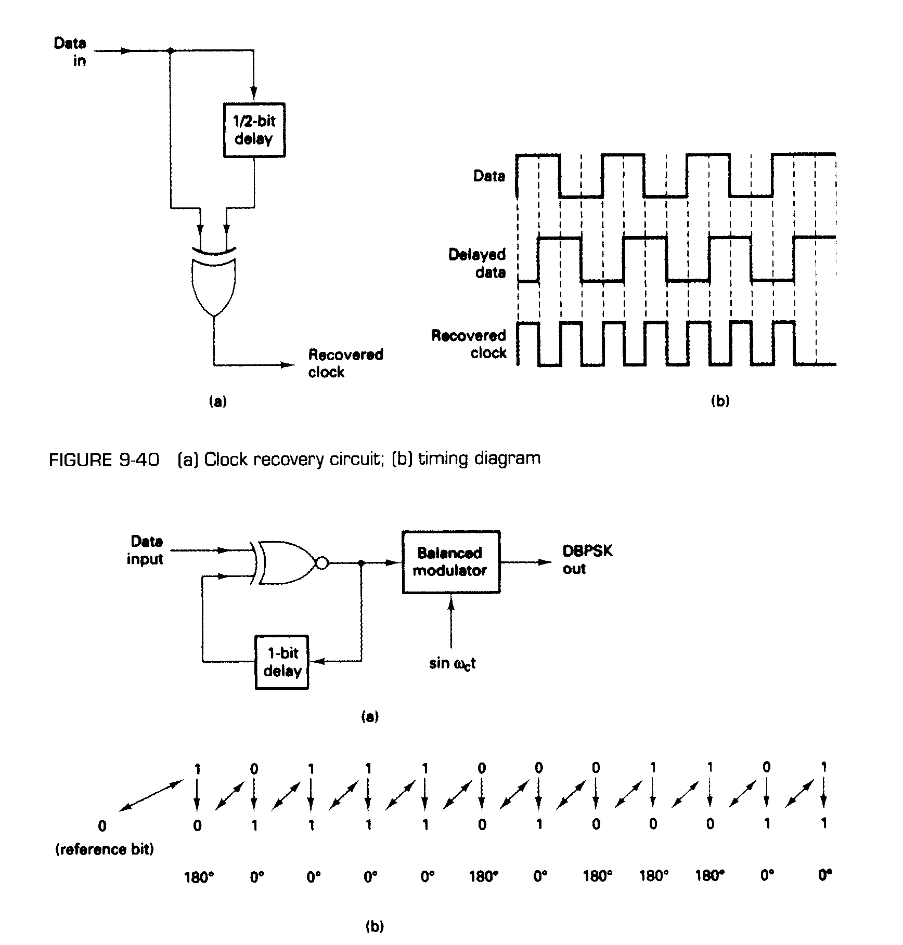
FIGURE 2-37 DBPSK modulator (a) block diagram (b) timing diagram

2-8-1-2 DBPSK receiver.

Figure 9-38 shows the block diagram and timing sequence for a DBPSK receiver. The received signal is delayed by one bit time, then compared with the next signaling element in the balanced modulator. If they are the same. J logic 1(+ voltage) is generated. If they are different, a logic 0 (- voltage) is generated. [f the reference phase is incorrectly assumed, only the first demodulated bit is in error. Differential encoding can be implemented with higher-than-binary digital modulation schemes, although the differential algorithms are much more complicated than for DBPS K.

The primary advantage of DBPSK is the simplicity with which it can be implemented. With DBPSK, no carrier recovery circuit is needed. A disadvantage of DBPSK is, that it requires between 1 dB and 3 dB more signal-to-noise ratio to achieve the same bit error rate as that of absolute PSK.

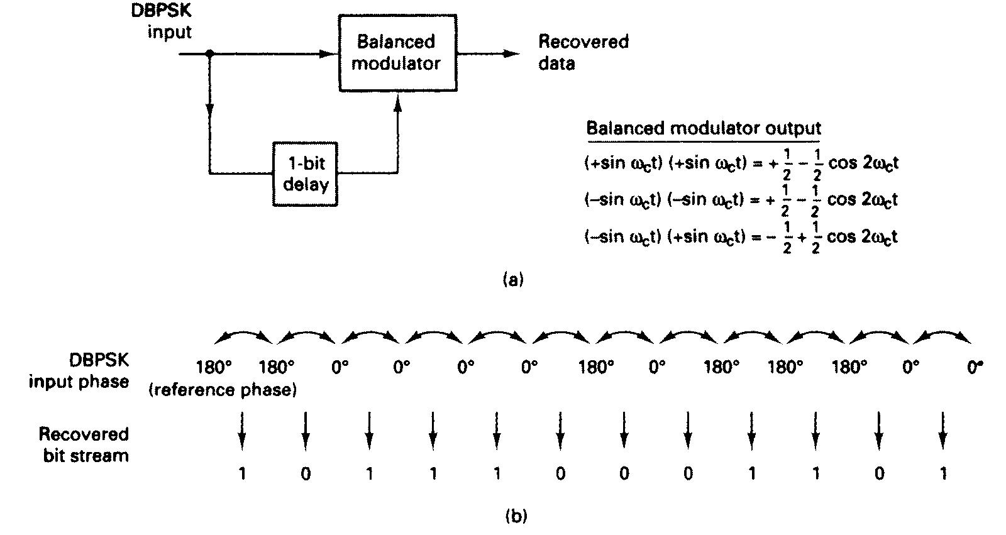

FIGURE 2-38 DBPSK demodulator: (a) block diagram; (b) timing sequence

2-9 PROBABILITY OF ERROR AND BIT ERROR RATE

Probability of error P(e) and bit error rate (BER) are often used interchangeably

BER is an empirical (historical) record of a system's actual bit error performance.

For example, if a system has a BER of 10⁻⁵, this means that in past performance there was one bit error for every 100,000 bits transmitted.

Probability of error is a function of the carrier-to-noise power ratio (or, more specifically, the average energy per bit-to-noise power density ratio) and the number of possible encoding conditions used (M-ary).

Carrier-to-noise power ratio is the ratio of the average carrier power (the combined power of the carrier and its associated sidebands) to the thermal noise power Carrier power can be stated in watts or dBm. where

C_{(dBm)} = 10 log [C_{(watts)} / 0.001] (2.28)

Thermal noise power is expressed mathematically as
N = KTB (watts) (2.29)

where
N = thermal noise power (watts)
K = Boltzmann's proportionality constant (1.38 X 10⁻²³ joules per kelvin)
T= temperature (kelvin: 0 K=-273° C, room temperature = 290 K)
B = bandwidth (hertz)

Stated in dBm, N_{(dBm)} = 10 log [KTB / 0.001] (2.30)

Mathematically, the carrier-to-noise power ratio is

C / N = C / KTB (unitless ratio) (2.31)

where
C = carrier power (watts)
N = noise power (watts)
Stated in dB, C / N (dB) = 10 log [C / N]
= C_{(dBm)} – N_{(dBm)} (2.32)

Energy per bit is simply the energy of a single bit of information. Mathematically, energy per bit is

E_{b} = CT_{b} (J/bit) (2.33)

where

E_{b} = energy of a single bit (joules per bit)
T_{b} = time of a single bit (seconds)
C = carrier power (watts)

Stated in dBJ, E_{b(dBJ)} = 10 log E_{b} (2.34)

and because T_{b} = 1/f_{b}, where f_{b} is the bit rate in bits per second, E_{b} can be rewritten as
E_{b} = C / f_{b} (J/bit) (2.35)

Stated in dBJ, E_{b(dBJ)} = 10 log C / f_{b} (2.36)
= 10 log C – 10 log f_{b} (2.37)

Noise power density is the thermal noise power normalized to a 1-Hz bandwidth (i.e., the noise power present in a 1-Hz bandwidth). Mathematically, noise power density is

N_{o} = N / B (W/Hz) (2.38)

where
N_{o} = noise power density (watts per hertz)
N = thermal noise power (watts)
B = bandwidth (hertz)

Stated in dBm, N_{o(dBm)} = 10 log (N/0.001) – 10 log B (2.39)

Combining Equations 2.29 and 2.38 yields
N_{o} = KTB / B = KT ( W/ Hz ) (2.41)

Stated in dBm, N_{o(dBm)} = 10 log (K/0.001) + 10 log T (2.42)

Energy per bit-to-noise power density ratio is used to compare two or more digital modulation systems that use different transmission rates (bit rates), modulation schemes (FSK, PSK, QAM), or encoding techniques (M-ary).

Mathematically, E_{b}/N_{o} is

E_{b}/N_{o} = (C/f_{b}) / (N/B) (2.43)

where E_{b}/N_{o} is the energy per bit-to-noise power density ratio. Rearranging Equation 2.43 yields the following expression:

E_{b}/N_{o} = (C/N) x (B/f_{b}) (2.44)

where
E_{b}/N_{o} = energy per bit-to-noise power density ratio
C/N = carrier-to-noise power ratio
B/f_{b} = noise bandwidth-to-bit rate ratio

Stated in dB, E_{b}/N_{o} (dB) = 10 log (C/N) + 10 log (B/f_{b}) (2.45)

= 10 log E_{b} - 10 log N_{o} (2.46)

The probability of error for coherent FSK is

$P(e)=\text{erfc}\sqrt{\frac{E_{b}}{N_{0}}}$ (2.54)

Figure 2-42 shows probability of error curves for both coherent and noncoherent FSK for several values of E_{b}/N_{o}. From Equations 2-53 and 2-54, it can be determined that the probability of error for noncoherent FSK is greater than that of coherent FSK for equal energy per bit-to-noise power density ratios.

