A Course File
On
DYNAMICS OF MACHINERY
(II- B. Tech. – II– Semester)
Submitted to
DEPARTMENT OF MECHANICAL ENGINEERING

By
Mr. S.FAQRUDDIN
(Asst. Professor, Dept. of ME)


CMR ENGINEERING COLLEGE
Kandlakoya(V), Medchal Road, Hyderabad – 501 401
Ph. No. +91-9248727229 +91-08418 - 200037

(2017-18)

CONTENTS

Sl. No. | Particulars | Page No.
1 | JNTUH Syllabus
2 | Student Entry Behavior or Pre-requisites
3 | Course Objectives
4 | Course Outcomes
5 | Mapping of Course with PEOs-PSOs-POs
6 | Mapping Of Course Outcomes with PEOs
7 | Mapping Of Course Outcomes with PSOs
8 | Mapping Of Course Outcomes with POs
9 | Direct Course Assessment
10 | Indirect Course Assessment
11 | Overall Course Assessment and Attainment level
12 | Pi diagrams, Bar charts, Histograms for representing results
13 | Lesson/Course Plan
14 | Actions and Assessment Plan
15 | Lecturer Notes
16 | Question Bank
17 | Internal Examination Question Papers with key
18 | External/End Examination Question Papers

SYLLABUS
JAWAHARLAL NEHRU TECHNOLOGICAL UNIVERSITY HYDERABAD
II Year B. Tech. ME - II Sem L T/P/D C 4 1/0/0 4
ME403ES: DYNAMICS OF MACHINERY
Pre-requisite: Kinematics of machines
Course Objectives: The objective is to introduce some of the components mainly used in IC Engines and make analysis of various forces involved. Subjects deals with topics like inertia forces in slider crank mechanism; IC Engine components & the analysis like governors is introduced. It also deals with balancing of rotating & reciprocating parts. Studies are made about balancing of multi cylinder engines, Radial engines etc. study of primary & secondary forces are considered while balancing. Finally they are introduced to the topic of vibrations. The study deals with linear, longitudinal, & torsional vibrations. The idea is to introduce the concept of natural frequency and the importance of resonance and critical speeds.
Course Outcome: the study of KOM& DOM are necessary to have an idea while designing the various machine members like shafts, bearings, gears, belts & chains and various I.C.
Engine Components & Machine tool parts.
UNIT – I
Precession: Gyroscopes – effect of precession – motion on the stability of moving vehicles
such as motorcycle – motorcar – aeroplanes and ships.
Static and Dynamic Force Analysis: Static force analysis of planar mechanisms – Analytical Method – Dynamic Force Analysis – D’Alembert’s principle, Dynamic Analysis of 4-link mechanism, Slider Crank Mechanism.
UNIT – II
Turning Moment Diagram And Flywheels: Engine Force Analysis – Piston Effort, Crank Effort, etc., Inertia Force in Reciprocating Engine – Graphical Method - Turning moment diagram –fluctuation of energy – flywheels and their design - Inertia of connecting rod inertia force in reciprocating engines – crank effort and torque diagrams.-.
UNIT – III
Friction: pivots and collars – uniform pressure, uniform wear – friction circle and friction axis: lubricated surfaces – boundary friction – film lubrication. Clutches – Types – Single plate, multi-plate and cone clutches.
Brakes And Dynamometers: Types of brakes: Simple block brake, band and block brake internal expanding shoe brake-effect of braking of a vehicle. Dynamometers – absorption and transmission types. General description and methods of operation.
UNIT – IV
Governors: Types of governors - Watt, Porter and Proell governors. Spring loaded governors – Hartnell and Hartung with auxiliary springs. Sensitiveness, isochronisms and hunting – stability – effort and power of the governors.
Balancing : Balancing of rotating masses- Primary, Secondary, and higher balancing of reciprocating masses. Analytical and graphical methods. Unbalanced forces and couples. Examination of “V” and multi cylinder in-line and radial engines for primary and secondary balancing- locomotive balancing – Hammer blow – Swaying couple – variation of tractive effort.
UNIT – V
Vibrations: Free Vibration of mass attached to vertical spring – Transverse loads – vibrations of beams with concentrated and distributed loads. Dunkerly’s method – Raleigh’s method. Whirling of shafts – critical speed – torsional vibrations – one, two and three rotor systems.
Text Books:
1. Theory of Machines /S.S.Rattan / Mc Graw Hill.
2. Theory of Machines /Sadhu Singh/ Pearson
Reference Books:
1. Theory of Machines and Mechanisms/Joseph E. Shigley / Oxford
2. Theory of Machines / Rao,J.S / New Age

2. Student Entry Behavior or Pre-requisites
1. Skills which the student already possesses those are relevant to the learning task.
2. Manufacturing processes related to machining are included in this subject.
3. All machines are included in this course to understand the basic concepts in machining science

3. Course Objectives

Course Objective No | Course Objective Statement
Course Objective-1 | Understand synthesis and analysis by providing significant skills and experience in creating and modeling mechanisms
Course Objective-2 | To make students understand parameters related to angular motion and effect of gyroscopic couple on moving bodies undergoing angular motion  .
Course Objective-3 | To make students understand the basics of friction and various conditions of friction in engineering applications
Course Objective-4 | To make students understand the procedure to plot turning moment diagrams and also learn about fluctuation of energy in the crank of an engine.
Course Objective-5 | Understand static and dynamic balancing of mechanisms/ machines.
Course Objective-6 | To make students understand the dynamics i.e. velocities, accelerations, forces and their effect on all machine/ engine components

4. Course Outcomes

Course Outcome No | Course Outcome Statement
Course Outcome-1 | Apply basic principles of mechanisms in mechanical systems
Course Outcome-2 | Design better mechanical systems utilizing the concept of gyroscopic couple and improving the existing one according to the need and changes in requirements.
Course Outcome-3 | Student will be able to design power transmission machine members like shafts, power screws and braking system for automobiles and also analyze them.
Course Outcome-4 | Design appropriate flywheels to control the variation in speed during each cycle of an engine.
Course Outcome-5 | Perform balancing of rotating and reciprocating masses, model and analyze mechanical systems subjected to vibrations.  .
Course Outcome-6 | Student can design an effective and safe machine/ engine in an economical manner.

Course Objective and Course Outcome Mapping (only Ticking)
Course Objectives | Course Outcomes
Course Objectives | CO-1 | CO-2 | CO-3 | CO-4 | CO-5 | CO-6
Course Objective-1 | √
Course Objective-2 |  | √
Course Objective-3 |  |  | √
Course Objective-4 |  |  |  | √
Course Objective-5 |  |  |  |  | √
Course Objective-6 | √ | √ | √ | √ | √ | √

5. Mapping of Course with PEOs-PSOs-POs

Sl. No. | PEOs Name | Program Education Objective Statements
1 | PEO - 1 | Enrich fundamental knowledge in mathematical, science, engineering concepts with core competency in diversified fields to analyze and solve the mathematical problems.[PO’s: 1,2,3,4,5,6,7,8,9,10,11 and 12] [PSO’s: 1,2,3]
2 | PEO – 2 | Inculcate design & analysis skills on par with technological changes in core and allied domains for result of higher education &research, careers and entrepreneurship. [PO’s: 1,2,3,4,5,6,7,8,9,10 ,11and 12] [PSO’s: 1, 2 and 3]
3 | PEO – 3 | Infuse life-long learning, professional ethics, responsibilities along with ability to communicate effectively to adapt to innovation and change with a sense of social and environmental concern. [PO’s: 1,2,3,4,5,6,7,8,9,10,11 and 12] [PSO’s: 2 and 3]

Program Specific Objectives (PSOs)

Sl. No. | PSOs Name | Program Specific Objective Statements
1 | PSO - 1 | Apply fundamental of mathematics, basic science and engineering by using state of art technologies to solve the problems related to thermal and production fields. [PO:1,2,3,4 and 5] & [PEO:1 and 2]
2 | PSO – 2 | Implement profound knowledge of engineering to model, design, analyze the mathematical components &systems using design tools such as CATIA, ProE , ANSYS, ABAQUS, For future research and career advancement. [PO:1,2,3,4,5,10 11and 12]& [PEO:1,2 and 3]
3 | PSO – 3 | Ensure employability and career development skills through Industry oriented mini & major projects, internship, industry visits, seminars and workshops. [PO:6,7,8,9,10,11 and 12] & [PEO:1,2 and 3]

Program Outcomes (POs)

PO Name | Graduate Attributes | PO Statements
PO1 | Engineering knowledge | Apply the knowledge of mathematics, science, engineering fundamentals, and an engineering specialization to the solution of complex engineering problems. [PEO’s: 1,2 and 3] [PSO’s: 1,2 and 3]
PO 2 | Problem analysis | Identify, formulate, review research literature, and analyze complex engineering problems reaching substantiated conclusions using first principles of mathematics, natural sciences, and engineering sciences. [PEO’s: 1,2 and 3] [PSO’s: 1,2 and 3]
PO 3 | Design/ development of solutions | Design solutions for complex engineering problems and design system components or processes that meet the specified needs with appropriate consideration for the public health and safety, and the cultural, societal, and environmental considerations. [PEO’s: 1,2 and 3] [PSO’s: 1,2 and 3]
PO 4 | Conduct investigations of complex problems | Use research-based knowledge and research methods including design of experiments, analysis and interpretation of data, and synthesis of the information to provide valid conclusions. [PEO’s: 1,2 and 3] [PSO’s: 1,2 and 3]
PO 5 | Modern tool usage | Create, select, and apply appropriate techniques, resources, and modern engineering and IT tools including prediction and modeling to complex engineering activities with an understanding of the limitations. [PEO’s: 1,2 and 3] [PSO’s: 1,2 and 3]
PO 6 | The engineer and society | Apply reasoning informed by the contextual knowledge to assess societal, health, safety, legal and cultural issues and the consequent responsibilities relevant to the professional engineering practice. [PEO’s: 2 and 3]
PO 7 | Environment and sustainability | Understand the impact of the professional engineering solutions in societal and environmental contexts, and demonstrate the knowledge of, and need for sustainable development. [PEO’s: 1,2 and 3]
PO 8 | Ethics | Apply ethical principles and commit to professional ethics and responsibilities and norms of the engineering practice. [PEO’s: 1,2 and 3] [PSO’s: 2 and 3]
PO 9 | Individual and team work | Function effectively as an individual, and as a member or leader in diverse teams, and in multidisciplinary settings. [PEO’s: 1,2 and 3] [PSO’s: 3]
PO 10 | Communication | Communicate effectively on complex engineering activities with the engineering community and with society at large, such as, being able to comprehend and write effective reports and design documentation, make effective presentations, and give and receive clear instructions. [PEO’s: 1,2 and 3] [PSO’s: 2 and 3]
PO 11 | Project management and finance | Demonstrate knowledge and understanding of the engineering and management principles and apply these to one’s own work, as a member and leader in a team, to manage projects and in multidisciplinary environments. [PEO’s: 1 and 3] [PSO’s: 2 and 3]
PO 12 | Life-long learning | Recognize the need for, and have the preparation and ability to engage in independent and life-long learning in the broadest context of technological change. [PEO’s: 1,2 and 3] [PSO’s: 1,2 and 3]

Course Mapping

Course Name | PEO1 | PEO2 | PEO3 | PSO4 | PSO5 | PSO6
Dynamics of Machinery | √ | √ | √ | √ | √ | √

Course Name | Po₁ | Po₂ | Po₃ | Po₄ | Po₅ | Po₆ | Po₇ | Po₈ | Po₉ | Po₁₀ | Po₁₁ | Po₁₂
Dynamics of Machinery | √ | √ | √ | √ | √ | √ | √ | √ | √ | √ | √ | √

6. Mapping Of Course Outcomes With PEOs

No | Course Outcomes | PEO1 | PEO2 | PEO3
1 | CO - 1 | √ | √ | √
2 | CO – 2 | √ | √ | √
3 | CO – 3 | √ | √ | √
4 | CO – 4 | √ | √ | √
5 | CO – 5 | √ | √ | √
6 | CO - 6 | √ | √ | √

Course Outcomes/PEO | PEO-I | PEO-II | PEO-III
1 | H | M | L
2 | M | H | H
3 | H | H | H
4 | H | H | H
5 | H | H | H
6 | H | H | H

- Mapping Of Course Outcomes With PSOs

Course Outcomes/PSO | PSO-I | PSO-II | PSO-III
1 | √ | √
2 | √ | √
3 | √ | √
4 | √ | √ | √
5 | √ | √
6 | √ | √ | √

Course Outcomes/PSO | PSO-I | PSO-II | PSO-III
1 | H | H | L
2 | H | H | L
3 | H | H | --
4 | H | H | H
5 | H | H | L
6 | H | H | H

8. Mapping Of Course Outcomes With POs

No | Course Outcomes | Po₁ | Po₂ | Po₃ | Po₄ | Po₅ | Po₆ | Po₇ | Po₈ | Po₉ | Po₁₀ | Po₁₁ | Po₁₂
1 | CO - 1 | √ | √ | √ | √ | √ | √ | √ | √ | - | √ | √ | √
2 | CO – 2 | √ | √ | √ | √ | √ | √ | √ | √ | - | √ | √ | √
3 | CO – 3 | √ | √ | √ | √ | √ | √ | √ | √ | √ | √ | √ | √
4 | CO – 4 | √ | √ | √ | √ | √ | √ | √ | √ | √ | √ | √ | √
5 | CO – 5 | √ | √ | √ | √ | √ | √ | √ | √ | √ | √ | √ | √
6 | CO - 6 | √ | √ | √ | √ | √ | √ | √ | √ | √ | √ | √ | √

No | Course Outcomes | Po₁ | Po₂ | Po₃ | Po₄ | Po₅ | Po₆ | Po₇ | Po₈ | Po₉ | Po₁₀ | Po₁₁ | Po₁₂
1 | CO - 2 | 3 | 3 | 3 | 3 | 1 | 2 | 2 | 2 | 2 | 2 | 2 | 3
2 | CO – 3 | 3 | 3 | 3 | 3 | 3 | 2 | 2 | 2 | 2 | 2 | 3 | 3
3 | CO – 3 | 3 | 3 | 3 | 3 | 2 | 2 | 2 | 2 | 2 | 2 | 3 | 3
4 | CO – 2 | 3 | 3 | 3 | 3 | 2 | 2 | 2 | 2 | 2 | 2 | 3 | 3
5 | CO – 2 | 3 | 3 | 3 | 3 | 2 | 2 | 2 | 2 | 2 | 2 | 3 | 3
6 | CO - 3 | 3 | 3 | 3 | 3 | 3 | 2 | 2 | 2 | 2 | 2 | 3 | 3

9. Direct Course Assessment

No | Description | Targeted Performance | Actual Performance | Remarks | Course Attainment
1 | Internal Marks(25) | 60% of Students(80 Students) should Secure 60% of Internal Marks i.e., 15 Marks | 123 Students Secured 15 Marks | All Course the Outcomes in general attained & Marks Awarded or Attainment Level is 3(Strong & High) | 3 M
2 | External Marks(75) | 30% of Students(40 Students) should Secure 40% of External Marks i.e., 30 Marks | 45 Students Secured 30 Marks | All the Course Outcomes in general attained & Marks Awarded or Attainment Level is 3(Strong & High) | 3 M
3 | Clearing of Subject or acquiring credit as mentioned | A minimum of 70% of Students(93 Students) should clear this course in first attempt | 105 Students should secure 40 Marks or 3 Credits whichever is lower | All the Course Outcomes in general attained & Marks Awarded or Attainment Level is 3(Strong & High) | 3M
4 | Assignments | 80% of Students should secure 80% of Assignment Marks i.e., 4M.. | 110 Students out of 132 students got 4 Marks | All Course Outcomes in general attained Marks Awarded or Attainment Level is 3(Strong & High) | 3M
 | Average Course Attainment=(3+3+3+3)/4=(12/4)=3 Strong & High
- Course Attainment Level=3M(High)
- Performance in Internal & End Exams is Substantial.
- Hence all the Course Outcomes are summarily Attained
- As Direct Assessment is equal to 80% of 3 Marks i.e., 2.4 Marks

10. Indirect Course Assessment

(As mentioned-strong (3), moderate (2), weak (1) & no comment (0))

Mission Statement of ME
- Provide fundamentals and state of art technical knowledge to promote quality education in frontier areas of Mechanical Engineering.
- Emphasize on collaborative research and consultancy by initiating MOUs with industries and R&D organizations.
- Enrich the abilities of self learning, ethics, entrepreneurship and leadership through effective interaction with stakeholders to handle real world challenges.

Category: Faculty/GB Members/Eminent Academicians/ Industrialists/Professional Association Members/Alumni Association/ Resource Persons of Guest Lectures, Seminars, Workshops, FDPs, Fests, Conferences.
Representing Person Name & Address:_________________ & Category:________

No | Mission Elements | Strong | Moderate | Weak | No Comment
M-1 | Fundamentals | 9*3 | 1*2 | 0*1 | 2.9
M-2 | Technical Knowledge | 8*3 | 2*2 | 0*1 | 2.8
M-3 | Quality Education | 10*3 | 0*2 | 0*1 | 3
M-4 | Emphasize On Collaborative Research | 0*3 | 0*2 | 10*1 | 1
M-5 | Enrich Self Learning Abilities | 6*3 | 4*2 | 0*1 | 2.6
M-6 | Ethics, Entrepreneurship And Leadership Ability | 1*3 | 9*2 | 0*1 | 2.1
M-7 | Effective Interaction With Stakeholders | 0*3 | 0*2 | 10*1 | 1
M-8 | Real World Challenges | 0*3 | 0*2 | 10*1 | 1
Total |  |  |  |  | 16.4
Percentage |  |  |  |  | 2.05

Course Assessment through Student Satisfaction Survey
(Using Indirect Assessment Technique through a feedback for a Weight age of 20%)

Year & Semester: III-I Academic Year: 2012-13
Course Title: DOM
No. of Students on Rolls as per Attendance Register: 60 (Response by: 60 )
Name of the Faculty: M. Arun Kumar Reddy Designation: Assistant professor
No | Question Based on PEO/PO/PSO/CO | Mission Element | Medium/Parameter | Strong/ high (3) | Moderate/ medium (2) | Weak/ low (1) | No comment (0) | Total | Grade %
1 | How far the course impart fundamentals through interactive learning and contribute to core competence? | Impart Fundamentals & Interaction with stakeholders | Class room teaching, simulations, labs, practice, mini & main Projects, conferences, professional and student association activities, technical clubs, guest lectures, workshops, student technical fests | 30 | 20 | 10 |  | 150 | 2.50
2 | To what extent does the course provide required knowledge to foster continuous learning? | Foster Continuous Learning | simulations, labs, practice, mini & main Projects, conferences, prof. and student association activities, technical clubs, guest lectures, workshops, student technical fests | 30 | 20 | 10 |  | 140 | 2.33
3 | Rate the content of syllabus in justification of industry and societal needs? | anticipate & Satisfying | Class room teaching, simulations, labs, practice, mini & main Projects, conferences, prof. and student association activities, technical clubs, guest lectures, workshops, student technical fests | 40 | 15 | 5 |  | 155 | 2.58
4 | Rate focus of the course in providing value based education to be a socially committed professional? | Value based Socially Committed Professional | NSS Activities, Environmental Events, Literary events/activities, professional association activities | 35 | 20 | 5 |  | 150 | 2.50
5 | Rate the role of the facilitator in mentoring and promoting the self learning abilities to excel academically and professionally? | Self Learning Abilities & Holistic Development | TLP, use & availability of digital library, internet access, industrial visits | 40 | 10 | 10 |  | 150 | 2.50
6 | Rate the methodology adopted and techniques used in teaching learning processes. | TLP | Tools, techniques, methods, teaching aids used in class room instructions | 30 | 20 | 10 |  | 140 | 2.33
7 | Rate the course in applying sciences & engineering fundamentals in providing research based conclusions with the help of modern tools? | Applying fundamentals & use of modern tools for R&D | Mini and main projects, latest software, and R&D activities | 40 | 15 | 5 |  | 155 | 2.58
8 | Did the course have any scope to design, develop and test a system or component? | to design, develop and test a system or component | Main Projects, seminars, workshops, training programmes | 40 | 15 | 5 |  | 155 | 2.58
9 | Rate scope of this course in addressing cultural, legal, health, environment and safety issues? | Cultural, legal, health, environment and safety issues | NSS Activities, Environmental Events, Literary events/activities, professional association activities | 30 | 20 | 10 |  | 140 | 2.33
10 | Scope of applying management fundamentals to demonstrate effective technical project presentations & report writing? | use of management fundamentals for effective project management & control techniques | Group projects, Team Events, simulations, practice, conferences, prof. and student association activities, technical clubs, workshops, student technical fests | 35 | 15 | 10 |  | 145 | 2.41
Grand Average 2.46

11. Overall Course Assessment
Overall Assessment Of Direct & Indirect Assessment 100%(80% of Direct Assessment & 20% of Student Satisfaction Survey) for each course

No | Assessment Type | Weightage | Attainment Level
1 | Direct-Assignment, Quiz, Subjective, University Exams, Results, Bench Marks | 0.80 | 0.80(2.92)=2.34 Max
2 | Indirect-Surveys-Questionnaire | 0.20 | 0.20(2.46)=0.49 Max
 | Overall Course Attainment | 1.00 | 2.83 High

12. Pi diagrams, Bar charts, Histograms

Description | Marks | 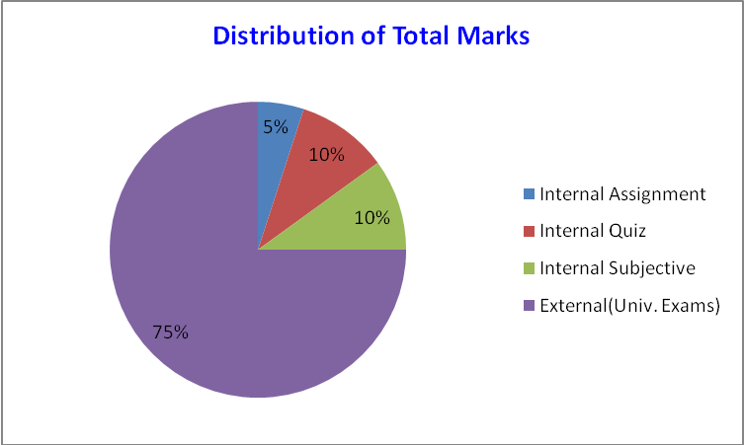
Internal Assignment | 5
Internal Quiz | 10
Internal Subjective | 10
External(Univ. Exams) | 75

- Lesson/Course Plan
NO. of hrs | DATE  FROM | DATE  TO | TOPICS
5 | 14-12-2017 | 21-12-2017 | Gyroscopes - effect of precession - motion on the stability of moving vehicles such as motorcycle
5 | 22-12-2017 | 30-12-2017 | motorcar - aero planes and ships. Static and Dynamic Force Analysis of planar mechanisms.
5 | 02-01-2018 | 09-01-2018 | Turning Moment Diagram And Flywheels: Engine Force Analysis – Piston Effort, Crank Effort, etc., Inertia Force in Reciprocating Engine – Graphical Method -
5 | 10-01-2018 | 20-01-2018 | Turning moment diagram –fluctuation of energy – flywheels and their design - Inertia of connecting rod inertia force in reciprocating engines – crank effort and torque diagrams
5 | 22-01-2018 | 31-01-2018 | Friction: Inclined plane - Friction of screw and nuts - Pivots and collars - uniform pressure, uniform wear
6 | 06-02-2018 | 12-02-2018 | friction circle and friction axis: lubricated surfaces - boundary friction - film lubrication, Clutches, Single plate, multi plate, cone clutch, centrifugal clutches.
6 | 13-02-2018 | 19-02-2018 | Brakes And Dynamometers: Simple block brake - Internal expanding brake band brake of vehicle
5 | 20-02-2018 | 28-02-2018 | Dynamometers - absorption and transmission types, General description and methods of operation.
6 | 01-03-2018 | 08-03-2018 | Governors: Watt, Porter and Proell governors- Spring loaded governors - Hartnell and Hartung with auxiliary springs
5 | 09-03-2018 | 13-03-2018 | Sensitiveness, isochronisms and hunting- effort and power of the governors.
5 | 14-03-2018 | 19-03-2018 | Balancing: Balancing of rotating masses- Primary, Secondary, and higher balancing of reciprocating masses. Analytical and graphical methods. Unbalanced forces and couples.
5 | 20-03-2018 | 24-03-2018 | Examination of "V" and multi cylinder inline and radial engines for primary and secondary balancing- locolotive balancing - Hammer blow - Swaying couple - variation of tractive effort.
5 | 26-03-2018 | 31-03-2018 | Vibrations: Free Vibration of mass attached to vertical soring - oscillation of pendulums- Transverse loads - vibrations of beams with concentrated and distributed loads.
5 | 02-04-2018 | 05-04-2018 | Dunkerly's method - Raleigh's method. Whiirling of shafts - critical speed - torsional vibrations - one, two and three rotor systems.

  - Actions and Assessment Plan

Action & Assessment plan (to improve the course plan to meet the objectives)
Actions
Students should have to attend the lecture classes and maintain and follow the lecture notes of the subject. There are other requirements other than attending the classes. The following actions taken to improve the course plan and meet the objectives.
1. Assignments
Assignments were given to students on weekly basis. Every week one topic will be given based on previous year question papers and important topics from each topic as and when then topic is thought to the students. Students’ evaluation will be done on the basis of performance in the assignments and feedback will be given to improve their performance.
Mini Project
Students will be made to undergo a Mini Project for duration of 15 days along with their class work. The project enables the students to be aware of machining processes.
2. Workshop & Seminars
Students are encouraged to attend various workshops held at different organizations in order to improve their knowledge in machine tools subject. Seminars are conducted every fortnightly at college premises and students take active participation in seminars on machine tools

  - Lecturer Notes

Unit1
Gyroscope and its applications

Gyroscope
A gyroscope is a device for measuring or maintaining orientation, based on the principles of conservation of angular momentum. A mechanical gyroscope is essentially a spinning wheel or disk whose axle is free to take any orientation. This orientation changes much less in response to a given external torque than it would without the large angular momentum associated with the gyroscope's high rate of spin. Since external torque is minimized by mounting the device in gimbals, its orientation remains nearly fixed, regardless of any motion of the platform on which it is mounted. Gyroscopes based on other operating principles also Exit, such as the electronic, microchip-packaged MEMS gyroscope devices found in consumer electronic devices, solid state ring lasers, fiber optic gyroscopes and the extremely sensitive quantum gyroscope. Applications of gyroscopes include navigation (INS) when magnetic compasses do not work (as in the Hubble telescope) or are not precise enough (as in ICBMs) or for the stabilization of flying vehicles like radio-controlled helicopters or UAVs. Due to higher precision, gyroscopes are also used to maintain direction in tunnel mining.
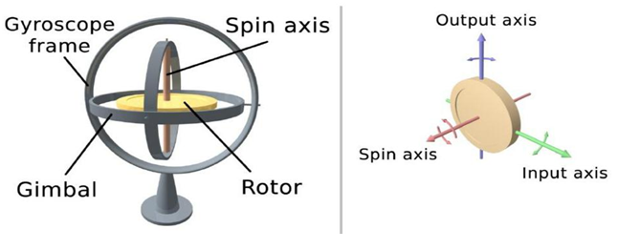(20) Description and diagram:
Diagram of a gyro wheel. Reaction arrows about the output axis (blue) correspond to forces applied about the input axis (green), and vice versa. Within mechanical systems or devices, a conventional gyroscope is a mechanism comprising a rotor journal led to spin about one axis, the journals of the rotor being mounted in an inner gimbal or ring, the inner gimbal is journal led for oscillation in an outer gimbal which is journal led in another gimbal. So basically there are three gimbals. The outer gimbal or ring which is the gyroscope frame is mounted so as to pivot about an axis in its own plane determined by the support. This outer gimbal possesses one degree of rotational freedom and its axis possesses none. The next inner gimbal is mounted in the gyroscope frame (outer gimbal) so as to pivot about an axis in its own plane that is always perpendicular to the pivotal axis of the gyroscope frame (outer gimbal). This inner gimbal has two degrees of rotational freedom. Similarly, next innermost gimbal is attached to the inner gimbal which has three degree of rotational freedom and its axis posses two. The axle of the spinning wheel defines the spin axis. The rotor is journaled to spin about an axis which is always perpendicular to the axis of the innermost gimbal. So, the rotor possesses four degrees of rotational freedom and its axis possesses three. The wheel responds to a force applied about the input axis by a reaction force about the output axis.
The behavior of a gyroscope can be most easily appreciated by consideration of the front wheel of a bicycle. If the wheel is leaned away from the vertical so that the top of the wheel moves to the left, the forward rim of the wheel also turns to the left. In other words, rotation on one axis of the turning wheel produces rotation of the third axis.
E f f e c t o f t h e g y r o s c o p i c c o u p l e o n a n a e r o p l a n e
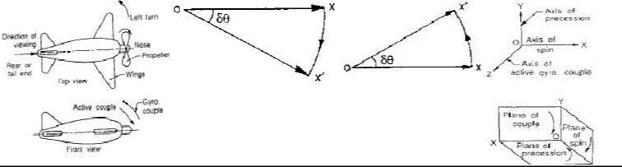

(22) EFFECT OF GYROSCOPIC COUPLE

This couple is, therefore, to raise the nose and dip the tail of the aero plane.

Notes

1. When the aero plane takes a right turn under similar Conditions as discussed above, the effect of the reactive Couple will be to dip the nose and raise the tail of the aero plane.

- When the engine or propeller rotates in anticlockwise direction when viewed from the rear or tail end and the aero plane takes a left turn, then the effect of reactive gyroscopic couple will be to dip the nose and raise the tail of the aero plane.

- When the aero plane takes a right turn under similar Conditions as mentioned in note 2 above, the effect of Reactive gyroscopic couple will be to raise the nose and dip the of the aero plane.

- When the engine or propeller rotates in clockwise direction when viewed from the front and the aero plane takes a left turn, then the effect of reactive gyroscopic couple will be to raise the tail and dip the nose of the aero plane.

- When the aero plane takes a right turn under similar conditions as mentioned in note4 above, the effect of reactive gyroscopic couple will be to raise the nose and dip the tail of the aero plane.

Effect of gyroscopic couple on ship
The top and front views of a naval ship are shown in fig. The fore end of the ship is called bow and the rear end is known as stern or aft. The left hand and the right hand sides of the ship, when viewed from the stern are called port and star board respectively. We shall now discuss the effect of gyroscopic couple in the naval ship in the following three cases:

- Steering

- Pitching, and

- Rolling

Effect of Gyro scopic Couple on a Naval Ship during pitching& Steering
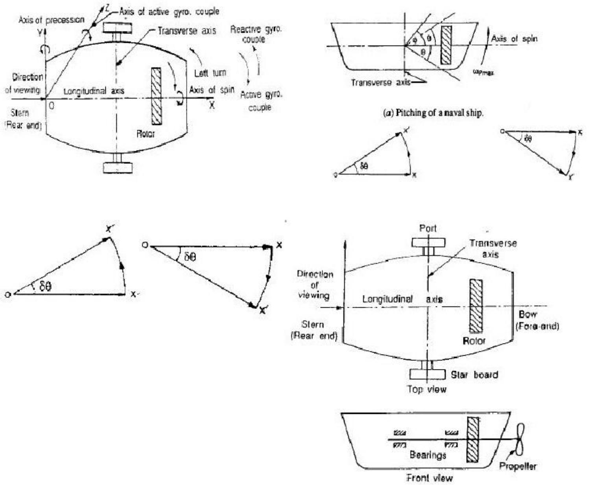

Steering is the turning of a complete ship in a curve towards left or right, while it moves forward, considers the ship taking a left turn, and rotor rotates in the clockwise direction when viewed from the stern, as shown in Fig. below. The effect of gyroscopic couple on a naval ship during steering taking left or right turn may be obtained in the similar way as for an aero plane as discussed in Art.

When the rotor of the ship rotates in the clockwise direction

when viewed from the stern, it will have its angular momentum vector in the direction ox as shown in Fig. A1. As the ship steers to the left, the active gyroscopic couple will change the angular momentum vector from ox to ox’. The vector xx’ now represents the active gyroscopic couple and is perpendicular to ox. Thus the plane of active gyroscopic couple is perpendicular to xx’ and its direction in the axis OZ for left hand turn is clockwise as shown in Fig below. The reactive gyroscopic couple of the same magnitude will act in the opposite direction (i.e in anticlockwise direction). The effect of this reactive gyroscopic couple is to raise the bow and lower the stern.

Notes

- When the ship steers to the right under similar condition as discussed above, the effect of the reactive gyroscopic couple, as shown in Fig. B1, will be to raise the stern and lower the bow.
- When the rotor rotates in the anticlockwise direction, when viewed from the stern and the ship is steering to the left, then the effect of reactive gyroscopic couple will be to lower the bow and raise the stern.

- When the ship is steering to the right under similar conditions as discussed in note 2 above, then the effect of reactive gyroscopic couple will be to raise the bow and lower the stern.

- When the rotor rotates in the clockwise direction when viewed from the bow or fore end and the ship is steering to the left, then the effect of reactive gyroscopic couple will be to raise the stern and lower the bow.

- When the ship is steering to the right under similar conditions as discussed in note 4 above, then the effect of reactive gyroscopic couple will be to raise the bow and lower the stern.

- The effect of the reactive gyroscopic couple on a boat propelled by a turbine taking left or

right turn.

Effect of Gyro scopic couple on a Naval Ship during Rolling:

We know that, for the effect of gyroscopic couple to occur, the axis of precession should always be perpendicular to the axis of spin. If, however, the axis of precession becomes parallel to the axis of spin, there will be no effect of the gyroscopic couple acting on the body of the ship. In case of rolling of a ship, the axis of precession (i.e. longitudinal axis) is always parallel to the axis of spin for all positions. Hence, there is no effect of the gyroscopic couple acting on the body of a ship.

Effect of Gyro scopic couple on a 4- wheel drive :
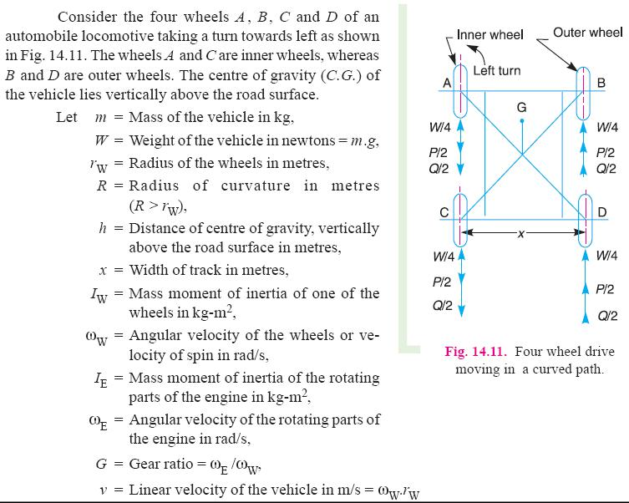

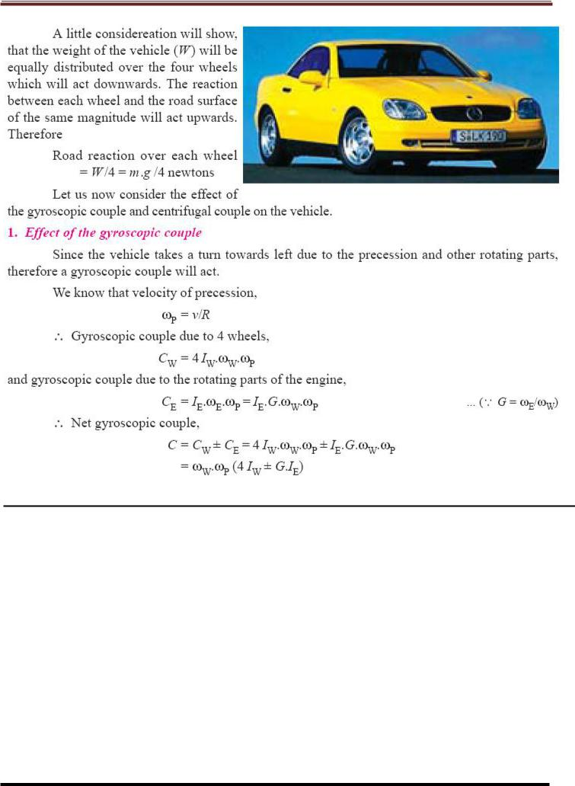

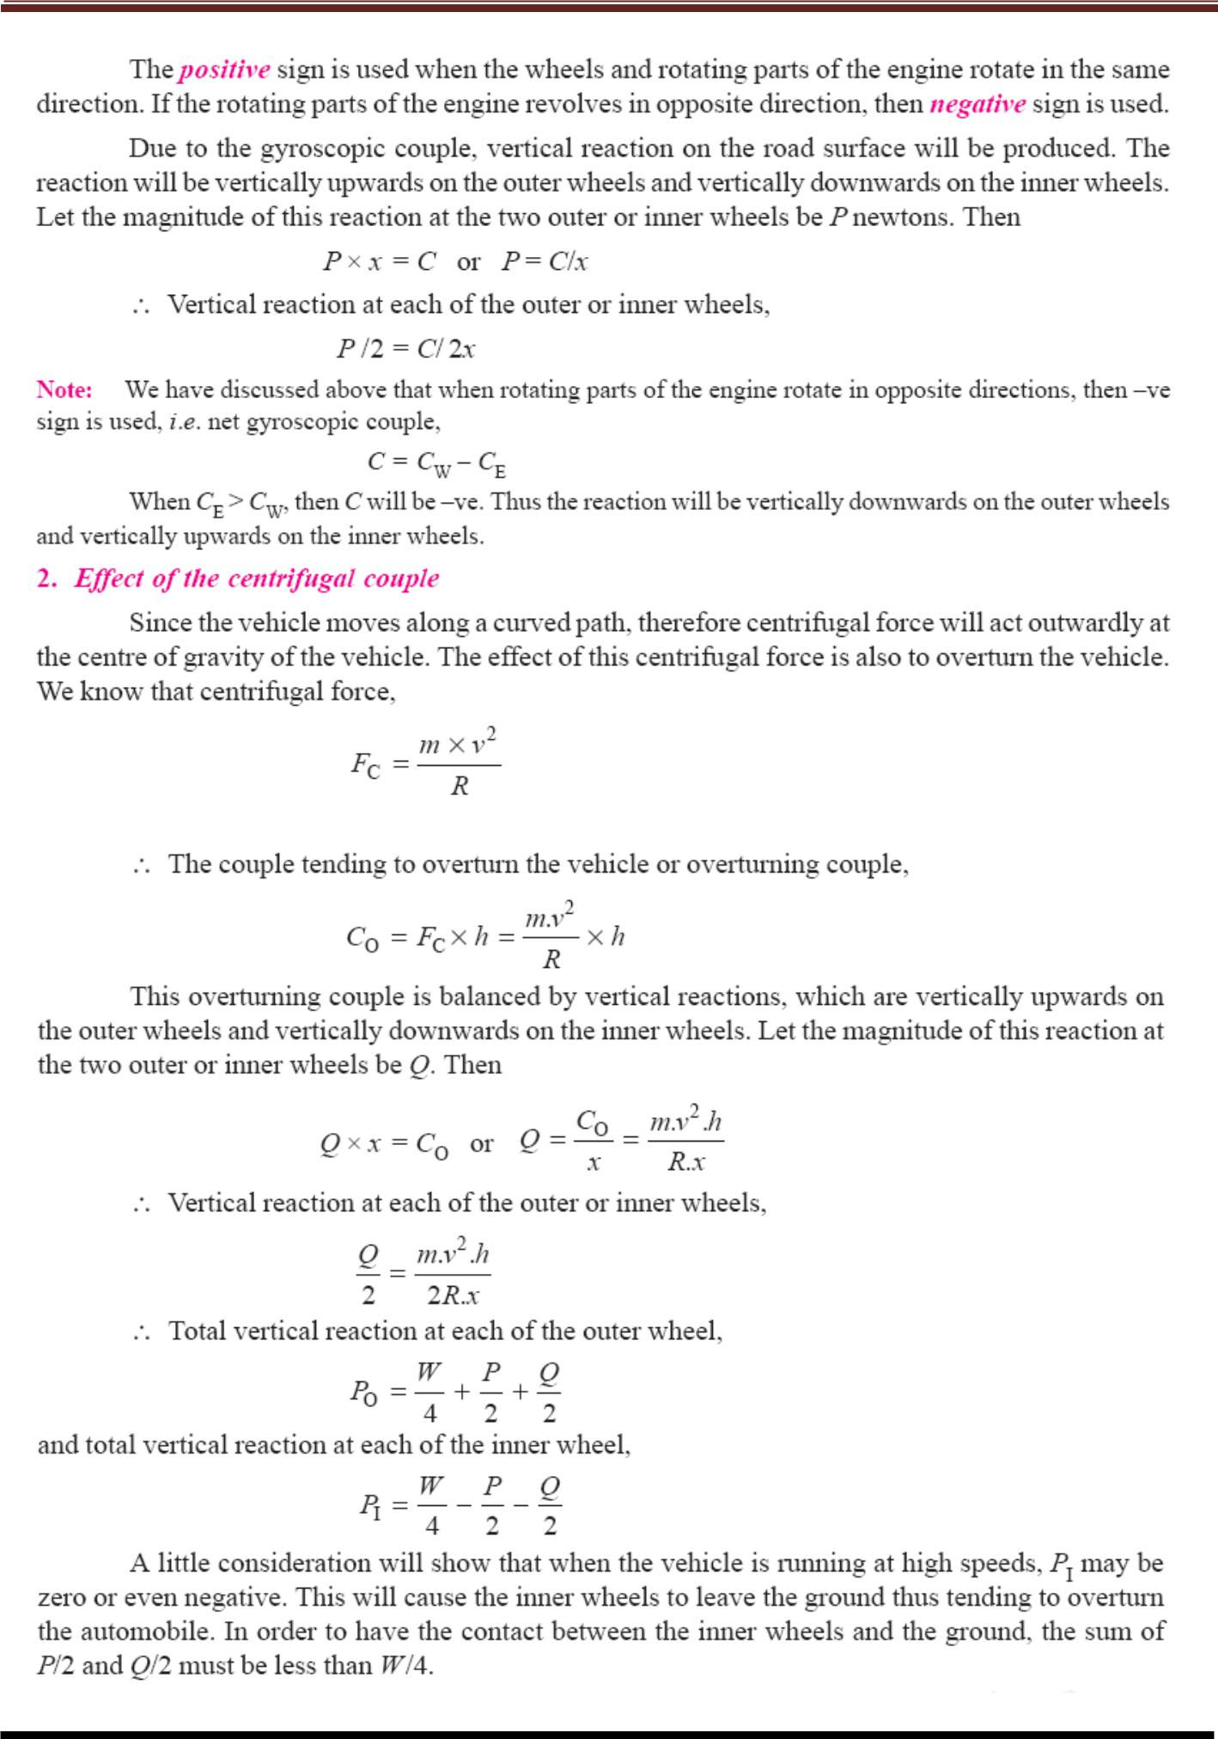

STATIC AND DYNAMIC FORCE ANALYSIS

Analyses the forces and couples on the members of the machine due to external forces (static force analysis) also analyses the forces and couples due to accelerations of machine members ( Dynamic force analysis) Deflections of the machine members are neglected in general by treating machine members as
Rigid bodies (also called rigid body dynamics). In other words the link must be properly designed to withstand the forces without undue deformation to facilitate proper functioning of the system.
In order to design the parts of a machine or mechanism for strength, it is necessary to determine the forces and torques acting on individual links. Each component however small, should be carefully analysed for its role in transmitting force. The forces associated with the principal function of the machine are usually known or assumed.
Ex:
a) Piston type of engine: gas force on the piston is known or assumed
b) QRM – Resistance of the cutting tool is assumed.

a & b are called static forces.

Example of other static forces are:
i. Energy transmitted
ii. Forces due to assembly
iii. Forces due to applied loads
iv. Forces due to changes in temperature
v. Impact forces
vi. Spring forces
vii. Belt and pulley
viii. Weights of different parts

Apart from static forces, mechanism also experiences inertia forces when subjected to acceleration, called dynamic forces. Static forces are predominant at lower speeds and dynamic forces are predominant at higher speeds.

Force analysis:
The analysis is aimed at determining the forces transmitted from one point to another, essentially from input point to out put point. This would be the starting point for strength design of a component/ system, basically to decide the dimensions of the components Force analysis is essential to avoid either overestimation or under estimation of forces on machine member
Under estimation: leads to design of insufficient strength and to early failure.
Overestimation: machine component would have more strength than required.
Over design leads to heavier machines, costlier and becomes not competitive
Graphical analysis of machine forces will be used here because of the simplification it offers to a problem, especially in cases of complex machines. Moreover, the graphical analysis of forces is a direct application of the equations of equilibrium.

General Principle of force analysis:

A machine / mechanism is a three dimensional object, with forces acting in three dimensions. For a complete force analysis, all the forces are projected on to three mutually perpendicular planes. Then, for each reference plane, it is necessary that, the vector sum of the applied forces in zero and that, the moment of the forces about any axis perpendicular to the reference plane or about any point in the plane is zero for equilibrium.

That is ∑F 0 & ∑M  0 or
∑F 0 & ∑F  0 and ∑M  0 x y
A force is a vector quantity and three in properties define a force completely;
i. Magnitude
ii. Direction
iii. Point of application

Some basic aspects and notations
i. Force applied at A
ii. Force vector is inclined at 60 to the reference plane.
iii. Length of the vector represents the magnitude of the force to some scale.

Unit – 2
Turning Moment Diagram
Force Analysis

(1) Introduction:

If the acceleration of moving links in a mechanism is running with considerable amount of linear and/or angular accelerations, inertia forces are generated and these inertia forces also must be overcome by the driving motor as an addition to the forces exerted by the external load or work the mechanism does.
(2) Newton’s Law:
First Law
Everybody will persist in its state of rest or of uniform motion (constant velocity) in a straight line unless it is compelled to change that state by forces impressed on it. This means that in the absence of a non-zero net force, the center of mass of a body either is at rest or moves at a constant velocity.
Second Law
A body of mass m subject to a force F undergoes an acceleration a that has the same direction as the force and a magnitude that is directly proportional to the force and inversely proportional to the mass, i.e., F = ma. Alternatively, the total force applied on a body is equal to the time derivative of linear momentum of the body.

Third Law
The mutual forces of action and reaction between two bodies are equal, opposite and collinear. This means that whenever a first body exerts a force F on a second body, the second body exerts a force −F on the first body. F and −F are equal in magnitude and opposite in direction. This law is sometimes referred to as the action-reaction law, with F called the "action" and −F the "reaction"

- Types of force Analysis:

  - Equilibrium of members with two forces
  - Equilibrium of members with three forces
  - Equilibrium of members with two forces and torque
  - Equilibrium of members with two couples.
  - Equilibrium of members with four forces.

(4) Principle of Super Position:
Sometimes the number of external forces and inertial forces acting on a mechanism are too much for graphical solution. In this case we apply the method of superposition. Using superposition the entire system is broken up into (n) problems, where n is the number of forces, by considering the external and inertial forces of each link individually. Response of a linear system to several forces acting simultaneously is equal to the sum of responses of the system to the forces individually. This approach is useful because it can be performed by graphically.

(5) Free Body Diagram:
A free body diagram is a pictorial representation often used by physicists and engineers to analyze the forces acting on a body of interest. A free body diagram shows all forces of all types acting on this body. Drawing such a diagram can aid in solving for the unknown forces or the equations of motion of the body. Creating a free body diagram can make it easier to understand the forces, and torques or moments, in relation to one another and suggest the proper concepts to apply in order to find the solution to a problem. The diagrams are also used as a conceptual device to help identify the internal forces—for example, shear forces and bending moments in beams—which are developed within structures.

(6) D’Alemberts Principle:
D'Alembert's principle, also known as the Lagrange–d'Alembert principle, is a statement of the fundamental classical laws of motion. It is named after its discoverer, the French physicist and mathematician Jean le Rond d'Alembert. The principle states that the sum of the differences between the forces acting on a system and the time derivatives of the momenta of the system itself along any virtual displacement consistent with the constraints of the system is zero.
(7) Dynamic Analysis of Four bar Mechanism:
A four-bar linkage or simply a 4-bar or four-bar is the simplest movable linkage. It consists of four rigid bodies (called bars or links), each attached to two others by single joints or pivots to form closed loop. Four-bars are simple mechanisms common in mechanical engineering machine design and fall under the study of kinematics.

- Dynamic Analysis of Reciprocating engines.
- Inertia force and torque analysis by neglecting weight of connecting rod.
- Velocity and acceleration of piston.

- Angular velocity and Angular acceleration of connecting rod.

- Force and Torque Analysis in reciprocating engine neglecting the weight of connecting rod.
- Equivalent Dynamical System
- Determination of two masses of equivalent dynamical system

Turning Moment Diagram:

The turning moment diagram is graphical representation of the turning moment or crank effort for various positions of crank.

Single cylinder double acting engine:
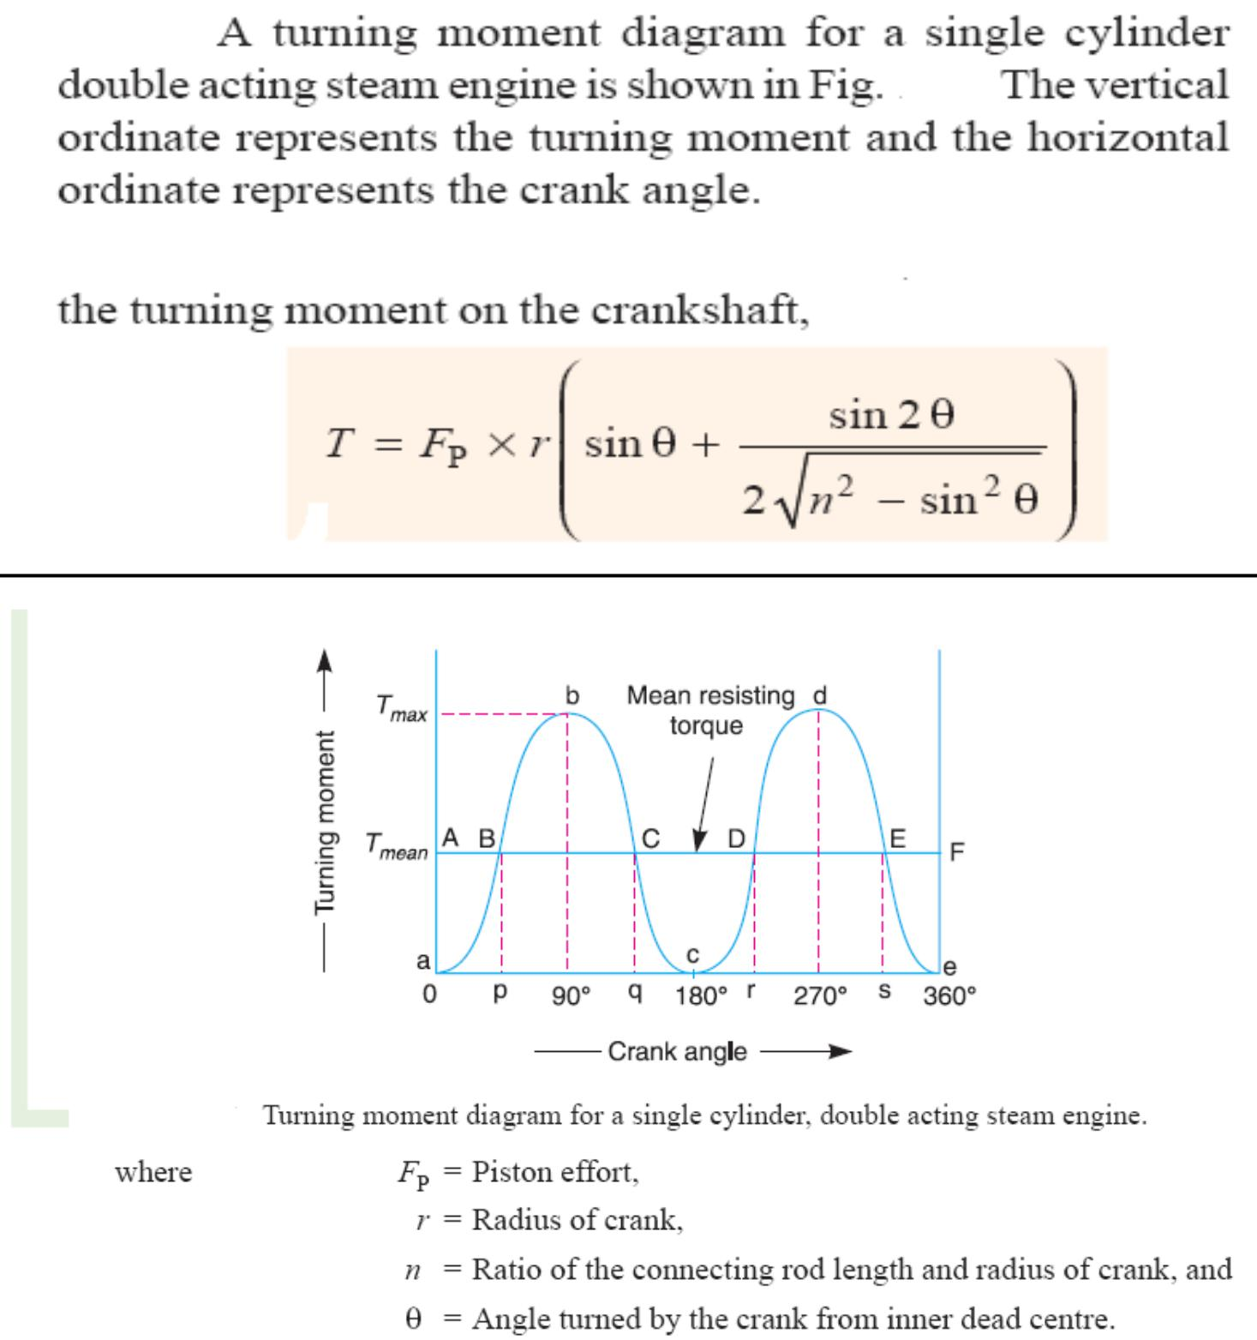

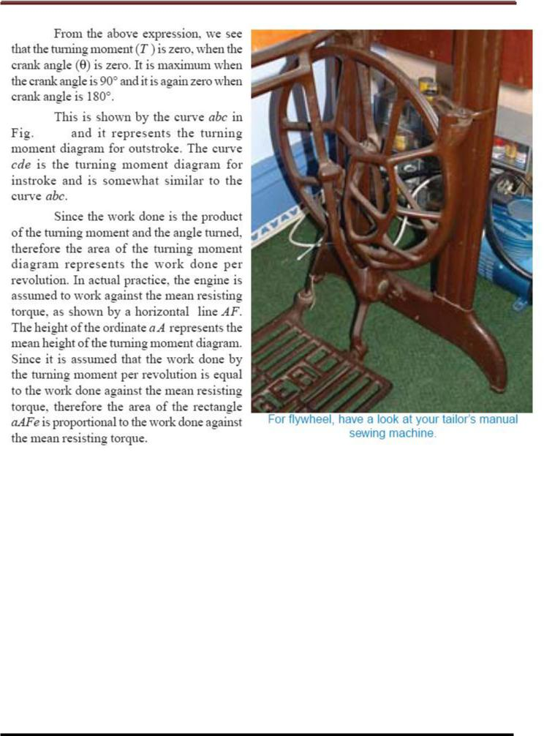

Turning moment diagram for 4-stroke I.C engine:
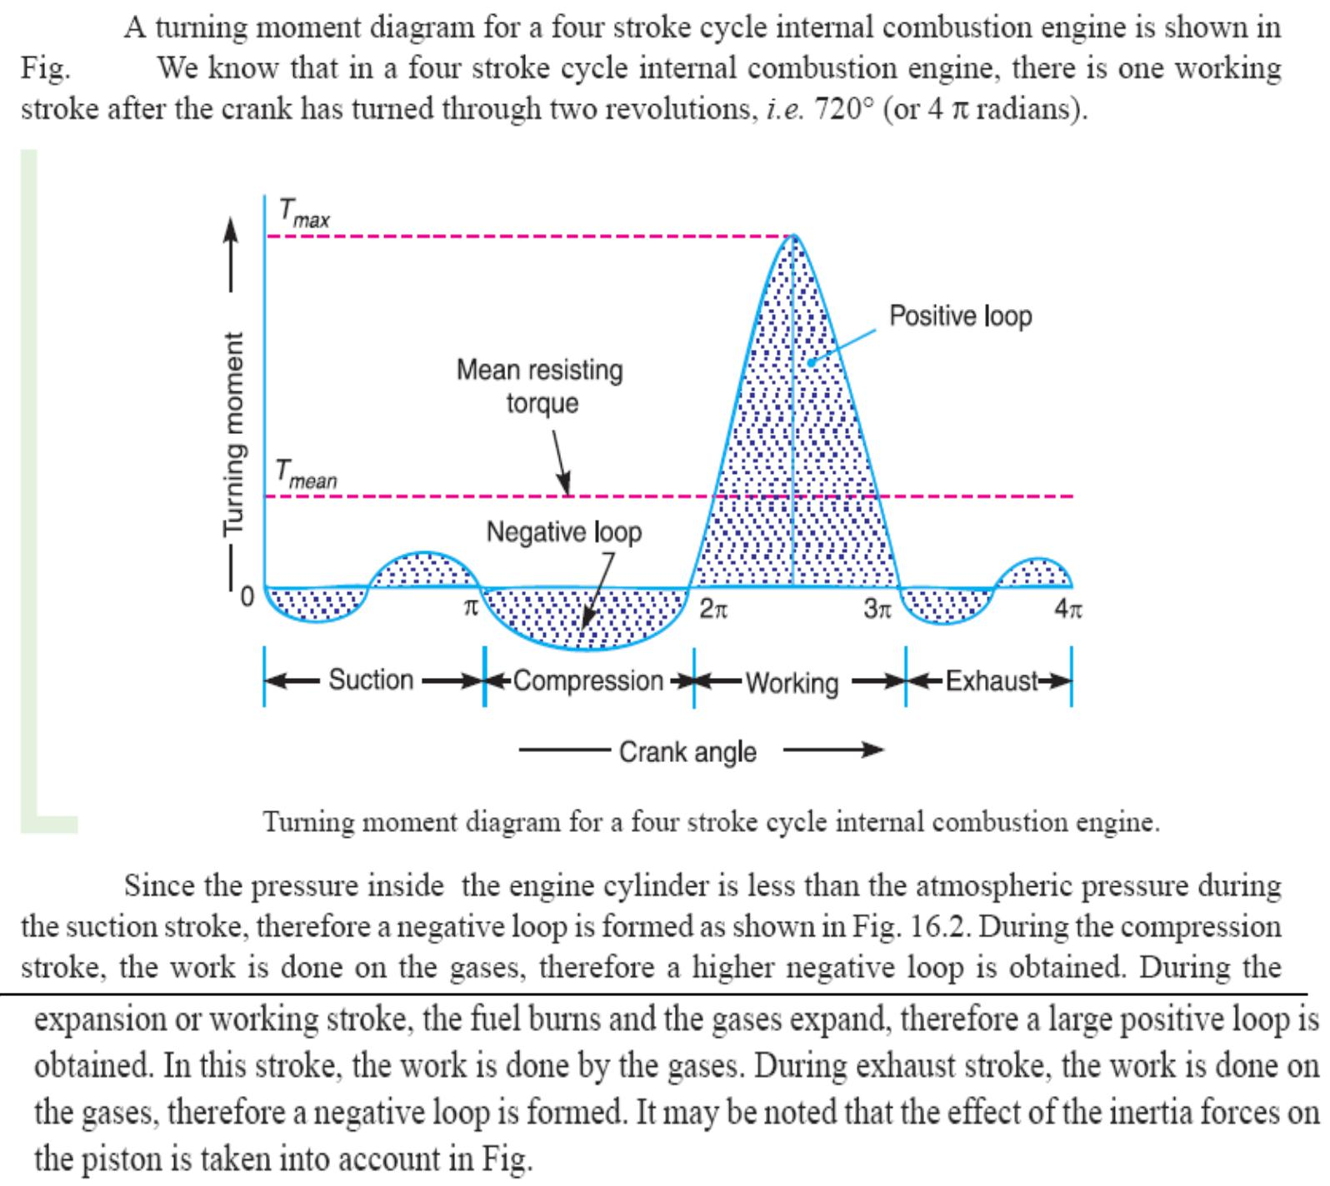

Turning moment diagram for a multi cylinder engine:
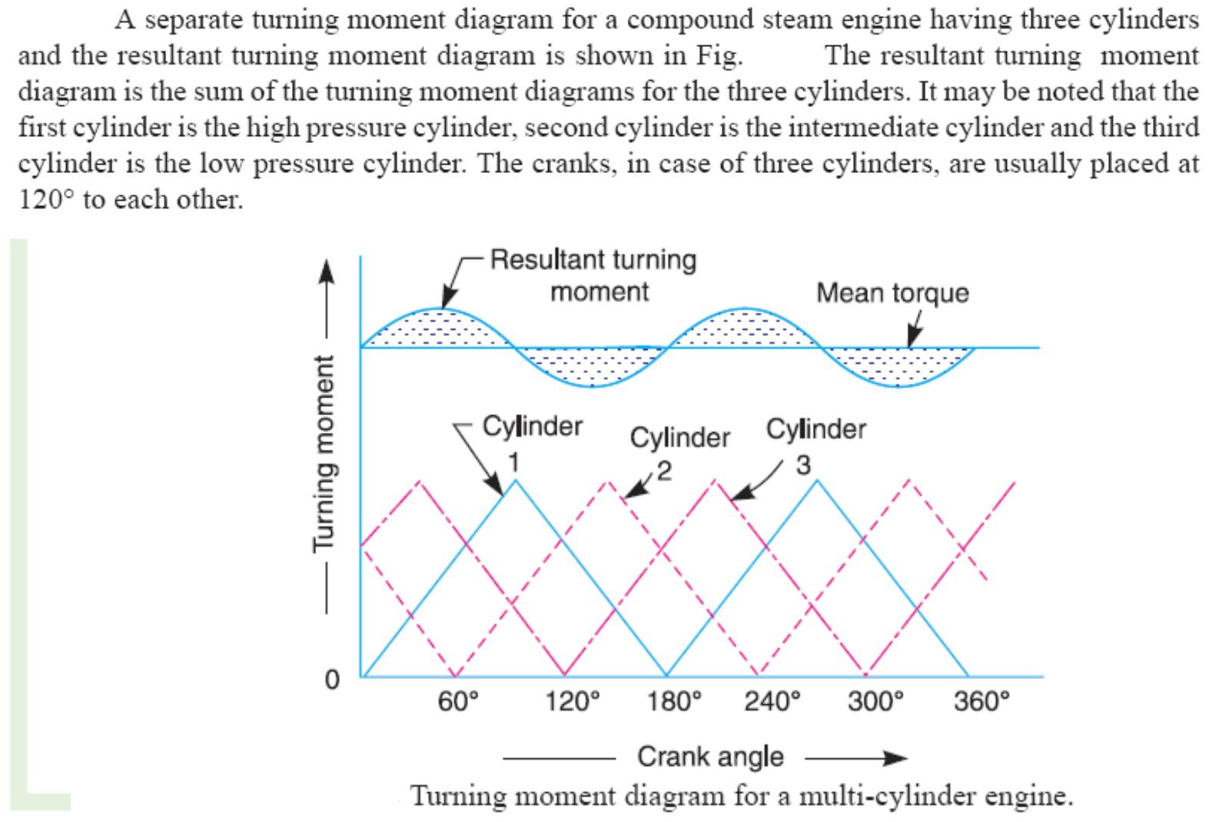

Fluctuation of Energy:

The difference in the kinetic energies at the point is called the maximum fluctuation of

energy.
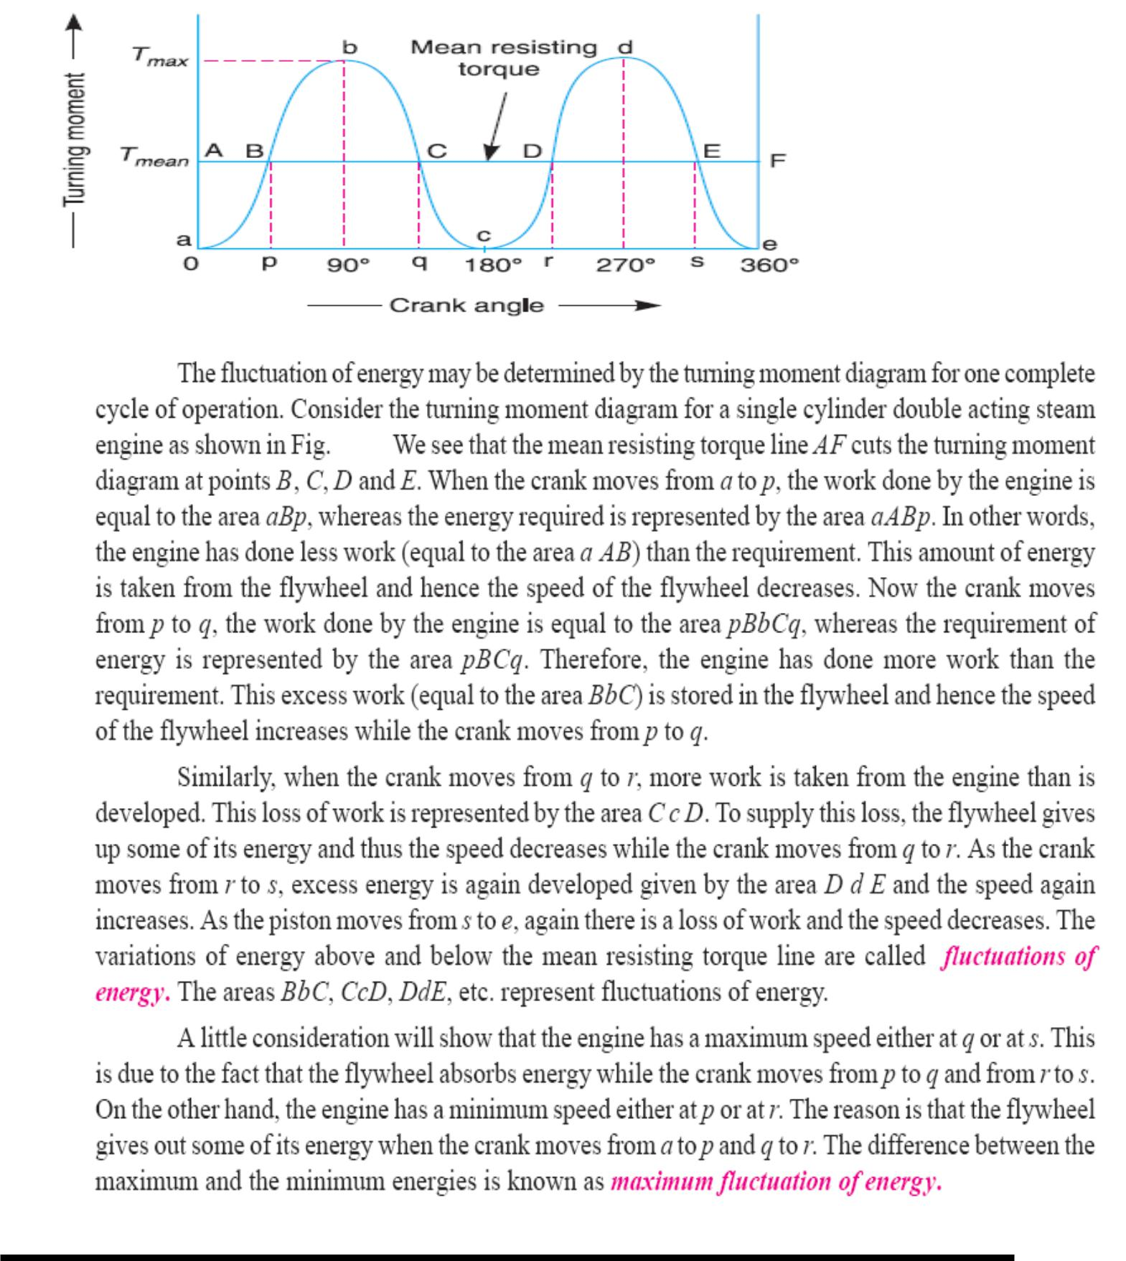

Fluctuation of Speed:

This is defined as the ratio of the difference between the maximum and minimum angular speeds during a cycle to the mean speed of rotation of the crank shaft.

Maximum fluctuation of energy:
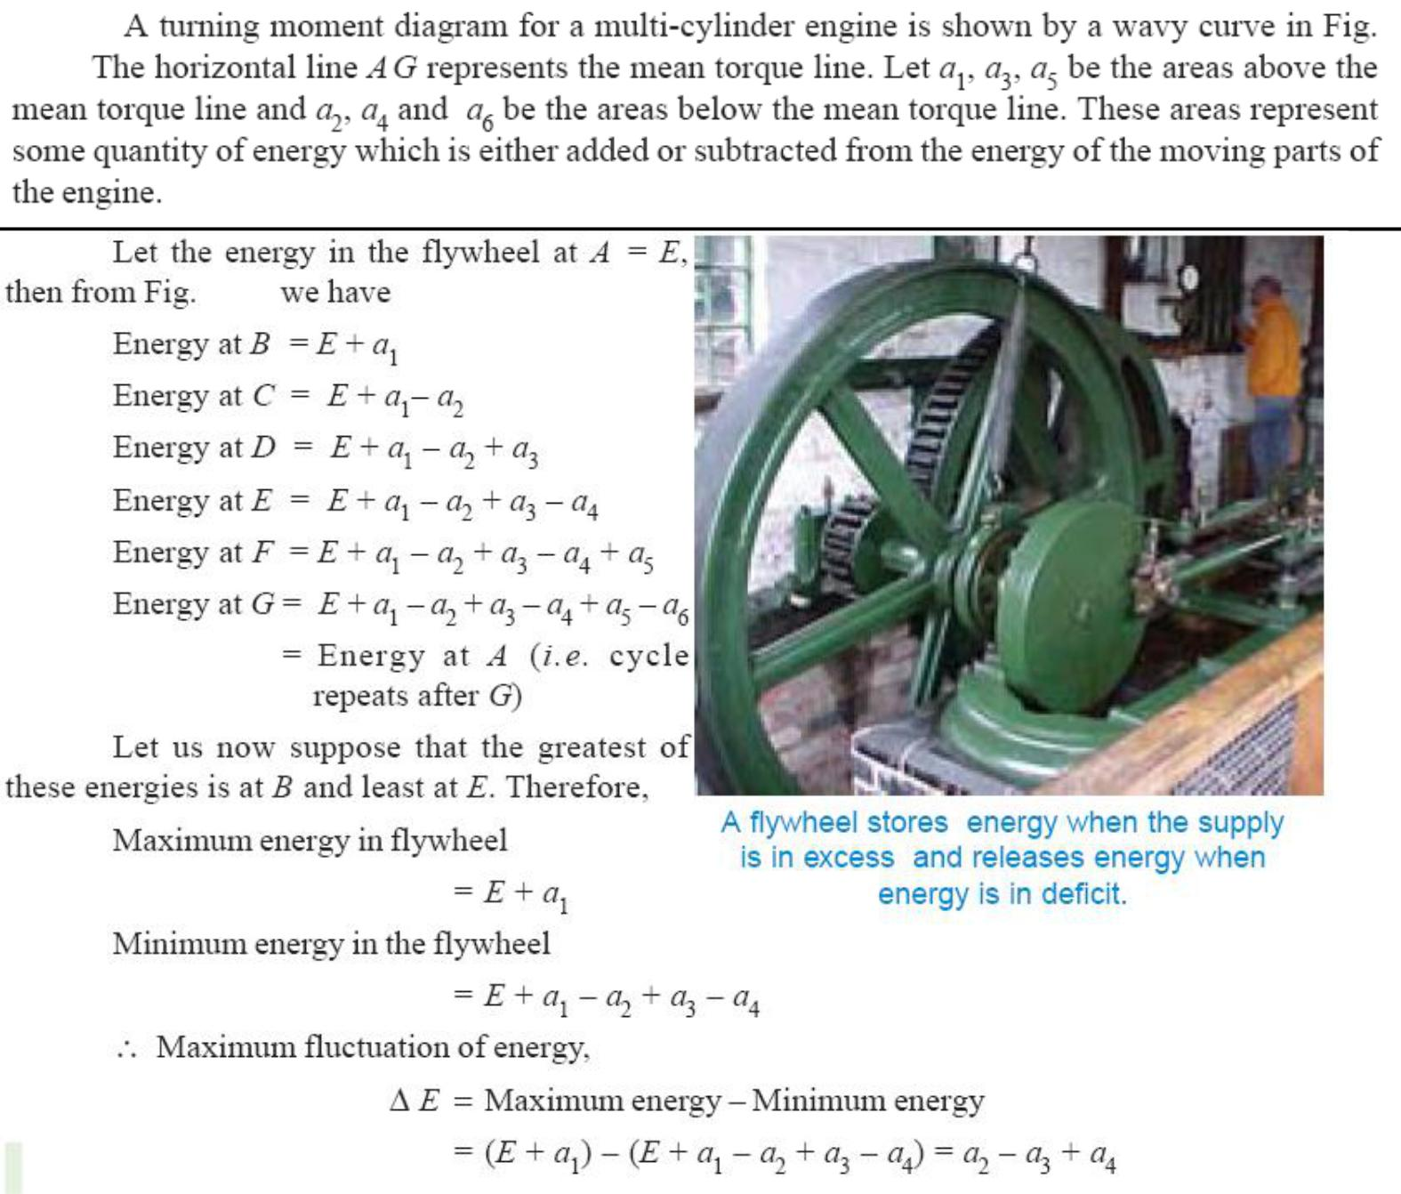

Coefficient of fluctuation of energy:
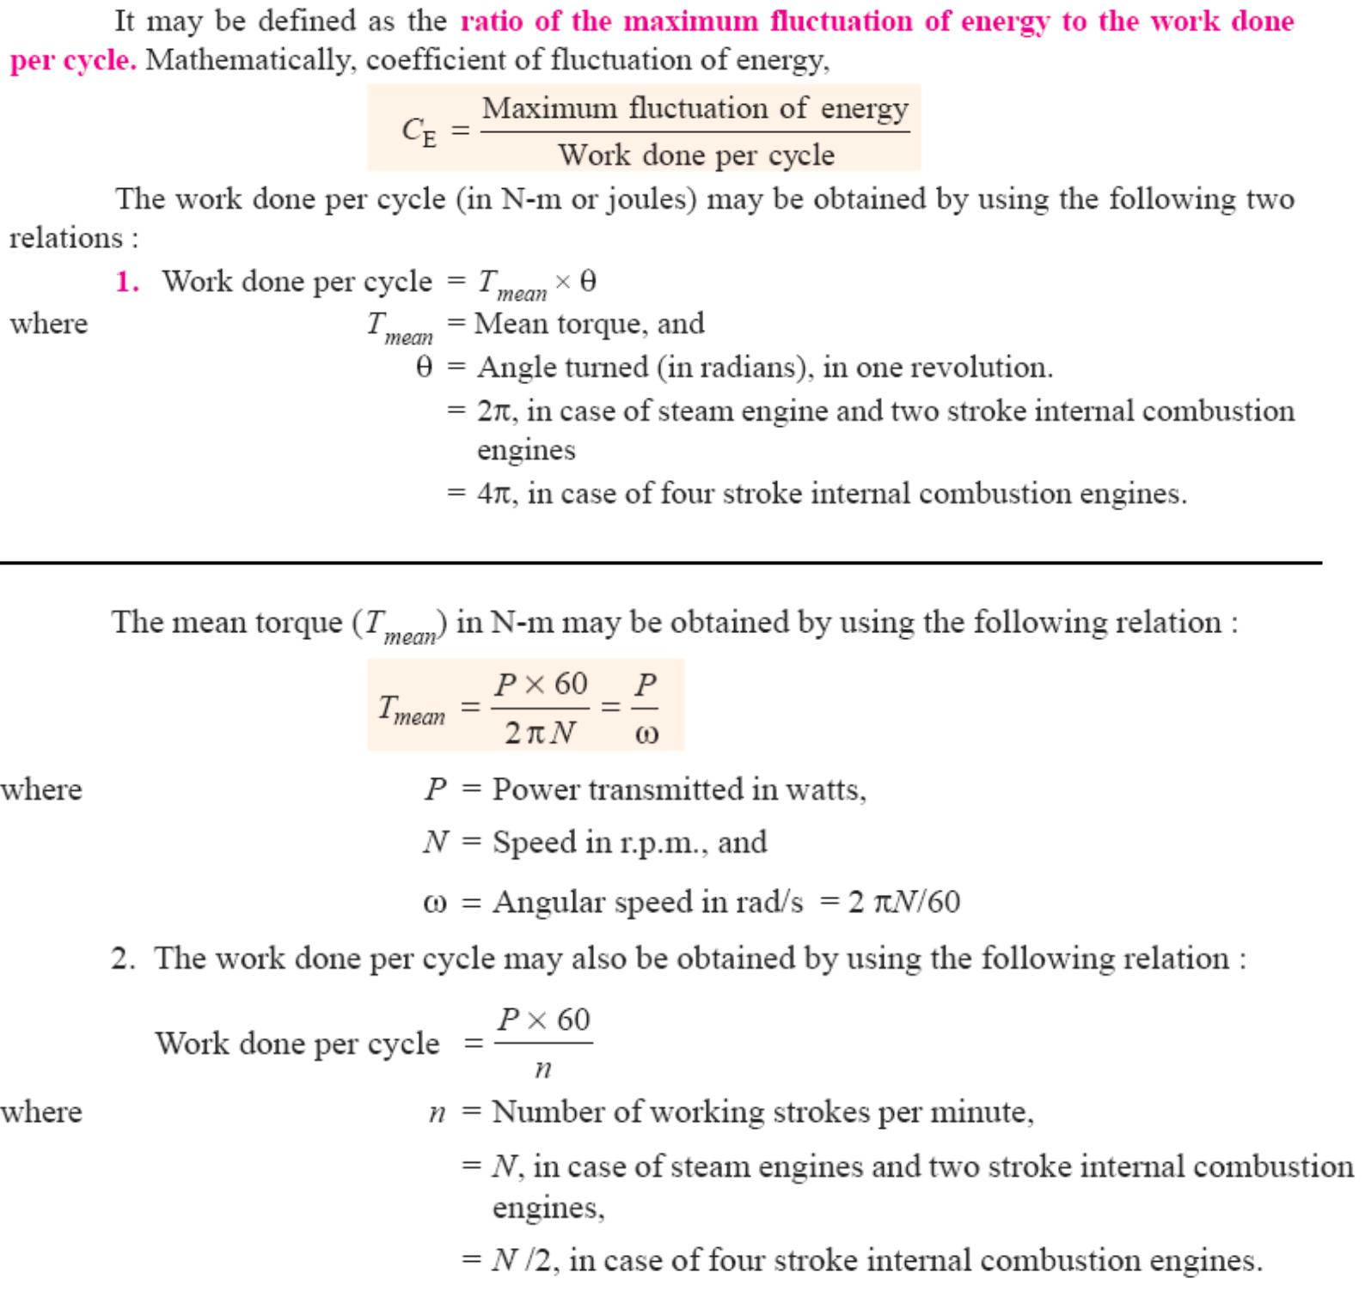

Coefficient of fluctuation of speed:
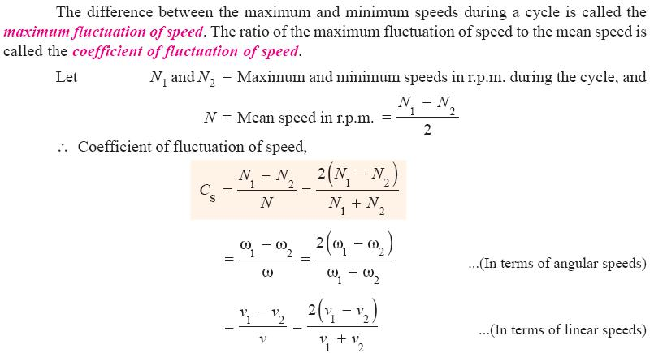

Energy stored in flywheel:

A flywheel is a rotating mass that is used as an energy reservoir in a machine. It absorbs energy in the form of kinetic energy, during those periods of crank rotation when actual turning moment is greater than the resisting moment and release energy, by way of parting with some of its K.E, when the actual turning moment is less than the resisting moment.
Flywheel in punching press:

The flywheels used for prime movers constitute a class of problems in which the resisting torque is assumed to be constant and the driving torque varies. flywheels used in punching, riveting and similar machines constitute another class of problems in which the actual(driving) turning moment provided by an electric motor is more or less constant but the resisting torque(load) varies.

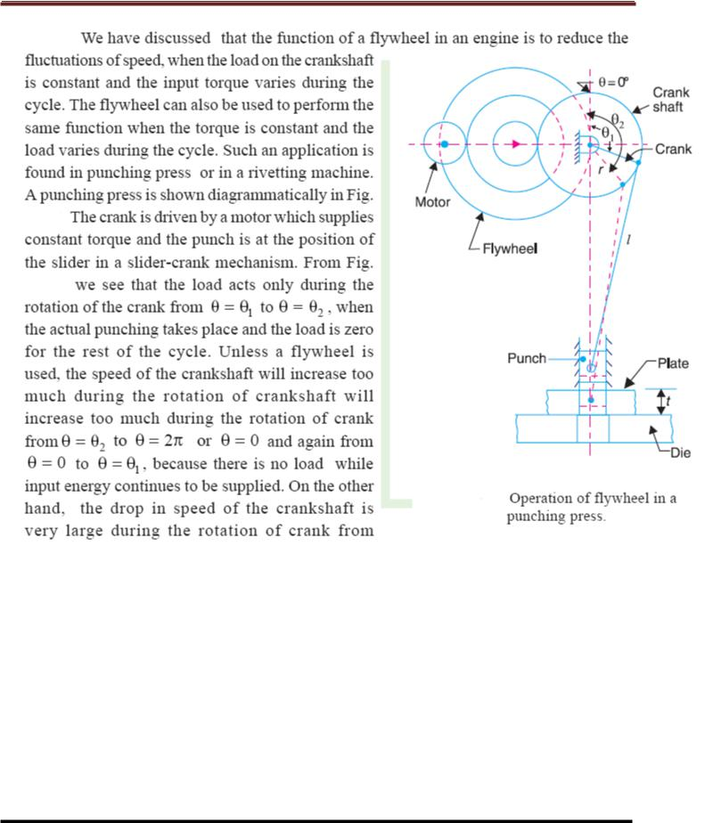

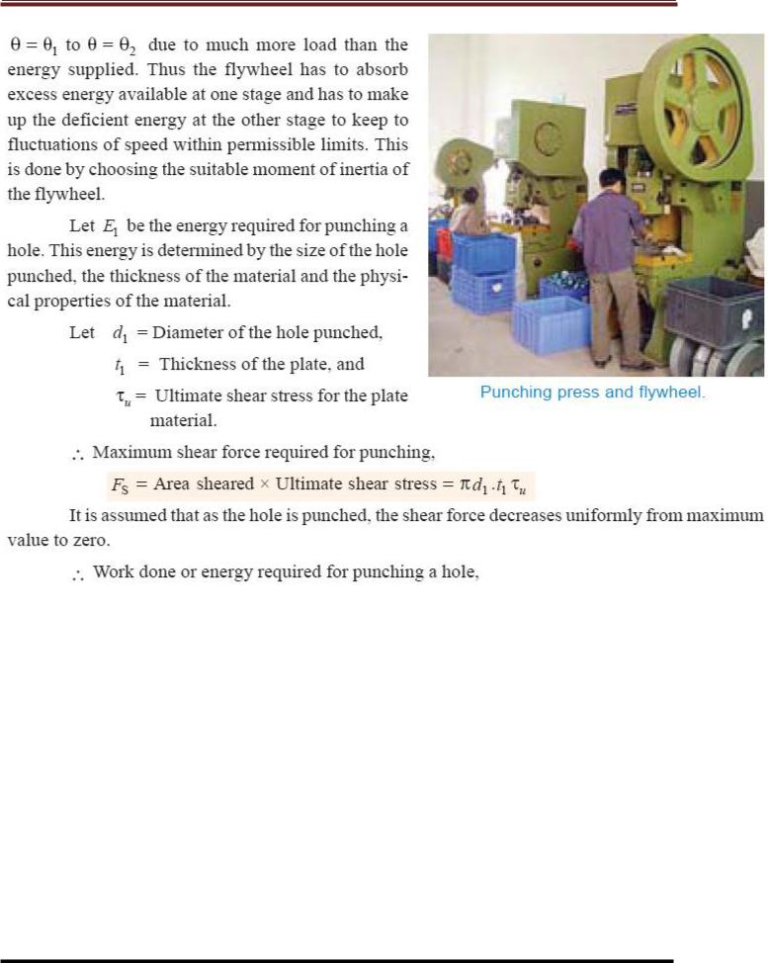

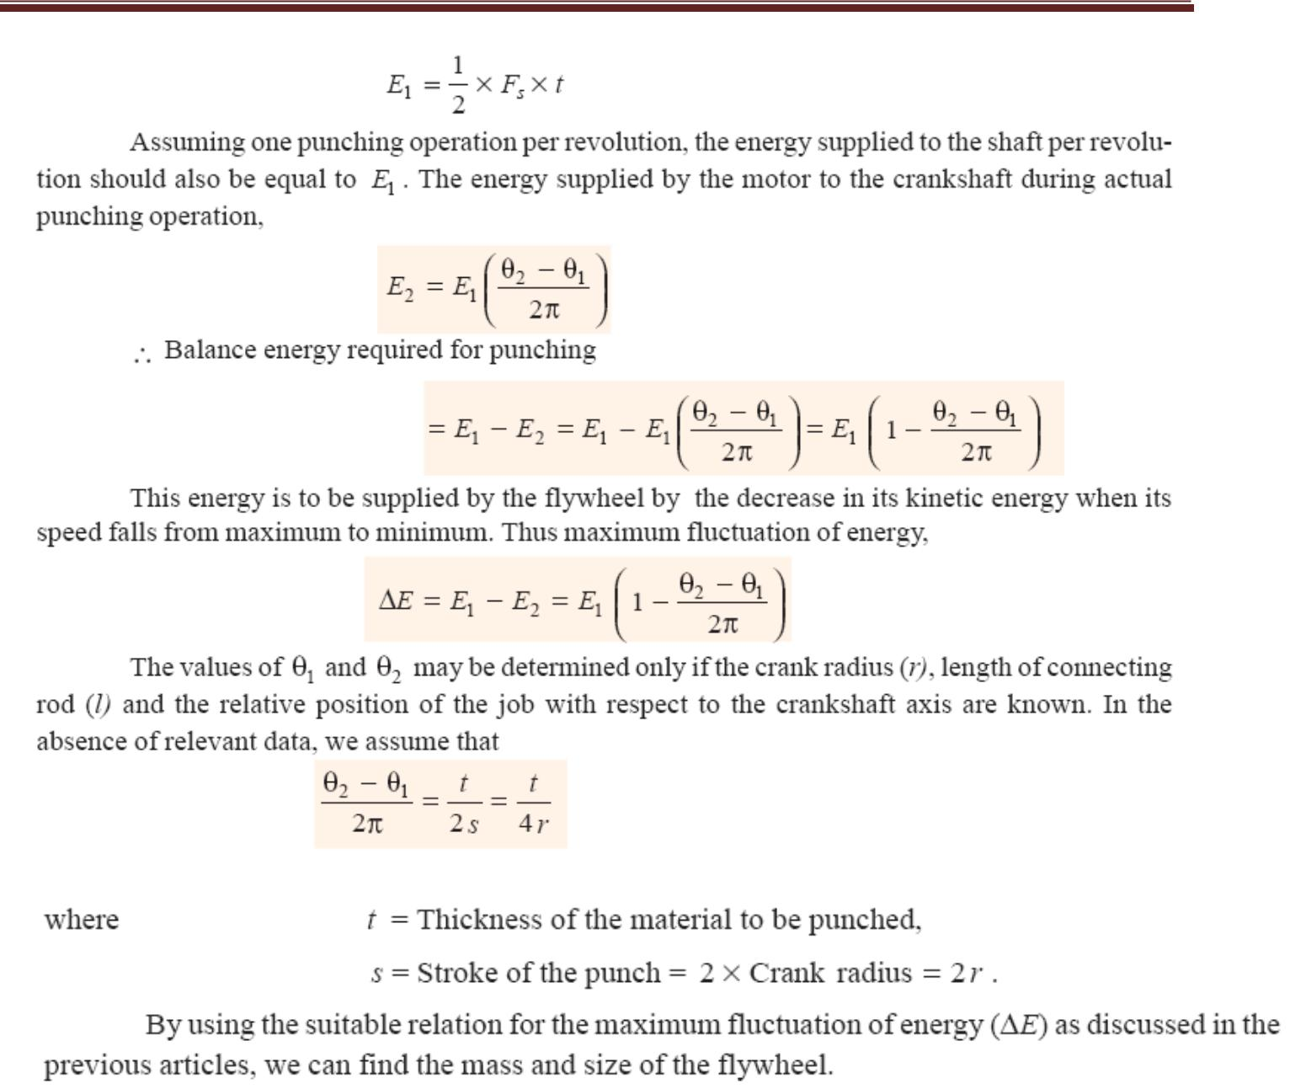

(19) Cam dynamics:
Mechanism provides a non-linear I/O relationship. Different mechanism like single or multi-degree of freedom, intermittent motion mechanisms and linkages etc. have different I/O Relationship. When we can not obtain a certain functions from the well known mechanisms, we use a cam mechanism. It is a one degree of freedom mechanism of two moving links. One is cam and the other is follower.

- Rigid and elastic body cam system.
- Analysis of eccentric cam
- Problems on Cam –follower system.

Unit-IV
Governor

Introduction:
A centrifugal governor is a specific type of governor that controls the speed of an engine by regulating the amount of fuel (or working fluid) admitted, so as to maintain a near constant speed whatever the load or fuel supply conditions. It uses the principle of proportional control.

It is most obviously seen on steam engines where it regulates the admission of steam into the cylinder(s). It is also found on internal combustion engines and variously fuelled turbines, and in some modern striking clocks.
Principle of Working:
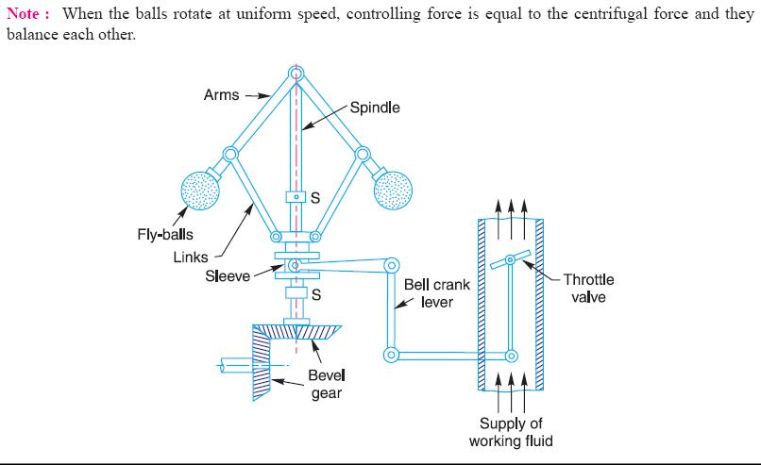

Power is supplied to the governor from the engine's output shaft by (in this instance) a belt or chain (not shown) connected to the lower belt wheel. The governor is connected to a throttle valve that regulates the flow of working fluid (steam) supplying the prime mover (prime mover not shown). As the speed of the prime mover increases, the central spindle of the governor rotates at a faster rate and the kinetic energy of the balls increases. This allows the two masses on lever arms to move outwards and upwards against gravity. If the motion goes far enough, this motion causes the lever arms to pull down on a thrust bearing, which moves a beam linkage, which reduces the aperture of a throttle valve. The rate of working-fluid entering the cylinder is thus reduced and the speed of the prime mover is controlled, preventing over speeding.

Mechanical stops may be used to limit the range of throttle motion, as seen near the masses in the image at right.

The direction of the lever arm holding the mass will be along the vector sum of the reactive centrifugal force vector and the gravitational force.
Classification of governors:

Governors are classified based upon two different principles.
These are:
- Centrifugal governors

- Inertia governors
Centrifugal governors are further classified as –
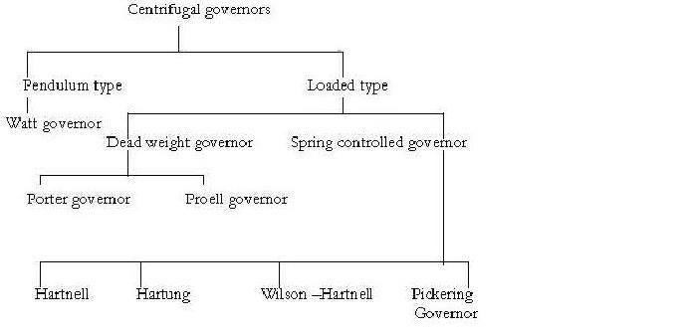

Height of governor
It is the vertical distance between the centre of the governor halls and the point of intersection between the upper arms on the axis of spindle is known as governor height. It is generally denoted by h.
Sleeve lift

The vertical distance the sleeve travels due to change in the equilibrium Speed is called the sleeve lift. The vertical downward travel may be termed as Negative lift
Isochronisms
This is an extreme case of sensitiveness. When the equilibrium speed is constant for all radii of rotation of the balls within the working range, the governor is said to be in isochronism. This means that the difference between the maximum and minimum equilibrium speeds is zero and the sensitiveness shall be infinite.
Stability
Stability is the ability to maintain a desired engine speed without Fluctuating. Instability results in hunting or oscillating due to over correction. Excessive stability results in a dead-beat governor or one that does not correct sufficiently for load changes
Hunting

The phenomenon of continuous fluctuation of the engine speed above and below the mean speed is termed as hunting. This occurs in over- sensitive or isochronous governors. Suppose an isochronous governor is fitted to an engine running at a steady load. With a slight increase of load, the speed will fall and the sleeve will immediately fall to its lowest position. This shall open the control valve wide and excess supply of energy will be given, with the result that the speed will rapidly increase and the sleeve will rise to its higher position. As a result of this movement of the sleeve, the control valve will be cut off; the supply to the engine and the speed will again fall, the cycle being repeated indefinitely. Such a governor would admit either more or less amount of fuel and so effect would be that the engine would hunt.
Sensitiveness
A governor is said to be sensitive, if its change of speed s from no Load to full load may be as small a fraction of the mean equilibrium speed as possible and the corresponding sleeve lift may be as large as possible.
Suppose

ω1 = max. Equilibrium speed ω2 = min. equilibrium speed

ω = mean equilibrium speed = (ω1+ ω2)/2 Therefore sensitiveness = (ω1- ω2)/2
Characteristics and qualities of centrifugal governor:

For satisfactory performance and working a centrifugal governor should possess The following qualities.
- On the sudden removal of load its sleeve should reach at the top most position at Once.

- Its response to the change of speed should be fast.
- Its sleeve should float at some intermediate position under normal operating Conditions.

- At the lowest position of sleeve the engine should develop maximum power.
- It should have sufficient power, so that it may be able to exert the required force

At the sleeve to operate the control & mechanism
Watt governor:
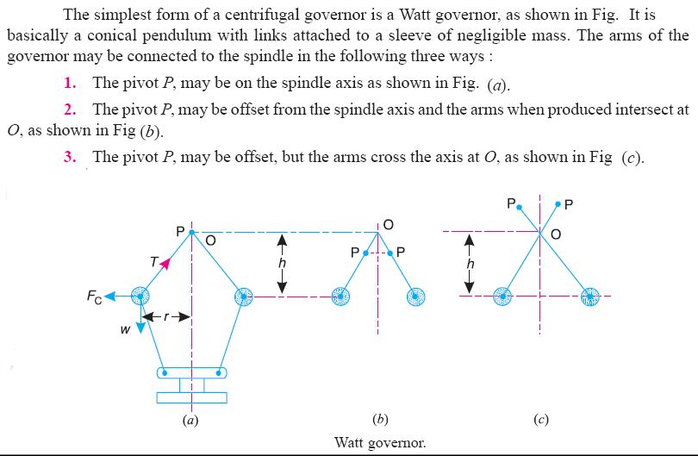

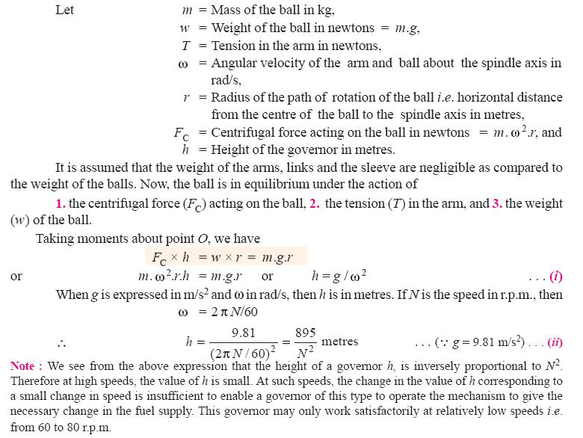

Porter governor:
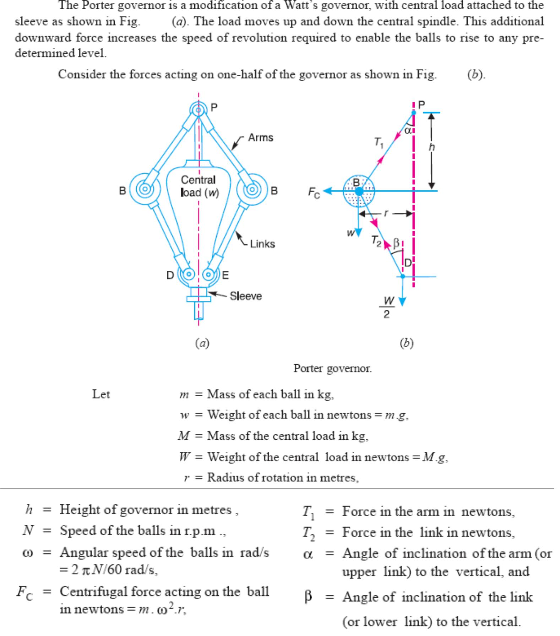

Proell governor:
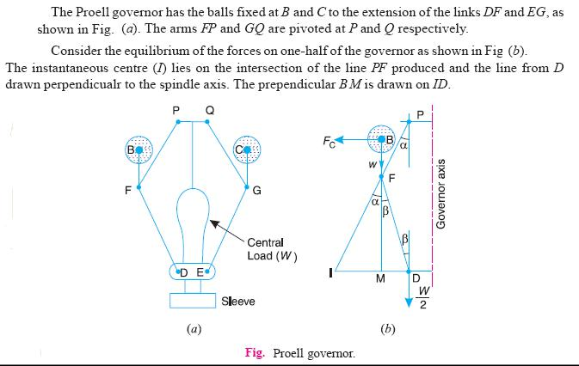

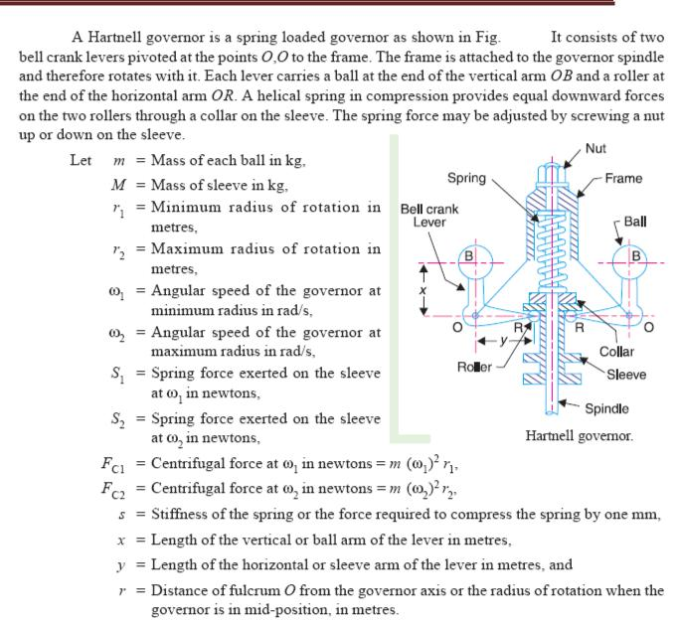
Hartnell governor:

Hartung governor:
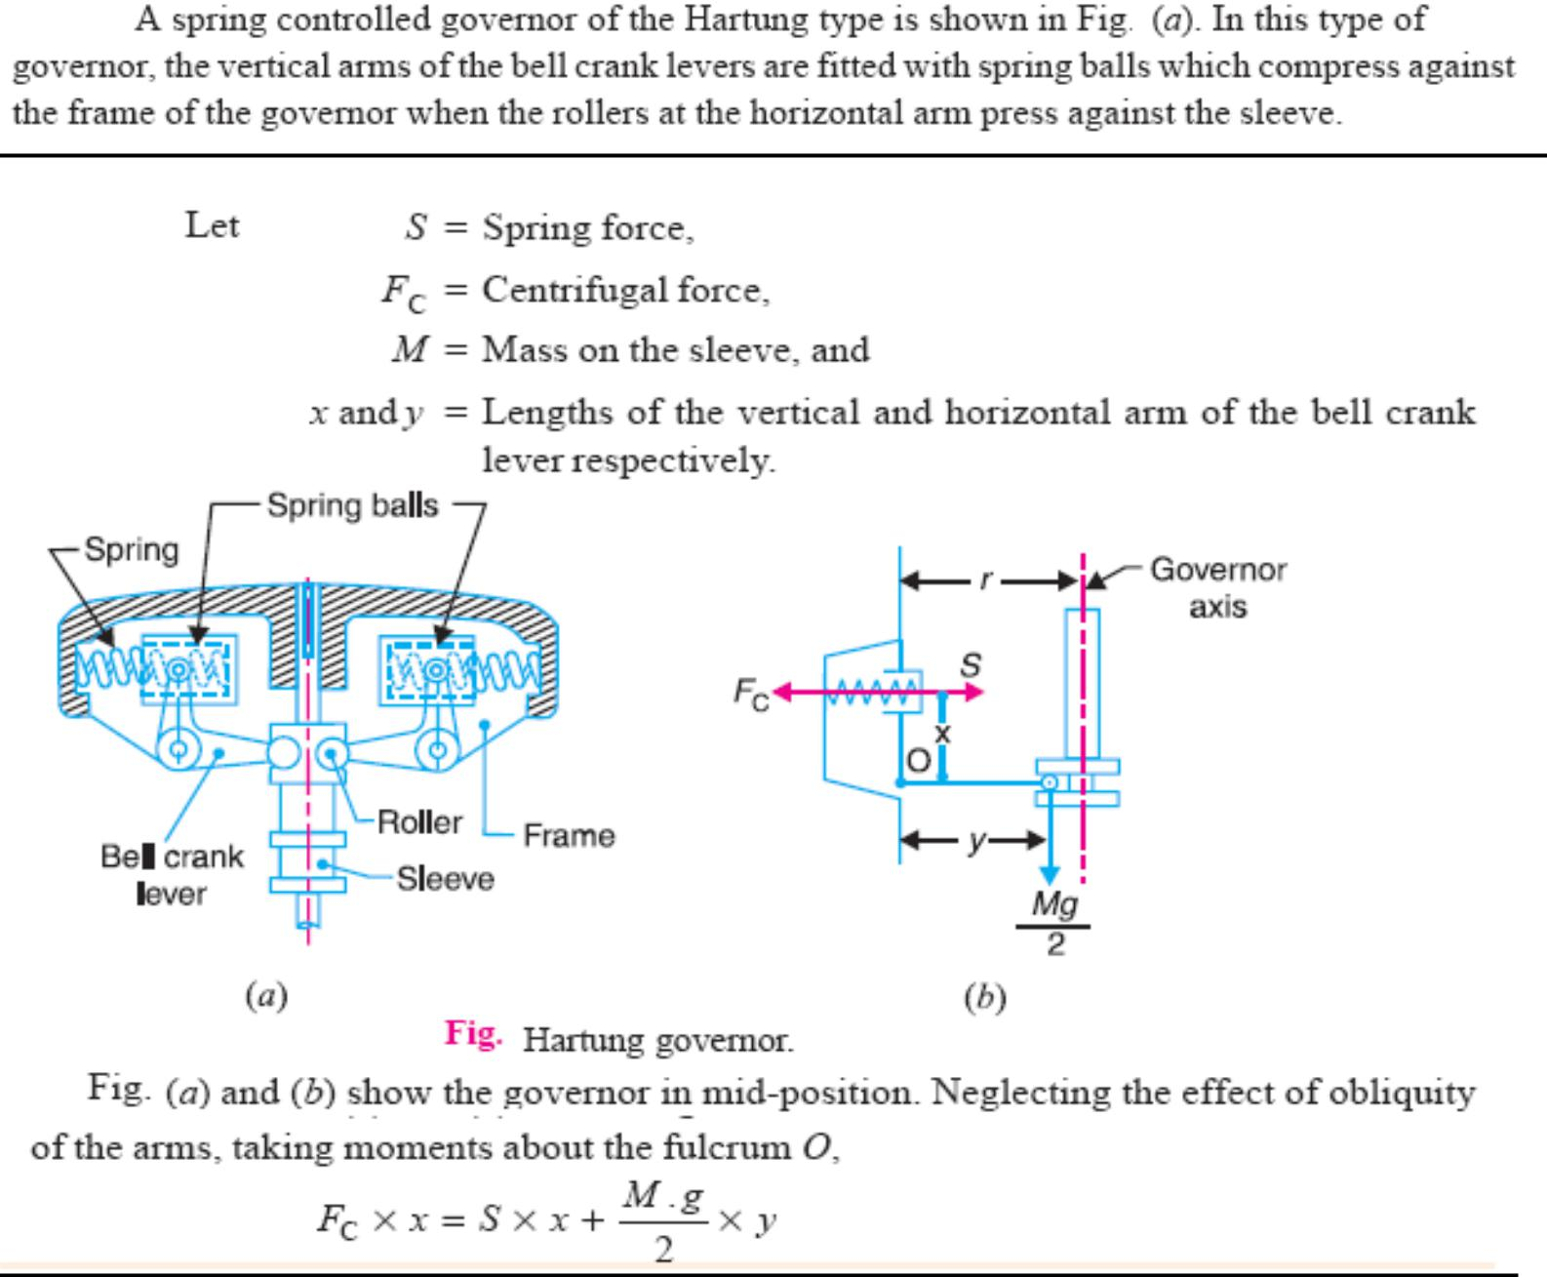

Wilson Hartnell governor:
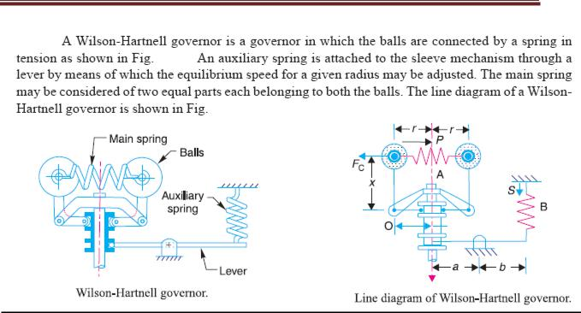

Pickering governor:
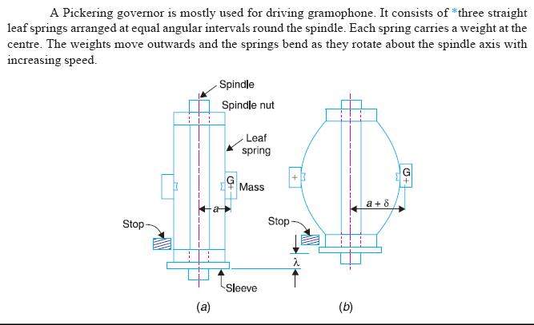

Difference between a flywheel and a governor:

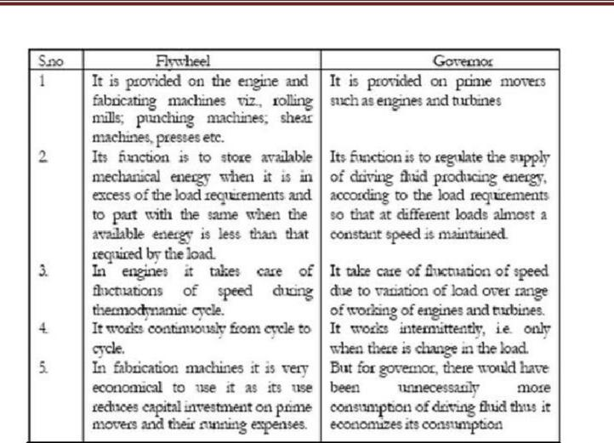

BALANCING
Introduction:

Balancing is the process of eliminating or at least reducing the ground forces and/or moments. It is achieved by changing the location of the mass centres of links. Balancing of rotating parts is a well known problem. A rotating body with fixed rotation axis can be fully balanced i.e. all the inertia forces and moments. For mechanism containing links rotating about axis which are not fixed, force balancing is possible, moment balancing by itself may be possible, but both not possible. We generally try to do force balancing. A fully force balance is possible, but any action in force balancing severe the moment balancing.
Balancing of rotating masses:
The process of providing the second mass in order to counteract the effect of the centrifugal force of the first mass is called balancing of rotating masses.
Static balancing:
The net dynamic force acting on the shaft is equal to zero. This requires that the line of action of three centrifugal forces must be the same. In other words, the centre of the masses of the system must lie on the axis of the rotation. This is the condition for static balancing.
Dynamic balancing:
The net couple due to dynamic forces acting on the shaft is equal to zero. The algebraic sum of the moments about any point in the plane must be zero.
Various cases of balancing of rotating masses:

  - Balancing of a single rotating mass by single mass rotating in the same plane.

  - Balancing of a single rotating mass by two masses rotating in the different plane.

  - Balancing of a several masses rotating in single plane.
  - Balancing of a several masses rotating in different planes.

Balancing of a single rotating mass by single mass rotating in the same plane:
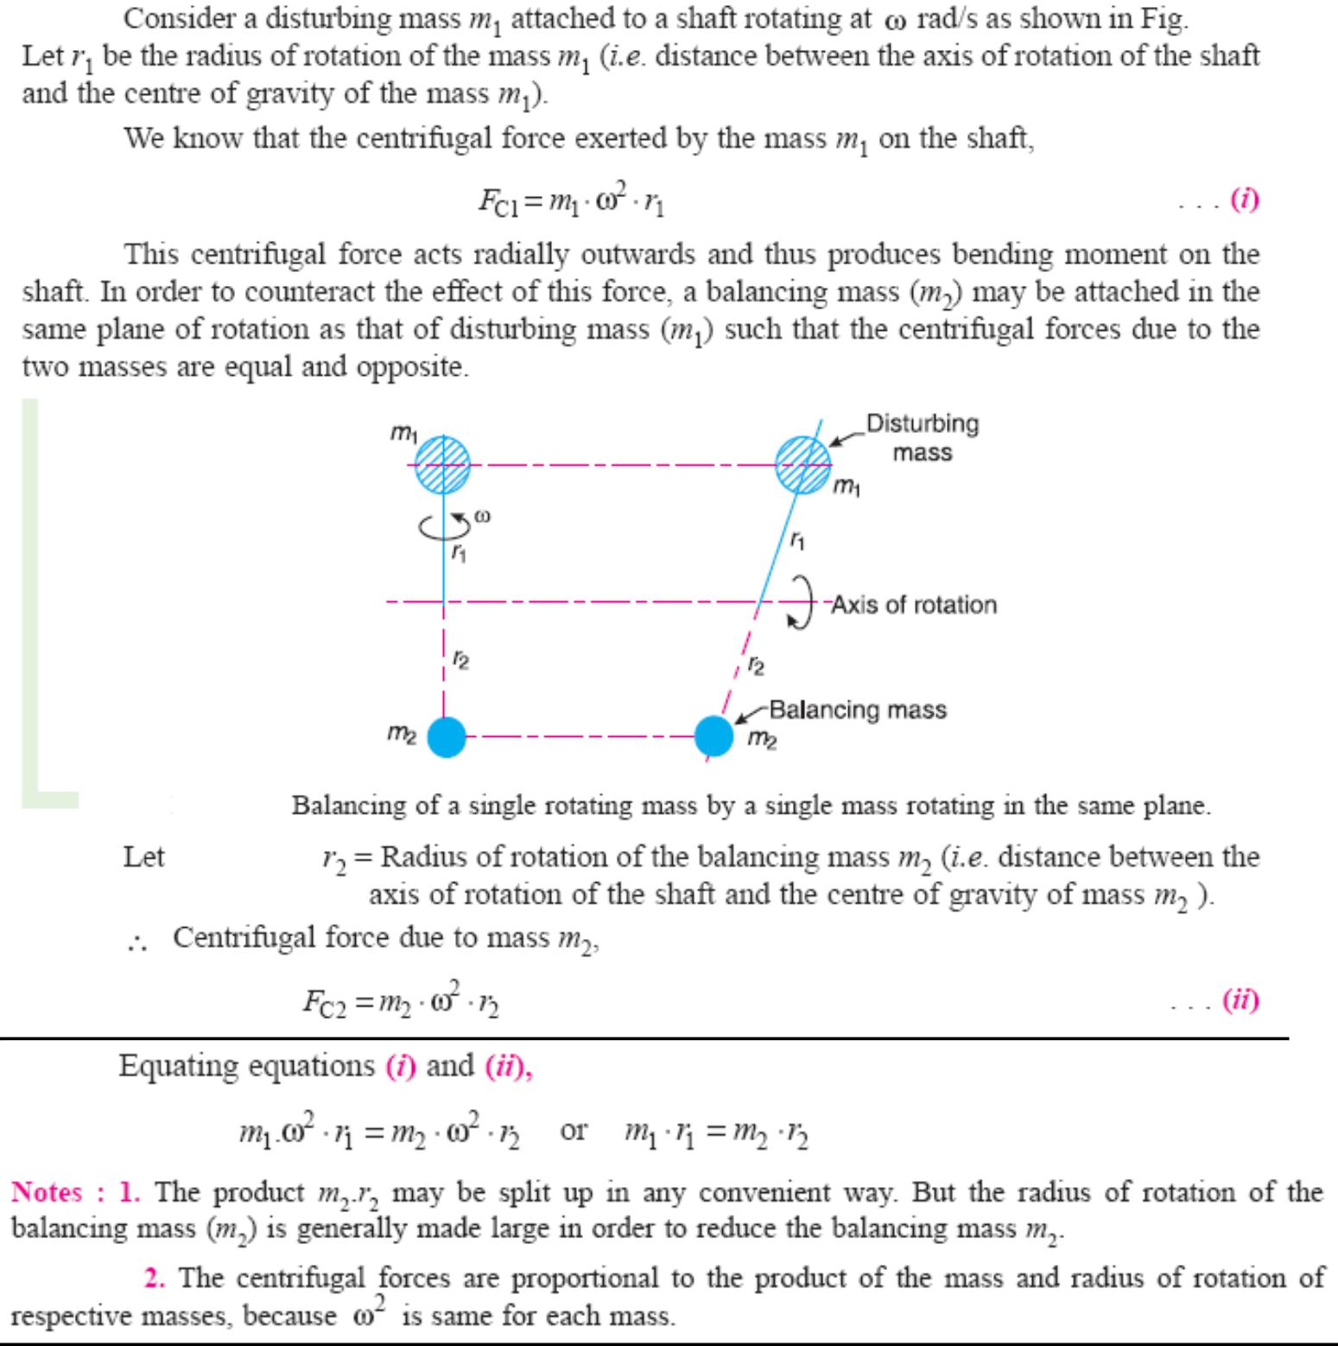

Balancing of a single rotating mass by two masses rotating in the different plane:
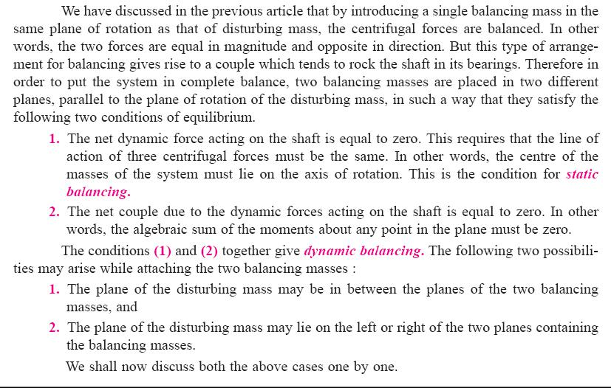

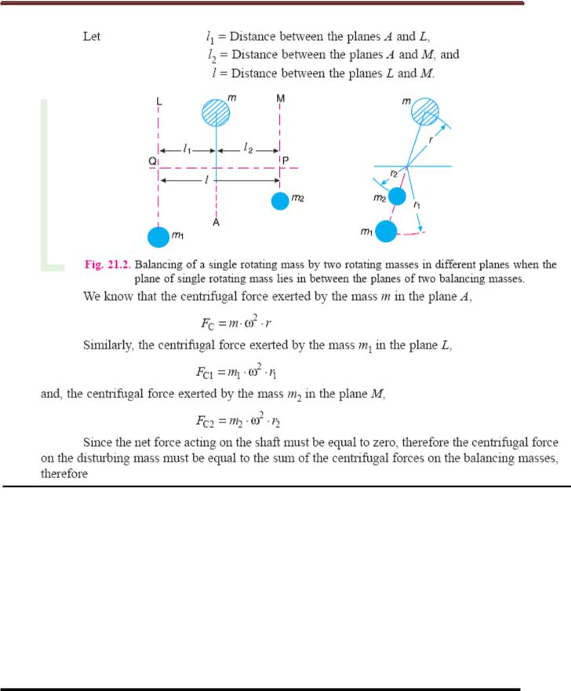

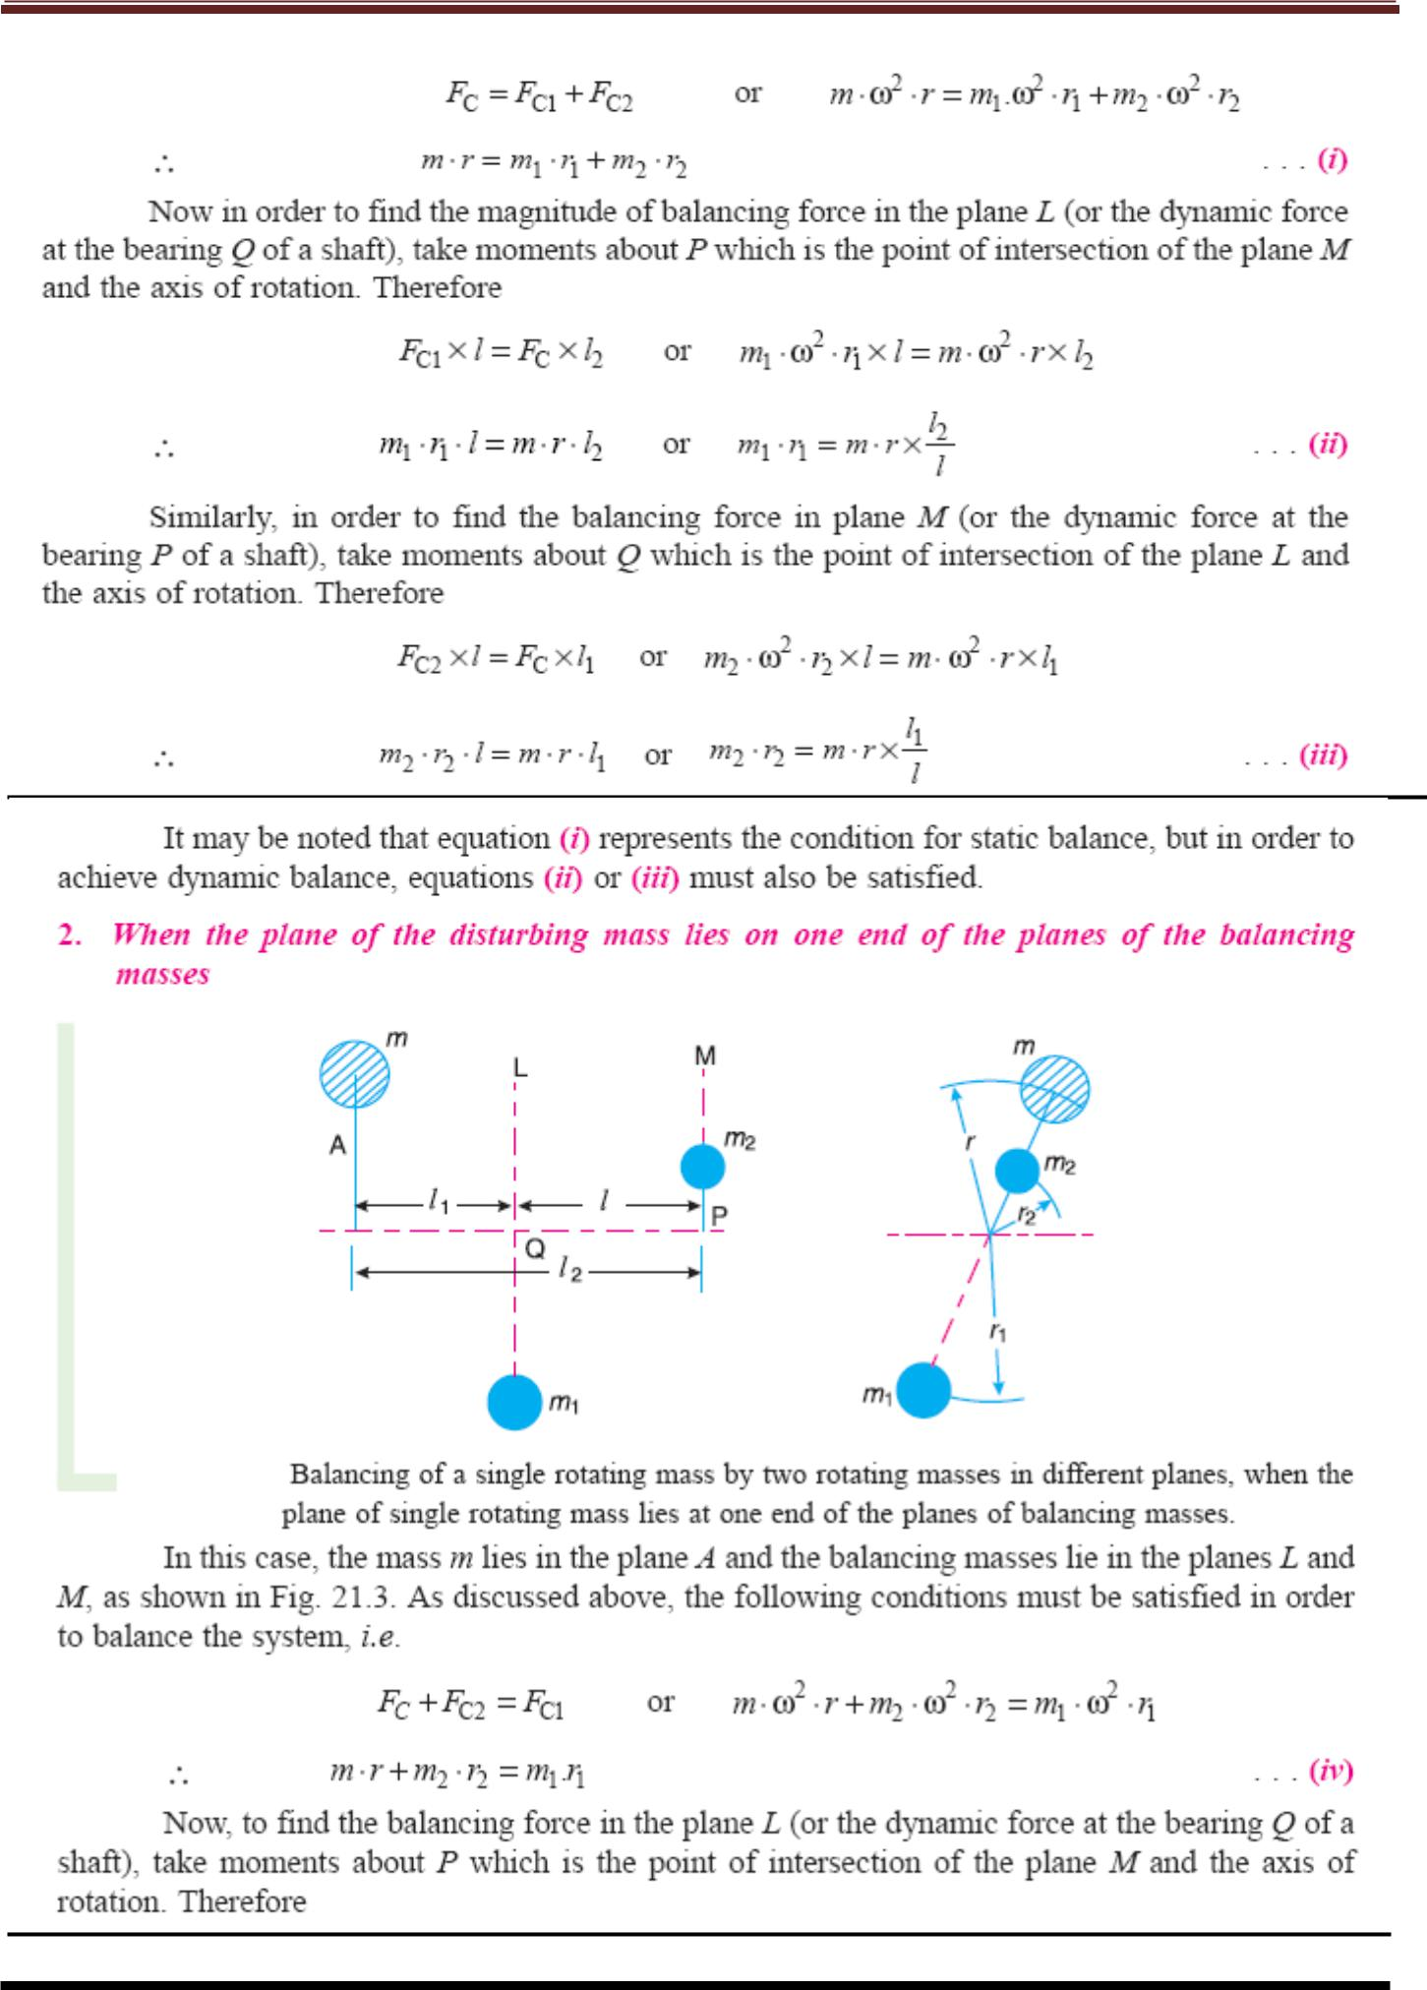

Balancing of a several masses rotating in same plane:
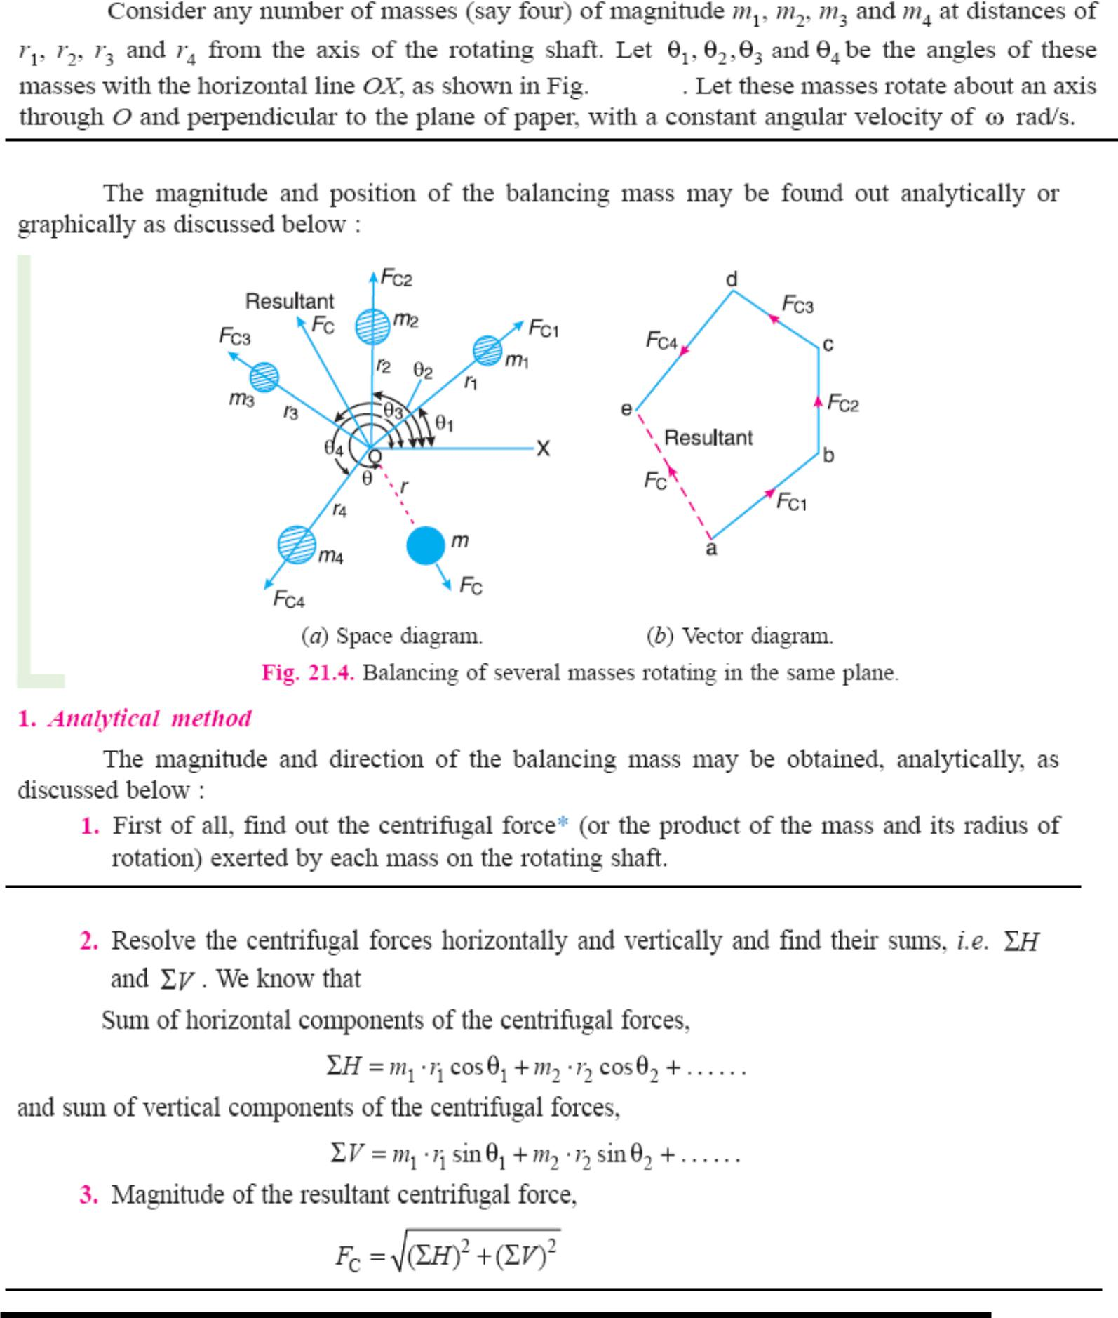

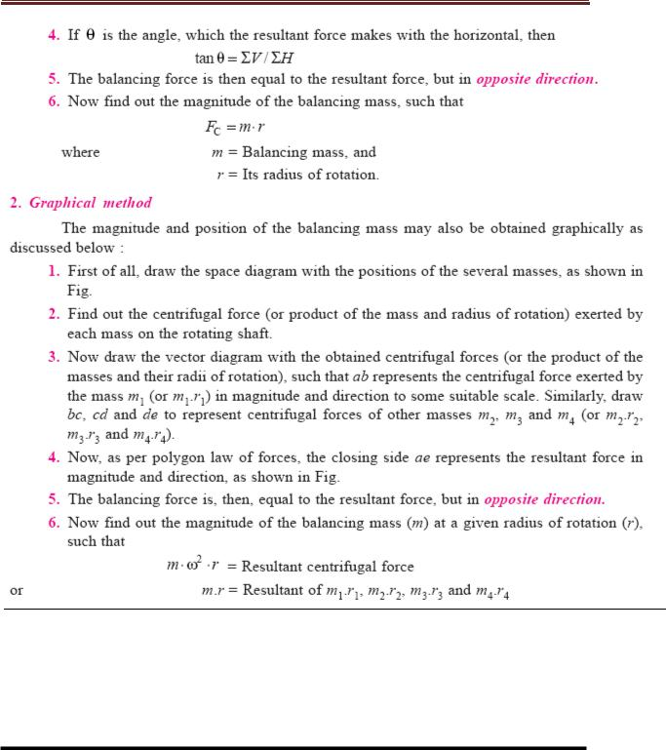

Balancing of several masses rotating different plane:
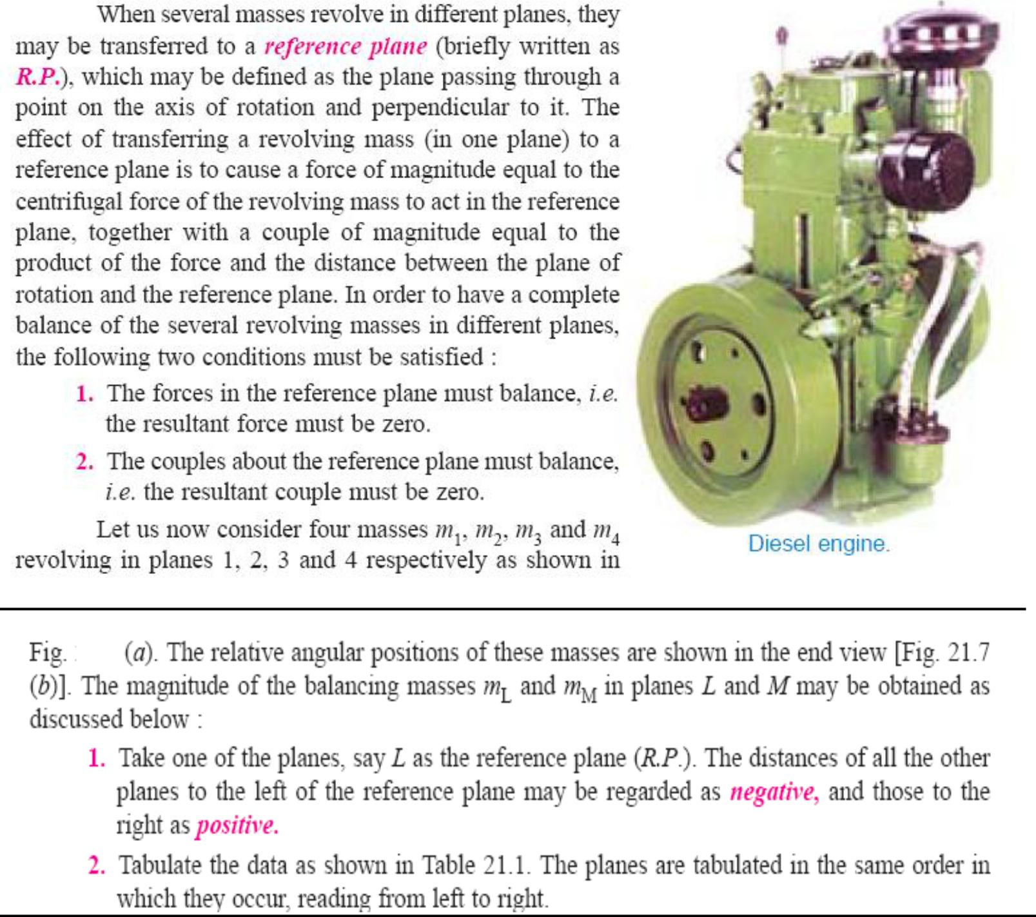

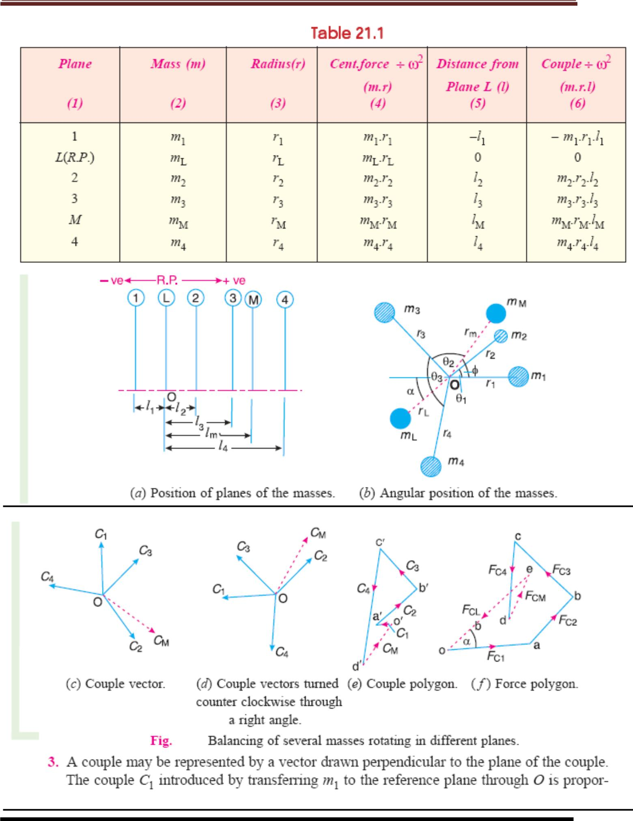

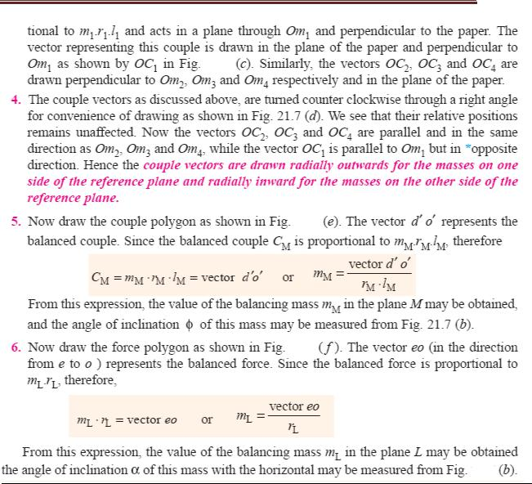

Balancing of Reciprocating masses:

Mass balancing encompasses a wide array of measures employed to obtain partial or complete compensation for the inertial forces and moments of inertia emanating from the crankshaft assembly. All masses are externally balanced when no free inertial forces or moments of inertia are transmitted through the block to the outside. However, the remaining internal forces and moments subject the engine mounts and block to various loads as well as deformities and vibratory stresses. The basic loads imposed by gas-based and inertial forces

Primary and secondary unbalanced forces of reciprocating parts:
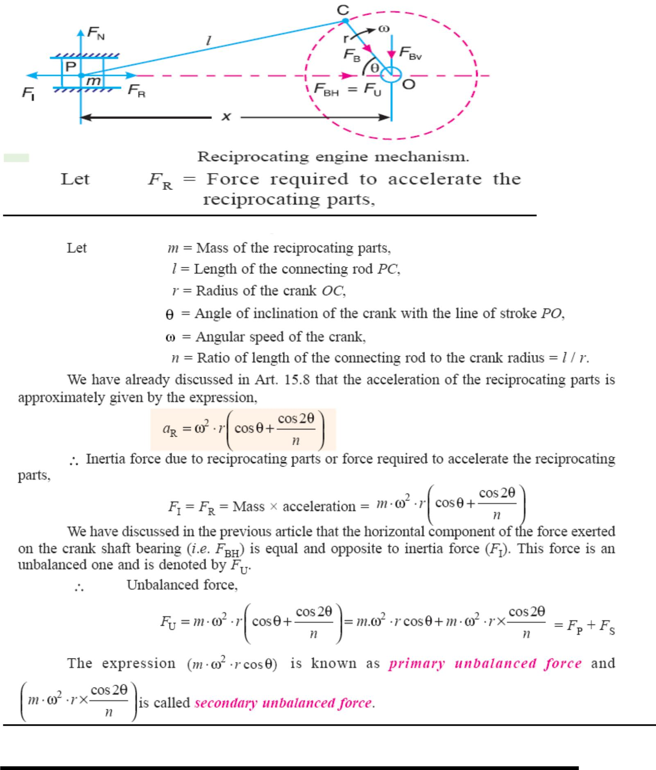

Balancing of single cylinder engine:
A single cylinder engine produces three main vibrations. In describing them we will assume that the cylinder is vertical. Firstly, in an engine with no balancing counterweights, there would be an enormous vibration produced by the change in momentum of the piston, gudgeon pin, connecting rod and crankshaft once every revolution. Nearly all single-cylinder crankshafts incorporate balancing weights to reduce this. While these weights can balance the crankshaft completely, they cannot completely balance the motion of the piston, for two reasons. The first reason is that the balancing weights have horizontal motion as well as vertical motion, so balancing the purely vertical motion of the piston by a crankshaft weight adds a horizontal vibration. The second reason is that, considering now the vertical motion only, the smaller piston end of the connecting rod (little end) is closer to the larger crankshaft end (big end) of the connecting rod in mid-stroke than it is at the top or bottom of the stroke, because of the connecting rod's angle. So during the 180° rotation from mid-stroke through top-dead-center and back to mid-stroke the minor contribution to the piston's up/down movement from the connecting rod's change of angle has the same direction as the major contribution to the piston's up/down movement from the up/down movement of the crank pin. By contrast, during the 180° rotation from mid-stroke through bottom-dead-center and back to mid-stroke the minor contribution to the piston's up/down movement from the connecting rod's change of angle has the opposite direction of the major contribution to the piston's up/down movement from the up/down movement of the crank pin. The piston therefore travels faster in the top half of the cylinder than it does in the bottom half, while the motion of the crankshaft weights is sinusoidal. The vertical motion of the piston is therefore not quite the same as that of the balancing weight, so they can't be made to cancel out completely.
Secondly, there is a vibration produced by the change in speed and therefore kinetic energy of the piston. The crankshaft will tend to slow down as the piston speeds up and absorbs energy, and to speed up again as the piston gives up energy in slowing down at the top and bottom of the stroke. This vibration has twice the frequency of the first vibration, and absorbing it is one function of the flywheel.
Thirdly, there is a vibration produced by the fact that the engine is only producing power during the power stroke. In a four-stroke engine this vibration will have half the frequency of the first vibration, as the cylinder fires once every two revolutions. In a two-stroke engine, it will have the same frequency as the first vibration. This vibration is also absorbed by the flywheel.
Balancing of inertial forces in the multi-cylinder engine:
In multi-cylinder engines the mutual counteractions of the various components in the Crank shaft assembly are one of the essential factors determining the selection of the Crank shafts configuration and with it the design of the engine itself. The inertial forces are Balanced if the common centre of gravity for all moving crankshaft-assembly components lies at the crankshaft's midpoint, i.e. if the crankshaft is symmetrical (as viewed from the front). The crankshaft's symmetry level can be defined using geometrical representations of 1st- and 2nd-order forces (star diagrams). The 2nd order star diagram for the four-cylinder in-line engine is asymmetrical, meaning that this order is characterized by substantial free inertial Forces. These

forces can be balanced using two countershafts rotating in opposite directions at double the rate of the crankshaft (Lanchester system).
Partial balancing of Locomotives:
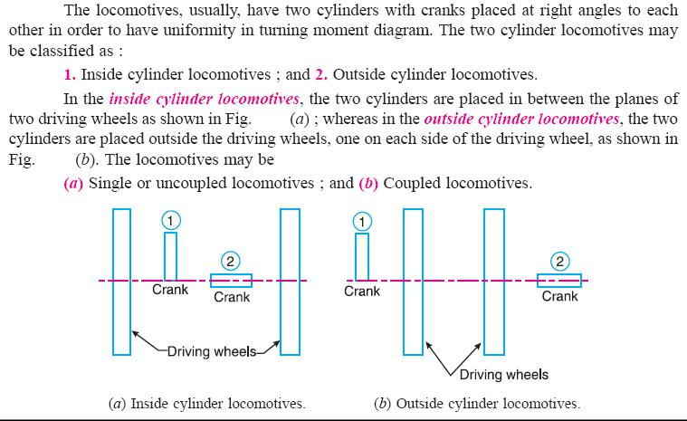

Variation of Tractive force:
The resultant unbalanced force due to the cylinders, along the line of stroke, is known as tractive force.

Swaying Couple:

The couple has swaying effect about a vertical axis, and tends to sway the engine alternately in clock wise and anticlockwise directions. Hence the couple is known as swaying couple.
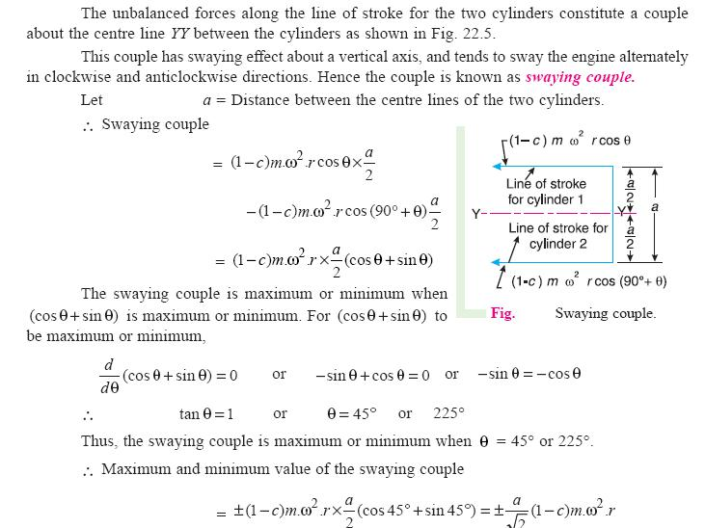

Hammer blow:

The maximum magnitude of the unbalanced force along the perpendicular to the line of stroke is known as Hammer blow.
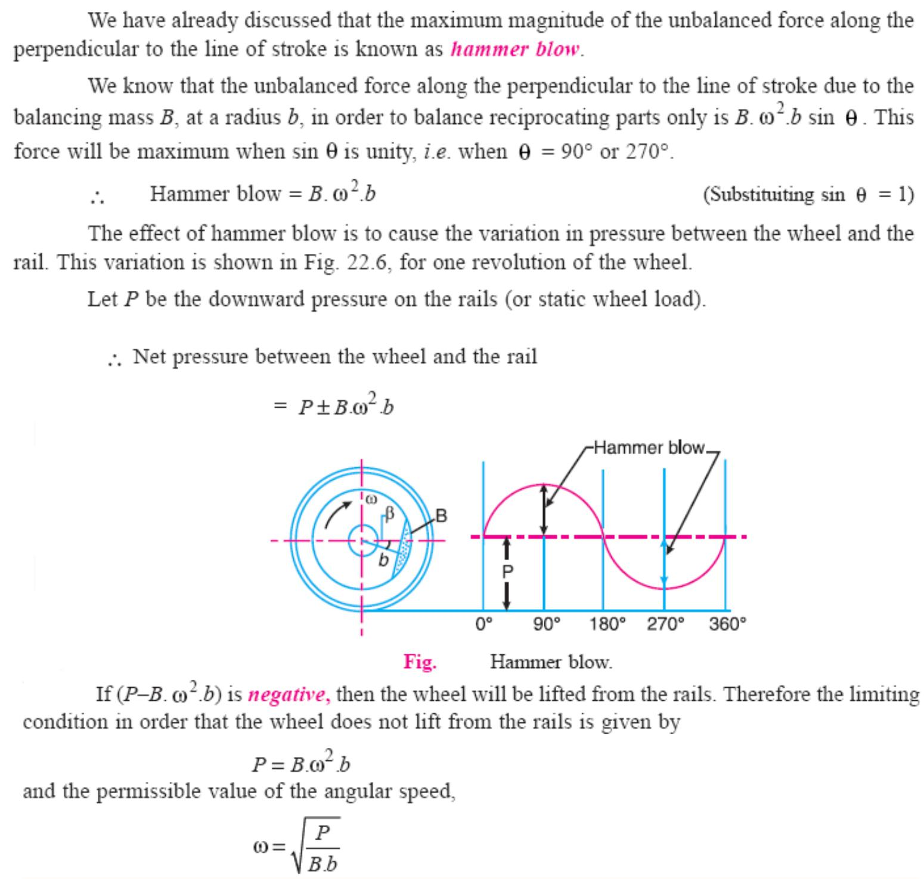

Balancing of Inline engines:
An in-line engine is one wherein all the cylinders are arranged in a single line, one behind the other as schematically indicated in Fig. Many of the passenger cars found on Indian roads such as Maruti 800, Zen, Santro, Honda City, Honda CR-V, and Toyota Corolla all have four cylinder in-line engines. Thus this is a commonly employed engine and it is of interest to us to understand the analysis of its state of balance.

For the sake of simplicity of analysis, we assume that all the cylinders are identical viz., r, ,

and are same. Further we assume that the rotating masses have been balanced out for all cylinders and we are left with only the forces due to the reciprocating masses.

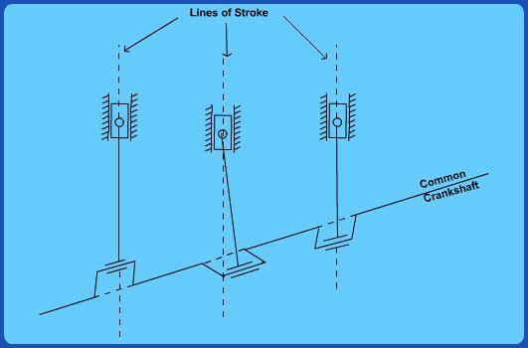

Balancing of radial engines:
A radial engine is one in which all the cylinders are arranged circumferentially as shown in Fig.These engines were quite popularly used in aircrafts during World War II. Subsequent developments in steam/gas turbines led to the near extinction of these engines. However it is still interesting to study their state of balance in view of some elegant results we shall discuss shortly. Our method of analysis remains identical to the previous case i.e., we proceed with the assumption that all cylinders are identical and the cylinders are spaced at uniform interval 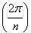 around the circumference.

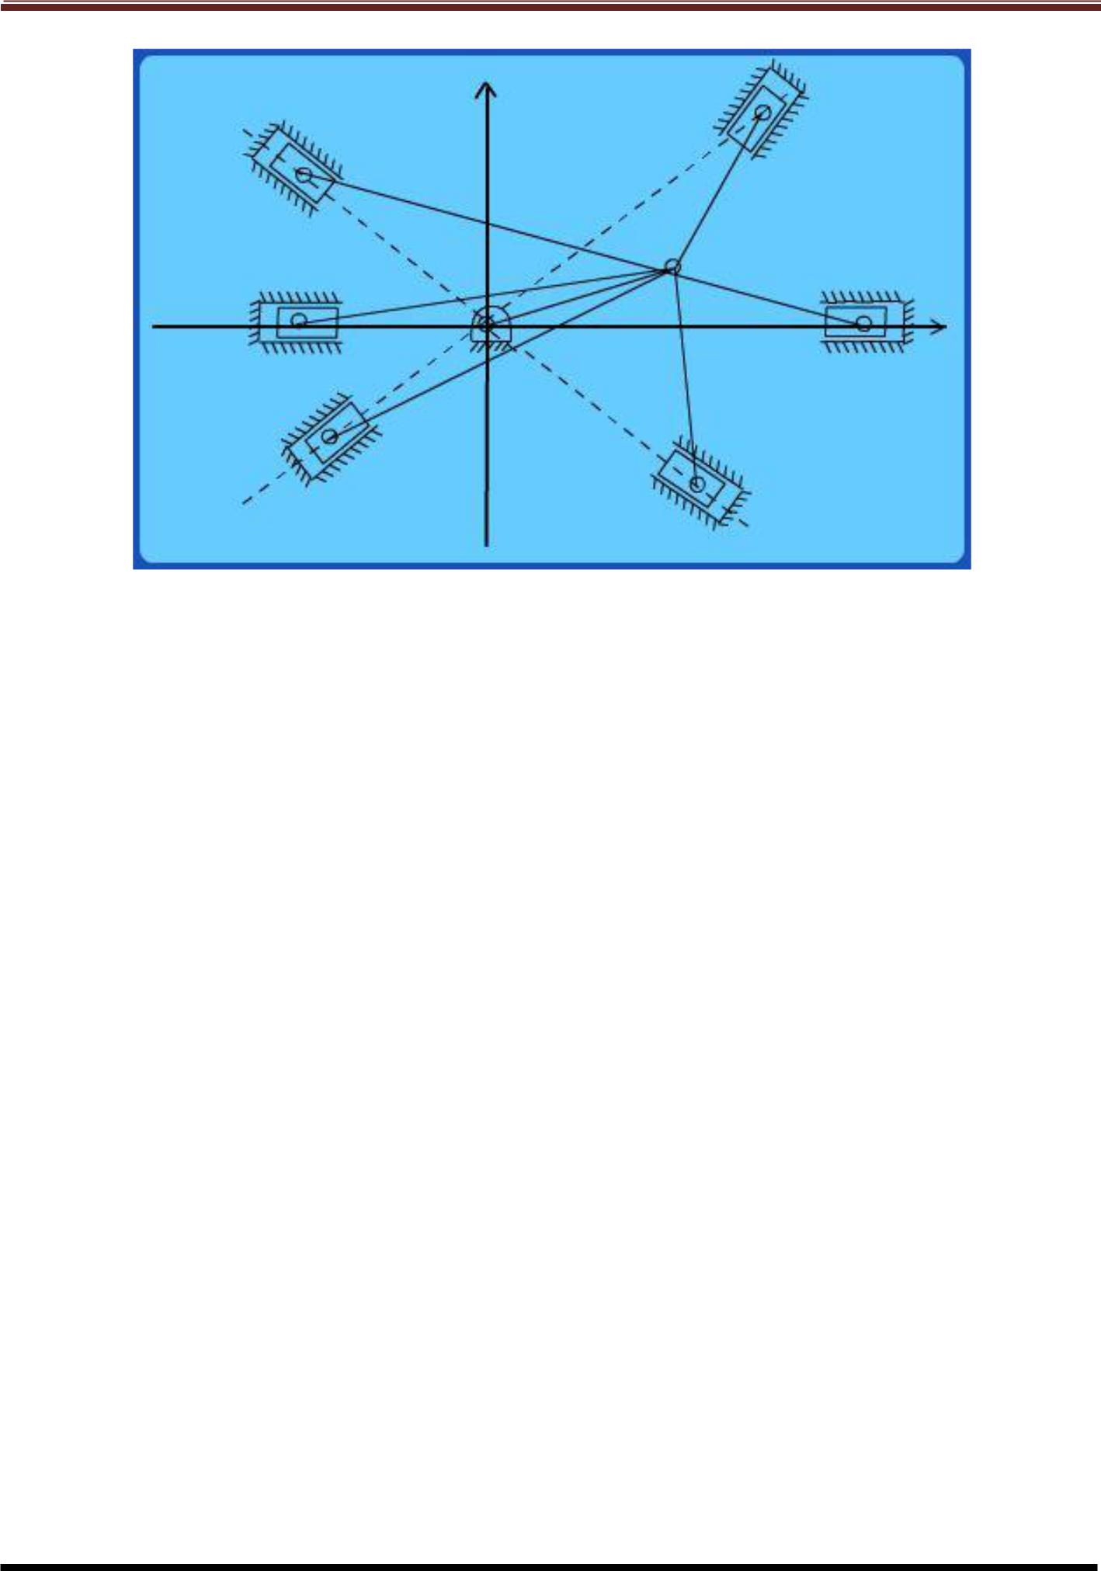

UNIT - V:
Vibrations:
FREE VIBRATIONS

(1) Introduction:
When a system is subjected to an initial disturbance and then left free to vibrate on its own, the resulting vibrations are referred to as free vibrations .Free vibration occurs when a mechanical system is set off with an initial input and then allowed to vibrate freely. Examples of this type of vibration are pulling a child back on a swing and then letting go or hitting a tuning fork and letting it ring. The mechanical system will then vibrate at one or more of its "natural frequencies" and damp down to zero.
(2) Basic elements of vibration system:
Mass or Inertia
Springiness or Restoring element
Dissipative element (often called damper)
External excitation
(3) Causes of vibration:
Unbalance: This is basically in reference to the rotating bodies. The uneven distribution of mass in a rotating body contributes to the unbalance. A good example of unbalance related vibration would be the ―vibrating alert‖ in our mobile phones. Here a small amount of unbalanced weight is rotated by a motor causing the vibration which makes the mobile phone to vibrate. You would have experienced the same sort of vibration occurring in your front loaded washing machines that tend to vibrate during the ―spinning‖ mode.
Misalignment: This is an other major cause of vibration particularly in machines that are driven by motors or any other prime movers.
Bent Shaft: A rotating shaft that is bent also produces the the vibrating effect since it losses it rotation capability about its center.
Gears in the machine: The gears in the machine always tend to produce vibration, mainly due to their meshing. Though this may be controlled to some extent, any problem in the gearbox tends to get enhanced with ease.
Bearings: Last but not the least, here is a major contributor for vibration. In majority of the cases every initial problem starts in the bearings and propagates to the rest of the members of the machine. A bearing devoid of lubrication tends to wear out fast and fails quickly, but before this is noticed it damages the remaining components in the machine and an initial look would seem as if something had gone wrong with the other components leading to the bearing failure.

(4) Effects of vibration:
(a)Bad Effects:

The presence of vibration in any mechanical system produces unwanted noise, high stresses, poor reliability, wear and premature failure of parts. Vibrations are a great source of human discomfort in the form of physical and mental strains.
(b)Good Effects:
A vibration does useful work in musical instruments, vibrating screens, shakers, relive pain in physiotherapy.
- Methods of reduction of vibration:

  - -unbalance is its main cause, so balancing of parts is necessary.
  - -using shock absorbers.
  - -using dynamic vibration absorbers.
  - -providing the screens (if noise is to be reduced)

- Types of vibratory motion:

  - Free Vibration
  - Forced Vibration

- Terms used vibratory motion:

(a)Time period (or)period of vibration:
It is the time taken by a vibrating body to repeat the motion itself.time period is usually expressed in seconds.
(b) Cycle:
It is the motion completed in one time period.
(c) Periodic motion:
A motion which repeats itself after equal interval of time.
(d)Amplitude (X)

The maximum displacement of a vibrating body from the mean position.it is usually expressed in millimeter.
(e) Frequency (f)
The number of cycles completed in one second is called frequency

(8) Degrees of freedom:

The minimum number of independent coordinates required to specify the motion of a system at any instant is known as D.O.F of the system
(9) Single degree of freedom system:
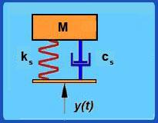

The system shown in this figure is what is known as a Single Degree of Freedom system. We use the term degree of freedom to refer to the number of coordinates that are required to specify completely the configuration of the system. Here, if the position of the mass of the system is specified then accordingly the position of the spring and damper are also identified. Thus we need just one coordinate (that of the mass) to specify the system completely and hence it is known as a single degree of freedom system.
(10) Two degree of freedom system:
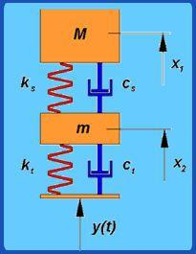

A two degree of freedom system With reference to automobile applications, this is referred as ―quarter car‖ model. The bottom mass refers to mass of axle, wheel etc components which are below the suspension spring and the top mass refers to the mass of the portion of the car and passenger. Since we need to specify both the top and bottom mass positions to completely specify the system, this becomes a two degree of freedom system.

11. Types of Vibratory motion:
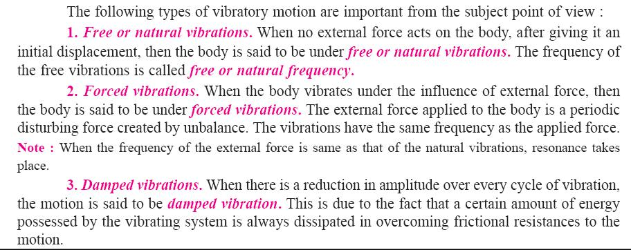

(12) Types of Vibration:

(a)Longitudinal vibration (b)Transverse Vibration ( c)Torsional Vibration.
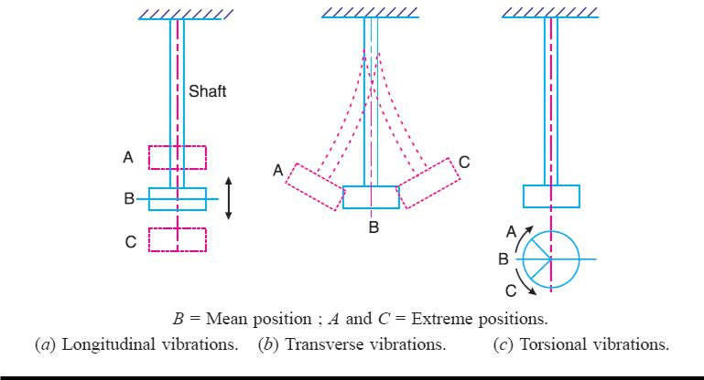

(13) Longitudinal Vibration:

When the particles of the shaft or disc moves parallel to the axis of the shaft, then the vibrations known as longitudinal vibrations.

(14) Free undamped longitudinal vibrations;

When a body is allowed to vibrate on its own, after giving it an initial displacement, then the ensuring vibrations are known as free or natural vibrations. When the vibrations take place parallel to the axis of constraint and no damping is provided, then it is called free undamped longitudinal vibrations.

(15) Natural frequency of free undamped longitudinal vibration:

(15.a) Equilibrium method or Newton’s method:
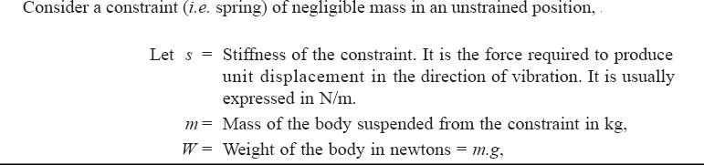

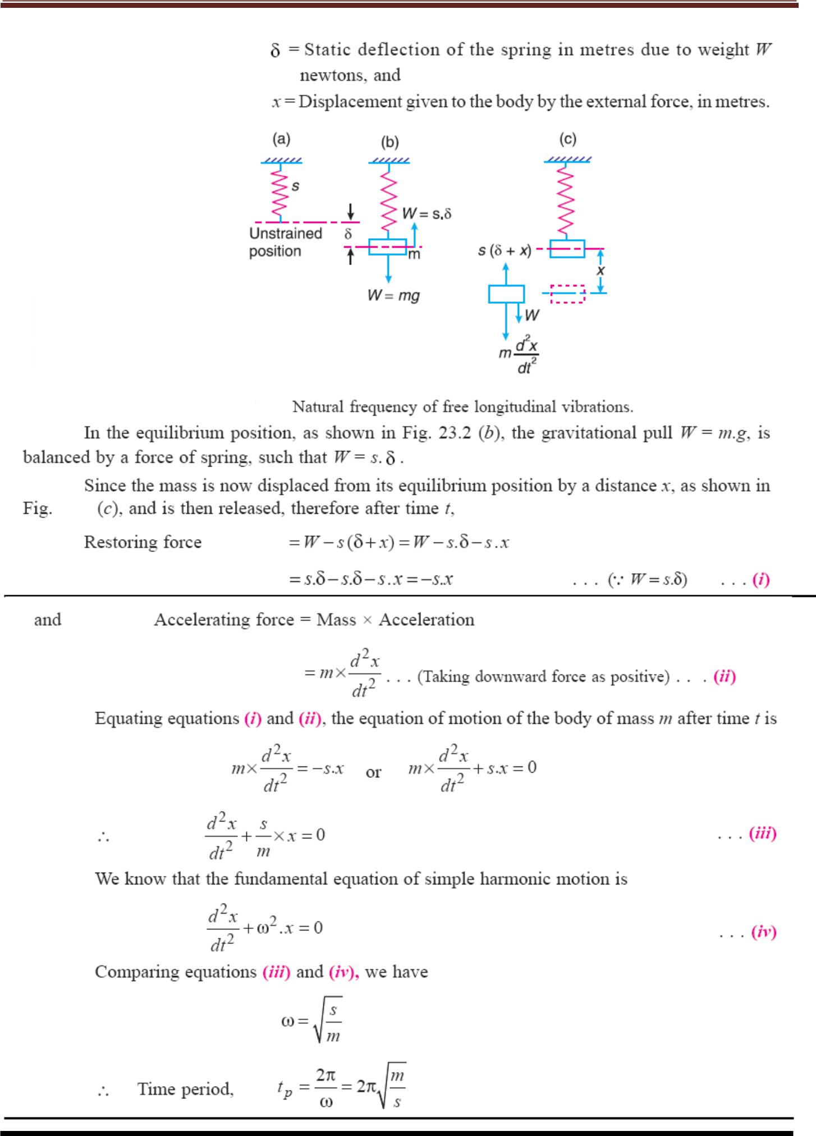

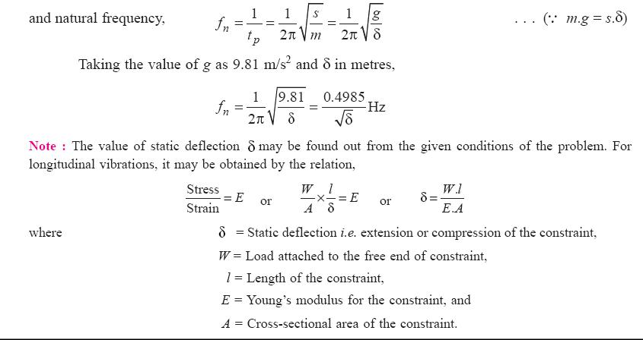

(15.b)Energy Method

In free vibrations, no energy is transferred into the system or from the system. Therefore, the total energy (sum of KE and PE)is constant and is same all the times.
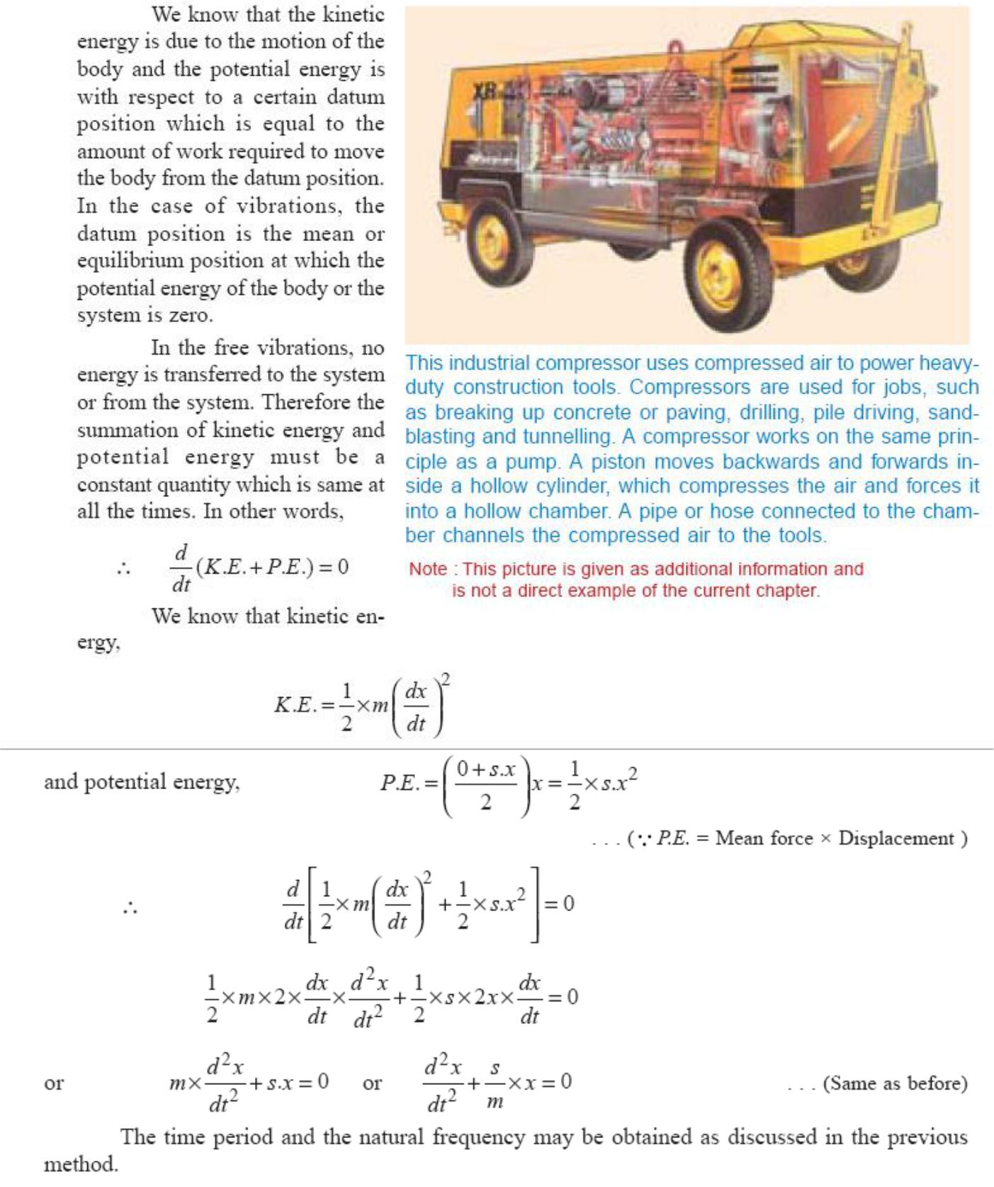

(c)Rayleigh’s method

In this method, the maximum kinetic energy at mean position is made equal to the maximum potential energy at the extreme position.
(16) Equivalent stiffness of spring.
- Springs in series

- Springs in parallel
- Combined springs

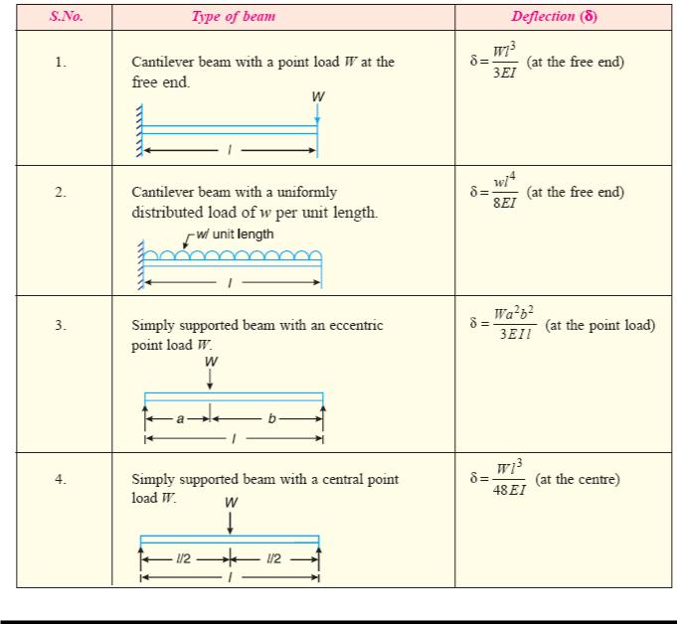
- Inclined springs

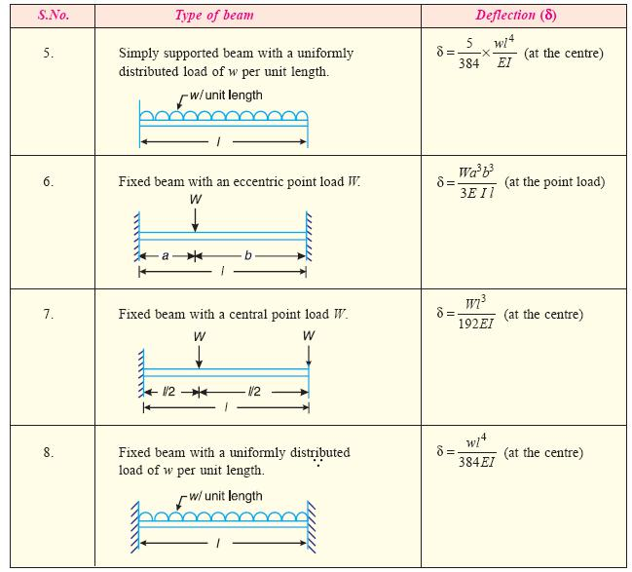

(17) Damping:

It is the resistance to the motion of a vibrating body. The vibrations associated with this resistance are known as damped vibrations.

(18) Types of damping:
- Viscous damping
- Dry friction or coulomb damping

- Solid damping or structural damping
- Slip or interfacial damping.

- Damping Coefficient:

The damping force per unit velocity is known as damping coefficient.
- Equivalent damping coefficient:

Dampers may be connected either in series or in parallel to provide required damping.
(21) Damped Vibration:
The vibrations associated with this resistance are known as damped vibrations.
(22) Damping factor:
Damping factor can be defined as the ratio of actual damping coefficient to critical damping coefficient.
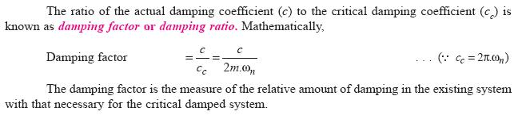

Thus mainly three cases arise depending on the value of
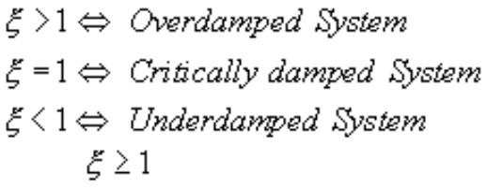

When the system undergoes aperiodically decaying motion and hence such systems are said to be

Overdamped Systems.

An example of such a system is a door damper – when we open a door and enter a room, we want the door to gradually close rather than exhibit oscillatory motion and bang into the person entering the room behind
us! So the damper is designed such that

Critically damped motion ( a hypothetical borderline case separating oscillatory decay from a periodic decay) I the fastest decaying aperiodic motion.

When ―< 1‖, x(t) is a damped sinusoid and the system exhibits a vibratory motion whose amplitude keeps diminishing. This is the most common vibration case and we will spend most of our time studying such systems. These are referred to as Underdamped systems.

(23) Logarithmic decrement:

It is defined as the natural logarithm of ratio of any two successive amplitudes of an under damped system. It is a dimensionless quantity.

We define Damping factor as
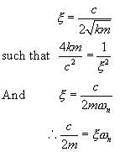

(24) Transverse Vibration:

When the particles of the shaft or disc moves approximately perpendicular to the axis of the shaft, then the vibrations known as transverse vibrations.
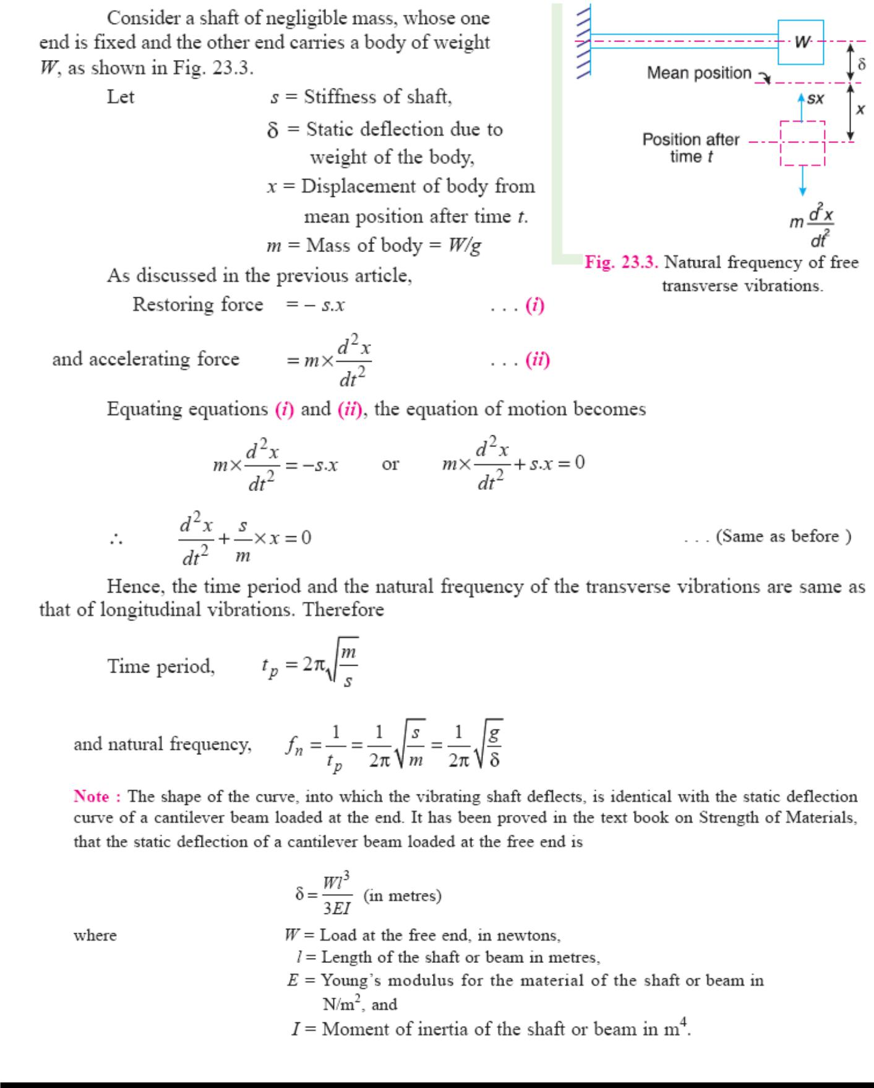

(25) Whirling speed of shaft:

The speed, at which the shaft runs so that the additional deflection of the shaft from the axis of rotation becomes infinite, is known as critical or whirling speed.

No shaft can ever be perfectly straight or perfectly balanced. When an element of mass is a distance from the axis of rotation, centrifugal force, will tend to pull the mass outward. The elastic properties of the shaft will act to restore the ―straightness‖. If the frequency of rotation is equal to one of the resonant frequencies of the shaft, whirling will occur. In order to save the machine from failure, operation at such whirling speeds must be avoided.
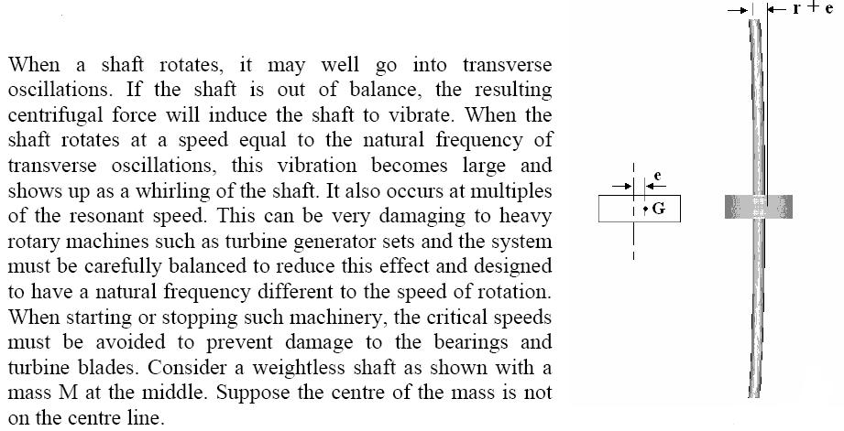

The whirling frequency of a symmetric cross section of a given length between two points is given by:
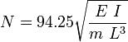

RPM

Where E = young's modulus, I = Second moment of area, m = mass of the shaft, L= length of the shaft between points

A shaft with weights added will have an angular velocity of N (rpm) equivalent as follows:
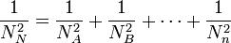

(26) Torsional Vibration:

When the particles of the shaft or disc move in a circle about the axis of the shaft, then the vibrations known as tensional vibration
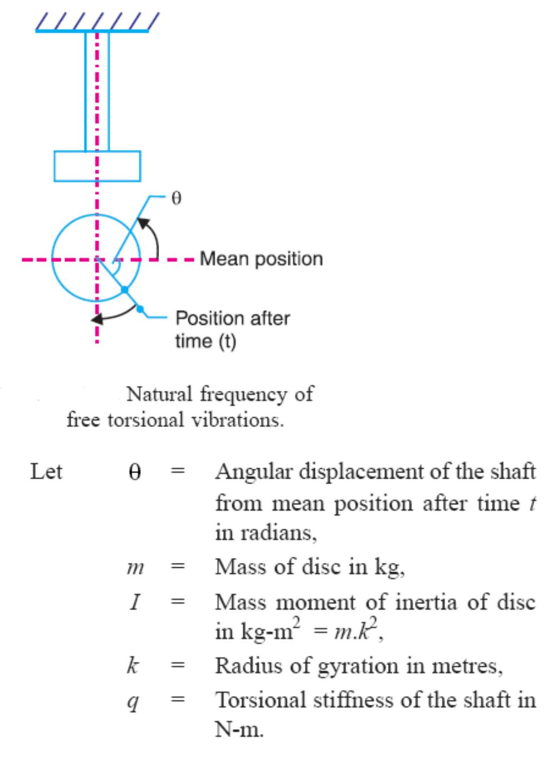

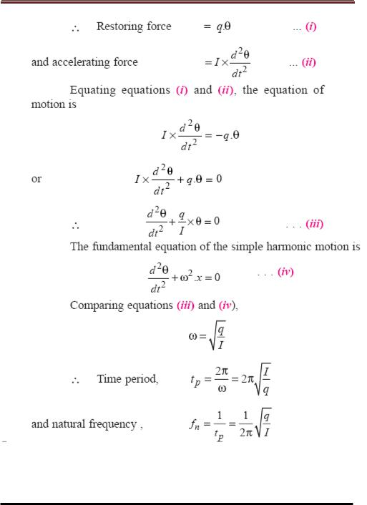

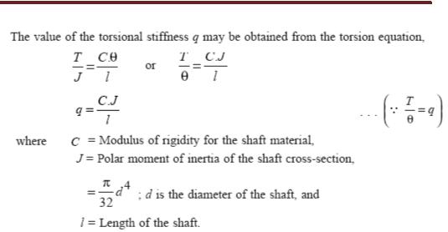

(27) Torsional vibration of a single rotor system:
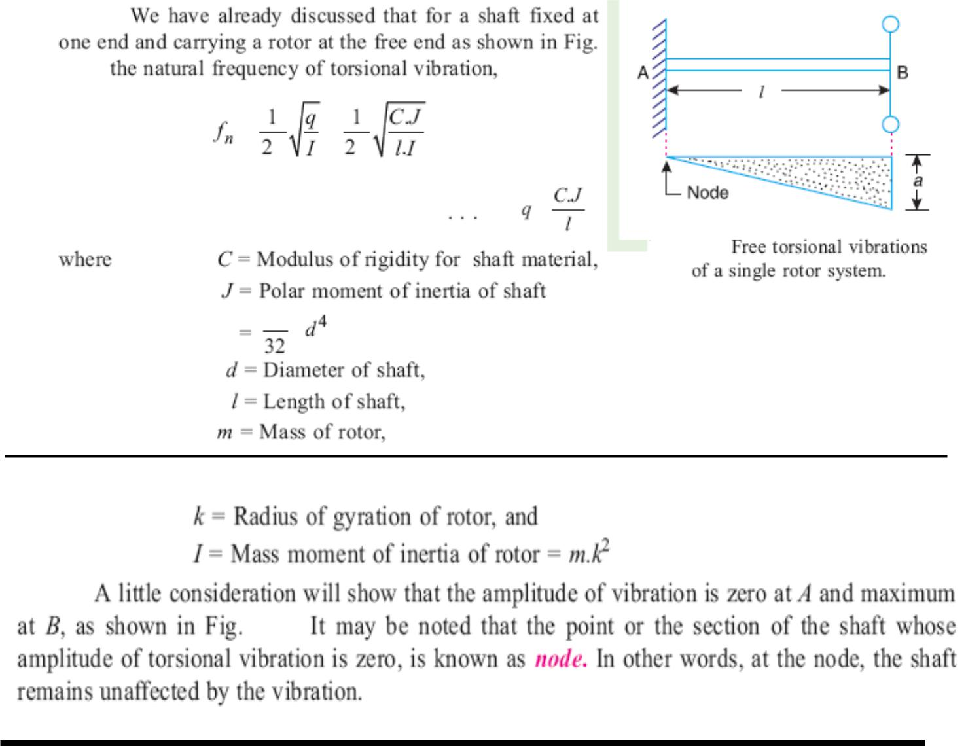

(28) Torsional vibration of a two rotor system:
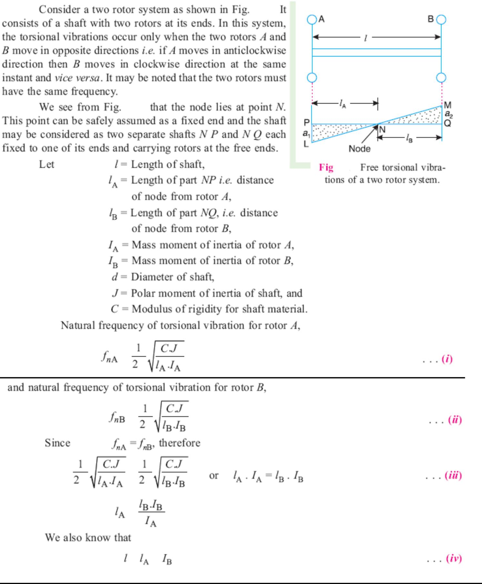

(29) Torsionally equivalent shaft:
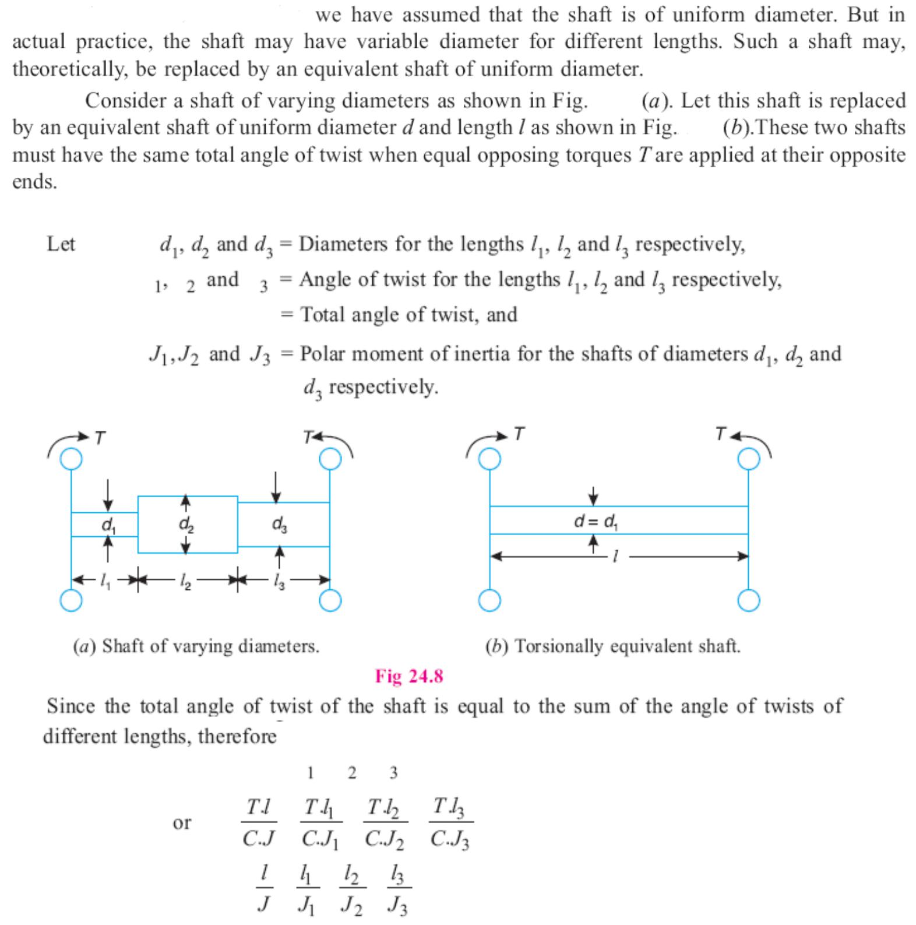

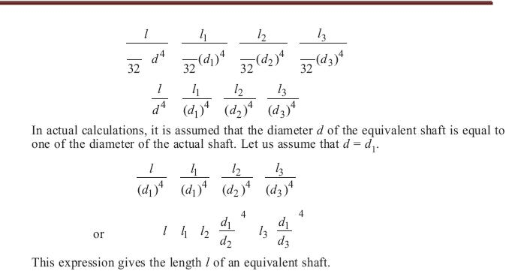

16. Question Bank

Dynamics of Machines

UNIT-I (FORCE ANALYSIS)

PART-A

- What is free body diagram?

- Define static force analysis.

- Differentiate between static and dynamic equilibrium.

- Define applied and constraint forces.

- Differentiate between static force analysis and dynamic force analysis.

- Define inertia force.

- Define inertia torque.

- State D’Alembert’s principle.

- State the principle of superposition.

- Define piston effort.

- Define crank effort and crank-pin effort.

  - What is meant by turning moment diagram or crank effort diagram?

- Explain the term maximum fluctuation of energy in fly wheel.

- Define coefficient of fluctuation of energy.

- Define coefficient of fluctuation of speed.

- Define coefficient of steadiness.

- Why flywheels are needed in forging and pressing operations?

- What is cam dynamics?

- Define unbalance and spring surge.

- Define windup. What is the remedy for camshaft windup?

- What are the effect and causes of windup?

PART-B (FORCE ANALYSIS) (16 marks)

- For reciprocating engine, derive the expression for (i)Velocity and acceleration of the piston

(ii)Angular velocity and angular acceleration of the connecting rod

2. In a reciprocating engine mechanism, if the crank and connecting rod are 300mm and 1m long respectively and the crank rotates at a constant speed of 200r.p.m.Determine analytically,

1. The crank angle at which the maximum velocity occurs and
2. | Maximum velocity of piston.
3. | Derive the relevant equations.
3. (i)Deduce the expression for the inertia force in the reciprocating |  | force neglecting the weight
 | of the connecting rod.

(ii)A vertical petrol engine with cylinder of 150mm diameter and 200mm strokes has a connecting rod of 350mm

long. The mass is 1.6kg and the engine speed is 1800 rpm. On the expansion | stroke with crank angle 30˚
fromTDC, the gas pressure is 750KPa.Determine the net thrust on the piston.
4. (i)Define coefficient of fluctuation of speed and coefficient of fluctuation of energy.

(ii)The radius of gyration of a fly wheel is 1meter and fluctuation of speed is not to exceed 1% of the mean speed of the flywheel. If the mass of the flywheel is 3340kg and the steam develops 150KW at 135rpm, then find,

1.Maximum fluctuation of energy 2. Coefficient of fluctuation of energy

5. The length of crank and connecting rod of a horizontal reciprocating engine are 100mm and 500mm respectively. The crank is rotating at 400rpm.When the crank has turned 30˚ from the IDC, find analytically

1.Velocity of piston

- Acceleration of piston

- Angular velocity of connecting rod

4. Angular acceleration of connecting rod.

6. The length and connecting rod of a horizontal reciprocating engine are 200mm and 1meter respectively. The crank is rotating at 400rpm.When the crank has turned 30˚ from the inner dead center, the difference of pressure between cover end and piston rod is 0.4 N/mm2. If the mass of the reciprocating parts is 100Kg and a cylinder

bore is 0.4meters.Calculate

(i)Inertia force (ii) Force on piston (iii) Piston effort (iv) Thrust on the side of the cylinder walls (v) Thrust

in the connecting rod (vi)Crank effort.

7. A horizontal gas engine running at 210rpm has a bore of 220mm and a stroke of 440mm. The connecting rod is 924mm long the reciprocating parts weight 20kg.When the crank has turned through an angle of 30˚ from IDC, the gas pressure on the cover and the crank sides are 500KN/m2 and 60KN/m2 respectively. Diameter of the

piston rod is 40mm.Determine,

1. Turning moment on the crank shaft

2.Thrust on bearing

3. Acceleration of the flywheel which has a mass of 8kg and radius of gyration of 600mm while the power

of the engine is 22KW.

8. A single cylinder vertical engine has a bore of 300mm and a stroke of 400mm.The connecting rod is 1000mm long. The mass of the reciprocating parts is 140kg.On the expansion stroke with the crank at 30˚from the top dead center, the gas pressure is 0.7MPa.If the runs at 250rpm, determine;

1. Net force acting on the piston 2.resultant load on the gudgeon pin

- Thrust on cylinder walls

- The speed above which other things remaining same, gudgeon pin loads would be reversed in Direction

- A vertical double acting steam engine has a cylinder 300mm diameter and 450mm stroke and runs at 200rpm.The reciprocating parts has a mass of 225kg and the piston rod is 50mm diameter.

The connecting rod is 1.2m long. When the crank has turned 125˚ from IDC the steam
pressure above the piston is 30KN/m2.calculate,
(i)Crank-pin effort
(ii)The effective turning moment on the crank shaft.

10. The turning moment diagram for a petrol engine is drawn to a scale of 1mm to 6N-9-9m and the horizontal scale of 1mm to 1˚.The turning moment repeat itself after every half revolution of the engine. The area above and below the mean torque line are 305, 710, 50,350,980and 275mm2. The mass of rotating parts is 40kg at a radius

of gyration of 140mm.Clculate the coefficient of fluctuation of speed if the mean speed is 1500rpm.

11. The torque delivered by a two stroke engine is represented by T= (1000+300sin2θ-500cos2θ) N-m

where θ is the angle turned by the crank from the IDC. The engine speed is 250rpm.The mass of the flywheel is 400kg and radius of gyration 400mm. Determine ,

(i)the power developed

(ii)the total percentage fluctuation of speed

(iii)the angular acceleration of flywheel when the crank has rotated through an angle of 60˚ from the IDC.

(iv) the maximum angular acceleration and retardation of the flywheel.

UNIT-II (BALANCING)

PART-A
What is meant by balancing of rotating masses?

- Why rotating masses are to be dynamically balanced?

- Define static balancing.

- Define dynamic balancing.

- State the conditions for static and dynamic balancing.

- State the conditions for complete balance of several masses revolving in different planes of a shaft.

- Why complete balancing is not possible in reciprocating engine?

- Can a single cylinder engine be fully balanced? Why?

- Differentiate between the unbalanced force caused due to rotating and reciprocating masses.

- Why are the cranks of a locomotive, with two cylinders, placed at 90˚ to each other?

- List the effects of partial balancing of locomotives.
- Define swaying couple.

- Define hammer blow with respect to locomotives.

- What are the effects of hammer blow and swaying couple?

- Define direct and reverse cranks.

- what for the balancing machines are used?

- What are different types of balancing machines?

PART-B (BALANCING)

1. A shaft is rotating at a uniform angular speed. Four masses M1, M2, and M3and M4 of magnitudes 300kg, 450kg, 360kg, 390kg respectively are attached rigidly to the shaft. The masses are rotating in the same plane. The corresponding radii of rotation are 200mm, 150mm, 250mmand 300mm respectively. The angle made by these masses with horizontal are 0˚.45˚, 120˚and 255˚respectively.

Find,(i) the magnitude of balancing mass
(ii) the position of balancing mass if its radius of rotation is 200mm.

2. Four masses M1, M2, M3, and M4 are 200kg, 300kg, 240kg and 260kg respectively. The corresponding radii of rotation are 0.2m, 0.15m, 0.25m and 0.3m respectively and the angle between successive masses45˚, 75˚,

and135˚.Find the position and magnitude of balance mass required if its radius of rotation is 0.25m.
3. The data for three rotating masses are given below:-
M1=4kg | r1=75mm | θ1=45
M2=3kg | r2=85mm | θ2=135
M3=2.5kg | r3=50mm | θ3=240
Determine the amount of counter mass at a radial distance of 65mm required for their static balance

4. Four masses A, B, C, and D are completely balanced masses C and D makes angles of 90˚ and 195˚ respectively with B in the same sense. The rotating masses have the following properties:
m_{A}=25kg | r_{A}=150mm
m_{B}=40kg | r_{B}=200mm
m_{C}=35kg | r_{C}=100mm
 | r_{D}=180mm
Planes B and C are 250mm apart. Determine (i) the mass A and its angular position
 | (ii) the position of planes A and D.

5. A, B, C and D are four masses carried by a rotating shaft at radii 100mm,125mm,200mm and 150mm respectively. The planes in which the masses revolve are spaced 600mm apart and the masses of B,C and D are 10kg,5kg and 4kgrespectively.Find the required mass A and relative angular setting of the four masses so that the

shaft be in complete balance.
6. Four masses A, B, C and D revolves at equal radii and equally spaced along a shaft. The mass B is 7kg and the radii of C and D make angle s of 90˚ and 240 ˚respectively with the radius of B.Find the magnitude of masses

A,C and D and angular position of A . So that the system may be completely balanced.

7. A shaft caries four rotating masses A, B, C and D which are completely balanced. The masses B, C and Dare 50kg, 80kg and 70kg respectively. The masses C and D make angles of 90˚ and 195˚ respectively with mass B in the same sense. The masses A,B,C and D are concentrated at radius 75mm,100mm,50mm and

90mmrespectively.The plane of rotation of masses B and C are 250mm apart. Determine
(i) the magnitude of mass A and its angular position
(ii) the position of planes A and D.

8. A four cylinder vertical engine has cranks 150mm long. The plane of rotation of the first, second and fourth cranks are 400mm,200mm and 200mm respectively from that of the third crank and their reciprocating masses are 50kg,60kg and 50kg respectively. Find the mass of the reciprocating parts for the third cylinder and relative

angular position of the cranks in order that the engine may be in complete balance.

9. A four cylinder vertical engine has cranks 300mm long. The plane of rotation of the first, third and fourth cranks are 750mm,1050mm and 1650mm respectively from that of the second crank and their reciprocating masses are 10kg,400kg and 250kg respectively. Find the mass of the reciprocating parts for the second cylinder and relative

angular position of the cranks in order that the engine may be in complete balance.
10. Derive the following | expression of effects of partial balancing in two cylinder locomotive | engine
(i) Variation of tractive force | (ii) Swaying couple (iii) Hammer blow

UNIT-V (FREE VIBRATION)

PART-A

- What are the causes and effect of vibration?

- Define frequency, cycle, period and free vibration.

- What are the different types of vibrations?

- State different method of finding natural frequency of a system.

- What is meant by free vibration and forced vibration?

- Define resonance.

- What is meant by degrees of freedom in a vibrating system?

- What is the natural frequency of simple spring mass system?

- Determine the natural frequency of mass of 10kgsuspended at the bottom of two springs (of stiffness: 5N/mm and 8N/mm) in series.

- What is the effect of inertia on the shaft in longitudinal and transverse vibrations?

- State the expression for the frequency of simple pendulum.

- Give the expression for natural frequency of water, which oscillates in a ‘U’tube manometer?

- What are the different types of damping?

- Draw the schematic diagram of a free damped vibration system and write the governing differential equation of the system.

- Sketch the Time Vs Displacement for under-damped and over-damped systems.

- What is the limit beyond which damping is detrimental and why?

- What is meant by critical damping?

- What type of motion is exhibited by a vibrating system when it is critically damped?

- Define critical or whirling speed.

- What are the factors that affect the critical speed of a shaft?

- What are the causes of critical speed?

- Differntiate between transverse and torsional vibrations.

PART-B (FREE VIBRATION)

1. Derive an expression for the natural frequency of the free longitudinal vibration by

(i)Equilibrium method (ii) Energy method (iii)Rayleigh’s method

- In a single degree of damped vibration system a suspended mass of 8kg makes 30 oscillations in 18 seconds. The amplitude decreases in 18 seconds. The amplitude decreases to 0.25 of the initial value after 5 oscillations. Determine (i) the spring stiffness (ii) logarithmic decrement (iii) damping factor (iv) Damping coefficient. (16)

- Determine equation of motion when a liquid column vibrating in a ‘U’tube by

(i) Newton’s method (ii) Energy method and hence find its natural frequency.

4. (i)Deduce the expression for the free longitudinal vibration in terms of spring stiffness, its inertia effect and

suspended mass.

(ii)A spring mass system has spring stiffness ‘s’N/m and has a mass of ‘m’kg.It has the natural frequency of vibration as 12Hz.An extra 2kg mass is coupled to ‘m’ and natural frequency reduces by 2Hz.Find the value of ‘s’

and ‘m’.

5.Avibrating system consists of a mass of 8kg,spring of stiffness 5.6N/m and dashpot of damping coefficient of 40N/m/s.Find,(i)Critical damping coefficient (ii) the damping factor (iii)the natural frequency of damped vibration (iv)the logarithmic decrement(v)the ratio of two consecutive amplitude (vi)the number of cycle after which the original amplitude is reduced to 20 percent.

6. An instrument vibrates with a frequency of 1Hz when there is no damping. When the damping is provided, the frequency of damped vibration was observed to be 0.9Hz.

Find, (i) damping factor (ii) logarithmic decrement.
7. Find the equation of notion for the spring mass-dashpot system for the cases when
(i) ζ = 2 (ii)ζ = 1 and (iii)ζ = 0.3. The mass ‘m’is displaced by a distance of 30mm and released

8. Between a solid mass of 0kg and the floor are kept two slabs of isolates, natural rubber and felt, in series. The natural rubber slab has a stiffness of 3000N/m and equivalent viscous damping coefficient of 100 N-sec/m.The

felt has a stiffness of 12000N/m and equivalent viscous damping coefficient of 330N-sec/m.Determine undamped

and the damped natural frequencies of the system in vertical direction.

9. (i) A cantilever shaft 50mm diameter and 300mm long has a disc of mass 100kg at its free end. The young’s modulus for the shaft material is 200GN/m2.SDetermine the frequency of longitudinal and transverse vibration of

the shaft.
(ii)Explain the sketches different cases of damped vibrations.

- The barrel of a large gun recoils against a spring on firing. At the end of the firing, a dashpot is engaged that allows the barrel to return to its original position in minimum time without oscillation. Gun barrel mass is 400kg and initial velocity of recoils 1m.Determine spring stuffiness and critical damping coefficient of dashpot. (16)

- A steel shaft 100mm in diameter is loaded and support in shaft bearing 0.4m apart. The shaft carries three loads: first mass 12kg at the centre, second mass 10kg at a distance 0.12m from the left bearing and third mass of 7kg at a distance 0.09m from the right bearing. Find the value of the critical speed by using Dunker ley’s
method. E=2X10¹¹N/m²

UNIT-IV (GOVERNOR AND GYROSCOPE)

PART-A

- What is the function of governor?

- How governors are classified?

- Differentiate between governor and fly wheel.

- What is meant by sensitiveness of a governor?

- What is the effect of friction on the governor?

- Define coefficient of sensitiveness.

- What is meant by hunting?

- What is meant by isochronous conditions governor?

- Give application of gyroscopic principle.

- What is gyroscopic torque?

- What is the effect of gyroscopic couple on rolling of ship? Why?

- Define gyroscopic couple.

- Write expression for gyroscopic couple.

PART-B (GOVERNOR AND GYROSCOPE)

1. A porter governor has equal arms each 250mm long and pivoted on the axis of rotation. Each ball has a mass of 5kg and mass of the central load on the sleeve is 25kg.The radius of rotation of the ball is 150mm when governor is at maximum speed. Find the maximum and minimum speed and range of speed of the governor.

2. The length of the upper and lower arms of a porter governor are 200mm and 250mm respectively. Both the arms are pivoted on the axis of rotation. The central load is 150N, the weight of the each ball is 20N and the friction of the sleeve together with the resistance of the operating gear is equivalent to a force of 30N at the sleeve. If the limiting inclinations of the upper arms to the vertical are 30˚ and 40˚ taking friction in to account. Find
the range of speed of the governor.

3. Calculate the rage of speed of a porter governor which has equal arms of each 200mm long and pivoted on the axis of rotation .The mass of each ball is 4kg and the central load of the sleeve is 20kg.The radius of rotation of

the ball is 100mm when the governor being to lift and 130mm when the governor is at maximum speed.

4. A hartnell governor having a central sleeve spring and two right angled bell crank lever operates between 290rpm and 310rpm for a sleeve lift of 15mm.The sleeve and ball arms are 80mm and 120mm repectively.The

levers are pivoted at 120mm from the governoraxis and mass of the ball is 2.5kg.The ball arms are parallel at lowest equilibrium speed.Determine (i) load on the spring at maximum and minimum speeds and (ii) Stiffness of

the spring.

5. A governor of hartnell type has equal balls of mass 3kg, set initially at a radius of 200mm.The arms of the bell-

crank lever are 110mm vertically and 150mm horizontally. Find (i) the initial compressive force on the spring at a radius of 200mm at240rpm and (ii) the stiffness of the spring required to permit a sleeve movement of 4mm on a

fluctuation of 7.5 percent in the engine speed.

6. The controlling force in a spring controlled governor is 1500N when radius of rotation is 200mm and 887.5N when radius of rotation is 130mm.The mass of each ball is 8kg.If the controlling force curve is a straight line, then find (i) Controlling force at 150mm radius of rotation (ii) Speed of the governor at 150mm radius.(iii)Increase in initial tension so that governor is isochronous.

(iv) Isochronous speed.

7. In a spring controlled governor, the controlling force curve is a straight line. When the balls are 400mm apart, the controlling force is 1200N and when 200mm apart, the controlling force is 450N.Determine the speed at which the governor runs when the balls are 250mm apart. When initial tension on the spring would be required for

isochronisms and what would be the speed. Take mass of each ball to be 10kg.

8. Calclate the minimum speed of a proell governor, which has equal arms each of 200mm and are provided on the axis of rotation. The mass of each ball is 4kg and the central mass on the sleeve is 20kg.The extension arms of the lower links are each 60mm long and parallel to the axis when the minimum radius of the ball is 100mm.of

load.
9. (i) Explain the effect of Gyroscopic couple on a Naval ship during pitching.
(ii) Explain the effect of Gyroscopic couple on a Aeroplane.

10.Each paddle wheel of a steamer have a mass of 1600kg and a radius of gyration of 1.2meters.The steamer turns to port in a circle of 160meters radius at 24Km/hr.The speed of the paddle is 90rpm.Find the magnitude and

effect of the gyroscopic couple acting on the steamer.

11. The rotor of a turbine yatch rotates at 1200rpm clockwise when viewed from stern. The rotor has a mass of 750 kg and radius of gyration of 250mm.Find the maximum gyroscopic couple transmitted to the hull when yacht pitches with a maximum angular velocity of 1 rad/s.What is the effect of this couple?

12. The turbine rotor of a ship has a mass of 20 tonnes and a radius of gyration 0.75.Its speed is 2000rpm.The ship pitches 6˚ above and below the horizontal position .One complete oscillation takes 18 seconds and the motion is simple harmonic. Determine (i) the maximum couple tending to shear the holding down bolt of the turbine

(ii)The maximum angular acceleration of the ship during pitching

(iii) The direction in which the bow will tend to turn while, if the rotation of the rotor is clockwise when locking from

rear.

17.Internal Examination Question Papers
Sub: Dynamics of machinery
MID-I
SET-I
Answer any Two Questions 2x5=10M
Duration: 1hr
- a) What is the effect of gyroscopic couple on rolling of ship? Why? CO1
b) The rotor of a turbine yatch rotates at 1200rpm clockwise when viewed from stern. The rotor has a mass of 750 kg and radius of gyration of 250mm.Find the maximum gyroscopic couple transmitted to the hull when yacht pitches with a maximum angular velocity of 1 rad/s. CO1
- a) Explain the effect of Gyroscopic couple on a Naval ship during pitching. CO1
b) The turbine rotor of a ship has a mass of 3500 kg. It has a radius of gyration of 0.45 m and a speed of 3000 r.p.m. clockwise when looking from stern. Determine the gyroscopic couple and its effect upon the ship:
1. when the ship is steering to the left on a curve of 100 m radius at a speed of 36 km/h.
2. when the ship is pitching in a simple harmonic motion, the bow falling with its maximum velocity. The period of pitching is 40 seconds and the total angular displacement between the two extreme positions of pitching is 12 degrees. CO1
- a) Define the terms coefficient of fluctuation of energy and coefficient of fluctuation of speed. CO2
b) The turning moment diagram for a multi cylinder engine has been drawn to a scale 1 mm = 600 N-m vertically and 1 mm = 3° horizontally. The intercepted areas between the output torque curve and the mean resistance line, taken in order from one end, are as follows : + 52, – 124, + 92, – 140, + 85, – 72 and + 107 mm2, when the engine is running at a speed of 600 r.p.m. If the total fluctuation of speed is not to exceed ± 1.5% of the mean, find the necessary mass of the flywheel of radius 0.5 m. CO2
- a) Describe the turning moment diagram for a single cylinder double acting steam engine?CO2
b) Distinguish between static and dynamic friction with suitable examples? CO3

SET-II
Answer any Two Questions 2x5=10M
Duration: 1hr
- A four-wheeled trolley car of mass 2500 kg runs on rails, which are 1.5 m apart and travels around a curve of 30 m radius at 24 km / hr. The rails are at the same level. Each wheel of the trolley is 0.75 m in diameter and each of the two axles is driven by a motor running in a direction opposite to that of the wheels at a speed of five times the speed of rotation of the wheels. The moment of inertia of each axle with gear and wheels is 18 kg-m2. Each motor with shaft and gear pinion has a moment of inertia of 12 kg-m2. The centre of gravity of the car is 0.9 m above the rail level. Determine the vertical force exerted by each wheel on the rails taking into consideration the centrifugal and gyroscopic effects. State the centrifugal and gyroscopic effects on the trolley. CO1
- The turbine rotor of a ship has a mass of 20 tones and a radius of gyration 0.75.Its speed is 2000 rpm. The ship pitches 6° above and below the horizontal position .One complete oscillation takes 18 seconds and the motion is simple harmonic. Determine (i) the maximum couple tending to shear the holding down bolt of the turbine.(ii) The maximum angular acceleration of the ship during pitching.
The direction in which the bow will tend to turn while, if the rotation of the rotor is clockwise when looking from rear. CO1
- The crank-pin circle radius of a horizontal engine is 300 mm. The mass of the reciprocating parts is 250 kg. When the crank has travelled 60° from I.D.C., the difference between the driving and the back pressures is 0.35 N/mm2. The connecting rod length between centres is 1.2 m and the cylinder bore is 0.5 m. If the engine runs at 250 r.p.m. and if the effect of piston rod diameter is neglected, calculate : 1. pressure on slide bars, 2. thrust in the connecting rod, 3. tangential force on the crank-pin, and 4. turning moment on the crank shaft. CO2
- The turning moment diagram for a petrol engine is drawn to the following scales : Turning moment, 1 mm = 5 N-m ; crank angle, 1 mm = 1°. The turning moment diagram repeats itself at every half revolution of the engine and the areas above and below the mean turning moment line taken in order are 295, 685, 40, 340, 960, 270 mm2. The rotating parts are equivalent to a mass of 36 kg at a radius of gyration of 150 mm. Determine the coefficient of fluctuation of speed when the engine runs at 1800 r.p.m. CO2

SET-III
Answer any Two Questions 2x5=10M
Duration: 1hr
- The turbine rotor of a ship has a mass of 2000 kg and rotates at a speed of 3000 r.p.m. clockwise when looking from a stern. The radius of gyration of the rotor is 0.5 m. Determine the gyroscopic couple and its effects upon the ship when the ship is steering to the right in a curve of 100 m radius at a speed of 16.1 knots (1 knot = 1855 m/hr). Calculate also the torque and its effects when the ship is pitching in simple harmonic motion, the bow falling with its maximum velocity. The period of pitching is 50 seconds and the total angular displacement between the two extreme positions of pitching is 12°. Find the maximum acceleration during pitching motion. CO1
- a) Describe the turning moment diagram for 4 Stroke I.C engine? CO2
b) . A single cylinder, single acting, four stroke gas engine develops 20 kW at 300 r.p.m. The work done by the gases during the expansion stroke is three times the work done on the gases during the compression stroke, the work done during the suction and exhaust strokes being negligible. If the total fluctuation of speed is not to exceed ± 2 per cent of the mean speed and the turning moment diagram during compression and expansion is assumed to be triangular in shape, find the moment of inertia of the flywheel. CO2
- The turning moment diagram for a multicylinder engine has been drawn to a scale 1 mm = 600 N-m vertically and 1 mm = 3° horizontally. The intercepted areas between the output torque curve and the mean resistance line, taken in order from one end, are as follows : + 52, – 124, + 92, – 140, + 85, – 72 and + 107 mm2, when the engine is running at a speed of 600 r.p.m. If the total fluctuation of speed is not to exceed ± 1.5% of the mean, find the necessary mass of the flywheel of radius 0.5 m. CO2
- a) Explain the effect of Gyroscopic couple on a Aeroplane. CO1
b) An aeroplane makes a complete half circle of 50 metres radius, towards left, when flying at 200 km per hour. The rotary engine and the propeller of the plane has a mass of 400 kg with a radius of gyration of 300 mm. The engine runs at 2400 r.p.m. clockwise, when viewed from the rear. Find the gyroscopic couple on the aircraft and state its effect on it. What will be the effect, if the aeroplane turns to its right instead of to the left ? CO1

MID-II
SET-I
Answer any Two Questions 2x5=10M
Duration: 1hr
- A simple band brake operates on a drum of 600 mm in diameter that is running at 200 r.p.m. The coefficient of friction is 0.25. The brake band has a contact of 270°, one end is fastened to a fixed pin and the other end to the brake arm 125 mm from the fixed pin. The straight brake arm is 750 mm long and placed perpendicular to the diameter that bisects the angle of contact. 1. What is the pull necessary on the end of the brake arm to stop the wheel if 35 kW is being absorbed? What is the direction for this minimum pull? 2. What width of steel band of 2.5 mm thick is required for this brake if the maximum tensile stress is not to exceed 50 N/mm²? CO3

- The contact surfaces in a cone clutch have an effective diameter of 75 mm. The semi-angle of the cone is 15º. The coefficient of friction is 0.3. Find the torque required to produce slipping of the clutch if an axial force applied is 180 N. This clutch is employed to connect an electric motor running uniformly at 1000 r.p.m. with a flywheel which is initially stationary. The flywheel has a mass of 13.5 kg and its radius of gyration is 150 mm. Calculate the time required for the flywheel to attain full speed and also the energy lost in the slipping of the clutch. CO3

- A shaft carries four masses A, B, C and D of magnitude 200 kg, 300 kg, 400 kg and 200 kg respectively and revolving at radii 80 mm, 70 mm, 60 mm and 80 mm in planes measured from A at 300 mm, 400 mm and 700 mm. The angles between the cranks measured anticlockwise are A to B 45°, B to C 70° and C to D 120°. The balancing masses are to be placed in planes X and Y. The distance between the planes A and X is 100 mm, between X and Y is 400 mm and between Y and D is 200 mm. If the balancing masses revolve at a radius of 100 mm, find their magnitudes and angular positions. CO4

- A Porter governor has equal arms each 250 mm long and pivoted on the axisof rotation. Each ball has a mass of 5 kg and the mass of the central load on the sleeve is 25 kg. Theradius of rotation of the ball is 150 mm when the governor begins to lift and 200 mm when thegovernor is at maximum speed. Find the minimum and maximum speeds and range of speed of the governor. CO4

SET-II
Answer any Two Questions 2x5=10M
Duration: 1hr
- A single plate clutch, effective on both sides, is required to transmit 25 kW at 3000 r.p.m. Determine the outer and inner radii of frictional surface if the coefficient of friction is 0.255, the ratio of radii is 1.25 and the maximum pressure is not to exceed 0.1 N/mm2. Also determine the axial thrust to be provided by springs. Assume the theory of uniform wear CO3

- The essential features of a transmission dynamometer are shown in Fig.19.35. A is the driving pulley which runs at 600 r.p.m. B and C are jockey pulleys mounted on a horizontal beam pivoted at D, about which point the complete beam is balanced when at rest. E is the driven pulley and all portions of the belt between the pulleys are vertical. A, B and C are each 300mm diameter and the thickness and weight of the belt are neglected. The length DF is 750 mm. Find : 1. the value of the weight W to maintain the beam in a horizontal position when4.5 kW is being transmitted, and 2. the value of W, when the belt just begins to slip on pulley A. The coefficient of friction being 0.2 and maximum tension in the belt 1.5 kN. CO3

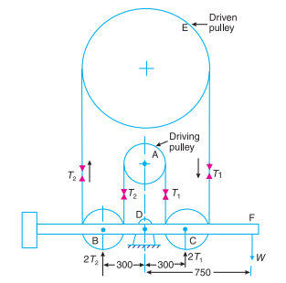
- A Porter governor has all four arms 250 mm long. The upper arms are attached on the axis of rotation and the lower arms are attached to the sleeve at a distance of 30 mm from the axis. The mass of each ball is 5 kg and the sleeve has a mass of 50 kg. The extreme radii of rotation are 150 mm and 200 mm. Determine the range of speed of the governor. CO4

- A shaft 1.5 m long, supported in flexible bearings at the ends carries two wheels each of 50 kg mass. One wheel is situated at the centre of the shaft and the other at a distance of 375 mm from the centre towards left. The shaft is hollow of external diameter 75 mm and internal diameter 40 mm. The density of the shaft material is 7700 kg/m3 and its modulus of elasticity is 200 GN/m2. Find the lowest whirling speed of the shaft, taking into account the mass of the shaft. CO5

SET-III
Answer any Two Questions 2x5=10M
Duration: 1hr
- The contact surfaces in a cone clutch have an effective diameter of 75 mm. The semi-angle of the cone is 150. The coefficient of friction is 0.3. Find the torque required to produce slipping of the clutch if an axial force applied is 180 N. This clutch is employed to connect an electric motor running uniformly at 1000 r.p.m. with a flywheel which is initially stationary. The flywheel has a mass of 13.5 kg and its radius of gyration is 150 mm. Calculate the time required for the flywheel to attain full speed and also the energy lost in the slipping of the clutch. CO3

- A simple band brake operates on a drum of 600 mm in diameter that is running at 200 r.p.m. The coefficient of friction is 0.25. The brake band has a contact of 270°, one end is fastened to a fixed pin and the other end to the brake arm 125 mm from the fixed pin. The straight brake arm is 750 mm long and placed perpendicular to the diameter that bisects the angle of contact. 1. What is the pull necessary on the end of the brake arm to stop the wheel if 35 kW is being absorbed? What is the direction for this minimum pull? 2. What width of steel band of 2.5 mm thick is required for this brake if the maximum tensile stress is not to exceed 50 N/mm²? CO3

- A shaft carries four masses A, B, C and D of magnitude 200 kg, 300 kg, 400 kg and 200 kg respectively and revolving at radii 80 mm, 70 mm, 60 mm and 80 mm in planes measured from A at 300 mm, 400 mm and 700 mm. The angles between the cranks measured anticlockwise are A to B 45°, B to C 70° and C to D 120°. The balancing masses are to be placed in planes X and Y. The distance between the planes A and X is 100 mm, between X and Y is 400 mm and between Y and D is 200 mm. If the balancing masses revolve at a radius of 100 mm, find their magnitudes and angular positions. CO4

- A Porter governor has equal arms each 250 mm long and pivoted on the axis of rotation. Each ball has a mass of 5 kg and the mass of the central load on the sleeve is 25 kg. The radius of rotation of the ball is 150 mm when the governor begins to lift and 200 mm when the governor is at maximum speed. Find the minimum and maximum speeds and range of speed of the governor. CO4

