**CMR ENGINEERING COLLEGE**

ENGINEERING CHEMISTRY

**I B.TECH**

**COURSE FILE**

**THE ACADEMIC YEAR 2017-18**

***Vision of the institute***

To be recognized as a premier institution in offering value based and futuristic quality technical education to meet the chnological needsof the society.

***Mission of the institute***

1.To impart value based quality technical education through innovative teaching and learning methods.

2.To continuously produce employable technical graduates with advanced technical skills to meet the current and future technological needs of the society.

3.To prepare the graduates for higher learning with emphasis on academic and industrial research.

**COURSE OUTCOMES :**

**CO1: Identify** different types of boiler troubles, choose appropriate method for softening and cleaning of water

**CO2:Explain** different types of conductance, electrode, electrode potential and determine EMF of a cell using Nerns’t equation.

**CO3: Compare** and contrast the chemical behavior and physical problems of polymers

**CO4 : Explain** different sources of energy and determine calorific value of fuel

**CO5: Explain** the setting and hardening of cement , clawsify different types of refractories , lubricants and composite materials

**CO6 : Distinguish** batteries, fuel cells which is used in different engineering field.

**PROGRAM OUTCOMES (POs):**

Engineering Graduates will be able to:

1.Engineering knowledge: Apply the knowledge of mathematics, science, engineering fundamentals, and an engineering specialization to the solution of complex engineering problems.

2. Problem analysis: Identify, formulate, review research literature, and analyze complex engineering problems reaching substantiated conclusions using first principles of mathematics, natural sciences, and engineering sciences.

3. Design/development of solutions: Design solutions for complex engineering problems and design system components or processes that meet the specified needs with appropriate consideration for the public health and safety, and the cultural, societal, and environmental considerations.

4. Conduct investigations of complex problems: Use researchbased knowledge and research methods including design of experiments, analysis and interpretation of data, and synthesis of the information to provide valid conclusions.

5. Modern tool usage: Create, select, and apply appropriate techniques, resources, and modern engineering and IT tools including prediction and modeling to complex engineering activities with an understanding of the limitations.

6. The engineer and society: Apply reasoning informed by the contextual knowledge to assess societal, health, safety, legal and cultural issues and the consequent responsibilities relevant to the professional engineering practice.

7. Environment and sustainability: Understand the impact of the professional engineering solutions in societal and environmental contexts, and demonstrate the knowledge of, and need for sustainable development

8. Ethics: Apply ethical principles and commit to professional ethics and responsibilities and norms of the engineering practice.

9. Individual and team work: Function effectively as an individual, and as a member or leader in diverse teams, and in multidisciplinary settings.

10. Communication: Communicate effectively on complex engineering activities with the engineering community and with society at large, such as, being able to comprehend and write effective reports and design documentation, make effective presentations, and give and receive clear instructions.

11. Project management and finance: Demonstrate knowledge and understanding of the engineering and management principles and apply these to one’s own work, as a member and leader in a team, to manage projects and in multidisciplinary environments.

12. Lifelong learning: Recognize the need for, and have the preparation and ability to engage in independent and lifelong learning in the broadest context of technological change.

**SESSION /LECTURE PLAN**

|  |  |  |  |  |  |
| --- | --- | --- | --- | --- | --- |
| **S.NO** | **Topic**  **(JNTU Syllabus)** | **Sub – Topic** | **No. of Lectures Required** | **Suggested Books** | **Remarks** |
| **1.** | **UNIT I**  WATER AND ITS TREATMENT | : Introduction –– types of hardness temporary and permanent hardness |  |  |  |
|  |  | hardness of water – causes of hardness | L1 | T1, T2, R3, R4 |  |
|  |  | expression and units of hardness | L2, L3 | T1, T2 |  |
|  |  | estimation of hardness by complexometric method | L4, L5 | T1,T2 |  |
|  |  | treatment of potable water: steps involved in the treatment of potable water | L6 | T1, T2 |  |
|  |  | defluoridation – nalgonda technique – determination of F- ion by ion selective method | L7, L8 | T1,T2, |  |
|  | **BOILER TROUBLES** | : Sludge , scales and caustic embrittlement | L9 | T1,T2 |  |
|  |  | Internal treatment of boiler feed water – calgon conditioning – phosphate conditioning- colloidal conditioning | L10, L11 | T1,T2 |  |
|  |  | softening of water by ion exchanger method | L12 | T1, T2, R1, R3, R4 |  |
|  |  | Desalination of water – reverse osmosis numerical problems | L13, L14 | T1, T2, R3 |  |
|  |  | sewage water steps involved in treatment of sewage. | L15 | T1 |  |
| **2** | **UNIT –II ELECTRO CHEMISTRY AND BATTERIES**: | : Electrochemistry : electrode – electrode potential , standard electrode potential | L16, L17 | T1, T2 |  |
|  |  | types of electrodes – construction and functioning of standard hydrogen electrode | L18 | T1, T2,R2. R1,R3.R4 |  |
|  |  | calomel and glass electrode | L19 | T1, T2 |  |
|  |  | Nernst equation – electrochemical series and its applications | L20, L21 | T1, T2 |  |
|  |  | electrochemical cells, Daniel cell – cell notation cell reaction and cell EMF | L22 | T1, T2, R1,R3.R4 |  |
|  |  | concept of concentration cells – electrolyte concentration cell numerical problems | L23 | T1, T2, |  |
|  | **BATTERIES:** | – primary battery (dry cell, alkaline cell and lithium cell) | L24 | T1, T2, |  |
|  |  | secondary battery (lead acid , ni – cd lithium ion cell). | L25 | T1, T2,R5 |  |
|  | **FUEL CELL** | hydrogen – oxygen | L26 | T1, T2, R5 |  |
|  |  | methanol – oxygen fuel cell – applications | L27 | R5 |  |
| **3.** | **UNIT III** | INTRODUCTION | L28 | T1, T2 |  |
|  | **POLYMERS** | definition – classification of polymers with examples | L29 | T1, T2 |  |
|  |  | types of polymerization – addition( free radical addition ) and condensation polymerization with examples. | L30 | T1, T2,R3,R4 |  |
|  | **PLASTICS** | definition and characteristics – thermo plastics and thermosetting plastics | L31, L32 | T1,T2,R3 |  |
|  |  | compounding and fabrication of plastics (compression and injection molding) | L33, L34 | T1, T2 |  |
|  |  | Preparation, properties and engineering applications of PVC and Bakelite. | L35 | T1, T2,R4 |  |
|  | **FIBERS** | Characteristics of fibers-preparation, properties and applications of nylon-6, 6 and Dacron | L36, L37 | T1, T2 |  |
|  |  | Fiber reinforced plastics (FRP) – applications | L38, L39 | T2 |  |
|  | **Rubbers** | natural rubber and its applications vulcanization – compounding of rubber | L40 | T1,T2 |  |
|  | **elastomers** – | characteristics – preparation – properties and application of Buna –S , Butyl and Thiokol rubber |  | T1,T2 |  |
|  | **Conducting polymers** | characteristics and classification with examples – mechanism of conduction in Trans – poly acetylene and applications of conducting polymers | L41 | T1,T2,R3.R4 |  |
|  | **Bio degradable polymers** | –– concept and advantages – poly acetic acid and poly vinyl alcohol and their applications. | L42, L43 |  | separate notes will be provided |
| **4.** | **UNIT IV** | **FUELS AND COMBUSTION** Classification – solid fuels: coal | L44 | T1, T2, R3,R4 |  |
|  |  | analysis of coal – proximate and ultimate analysis and their significance | L45 | T1,T2 |  |
|  |  | liquid fuels – petroleum and its refining , cracking – types – moving bed catalytic cracking | L46 | T1,T2 |  |
|  |  | knocking – octane and cetane rating, synthetic petrol – Fischer – Tropsch’s process | L47 | T1,T2 |  |
|  |  | gaseous fuels – composition and uses of natural gas , LPG and CNG. | L48 | T1,T2 |  |
|  | **COMBUSTION** | Definition, calorific value of fuel – HCV, LCV; | L49 | T1,T2 |  |
|  |  | calculation of air quantity required for combustion of a fuel |  |  |  |
| **5.** | **UNIT V**  Cement : | Portland cement , its composition , setting and hardening of Portland cement . | L50 | T1,T2,R3 |  |
|  | Refractors: | Refractors: | L51 | T1,T2,R4 |  |
|  | Lubricants | classification of lubricants, with examples – characteristics of a good lubricant – mechanism of lubrication ( thick film , thin film , and extreme pressure | L52 | T1,T2 |  |
|  |  | properties of lubricants : viscosity, cloud point , pourt point , flash point and fire point | L53 | T1,T2 |  |
|  | COMPOSITES | introduction – constituents ,advantages , | L54 |  | separate notes will be provided |
|  |  | classification and applications of composites | L55 |  | separate notes will be provided |

SUGGESTED BOOKS :

T1:engineering chemistry by p.c. Jain and Monica Jain , Dhanpatrai publishing . company

T2: chemistry of engineering materials by R.P.Mani and K.N Mishra , Cengage Learning .

REFERENCE BOOKS

R1: chemistry in Engineering Technology by Kuriase and Rajaram.tataMc Graw Hill Education Pvt LTD R2: R2:A Text Book of Engineering Chemistry by Dr.S.S. Dara and DR. K. mukkanti , S. Chand and company Ltd. 2010

R3 : A Text Book of Engineering Chemistry by Y.Bharathi Kumari , Jyotsna Cherukuri , VGS Publications

R4: : A Text Book of Engineering Chemistry by C. Parameshwara Murthy and Andra Naidu BS Publications

R5: Chemistry in Engineering and Technology By J.C.Kuriacose , J. Rajaram

NOTE: 1. Any subject in a semester is supplied to be completed in 120 – 125 periods

2. each period is 50 minutes

3. each unit duration and completion should be mentioned in the remarks column

4. list of suggested books are marked with codes like T1,T2,R1,R2 etc.

***ENGINEERING CHEMISTRY SYLLABUS( R16 )***

**UNIT –I**

WATER AND ITS TREATMENT : Introduction – hardness of water – causes of hardness – types of hardness temporary and permanent hardness – expression and units of hardness – estimation of hardness by complexometric method . numerical problems potable water and its specifications – steps involved in the treatment of potable watyer – disinfection of potable water by chlorination and ozonization, defluoridation – nalgonda technique – determination of F- ion by ion selective method

**BOILER TROUBLES**: Sludge , scales and caustic embrittlement . Internal treatment of boiler feed water – calgon conditioning – phosphate conditioning- colloidal conditioning softening of water by ion exchanger method. Desalination of water – reverse osmosis numerical problems sewage water steps involved in treatment of sewage.

**UNIT –II**

**ELECTROCHEMISTRY AND BATTERIES**: Electrochemistry : electrode – electrode potential , standard electrode potential, types of electrodes – construction and functioning of standard hydrogen electrode , calomel and glass electrode Nernst equation – electrochemical series and its applications . ELECTROCHEMICAL CELLS, Daniel cell – cell notation cell reaction and cell EMF – concept of concentration cells – electrolyte concentration cell numerical problems.

**BATTERIES:** cell and battery – primary battery (dry cell, alkaline cell and lithium cell) AND SECONDARY BATTERY (LEAD ACID , Ni – Cd lithium ion cell).

**FUEL CELL**: hydrogen – oxygen and methanol – oxygen fuel cell – applications

**UNIT III**

**POLYMERS:** definition – classification of polymers with examples – types of polymerization – addition( free radical addition ) and condensation polymerization with examples.

**PLASTICS** – definition and characteristics – thermo plastics and thermosetting plastics, compounding and fabrication of plastics (compression and injection molding). Preparation, properties and engineering applications of PVC and Bakelite.

**FIBERS:** Characteristics of fibers-preparation, properties and applications of nylon-6, 6 and Dacron. Fiber reinforced plastics (FRP) – applications

**Rubbers** – natural rubber and its applications vulcanization – compounding of rubber

**elastomers** – characteristics – preparation – properties and application of Buna –S , Butyl and Thiokol rubber

**Conducting polymers** – characteristics and classification with examples – mechanism of conduction in Trans – poly acetylene and applications of conducting polymers

Bio degradable polymers – concept and advantages – poly acetic acid and poly vinyl alcohol and their applications.

**UNIT IV**

**FUELS AND COMBUSTION**

Classification – solid fuels: coal – analysis of coal – proximate and ultimate analysis and their significance liquid fuels – petroleum and its refining , cracking – types – moving bed catalytic cracking , knocking – octane and cetane rating , synthetic petrol – Fischer – Tropsch’s process ; gaseous fuels – composition and uses of natural gas , LPG and CNG.

**COMBUSTION**

Definition, calorific value of fuel – HCV, LCV; calculation of air quantity required for combustion of a fuel.

**UNIT V**

Cement , refractory , lubricants and composites :

**Cement :** Portland cement , its composition , setting and hardening of Portland cement .

Special cement ; white cement , water proof cement , high alumina cement and acid proof cement

**Refractors:** classification, characteristics of a good refractory , refractoriness , refractoriness under load , porosity and chemical inertness – applications of refractoriness

**Lubricants** – classification of lubricants, with examples – characteristics of a good lubricant – mechanism of lubrication ( thick film , thin film , and extreme pressure ) – properties of lubricants : viscosity, cloud point , pourt point , flash point and fire point .

**Composites** : introduction – constituents of composites – advantages , classification and constituents of composites , applications of composites

**Q**

**UNIT I**

**I. WATER AND ITS TREATMENT**

**Introduction :**

Water is a natural gift on the earth is essential for human animal and plants. Human being use water for drinking, cooking bathing, cleaning and washing. It has a wide role in industries also. Without food, human can survive for a number of days, but water is such an essential that without it one cannot survive.

It has a wide role in industries also. Probably, its most important use as an engineering material is in the 2“steam generation’

Chemically, water has two atoms of hydrogen and one atom of oxygen having the molecular formula H2O. In several chemical reactions, water is formed along with the main product, e.g. acid reacts with base to give salt and water. Alcohols and organic acids react to give ester and H2O

Water molecule is a bent triatomic molecule with the bond angle 104.50 the oxygen atom present in the water molecule has sp3 – hybridsation, state having two bond pairs and two lone pairs.

104. 50

H H

Water is found in three physical states, liquid (water), solid (ice) and gas (vapour). The freezing point of water is 00C and the boiling point is 1000C. Several special behaviours found in water is due to the hydrogen bond present in it.

In nature water is present in abundance. About 96% of water forms the oceans, 2.2% forms the ice and snow, 1.2% forms the groundwater and the rest forms the surface water and the water present in the atmosphere. The various sources of water are rivers, tanks, reservoirs, seas, oceans, wells, tube wells, rain glaciers, etc.

**Hardness of water**

Hardness of water is that characteristic, which “prevents the lathering of soap” This is due to presence of Ca and Mg salts in water. Water passes through rocks and flows on the ground. The calcium and magnesium salts that are present in the rocks are dissolved in water and make it hard.

A sample of hard water, when treated with soap (sodium stearate) doesn’t produce lather, but forms a white scum or precipitate. This precipitate is formed, due to the formation insoluble soaps of calcium and magnesium. Typical reactions of soap (sodium stearate) with calcium chloride and magnesium sulphate are depicted as follows:

2 C17 H35 COONa + CaCl2 (C17H35COO) 2 Ca ↓ + 2NaCl

Sodium stearate (Hardness) Calcium stearate

(Soap) (Insoluble)

2 C17 H35 COONa + MgSO4  (C17H35COO) 2 Mg ↓ + Na2SO4

Sodium stearate Magnesium stearate

(Soap) (Insoluble)

Thus, water which does not produce lather with soap solution readily, but forms white precipitate, is called ‘hard water’. On the other hand water which lathers easily on shaking with soap solution, is called soft water. Such a water, consequently, does not contain dissolved calcium and magnesium salts in it.

**Cause of Hardness of Water:**

Water contains mineral salts (as Ca & Mg ions) that limit the formation of lather with soap called hard water. Such water contains metal ions (Ca & Mg Ions) which instead of lather form precipitate with soap.

The rain water dissolves sulphates, chlorides and carbonates of calcium and magnesium present in many rocks. These salts convert the carbonates of Ca and Mg into bicarbonates. These bicarbonates being soluble in water cause hardness.

**Types of Hardness:** Hardness of water is of two types

A).Temporary hardness (carbonate hardness)

B).permanent hardness (non – carbonate hardness)

**(a) Temporary hardness (carbonate hardness) The** hardness that can be removed simply by boiling is called the temporary hardness. It is due to the presence of dissolved bicarbonates, Temporary hardness is mostly destroyed by boiling of water, when bicarbonates are decomposed, yielding insoluble carbonates or hydroxides, which are deposited as a crust at the bottom of the vessel, Thus,

Ca (HCO3)2 boiling CaCO3  + H2O +CO2

Calcium Bicarbonate calcium carbonate (Insoluble)

Mg (HCO3)2 boiling Mg (OH) 2  + 2CO2

Magnisium Bicarbonate MagnisiumHydroxide (Insoluble)

**B) Permanent (or) Non – carbonate hardness:**

Permanent hardness cannot be removed by boiling. It is due to the presence of chlorides and sulphates of calcium, magnesium ions and other heavy metals. These salts cannot be removed by boiling. They are removed by different other methods.

**Measurement of Hardness:**

To estimate hardness, it is essential to know the various units to measure it. Hardness of water is measured in terms of CaCO3 because it is highly insoluble in water and also its molecular weight is 100 that make the calculation easier.

**Units of Hardness:**

**(i) Parts per million (ppm)**

It is the number of parts of equivalent CaCO3 per 106 part of water i.e.

1ppm = 1part of CaCO3 equivalent hardness present in 106 parts of water.

**(2) Milligrams per litre (Mg/L)**

It is the number of Milligrams of equivalent CaCO3 present per litre of water.

1mg / *l* = 1 mg of CaCO3 eq. hardness per liter of hard water.

But 1kg of water weighs =1kg = 1,000  1000mg = 106mg

1mg / *l* = 1mg of CaCO3 eq per 106 mg of water.

= 1 part of CaCO3 eq per 106 parts of water = 1ppm

**(3) Degree Clarke (OCl)** It is the number of grains of equivalent CaCO3 per gallon of water (or) it is parts of CaCO3 per gallon of water. (or) it is parts of CaCO3 equivalent hardness per 70,000 parts of water. Thus,

10 clarke (10Cl) = 1 grain of CaCO3 eq hardness per gallon of water or

10Cl = 1 part of CaCO3 equivalent hardness per 70,000 parts of water.

**(4) Degree French (0Fr):** It is the number of parts of CaCO3 per 105 parts of hard water thus,

10Fr = 1 part of equivalent CaCO3 per 105 parts of hard water

**(5) Equivalent per Million: EPM [mill equivalent per litre(meq/*l*)]** One Milligram equivalent of CaCO3 per liter of hard water is called equivalent per million (or)

Mill equivalent per litre is the number of milli equivalents of hardness present per liter Thus,

1Meq/L = 1 Meq of CaCO3 per Liter of water = 10-3  50g of CaCO3 eq per liter

= 50 mg of CaCO3 eq per litre

= 50 mg / *l* of CaCO3 eq

1mg = 50 ppm

(Or) 1 epm = 50 ppm of CaCO3

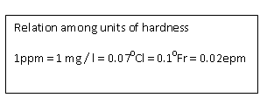

**EFFECTS OF HARDNESS**

1. Hard water is harmful for drinking due to the presence of Ca2+ ions.
2. Hard water used in boilers forms scales and sludge and results in corrosion, priming, and caustic embrittlement of the boiled containers.
3. Hard water does not give lather with soap, so it sticks in clothes and body.
4. Hardness in water causes blockage in holes.
5. Hard water is not suitable for laboratory analysis, because hardness produces ions interferes (disturbs) in various reactions.

Any water sample with hardness less than 150ppm is good and portable while beyond 350ppm is not suitable for consumption

**ESTIMATION OF HARDNESS OF WATER:-** The estimation of hardness of water is very essential for its use in boilers for steam generation as well as for industries uses. Hardness of water sample is determined by two different methods.

**(A). Soap Titration Method: (Soap Solution Method)** Hardness of water is determined by this method without using any indicators. Soluble soaps consists of sodium or potassium salts of higher fatty acids, such as oleic acid, stearic acid and palmitic acid. These soaps give lather with hard water only after sufficient quantity of the soap is added to precipitate all the hardness causing metal ions present in it in the form of their respective insoluble soaps.

2 C17 H35 COONa + CaCl2 (or) MgCl2  (C17H35COO) 2 Ca ↓ (or) Mg + 2NaCl

Sodium stearate (Hardness) Calcium (or) magnesium

(Soap) stearate (Insoluble)

2 C17 H35 COONa + Ca (HCO3)2 (C17H3ZCOO) 2Mg↓ (or) Ca+ 2 NaHCO3

Sodium stearate (or) Mg (HCO3)2 calcium (or) Magnesium stearate

(Soap) (Insoluble)

Thus, after all the hardness causing metal ions present in hard water sample are precipitated, the further addition of soap gives lather.

The total hardness of a water sample can be determined by titrating a measured quantity of the sample against a standard soap solution. The appearance of stable lather persisting even after shaking for about 2 minutes marks end – point.

If the water sample is boiled for 20 minutes to remove the temporary hardness and then is titrated with the standard soap solution as described above, the titre value corresponds to the permanent hardness of the sample. The difference between the two measurements corresponds to the temporary hardness. Hence,

Temporary hardness = total hardness – permanent hardness

**(B) EDTA Method**

This method gives more accurate results than soap titration method

HOOC – H2C CH2 - COOH

N – CH2 – CH2 – N

HOOC –H2C CH2 - COOH

Structure of EDTA

Ethylene diamine tetra acetic acid (EDTA) forms complexes with Ca2+ and Mg2+ as well as with many other metal cations, in aqueous solution. These complexes have the general formula given below

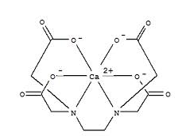

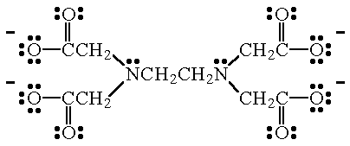

Thus in a hard water sample, the total hardness can be determined by titrating the Ca2+ and Mg2+ present in an adiquot of the sample with EDTA solution, using NH4Cl – NH4OH buffer solution of pH =10

and Eriochrome black – T as the metal indicator. At the end point the colour changes from wine red to blue colour.

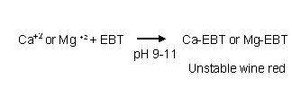

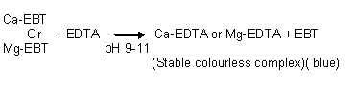

Permanent hardness can be determined by precipitating the temporary hardness by prolonged boiling for about 30 minutes followed by titration with the EDTA solution as above. The difference in the titre values corresponds to the temporary hardness of the water sample.hence

Hence, temporary hardness = total hardness - permanent hardness.

**Numerical Problems**

Although hardness of water is never present in the form of CaCO3 because it is insoluble in water, hardness of water is conveniently expressed in terms of equivalent amount of CaCO3

The reason for choosing CaCO3 as the standard for reporting – hardness of water is the case in calculations as its molecular weight is exactly 100. Morever it is the most insoluble salt that can be

precipitated in water treatment.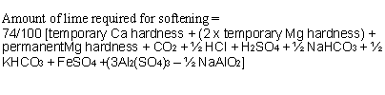

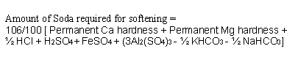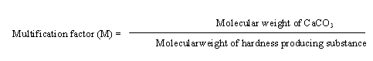

|  |  |  |  |  |
| --- | --- | --- | --- | --- |
| **Sl.No** | **Hard Salt** | **M.Wt** | **Equivalent Weight** | **Multification Factor (M)** |
| 1 | Ca(HCO3)2 | 162 | 81 | 100/162 |
| 2 | Mg(HCO3)2 | 146 | 73 | 100/146 |
| 3 | CaSO4 | 136 | 68 | 100/136 |
| 4 | CaCl2 | 111 | 55.5 | 100/111 |
| 5 | MgSO4 | 120 | 60 | 100/120 |
| 6 | Mg Cl2 | 95 | 47.5 | 100/95 |
| 7 | CaCO3 | 100 | 50 | 100/100 |
| 8 | MgCO3 | 84 | 42 | 100/84 |
| 9 | Mg ((NO3)2 | 148 | 74 | 100/148 |

**1. A water sample contains 408mg of CaSO4 per litre. Calculate the hardness in terms of CaCO3 equivalents.**

Solution: Hardness = [Mass of hardness producing substance]  M

Hardness = [ Mass of CaSO4 in mg/ *l* ]  M

Hardness = 408  100/136

Hardness = 300 mg/ *l* (or) 300 ppm

**2. A sample of water analysis was found to contain the following impurities.**

Impurity Ca (HCO3)2 Mg (HCO3)2 CaSO4 MgSO4

M.Wt 162 146 136 120

Quantity(amount) 4 6 8 10

Calculate the temporary, permanent and total hardness of water in ppm, 0Cl and 0Fr

Solution:

|  |  |  |  |
| --- | --- | --- | --- |
| **Constituent** | **Amount (A)  mg/*l*** | **Multification**  **Factor(M)** | **CaCO3 Equivalent**  **= [A]**  **[M]** |
| Ca(HCO3)2 | 4 | 100/162 | 4 x 100/162 = 2.47 mg / *l* |
| Mg(HCO3)2 | 6 | 100/146 | 6 x 100/146 = 4.11 mg/ *l* |
| CaSO4 | 8 | 100/136 | 8 x 100/136 = 5.88 mg / *l* |
| MgSO4 | 10 | 100/120 | 10/100/120 = 8.33 mg / *l* |

**Step : II – Determination of temporary hardness**As temporary hardness is due to bicarbonates of Ca and Mg therefore temporary hardness.

Temporary hardness = 2.47 + 4.11 = 6.58 mg / *l*

Hence, Temporary hardness = 658 mg / *l* = 6.58 ppm

= 6.58  0.07 = 0.460Cl

= 6.58  0.1 = 0.6580Fr

**Step – III: Determination of permanent hardness**

As permanent hardness in this case is due to CaSO4 and MgSO4

Permanent Hardness = 5.88 + 8.33 = 14.21 mg/*l*

= 14.21 ppm

= 14.21  0.07 = 0.9950Cl

= 14.21  0.1 = 1.4210Fr

**Total Hardness = Temp Hardness + Permanent Hardness**

= 6.58 + 14.21

= 20.79 mg/*l* (or) ppm

= 20.79  0.07 = 1.45530Cl

**Total Hardness** = 20.79  0.1 = 2.0790Fr

**(3) Calculate the carbonate hardness and non carbonate hardness of a sample of water containing the dissolved salts in one litre of hard water as given below also calculate the total hardness/**

Ca (HCO3)2 = 32.4mg; CaSO4 = 13.6mg; MgCl2 = 19.00mg; Mg(HCO3)2 = 14.6mg

Solution :

|  |  |  |  |
| --- | --- | --- | --- |
| **Hardness Producing Salts** | **Amount** | **Mortification Factor** | **Equivalent of CaCo3 - hardness** |
| Ca(HCO3)2 | 32.4mg | 100/162 | 32.4 100/162 = 20mg/*l* |
| CaSO4 | 13.6mg | 100/136 | 13.6 100/136 = 10mg/ *l* |
| MgCl2 | 19.0mg | 100/95 | 19.0  100/95 = 20mg/ *l* |
| Mg(HCO3)2 | 14.6mg | 100/146 | 14.6  100/146 = 10mg/ *l* |

Carbonate hardness due to Ca (HCO3) 2 and Mg (HCO3)2

= 20 + 10 + 30 mg / *l* (or) ppm

Non carbonate hardness (permanent hardness) due to CaSO4 & MgCl2

= 10+20 = 30 mg/ *l* (or) ppm

Total Hardness = 30 + 30 = 60 mg / *l* (or) ppm

(4) 100ml of water has a hardness equivalent of 12.5ml of 0.08N MgSO4. Calculate the hardness 0Fr?

**Solution:**

12.5 ml of 0.08N MgSO4 = 12.5 ml of 0.08N CaCO3

= 12.5 ml of (0.08  50 g /*l*)

= 12.5  0.08  50 / 1000 g CaCO3

= 50 /1000 g = 50  1000 / 1000 mg

This amount is in 100ml of water sample. So per litre, it will be

50 x 10 = 500mg/ *l* = 500 ppm

Total hardness = 500 ppm

= 500  0.1

= 500Fr ( 1 ppm = 0.1 0Fr)

**Potable Water (Drinking water) :**

Drinking water should be clear, odorless, cool & pleasant in taste. Its turbidity should not

Exceed 10 ppm and should be free from dissolved gases like H2S and also from minerals like Pb, As, Cr, Mn salts its Ph should be about 8.0 and it should be free from disease producing microorganisms.

**Purification**

The following treatment process are employed for purification of dinking H2O

Removal of Suspended Impurities

**i)Screening:**

The raw H2O is passed through screens having large no. of holes, where floating

Matters are retained.

ii) **Aeration:** the water is then passed through aerated which helps in exchange of gasses between water and air **,** thereby increase of oxygen content in water takes place and also impurities like Fe and Mn are also eliminated.

**iii) Sedimentation** Sedimentation is the process of allowing water to stand undisturbed in big Tanks, about 5m deep, when most of suspended particles settle down at the Bottom, due to the force of gravity. The top clear H2O is drawn out with pumps. The retention period in sedimentation tank ranges from 2-6 hrs. When H2O contains fine clay particles & colloidal matter, it is necessary to apply

**iv)Sedimentation with coagulation:**. Sedimentation with coagulation is the process of removing fine suspended & colloidal impurities by addition of chemicals to water before sedimentation. Coagulant forms an insoluble gelatinous, flocculent precipitate which adsorbs and entangles vey fine suspended impurities forming bigger flocs which settle down easily.

**v) Filtration :-** filtration helps in removal of the colloidal and suspended impurities which is not removed by sedimentation**.**

Filtration is carried out by sand filter. A sand filter consists of thick top layer of fine sand placed over coarse sand layer & gravels. It is provided with inlet for H2O and can under drain channel at bottom for exit of filtered water. Sedimented H2O entering the sand filter is distributed over fine sand bed. During filtration, the sand pores get clogged due to retention of impurities in pores. When the rate of filtration is slow, the working of filter is stopped & the top sand layer is scrapped off and replaced by sand.

**vi)** Disinfection **and sterilization :-** after the process of sedimentation, coagulation and filtration watrer still has some amount of pathogenic bacteria consequently, drinking water should be free from these disease producing bacteria.

The process of destroying the disease producing bacteria from H2O is called Disinfection and the chemicals which are used for killing bacteria are known as disinfectants.

The disinfection of water can be carried out by following methods.

* **BOILING:-** by boiling water for 15 – 20 minutes harmful bacteria are killed.
* **PASSING OZONE; -** when ozone is passed into the water , it produces nascent oxygen which is a powerful disinfectant.

**O**3  **O2 + [O]**

**Nascent Oxygen**

**CHLORINATION**:- chlorination reagents are 3 types

**\*By passing chloramines**: - chlorine is mixed with ammonia in the ratio 2:1 by volume to form a stable chloramine which produ ce hypochlorous acid, a powerful disinfectant.

Cl2 + NH3 NH2Cl + HCl

NH2Cl + H2O               HOCl + NH3

Hypo chlorous acid inactivates the enzymes of bacteria and kills bacteria

\***By bleaching powder: -** it contains 80% chlorine, when bleaching powder is used as disinfectant it is called hypo chlorination

CaOCl2 + H2O Ca (OH) 2 + Cl2

Cl2 + H2O HOCl + HCl

\***Chlorination: -** the process of applying calculated amount of Chlorine to water in order to kill the pathogenic bacteria is called Chlorination

When chlorine gas enters the water, the following reaction occurs:

Chlorine + Water Hypochlorous Acid + Hydrochloride

Cl2 + H2O HOCl + HCl

Hypochlorous acid is a powerful germicide which kills bacteria.

**Break point chlorination** The graph below shows what happens when chlorine (either chlorine gas or a hypochlorite) is added to water.  First (between points 1 and 2), the water reacts with reducing compounds in the water, such as hydrogen sulfide.  These compounds use up the chlorine, producing no chlorine residual.

Next, between points 2 and 3, the chlorine reacts with organics and ammonia naturally found in the water.  Some combined chlorine residual is formed - chloramines.  Note that if chloramines were to be used as the disinfecting agent, more ammonia would be added to the water to react with the chlorine.  The process would be stopped at point 3.  Using chloramine as the disinfecting agent results in little trihalomethane production but causes taste and odor problems since chloramines typically give a "swimming pool" odor to water.

In contrast, if hypochlorous acid is to be used as the chlorine residual, then chlorine *will* be added past point 3.  Between points 3 and 4, the chlorine will break down most of the chloramines in the water, actually lowering the chlorine residual.

Finally, the water reaches the breakpoint, shown at point 4.  “The **breakpoint** is the point at which the chlorine demand has been totally satisfied - the chlorine has reacted with all reducing agents, organics, and ammonia in the water”.  When more chlorine is added past the breakpoint, the chlorine reacts with water and forms hypochlorous acid in direct proportion to the amount of chlorine added.  This process, known as **breakpoint chlorination**, is the most common form of chlorination, in which enough chlorine is added to the water to bring it past the breakpoint and to create some free chlorine residual.

**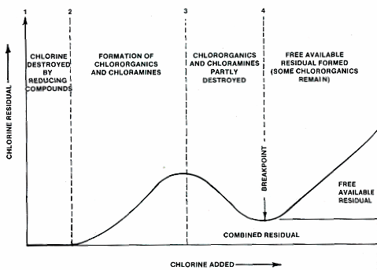**

**Advantages of breakpoint chlorination**

* It removes bad taste , color, oxides completely organic compounds , ammonia and other reducing impurities.
* It destroys completely ( 100% ) all disease producing bacteria.
* It removes growth of any weeds in water.

**DECHLORINATION**:-Over chlorination after break point produces unpleasant taste, odour, toxicity to water. It is removed by passing the water through a bed of granular carbon and also by the addition of SO2 and sodium thio sulphite

SO2 + Cl2 H2SO4  + 2HCl

Na2SO3+Cl2+H2O Na2SO4 + 2HCl

**DEFLUORIDATION** Defluoridation is the removal of excess fluoride from water. The National Environment Engineering Research Institute in Nagpur, India has evolved an economical and simple method of defluoridation, which is referred to as the Nalgonda technique.The Nalgonda technique has been repeatedly proven to be an economical and effective household defluoridation technique. In this commonly used technique, fluoride is precipitated using 500 mg/L of alum and 30 mg/L of lime

*Water samples*Tap water (1 lit) samples were collected in plastic cans from 20 different villages in the Nalgonda district. This water originated from different bore wells that were collected in a common tank in the village. In some locations, the source of the drinking water was identical to the tap water pumped from bore wells. In other villages, separate wells were provided for drinking water; these drinking water samples were also analyzed.  
  
*Methods of defluoridation*Initially, varying concentrations of alum and lime were added to untreated water to find the combination that would decrease fluoride levels to a maximum extent. After the addition of lime and alum, water samples were allowed to stand for 30 minutes, 60 minutes, and 120 minutes to determine the shortest time for maximum flocculation . The weight of the sediment formed after 1 hour from 250 ml of water is also given in . Values are an average of results obtained from 5 water samples.*Analysis of water samples*Fluoride was analyzed using ion selective electrodes from Merck. Calcium levels in the water were analyzed by the ortho-cresolpthalein complexone method. Magnesium was estimated by using the Magnon Complex method[[7]](http://www.atmph.org/article.asp?issn=1755-6783;year=2008;volume=1;issue=2;spage=56;epage=58;aulast=Suneetha" \l "ref7) and sodium and potassium were estimated using the flame photometer. Chloride levels were measured by the Mercuric Thiocyanate method. Iron was estimated using the Ferrozine method.[]](http://www.atmph.org/article.asp?issn=1755-6783;year=2008;volume=1;issue=2;spage=56;epage=58;aulast=Suneetha" \l "ref10) . Statistical analysis was done using Microsoft Excel® (MS office, Windows 2000).

**Determination of Fluoride Ion Using an Ion Selective Electrode**

INTRODUCTION

In recent years direct potentiometry has become important as an analytical technique largely because of the development of ion-selective electrodes (ISE). This type of electrode incorporates a special ion-sensitive membrane which may be glass, a crystalline inorganic material or an organic ion-exchanger. The membrane interacts specifically with the ion ofchoice, in our case fluoride, allowing the electrical potential of the half cell to be controlled predominantly by the F- concentration.

The potential of the ISE is measured against a suitable reference electrode using an electrometer or pH meter. The electrode potential is related to the logarithm of the concentration of the

measured ion by the Nernst equation. where n is the ion charge (negative for anions). The factor 2.303 RT/F has a theoretical value of 59 mV at 25 °C. The equation is only valid for very

dilute solutions or for solutions where the ionic strength is constant.

Ionic strength is defined by

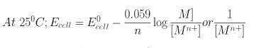

where n is the ion charge (negative for anions). The factor 2.303 RT/F as a theoretical value of 59 mV at 25 °C. The equation is only valid for verydilute solutions or for solutions where the ionic strength is constant. Ionic strength is defined by

I = 12ΣZi2Ci

where Zi is the charge on an ion and Ciis its concentration. ISEs are available for measuring more than 20 different cations (e.g., Ag+, Na+, K, Ca++, Cu++) and anions (e.g., F-, Cl-, S-2, CN-). In this experiment you will use a fluoride sensitive electrode and either a saturated calomel electrode (SCE) or Ag/AgCl external reference electrode to measure the luoride-ion content of a solution. Fluoride is added to drinking water and toothpaste to inhibit dental caries; it is also present in effluents from any ndustrial processes, e.g., manufacture of fluoro-polymers. Flouride ISEs nly respond to free ionized F- in solution and can thusbe used to measure his ion in the presence of other fluorine compounds, e.g., AlF63-organofluorine compounds. In other words, the electrode responds to F-activity.

REAGENTS AND EQUIPMENT

•NaF, dried at 100 °C for 1 hour.

•Liquid NaF unknown.

•KCl (7.55 g)

•Fluoride ISE and Ag/AgCl or SCE reference electrode.

•Multimeter or pH meter capable of displaying mV potentials

Truman State University CHEM 222 Lab Manual Revised

PROCEDURE

Preparation of Standards

1.Dry the NaF solid for 1 hour at 100 °C.

2.Accurately weigh out about 0.42 g of NaF, dissolve in deionized water, ilute to 100 mL in a volumetric flask and mix well. This solution is about 10-1F in NaF.

3.Transfer 10.00 mL of the solution prepared in (2) to a 100 mL volumetric flask using a pipet, dilute to volume with deionized water and mix well. This solution is about 10-2F in NaF.

4.Weigh out 7.55 g of KCl on a top-loading balance and dissolve in 100 mL of deionized water. This solution is 1 F in KCl.

5.Prepare standard solutions in four 100 mL volumetric flasks as follows:

mL 10-2F NaF (from 3) mL 1 F KCl (I) 1.00 10.00 (II) 2.00 10.00 (III) 5.00 10.00 (IV) 10.00 10.00 Dilute each flask to volume withdeionized water and mix wellAnalysis of Unknown Your unknown for this experiment is a solution. when you obtain your unknown, you need to quantitatively transfer it to a 100 mL volumetric flaskand dilute it to the mark, resulting in the prepared" unknown solution.

You are to report the results of this "prepared" unknown.

1.Add 1 mL of your prepared unknown, then 10 mLof KCl to a 100 mL volumetric flask. Dilute to the 100 mL markwith deionized water.

2.Measure the potential in mV of the fluoride ISE vs the reference lectrode for each of the four standards and unknowns

3.Pour about 30 mL of each standard or unknown solution into a clean, dry 100 mL beaker and immerse the electrodes in the solution to a depth of not more than 2 cm, as shown in Figure 1. Measure the electrode potential, taking care to note both the sign and the magnitude of the potential.

4.When you finish, rinse the electrodes with deionized water. Leave the reference electrode in the appropriate storage solution. The FISE should be stored dry and loosely capped.

DO NOT force the cap onto the electrode tip!

**TREATMENT OF RESULTS**

1.Accurately calculate the molarity of NaF for each of the standard solutions.

2.Plot a graph of the logarithm of [NaF] in the standard solutions vs E. Determine the best line through the four standard solution experimental points. Calculate the slope of the calibration curve, and its associated uncertainty. How nearly does it equal the theoretical slope, -59 mV?

(Slope = dE/ dlog[NaF]).

3.Utilizing the calibration curve, determine the concentration of NaF in your “prepared” unknown solution. Report this as percent fluoride (% w/v) in the “prepared” unknown.

Report the 95% confidence interval for your results.

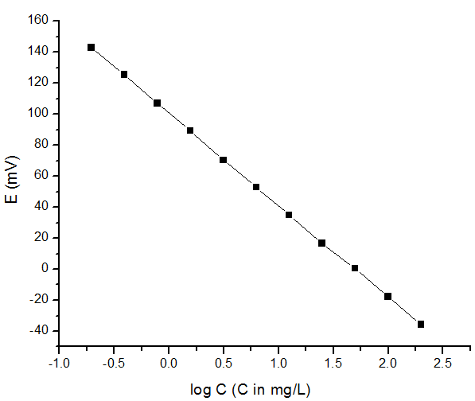

**BOILER TROUBLES**

Boiler troubles are mainly caused by the impurities present in the boiler feed water. The total removal of salts in boiler feed water is not made use of the scales produced in the boilers can act as insulators of heat. As a result of it more heat has to be supplied from outside of the boilers. The major boiler troubles are

1. Scales and sludge formation
2. Caustic embrittlement

(1) **Scales and sludge formation**

When water is evaporated in boilers to produce steam continuously the concentration of the salts present in the water increases progressively. As the concentration reaches a saturation point the salts are thrown out of water as precipitates either as sludges or as scales adhering to the walls of the boiler.

If the precipitate formed is soft, loose and slimy, it is called sludge. If the precipitate produced is hard and adheres very strongly to the walls of the boilers, it is known as scale.

**Reasons for scale and sludge formation.**

1. The solubility product of the salt must be exceeded by the product of concentration of constituent ions.
2. The solubility of the salt decreases with rise of temperature
3. The increase in the temperature can lead to reactions those results in the formation of insoluble.

**Scales:** Scales are hard deposits, which stick very firmly to the inner surface of the boiler. Scales are difficult to remove even with the help of hammer and chisel. Scales are the main source of boiler troubles. Scales may be formed inside the boiler due to:

1. **Decomposition of calcium bicarbonate**

Ca (HCO3)2 CaCO3 ↓ + H2O + CO2

Scale

However scale composed chiefly of calcium carbonate is soft and is the main cause of scale formation in low – pressure boilers but in high pressure boilers, CaCO3 is soluble

CaCO3 + H2O Ca (OH) 2 + CO2

**(ii) Deposition of calcium sulphate :**

The solubility of CaSO4 in water decreases with rise of temperature. Thus, solubility of CaSO4 is 3200ppm at 150C and it reduces to 55ppm at 300C and 27 ppm at 320C. In other words, CaSO4 is soluble in cold water, but almost completly insoluble in super heated water. Consequently, CaSO4 gets precipitated as hard scale on the boiler. This is the main cause of scales in high – pressure boilers.

**(iii) Hydrolysis of Magnesium salts.**

Dissolved Mg salts undergo hydrolysis forming magnesium hydroxide precipitate, which forms a soft type of scale.

MgCl2 + 2H2O Mg (OH)2 ↓ + 2 HCl

Scale

(iv) **Presence of Silica (SiO2)**

Even present in small quantities, deposits as calcium silicate (CaSiO3) and / or Magnesium silicate (MgSiO3), these deposits stick very firmly on the inner side of the boiler surface and are very difficulty to remove. One important source of silica in water is the sand filter.

**Disadvantage of scale formation**

**(i) Wastage of Fuel:** Scales have a poor thermal conductivity so the rate of heat transfer from boiler to inside water is greatly reduced. Inorder to provide a steady supply of heat to water excessive or over – heating is done and this causes increase in fuel consumption.

**(ii) Lowering of boiler safety:** Due to scale formation over heating of boilers is done in order to maintain a steady supply of steam. It makes the boiler material softer and weaker. This causes distortion of boiler tube and also makes the boiler unsafe to bear the pressure of the steam especially in high pressure boilers.

**(iii) Decrease in efficiency:** Deposition of scale in the valves and condensers of the boiler, choke them partially. This results in decrease in efficiency of the boiler.

(iv) **Danger of explosion:** When thick scales cracks due to uneven expansion, the water comes suddenly in contact with overheated portion and large amount of steam is formed instantaneously. This results in development of sudden high pressure which may cause explosion of the boiler.

**Removal of Scales:**

(i) Scales can be removed by applying thermal shocks. (Sudden heating and cooling)

(ii) Using scrapers, wire brush etc, scales can be removed.

(iii) Scales are removed by mechanical methods, i.e. if the scales are loosely adhering; it can be removed with the help of scrapers (or) piece of wood or wire brush

(iv) If the scales are loosely adhering they can also be removed by frequent blow – down operation. Blow –down operation is partial removal of hard water through a top of the bottom of the boiler, when extent of hardness in the boiler becomes alarmingly high.

Scales can also removed by chemical methods. If the scales are adherent and hard, they can be removed by dissolving them by adding chemicals.

Eg: CaCO3 scales can be dissolved by using 5-10% HCl. CaSO4 scales can be removed by adding EDTA, since the Ca – EDTA complex is highly soluble in water.

Prevention of scale formation by internal treatment:

**SLUDGE:** Sludge is a soft, loose and slimy deposit formed within the boiler. Sludge can easily scrap off with a wire brush. It is formed at comparatively colder portions of the boiler and collects in areas of the system, where the flow rate is slow or at bends. Sludges are formed by substances which have greater solubility in hot water than in cold H2O.

Eg : MgCO3, MgCl2, CaCl2, MgSO4 etc.

**Disadvantages of sludge formation**

1. Sludges are poor conductor of heat, so they tend to waste a portion of heat generated.
2. If sludges are formed along with scales, then former gets entrapped in the lather and both get deposited as scales.
3. Excessive sludge formation disturbs the working of the boiler. It settles in the regions of poor water circulation, such as pipe connection, plug opening, there by causing even choking of the pipes.

**Prevention of sludge formation**

1. By using well softened water. (2) By frequently blow – down operation.

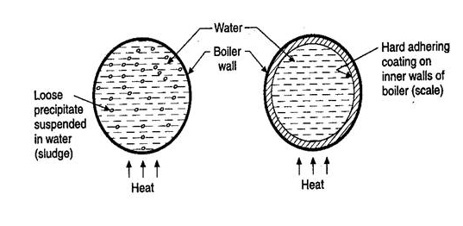**\***

**Sludges and Scales in boiler\***

**CAUSTIC EMBRITTLEMENT**

Caustic embrittlement is a type of boiler corrosion, caused by using highly alkaline water in the boiler. During softening process by lime – soda process, free Na2CO3 is usually present in small amounts in the softened water. In high pressure boilers, Na2CO3 decomposes to give NaOH and CO2 and this makes the boiler water “Caustic”.

Na2CO3 + H2O 2NaOH + CO2 (g)

The NaOH containing water flows into the minute hair – cracks always present in the inner side of boiler, by capillary action. Here water evaporates and the dissolved caustic soda concentration increases progressively. This caustic soda attacks the surrounding area, thereby dissolving iron of boiler as sodium ferrite (Na2FeO2). This causes embrittlement of boiler parts, particularly stressed parts (like bends, Joints, rivets, etc), caustic even failure of the boiler. Caustic cracking can be explained by considering the following concentration cell:

|  |  |  |  |
| --- | --- | --- | --- |
| **(-)Anode**  Iron at rivets, bends, joints, etc | Con  Concentrated  NaOH solution | dilute NaOH  Solution | **cathode(+)**  Iron at  Pla ne surfaces |

The iron surrounded by the dilute NaOH becomes the cathodic side, while the iron in contact with concentrated NaOH – become anodic part, which is consequently dissolved or corroded.

**Prevention of Caustic embrittlement:**

* By using sodium phosphate (Na3PO4) as softening reagent, instead of sodium carbonate (Na2CO3)
* Neutralising the alkali (NaOH) with a very small amount of acid
* By adding tannins, or lignin to boiler water, since these blocks the hair cracks, thereby preventing infiltration of caustic soda solution in these.
* By adding small amount of Na2SO4 to boiler water in order to block small hair cracks at stressed areas.

**Internal treatment:** In this method raw water is treated inside the boiler. Internal treatment means addition of suitable chemicals to reduce scale and sludge formation. It is mainly based on the solubility product. If the product of the concentration of ions exceeds the solubility product, it precipitates. This is a corrective method to remove slight residual hardness and to remove corrosion nature in water.

The following are the internal conditioning methods used in boilers.

(1**) Carbonate conditioning**

Scale formation in low pressure boilers can be avoided by adding sodium carbonate to boiler water, where CaSO4 is converted into calcium carbonate, a sludge which can be removed by blow down operation.

CaSO4 + Na2CO3 U+2192.svg CaCO3 ↓ + Na2SO4

CaCO3 is precipitated in the boiler as loose sludge which can be scrapped off. For the precipitation of CaCO3, the carbonate ions added should exceed the sulphate ions present in water.

If [] > K1 [] precipitation of CaCO3 occurs in preference to CaSO4

**(2) Colloidal Conditioning**

Scale formation in boilers is mainly due to the crystalline precipitates. When colloidal substances like Kerosene, tannin, agar-agar etc. are added to low pressure boilers, these substances get coated over the scale forming precipitates and forms colloidal, non sticky and sludge like precipitates which can be easily removed by mechanical methods or blow down operation.

**(3) Calgon (Conditioning) :**

The word calgon means ‘calcium gone’ i.e, the removal of by using sodium hexa meta phosphate [Na4 (PO3)6]-2.

2 CaSO4 +[Na4 (PO3)6]2- [Ca2 (PO3)6]2- + 2Na2SO4

Soluble complex

**(4) Phosphate conditioning:**

The scale formation can be avoided in high pressure boilers by adding trisodium phosphate or other types of phosphates according to the pH of boiler water. They react with Mg and Ca salts forming soft sludges of Mg3(PO4)2 and Ca3(PO4)2

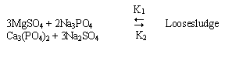

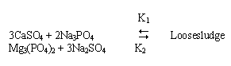 The added phosphate ion concentration should exceed the concentration of sulphate ion present in water for the precipitation of Ca3(PO4)2 (or) Mg3(PO4)2 which is a loose sludge. If (PO4)3 > K2 (SO4)2- ; then Ca3 (PO4)2 / Mg3 (PO4)2 precipitation occurs.

**The different phosphates used are:**

* + Na3PO4 – Tri sodium phosphate – used for too acidic water.
  + Na2HPO4  – Di sodium hydrogen phosphate – used for weakly alkaline
  + NaH2PO4 – Mono Sodium dihydrogen phosphate - used for alkaline water.

**(5) Treatment with sodium aluminate:**

When boiler is heated with sodium aluminate it gets hydrolyzed, gives sodium hydroxide and a gelatinous ppt. of A1 (OH) 3

Na2AlO2 + 2H2O NaOH + Al (OH) 3↓

NaOH formed above reacts with MgCl2 to form another flocculent precipitate of

Mg (OH)2. These two ppts. Entrap colloidal impurities – oil drops, sand and makes them settle down at the bottom which can be easily removed.

**SOFTENING OF WATER**

**Ion exchange (or) de-ionization (or) de-mineralization process**

Ion – exchange resins are insoluble, cross – linked, long chain organic polymers with a micro porous structure, and the functional groups attached to the chains are responsible for the ion – exchanging properties. Resins containing acidic functional groups (-COOH, SO3H etc.) are capable of exchanging their H+ions with other cations, which comes in their contact, whereas those containing basic functional groups (-OH) are capable of exchanging their anions, which comes in their contact. The ion – exchange resins may be classified as:

**i. cation exchange resins (RH+) :** These are mainly sulphonated styrene copolymers. These are capable to exchange their hydrogen ions with the cations, in the water.

**ii. Anion exchange resins (ROH):** these are mainly phenol formaldehyde (or) amine formaldehyde co polymer resin, which exchange their OH – ion with any anion present in the dissolved salts.

**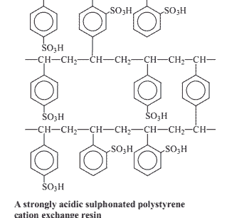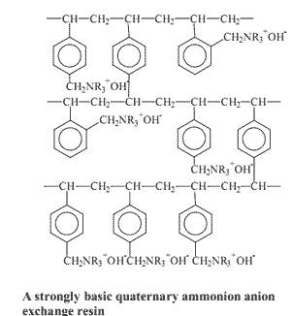**

**Process:** The hard water is passed first through cation exchange column, which removes all the cations like Ca2+, Mg2+ etc. from it, and equivalent amount of H+ ions are released from this column to water. Thus:

2RH• + Ca2+ R2Ca + 2H+

2RH• + Mg2+ R2Mg + 2H+

After cation exchange column, the hard water is passed through anion exchange column, which removes all the anions like  etc. present in the water and equivalent amount of OH­- ions are released from this column to water, thus;

R1OH– + Cl– R1Cl– + OH–

2R1OH– +  R1 + 2OH– ­

2R1OH– +  R12 + 2OH–

H+ and OH– ions (released from cation exchange and anion exchange columns respectively) get combined to produce water molecule.

H+ + OH– H2O

Thus, the water coming out from the exchanger is free from cations as well as anions. Ion – free water, is known as deionized or demineralised water.

**Regeneration:** When capacities of cations and anion exchangers to exchange H+ and OH– ions respectively are lost, they are then said to be exhausted.

The exhausted cation exchange column is regenerated by passing a solution of dil. HCl(or) dil. H2SO4. the regeneration can be represented as:

R2Ca2+ + 2H+ 2RH+ + Ca2+ (washing)

The column is washed with deionized water and washing (which contains Ca2+, Mg2+,Cl–,  ions) is passed to sink or drain.

The exhausted anion exchange column is regenerated by passing a solution of dil. NaOH. The regeneration can be represented as

R’Cl+ OH-  --------🡪 R’OH + Cl -

R2CO3 + OH- 2R-OH + CO3-2

The column is washed with deionised water and washing (which contains Na+ and SO42- or Cl- ions) is passed to sink or drain. The regenerated ion exchange resins are then used agar

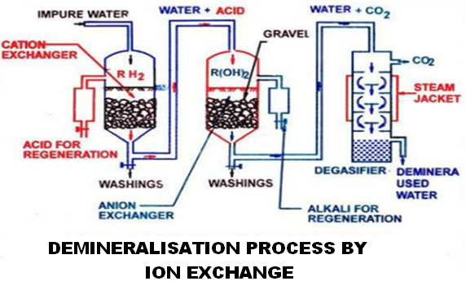

**Advantages:**

* The process can be used to soften highly acidic or alkaline water.
* It produces water of very low hardness (say – 2ppm). So it is very good for treating water for use in high pressure boilers
* The softened water is completely free from salts.

**Disadvantages**

* the equipment is little expensive
* If water contains turbidity then the output of the process is reduced. The turbidity must be below 10ppm.

**DESALINATION OF WATER**

**Reverse Osmosis**

When two solutions of unequal concentrations are separated by a semi permeable membrane (which does not permit the passage of dissolved solute particles (i.e.) molecules and ions), flow of solvent takes place form dilute to concentrated sides, is called osmosis. If a hydrostatic pressure in excess of osmotic pressure is applied on the concentrated side, the solvent is forced higher concentration to lower concentration. Thus the solvent flow is reverse and hence this method is called reverse osmosis. Thus in reverse osmosis pure water is separated from contaminated water. This membrane filtration is sometimes also called “Super filtration” (or) “hyper filtration” method:

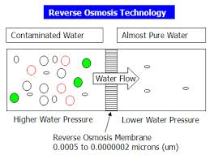 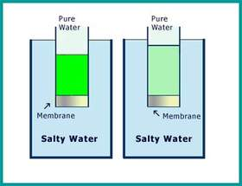

The reverse osmosis cell as shown above consists of a chamber fitted with a semipermeable membrane, above which sea water / impure water is taken and a pressure of 15-40 kg / cm2 is applied on the sea water / impure. The pure water is forced through the semipermeable membrane, which is made of very thin films of cellulose acetate. However superior membrane made of poly methyl methacrylate (PMM), Poly Acrylo Nitrile (PAN), and Polyamide polymers have to come to use.

**Advantages:**

* 1. Ionic and non – ionic, colloidal and high molecular weight organic matter is removed from the water sample.
  2. Cost of purification of water is less and maintenance cost is less
  3. This water can be used for high pressure boilers.

# Introduction to Wastewater or sewage water Treatment Processes

Wastewater treatment is closely related to the [standards](http://water.worldbank.org/water/node/83330) and/or expectations set for the effluent quality. Wastewater treatment processes are designed to achieve improvements in the quality of the wastewater. The various treatment processes may reduce:

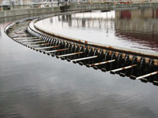

1. **Suspended solids** (physical particles that can clog rivers or channels as they settle under gravity)
2. **Biodegradable organics** (e.g. BOD) which can serve as “food” for microorganisms in the receiving body. Microorganisms combine this matter with oxygen from the water to yield the energy they need to thrive and multiply; unfortunately, this oxygen is also needed by fish and other organisms in the river. Heavy organic pollution can lead to “dead zones” where no fish can be found; sudden releases of heavy organic loads can lead to dramatic “fishkills”.
3. **Pathogenic bacteria** and other disease causing organisms These are most relevant where the receiving water is used for drinking, or where people would otherwise be in close contact with it; and
4. **Nutrients**, including nitrates and phosphates. These nutrients can lead to high concentrations of unwanted algae, which can themselves become heavy loads of biodegradable organic load Treatment processes may also neutralize or removing industrial wastes and toxic chemicals. This type of treatment should ideally take place at the industrial plant itself, before discharge of their effluent in municipal sewers or water courses.

Widely used terminology refers to three levels of wastewater treatment: primary, secondary, and tertiary (or advanced).

**Primary (mechanical) treatment** is designed to remove gross, suspended and floating solids from raw sewage. It includes screening to trap solid objects and sedimentation by gravity to remove suspended solids. This level is sometimes referred to as “mechanical treatment”, although chemicals are often used to accelerate the sedimentation process. Primary treatment can reduce the BOD of the incoming wastewater by 20-30% and the total suspended solids by some 50-60%. Primary treatment is usually the first stage of wastewater treatment. Many advanced wastewater treatment plants in industrialized countries have started with primary treatment, and have then added other treatment stages as wastewater load has grown, as the need for treatment has increased, and as resources have become available.

**Secondary (biological) treatment** removes the dissolved organic matter that escapes primary treatment. This is achieved by microbes consuming the organic matter as food, and converting it to carbon dioxide, water, and energy for their own growth and reproduction. The biological process is then followed by additional settling tanks (“secondary sedimentation", see photo) to remove more of the suspended solids. About 85% of the suspended solids and BOD can be removed by a well running plant with secondary treatment. Secondary treatment technologies include the basic activated sludge process, the variants of pond and constructed wetland systems, trickling filters and other forms of treatment which use biological activity to break down organic matter.

**Tertiary treatment** is simply additional treatment beyond secondary! Tertiary treatment can remove more than 99 percent of all the impurities from sewage, producing an effluent of almost drinking-water quality. The related technology can be very expensive, requiring a high level of technical know-how and well trained treatment plant operators, a steady energy supply, and chemicals and specific equipment which may not be readily available. An example of a typical tertiary treatment process is the modification of a conventional secondary treatment plant to remove additional phosphorus and nitrogen.

Disinfection, typically with chlorine, can be the final step before discharge of the effluent. However, some environmental authorities are concerned that chlorine residuals in the effluent can be a problem in their own right, and have moved away from this process. Disinfection is frequently built into treatment plant design, but not effectively practiced, because of the high cost of chlorine, or the reduced effectiveness of ultraviolet radiation where the water is not sufficiently clear or free of particles.

**UNIT II**

**ELECTROCHEMISTRY AND BATTERIES**

**Electrochemistry**” is the branch of chemistry which deals with the transformation of electrical energy into chemical energy and vice versa.

OR

Electrochemistry is concerned with effect of electrical voltages and current on chemical reaction (ionics) and chemical change which produce the voltage and current (electrodics).

Ionics means the nature and properties of substances containing ions and charged particles

Electrodics means relationship between the electric current and chemical reaction.

The laws of electrochemistry form the basis of electrolysis and electro synthesis.

**Electrolysis**:The process of decompositon of electrolyte in its molten state or solution phase by passing electricity is known as Electrolysis

Electrolysis is the process where electrical energy causes chemical changes.

**Example**: Electrolysis of water yields H2 and O2

2H2O 🡪 2H2+O2

**Electrical conduction**: The substances can be divided into four different types depending upon the capability of flow of electrons. They are electrical conductors, insulators, semiconductors and superconductors.

**Electrical conductors**: Generally all the good thermal conductors are good electrical conductors except Mica. They allow electrons to pass through then with minimum resistance and show no preference of direction of flow.

**Example**: Metals, metal sulphides, acids, bases, fused salts.

**Insulators:** Substances of this category do not allow the electricity to pass through them.

**Example**: Pure water, synthetic organic compounds like benzene, CCl4, ether.

In an insulator, the gap between the valence and conduction bond is consider large making flow of electrons difficult.

**Semiconductors:** Elements of 4A group, especially ‘Si’ and ‘Ge’ have properties that are intermediate between those of metal and non metals and therefore called semiconductors. Their conducted properties are considerable enhanced by the edition of certain impurities like phosphorus that have more valance electron than Si generally called donor impurities give n type semi conductors. Similarly acceptor impurities like Boron (B), Aluminum(Al) that have less number of valency electrons produce p type semi conductors.

The most valuable property derived out of doping and unidirectional flow of electrons is replacement of cumbersome value versions with small semi conductor pieces of thickness of pencil eraser called chips. This led to invention of solid state device like calculators, mini computers etc.

**Superconductors:** Led was fond to conduct electricity with zero résistance bellow 7.K. The mixture of Copper, barium and rare earth metal oxides exhibit zero resistance to as high as 130K the property of certain metals alloys and compound by virtue of which they conduct electricity with zero resistance is known as **super conductivity**.

Because of zero resistance of super conductors attain the capacity to store infinity amount of current. This allows transfer of power from the place of generation to utility. Super conductivity is expected to create vey high field strength electromagnets that can be used for many purposes like lifting super heavy weight.

**Electrode Potential:**

Electrode Potential of a metal is the measure of tendency of a metallic electrode to lose or gain electrons, when it is in contact with a solution of its own salt of unit molar concentration at 250C. Consequently, the tendency of an electrode to lose electrons is a direct measure of its tendency to get oxidized: and this tendency is called, oxidation potential, similarly, the tendency of an electrode to gain electrons is a direct measure of its tendency to get reduced and this tendency is known as reduction potential.

It is quite obvious that the value of reduction potential negative of its oxidation potential and vice versa. Thus, the oxidation potential of an electrode is + x volt, then its reduction potential will have a value of – x volt.

**REDOX REACTIONS:**

Oxidation is a process, which involves lose of electrons by a substance; while reduction is a process, which involves gain of electrons, some other substance must be involved in the reaction to accept these electrons. Similarly, if a substance accepts electrons, some other substance must be involved in the reaction to supply these electrons. In other words oxidation and reduction must always go side – by – side. Thus. If we place zinc metal in a solution of copper sulphate, immediate precipitation of Cu takes place.

Zn (s) + Cu2+ (aq )  Zn2+ (aq) + Cu(S)

In this change, the zinc atom (Zn) is oxidized to zinc ion (Zn2+), since it loses electrons; while the copper ion (Cu2+) is reduced to copper atom, since it gains electrons.

– [oxidation]----------------------(i)

 [Reduction]----------------------(ii)



The overall reaction, obtained by adding (i) and (ii), is called redox (or) oxidation – reduction reaction, each of these reaction, is known as half – reaction. The reaction(i), in which loss of electrons takes place, is called oxidation half – reaction, while the other reaction (ii), in which gain of electrons takes place, is called reduction half – reaction.

**Single electrode potential**: Each of these electrodes exhibits its characteristic electrode potential. This potential; is called Single electrode potential.

Ecell=Ecathode-Eanode

**Standard electrode potential**: The potential exhibited by a single electrode at unit concentration of the concerned metal ion or non-metal ion solution at 25o C is called **standard electrode potential**.

This is expressed by ‘E0’

Standard electrode potential ‘E0’value of a simple electrode is determined experimentally by combining the standard electrode with standard hydrogen electrode (S.H.E) .The EMF of the resulting.

**Standard hydrogen electrode**: To determine the potential difference of a single electrode experimentally, it is combined with a standard hydrogen electrode and the EMF of cell so constructed is measured with a potentiometer. Standard hydrogen electrode is constructed and used as standard electrode or reference electrode.

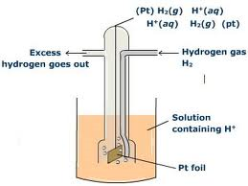

Pure hydrogen gas is bubbled into a solution of 1 M Hcl along ‘Pt’ electrode coated with platinum black. A platinum black placed in the solution at atmospheric pressure as shown in the diagram.

Generally the electrode is fitted into a tube. The tube will have two circular small holes. This tube is immersed in the acid solution such that one half of the circular hole is exposed to air and other half is in the solution.

The following equilibrium exists at the electrode

½ H2 (1 atm) H+ (aq)(1 M) +e-

**Types of electrodes:**

**Standard calomel electrode [S.C.E]**: Calomel electrode is particularly very simple to construct, free from surface sensitivity and accurate to use even in a very normal laboratory.

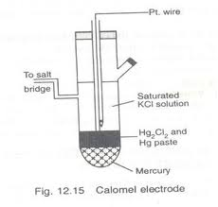

A calomel electrode consists of inner glass tube and outer jacket. In the inner glass tube a platinum wire is dipped into mercury which rests on a paste is in contact with KCl present in the outer jacket, through the glass frit plug fixed at the bottom inner glass tube. The calomel electrode potential depends on the concentration of KCl taken in the outer jacket.

Electrode reaction is

http://www.everyscience.com/Chemistry/Inorganic/Redox_Reactions/.images/calomelcellreaction.gif

And the corresponding reaction is

E Hg2Cl2/Cl- = E 0Hg2Cl2/Cl- -2.303/F log a2cl-

**Ion Selective Electrodes**:

Ion Selective electrode is the one which selectively responds to a specific ion in a mixture and the potential developed at electrode is a function of the concentration of that ion in the solution. The electrode generally consists of a Membrane which is capable of exchanging the specific ions with the solution with which it is in contact. Therefore these electrodes are also referred to as Membrane electrodes.

The Ion Selective electrode generally consists of ion selective membrane in contact with an analyte solution on one side and an internal reference solution on the other side. An internal reference electrode constituted in contact with the reference solution.

The electrode can be represented as follows;

Solution to be Internal Internal

Analysed // standard solution // reference electrode

[Mn+]=C1 [Mn+]=C2

The mechanism of potential development in ion selective electrodes is different from that in other types of electrodes. The observed potential of an ion selective electrode is a kind of junction potential that develops across a membrane that separates the analyte solution from reference solution. The potential developed across the membrane is a function of concentration of analyte and reference solution.

Ej=2.303RT/ nF log C1/C2

Where C1 and C2 are the concentration of the analyte and reference solution respectively. If the concentration of the inner standard solution is kept constant, then

Ej=k+ (2.303RT/ nF) log C1, where k is a constant k=-2.303RT/ nF log C2

Em=Ej+Eref

­ =k+ (2.303RT/ nF) log C1+ Eref

=E0M+ (2.303RT/ nF) log C1, Where E0M =k+ Eref

At 298 K EM= E0M+ (0.0591/ n) log C1­

The electrode is combined with an external reference electrode, and emf of the so formed cell is determined by potentiometric method. Knowing the electrode potential of the reference electrode ,the electrode potential of the ion selective electrode is calculated, which in turns gives the ion concentrations. The potentiometers are generally to read the ion content directly.

**Applications**:

Used to determine the concentrations of a number of cations and anions such as

H+,Li+,Na+,K+,Pb2+,F- etc.



**Glass electrode**:

**Principle**:when the glass electrode is immersed in another solution, whose pH value is to be determined, there develops a potential between the two surfaces of the membrane. The potential difference developed is proportional to the difference in pH value.

pH electrodes are called glass electrodes. Glass electrode is made of glass tube ended with small glass sensitive to proton. In side of the electrode is usually filled with buffered solution of chlorides in which silver wire covered with AgCl2 is immersed.

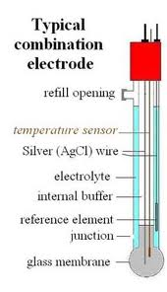

Active part of the electrode is the glass tube while tube has strong and thick walls bubble is made to be as thin as possible .Surface of the glass is protonated by both external and internal solution till the equilibrium achived.Both sides of the glass are charged by the adsorbed protons, this charge is responsible for potential difference.

**Determination of pH**:

To determine the pH of a given solution .the glass electrode is dipped in a solution whose pH need to be determined.It is combined with a saturated calomel electrode.

Hg/Hg2Cl2/Cl-//solution (pH=?)/glass/0.1 N HCl/AgCl/Ag

The emf of the so formed cell is determined potentiometrically.

Ecell=EG-Ecal

=E0G-0.0591 pH-Ecal

pH=(E0G-Ecal-Ecell)/0.0591

E0G Value is evaluated bu dipping the glass electrode in a solution of knows pH and measuring the emf of the cell formed when combined with a calomel electrode.

**Advantages**:

* Can be used in oxidizing and reducing environments.
* Electrodes are not get poisoned.

**Nernst equations and its applications**

Expression for Electrode potential: Consider a redox reaction:

Mn+(aq) + ne- = M(s)

Now for a reversible reaction, the freeenergy change (G) and its equilibrium constant (K) are inter-related as :

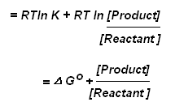

Where ∆G is known as the standarad free energy change (i.e. The change in free energy, when the concentrations of the reactants and the products are unity each). The above equation is known popularly as van’t Hoff reaction isotherm. In a reversible reaction, the electrical energy is produced at the expense of the free energy decrease i.e,



**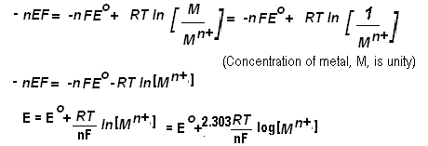**

This expression is known as Nernst’s equation for Electrode potential. At 250C

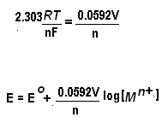

**Applications of Nernst equation**

1. Calculation of the potential of a cell under non-standard conditions.
2. Determination of an unknown concentration in a galvanic cell
3. Calculation of the pH of a solution

**NERNST EQUATION**

As given in the electrochemical series, an electrode or half Cell is said to have a standard value of reduction potential if the concentration of electrolyte is 1M at 298K. Nernst found that the single electrode potential (Reduction potential) varies with the change in concentration of ions and temperature and hence the EMF of the cell also varies. Walter Nernst (1889) derived a mathematical relationship between the standard electrode potential, temperature and the concentration of ions. This relationship is known as the Nernst equation. For a general reduction reaction occurring at an electrode.

Nernst equation can be written as follows

**At cathode:**

Mn+ + ne- M(s)

ECell = 

ECell = (Mn*+­­*)

 = 

Where E = Electrode potential of the metal

E0 = Standard EMF of the cell for 1M solution at 298K.

R = Gas constant (8.314 JK-1 mol-1)

T = Kelvin temperature (298K (or) 250­c)

n = Number of electrons involved in the cell reaction

F = Faraday of electricity, i.e., 96500 coloumbs.

Substituting the values, R = 8.314 JK-1 mol-; T = 298K; F = 96500C in the above relation, we get

= + -  (Mn*+­­*)

= +  (Mn*+­­*)

Let us consider a Daniel Cell in which the concentrations of Zn2+ ions and Cu2+ ions are different from 1M. In this Cell, zinc acts as anode while copper acts as cathode. Their electrode potentials can be written as:

 Here n = 2 …(1)

Also

 Here n = 2 …(2)

We know that, ECell = ECathode – Eanode

Substituting the values, we get ECell =  – 

ECell =  – 

ECell = 



**THE ELECTROCHEMICAL SERIES**:- The electrochemical series consists of a list of metals have been arranged in order of their standard electrode potentials. The standard electrode potentials which has been measured for most elements that form ions in solution. Metals which are higher in the electrochemical series displace metals which are lower in the sequence from solutions of their salts. The electrochemical series The following is a list of the standard potentials:

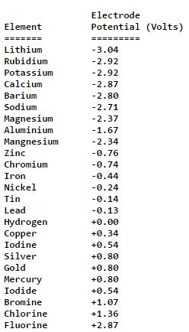

A negative value for electrode potential means that the element loses electrons more readily than hydrogen (i.e. it is better reducing agent). A positive value for electrode potential means that the element is a poor reducing agent than hydrogen.

A strong oxidising agent has a large positive potential and a strong reducing agent a large negative potential.

The electrochemical series is extremely useful for predicting the chemical behaviour of an element. An electropositive element will displace a less electropositive element from a solution of its ions (e.g. zinc will displace copper from a copper solution).

The applications of electrochemical series are:

* Oxidizing and reducing strengths
* Comparisons of reactivities of metals
* Calculation of EMF of cells
* Prediction of liberation of Hydrogen gas from acids by metals
* Predicting the feasibility of a redox reaction

**Electrochemical Cell : [Galvanic Cell or Voltaic Cell]**

An electrochemical cell is a device in which a redox reaction is utilized for the conversion of chemical energy into electric energy.

Ex : Dry Cell, and Lead storage battery

The electrode where oxidation occurs is called anode; while the electrode where reduction occurs, is called cathode.

The practical application of an electrochemical or galvanic cell is Daniel Cell. Its consists of zinc electrode, dipping in ZnSO4 solution (1M) and a copper electrode, dipping in CuSO4 solution (1M) taken in two different beakers.

The two solutions are connected by means of a salt bridge. Salt bridge is an inverted U – tube containing an aqueous solution of electrolyte such as KCl, KNO3, or K2SO4 (which does not react chemically during the process). Some gelatin (or) agar – agar is added to this aqueous solution of electrolyte to converted it into semi solid paste.

****

The moment the two electrodes are connected by a wire, the following reactions occur at different electrodes.

At anode  Zn 2+(aq) + 2e- [oxidation half reaction]

At anode Cu2+(aq)+2e- Cu(s) [reduction half reaction]

+ Cu2+(aq) Zn2+(aq) Cu(s) [ complete cell reaction]

Oxidation, takes place at the anode and reduction taken place at the cathode. The electrons flow from anode to cathode. The transference of electrons from Zn anode to Cu cathode leads to the accumulation of positive charge around the anode due to the formation of Zn2+ ions and the accumulation of negative charge around cathode due to deposition of Cu2+ ions as copper on the cathode. The positive charge so accumulated around the anode will prevent the flow of electrons from it. Similarly, accumulation of negative charge around the cathode will prevent the acceptance of electrons from the anode. As the transference of electrons stops, the current in the electrical circuit also stops.

All this stage, the salt bridge comes to the aid and restores the electrical neutrality of the solution in the two half cells (electrodes). When the concentration of Zn2+ ions around the anode increases, sufficient numbers of C1- ions migrate from the salt bridge to the anode half cell. Similarly, sufficient numbers of K+ ions migrate from the salt bridge to cathode half cell for neutralizing excess negative charge due to the additional ions in the cathode half cell. Thus, salt bridge provides cations and anions to replace the ions lost or produced in the two half cells. It maintains electrical neutrality of the two solutions in the two half cells. It allows the flow of current by completing the electrical circuit. It prevents intermixing a solution as well as ions in the two half cells, which may lead to a precipitation reactions.

**Representation of Galvanic cell:**

Zn / Zn SO4(aq) || CuSO4 (aq) / Cu

Zn ; Zn+2 (1M)|| Cu2+ (1M); Cu

1. on the left hand side anode is written and on the right hand side cathode is written.
2. Anode is written by writing the metal first and then the electrolyte. The two are separated by vertical line or semicolon.
3. Cathode is written by first writing the electrolyte and the metal thereafter. These two are separated by vertical line (or) semicolon.
4. The electrolyte may be represented as complete formula of the whole compound (or) by ionic species.
5. The two half cells, anode and cathode, are separated by double vertical lines which indicate “salt bridge”.

**Electromotive Force (OR) Cell potential (EMF)**

The flow of electricity from one electrode to another electrode in a galvanic cell indicates that the two electrodes have different potentials. This difference of potentials between the electrodes of a cell which causes flow of current from an electrode at higher potential to another at lower potential is known as electromotive force (or) cell potential.

The EMF of a cell is a qualitative measurement of the tendency of a net reaction to occur within the cell. Since the net cell reaction is a redox reaction, the EMF of a cell in a way measures relatively the tendency of oxidation reaction to occur at the anode and the tendency of reduction reaction to take place at the cathode of the cell:

**Mathematically :**

EMF or E Cell = oxidation potential of the anode + Redunction potential of the cathode

Since oxidation takes place at anode and reduction takes place of cathode.

E Cell = E anode (oxidation) + E cathode (Reduction)

and E Cell =E cathode (Reduction) - E anode (Reduction)

E Cell = oxdn potential of anode – oxdn potential of cathode

Always remember that when potential is not specified (i,e) as oxdn or redn potential; it means the given value is for reduction potential. While solving numerical problem, sign should be given importance. If Cell potential (EMF) is positive, the reaction is spontaneous. Further, the more +ve value of the E cell, the more faster is the reaction.

**Concentration cells:**

A Concentration cell is an electro chemical cell that as two equivalent half cells of the same material different only in Concentration.

The Concentration difference could be affected in the electrode material or in the electrolyte. Further they could be divided into cells with transference or without transference.

**Electrolyte Concentration Cell**:

In these Cell electrodes are identical but these are immersed in the solution of same electrolyte of different concentration. The source of the electrical energy in the cell is the tendency of the electrolyte to defuse from a solution of higher concentration to that of lower concentration. With the expiry of time, the two concentrations tend to becomes equal. Thus at the starting the emf of the cell is maximum and it gradually falls to zero.

Such cells are represented bellow;

M/Mn+ (C1) // Mn+ (C2) / M (C2>C1)

Zn/Zn2+ (C1) // Zn2+ (C2) / Zn (C2>C1)

The emf of the cell is given by the following expression;

E Cell = 0.0591 / n log C2/ C1 at 250 C

The above examples are typical example of electrolyte concentration cell with transference. Transference indicates the presence of salt bridge.

Examples of Electrolyte Concentration cell without transference is difficult to comprehend at this stage and are not considered now.

**Applications:**

1).The concentration cells are used to determine the solubility of sparingly soluble salts valency of the cation of the electrolyte and transition of the two allotropic forms of a metal used as electrodes etc.

2).Concentration cell corrosion occurs when two or more areas of a metal surface are in contact with different concentration of the same solution.

NUMERICAL PROBLEMS ON EMF

**BATTERIES :-**

Battery is a device which transforms chemical energy into electrical energy. The term battery is usually applied to a group of two or more electrical cells connected together electrically in series.

In general there are two types of batteries:

Primary batteries and secondary storage or accumulator batteries.

**Primary batteries** are constructed so that only one continuous or intermittent discharge can be obtained. These batteries are used as a source of ‘dc’ power where the following requirements are important**:**

* Convenience is of major importance
* The cost of a discharge is not much
* Electrical charging equipment or power is not readily available.
* Stand-by power is desirable without cell deterioration during periods of nonuse for days or years

**Secondary storage or accumulator batteries** they are constructed in such a manner that they can be recharged after partial or complete discharge. They are used as a source of ‘dc’ power where the following requirements are important:

* The battery is the primary source of power and large numbers of discharge-recharge cycles are required, as in industrial hand or rider trucks, submarines, mine or switching locomotives.
* The very large capacity is beneficial to the circuit, as in telephone exchanges.
* **l.Primary batteries: *example:Dry (Leclanche) cell***:
* **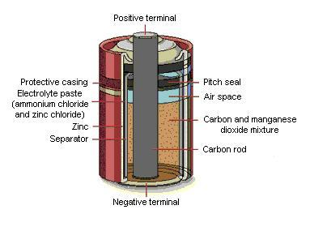** It consists of a Zinc anode which is shaped as a container for the electrolyte a carbon cathode surrounded by Mno2 and a paste of NH4Cl andZnCL2 as a cathodic depolarizer. Cathode depolarizer facilitates the H+ discharge reaction by removing the adsorbed hydrogen atoms. Such a cell known as “dry cell” because of the absence of any mobile or liquid phase .Electrolyte consists of NH4Cl ,ZnCL2and Mno2 to which starch is added to make it thick paste like so that it is less likely to leak .The cell is enclosed in polypropylene cylinder and given a plastic coating to reduce leakage.
* The Zn- MnO2 (dry) cell is represented as:
* Zn/ Zn2+, NH4+/MnO2/C
* The oxidation reaction at anode is
* Zn(S) Zn2+(aq) +2e-,
* The reduction reaction at cathode is

MnO2(S) +2H2O+2e­\_Mn2O3+2OH-(aq)



* But an reaction between OH- thus formed at cathode and NH4 +evolves NH3 (g). This liberated NH3 (g) disrupts the current flow

NH4 + (aq) +OH-(aq)NH3 (g) +H2O(l)

* This is prevented by a reaction of NH3 (g) with Zn2+to form the complex [Zn (NH3)2]Cl2(s).
* Thus the reaction at cathode can be written as:
* 2MnO2(s) + NH4 + (aq) +2e- [Zn(NH3)2]Cl2(s)



* So the net reaction is;
* Zn(s) + 2NH4 + (aq) + 2Cl-(aq) + 2MnO2(s) Mn2O3+-[Zn (NH3)2] Cl2(s) +2H2O (l)

The various reactions involved in the dry cell cannot be reversed by passing electricity back through the cell. Hence, the dry cell is primary cell.

ALKALINE BATTERY

DESCRIPTION :- it is improved form of the dry cell in which the electrolyte NH4OH is replaced by KOH. In alkaline battery , the powdered zinc is mixed with KOH & MnO2 to get a gel.

A carbon rod (graphite)acts as cathode , is immersed in the electrolyte in the centre of the cell. The outside cylindrical zinc body is made of zinc ,acts as anode.

**CELL REACTION**:-

At anode : Zn (s) + 2OH- (aq)  ---------🡪 Zn(OH)2 + 2e-

At Cathode : 2MnO2(s) +H2O(l)+ 2e- ---------🡪 Mn2O3  + 2OH- (aq)

OVER ALL REACTION: Zn (s)+ 2MnO2(s)+H2O(l) -------🡪 Zn(OH)2 + Mn2O3 + 2OH- (aq)

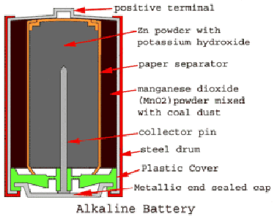

LITHIUN CELL

**ll.Secondary batteries:**

**Example:**

**1.The *Lead –acid storage cell*:** A storage cell can operate both as a voltaic cell and as an electrical cell .It has ability to work both ways, to receive electrical energy and also to supply it...When it operates as a voltaic cell, it supplies electrical energy and as a result it eventually becomes run-down. It then needs to be recharged .When being re-charged, the cell operates as an electrolytic cell.

Lead acid storage cell is the common example of storage. It is so classified because the electrolyte is an acid and plates are largely leads. It consists of a lead-antimony alloy coated with

lead di oxide as cathode and spongy as lead as anode. The electrolyte is a 20 % solution of H2SO4 .In fact, a lead accumulator for car consists of six lead-acid storage cells in series i.e. in electrolyte (H2SO4), six pairs, with inert porous partitions in between, are dipped.

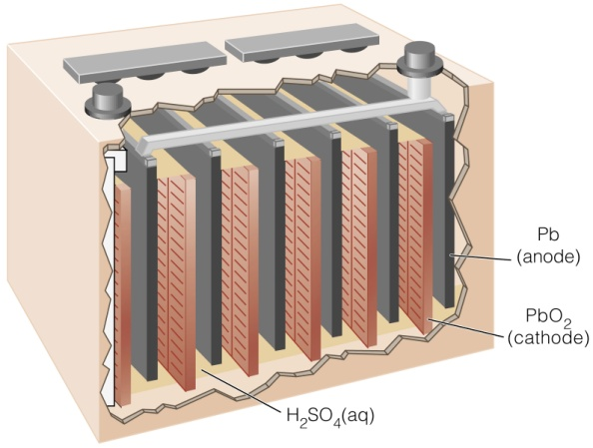

**Discharging**: when the lead accumulator is used for supplying electrical energy, it is said to be discharging. The lead electrode loses electrons, which flow through the wire.

I.e. At anode, oxidation takes place

**PbPb2++2e-**



The so formed Pb2+ ions then combine with SO42- ions.

**Pb2++ SO42-PbSO4**



The released electrons flow to the cathode, where PbO2 forms Pb2+.in other words, lead undergoes reduction at cathode.

**PbO2+2H++2e-Pb2++2H2O**



Pb2+ions then combine with SO42- ions.

**Pb2++ SO42-PbSO4**



Thus, the net reaction during use (discharging) is:

**Pb+PbO2+4H++2SO42-2PbSO4+2H2O+ENERGY**.



The voltage of each cell is about 2.0 Volta at a concentration of 21.4 % H2SO4 at 250 C. That’s why; a lead accumulator for car (consisting of six lead-acid storage cells in series) is capable of delivering 12 volts.

**Charging**: During discharging, PbSO4 is precipitated at both the electrodes. When PbSO4 covers completely both anode and cathode, the cell stops functioning as a voltaic cell. Further use, it needs to be re-charged.

Re-charging is done by passing an external e.m.f greater than 2 volts so that the reactions taking place during discharging are reversed.

Reaction at anode; **PbSO4+2H2OPbO2+SO42- +2H++2e**-



Reaction at cathode; **PbSO4+2H2OPb+SO42-**



Net reaction during charging is:

**2PbSO4+2H2O+ENERGY Pb+PbO2+4H++2SO42-**



**Applications**:

These cells are used for supplying current to electricalvehicals,railways,mines,laboratories,hospitals,automobiles, power stations, broadcasting stations, in telephone exchanges, gas engine ignition, stand-by supplies(UPS) etc.

***2.Nickel-Cadmium cell*:** **(Ni-Cd Cell)**

Nickel cadmium cell consists of a nickel wire gauze electrode. The anode consists of a mixture of spongy cadmium with (78 %) cadmium hydroxide,18% iron,1 % nickel and 1% graphite. The cathode contains nickel hydroxide (80%) cobalt hydroxide 2%, graphite 18% and traces of barium compound. Graphite increases the conductivity, the cobalt and barium compounds increases the efficiency of active material and also the life cycle.6M potassium hydroxide (KOH) is the electrolyte.

**Electrode reaction:** During discharging

At the anode: **Cd+2OH-  Cd (OH) 2 +2e-**



At the cathode: **2Ni (OH) 3 +2e-  2 Ni (OH)2+2 OH-**



The net cell reaction is

**Cd+Ni (OH) 3  2 Ni (OH) 2+2 Cd(OH)2**



reversed.

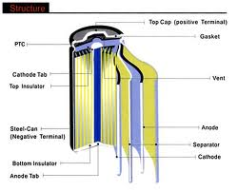

**Applications:**

Nickel cadmium cells are used in battery operated appliances such as pocket calculators, photo flash units, cordless garden tools, electric shaver’s instruments, alarm systems, transmitters, receivers, emergency lighting, hearing aids, telemeters, etc.

***3.Lithium batteries*:**

Lithium metal offers an attractive option be used as a battery anode material because of its light weight, low electrode potential, high electrochemical equivalence and good conductivity .For these reasons ,the use of lithium has predominated in the development of high performance, high energy density primary and secondary batteries.  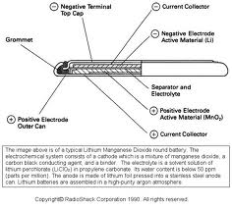

**Advantages of lithium batteries**:

* High cell voltage, up to 4 V, depending on the cathode material. This is because of the very negative electrode potential of Li/Li+.
* High energy density due to the low atomic mass of lithium.1 F is released by the dissolution of 7 g of the metal.
* Operation over a wide temperature range, from about 70-400 C.

**FUEL CELLS:**

A fuel cell is a galvanic cell in which the chemical energy contained in a readily available fuel oxidant system is converted directly into electrical energy by means of electrochemical process in which the fuel is oxidized at the cathode.

A fuel cell essentially consists of the following arrangements:

Fuel/electrode/electrolyte/electrode/oxidant.

**1.Hydrogen oxygen fuel cell**:

Hydrogen oxygen fuel cell is a simplest type in which hydrogen gas is used as a fuel and oxygen as oxidant..A schematic diagram of H2-O2 fuel cell is shown below;

The cell consists of a porous carbon electrode impregnated with catalysts such as finely divided platinum or palladium as anode. The cathode is also a porous carbon electrode impregnated with platinum or silver as catalyst. The electrolyte is an aqueous solution of KOH.The hydrogen gas fuel is continuously supplied at the anode and oxygen gas is supplied at the cathode. As hydrogen gas diffuses through the anode, it is adsorbed on the electrode surface and reacts with hydroxyl ions to form water. At the cathode oxygen diffusing through the electrode is adsorbed and reduced to hydroxyl ions. These electrode reactions are summarized bellow;

At the anode: 2H24H++4e-



4H++4OH-4H2O



-------------------------------

2H2+4OH-4H2O +4e



At the cathode: O2+2H2O+4e-  4OH-



The net cell reaction is, 2H2+O2H2O

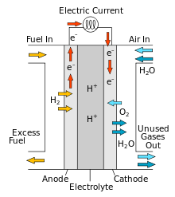 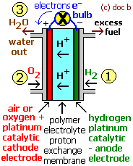

**Advantages of fuel cells**:

Theoretically the efficiency can be 100 %.But actually it is about 50-80 %,owing to over potential and resistance of the cell.

* High efficiency of the energy conversion process.
* No moving parts and so elimination of wear and tear.
* Silent operation.
* Absence of harmful waste products.
* No need of charging.

**2.Methanol-Oxygen fuel cell**

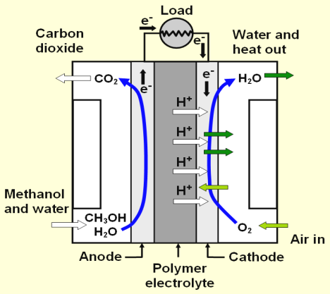

Direct-methanol fuel cells or DMFCs are a subcategory of [proton-exchange fuel cells](http://en.wikipedia.org/wiki/Proton_exchange_membrane_fuel_cell) in which [methanol](http://en.wikipedia.org/wiki/Methanol) is used as the fuel. Their main advantage is the ease of transport of methanol, an energy-dense yet reasonably stable liquid at all environmental conditions.

The DMFC relies upon the [oxidation](http://en.wikipedia.org/wiki/Redox) of [methanol](http://en.wikipedia.org/wiki/Methanol) on a [catalyst](http://en.wikipedia.org/wiki/Catalyst) layer to form [carbon dioxide](http://en.wikipedia.org/wiki/Carbon_dioxide). Water is consumed at the [anode](http://en.wikipedia.org/wiki/Anode) and is produced at the [cathode](http://en.wikipedia.org/wiki/Cathode). [Protons](http://en.wikipedia.org/wiki/Proton) (H+) are transported across the proton exchange membrane - often made from [Nafion](http://en.wikipedia.org/wiki/Nafion) - to the cathode where they react with [oxygen](http://en.wikipedia.org/wiki/Oxygen) to produce water. [Electrons](http://en.wikipedia.org/wiki/Electron) are transported through an external circuit from anode to cathode, providing power to connected devices.

The [half-reactions](http://en.wikipedia.org/wiki/Half-reaction) are:

|  |  |
| --- | --- |
|  | **Equation** |
| **Anode** | \mathrm{CH_3OH + H_2O \to 6\ H^+  + 6\ e^- + CO_2} oxidation |
| **Cathode** | \mathrm{\frac{3}{2} O_2 + 6\ H^+  + 6\ e^- \to 3\ H_2O} reduction |
| **Overall reaction** | \mathrm{CH_3OH + \frac{3}{2} O_2 \to 2\ H_2O + CO_2} redox reaction |

Methanol and water are adsorbed on a catalyst usually made of [platinum](http://en.wikipedia.org/wiki/Platinum) and [ruthenium](http://en.wikipedia.org/wiki/Ruthenium) particles, and lose protons until carbon dioxide is formed. As water is consumed at the [anode](http://en.wikipedia.org/wiki/Anode) in the reaction, pure methanol cannot be used without provision of water via either passive transport such as back [diffusion](http://en.wikipedia.org/wiki/Diffusion) ([osmosis](http://en.wikipedia.org/wiki/Osmosis)), or [active transport](http://en.wikipedia.org/wiki/Active_transport) such as pumping. The need for water limits the energy density of the fuel.

Platinum is used as a catalyst for both half-reactions. This contributes to the loss of cell voltage potential, as any methanol that is present in the cathode chamber will oxidize. If another catalyst could be found for the reduction of oxygen, the problem of methanol crossover would likely be significantly lessened. Furthermore, platinum is very expensive and contributes to the high cost per kilowatt of these cells.

**Cross-over current**

Methanol on the anodic side is usually in a weak solution (from 1M to 3M), because methanol in high concentrations has the tendency to diffuse through the membrane to the cathode, where its concentration is about zero because it is rapidly consumed by oxygen. Low concentrations help in reducing the cross-over, but also limit the maximum attainable current.

**UNIT III**

**III.POLYMERS**

Polymer is a macro molecule formed by the union of many small molecules.

Depending upon the structure, a polymer may be linear or branched.

|  |  |
| --- | --- |
| Ex. – CH2 – CH2 – | CH2--Si – O – Si – O - Si |
| Polyethylene | | |
| Linear | CH2- Si – O – Si – O – |
|  | Branched silicon resin. |

Depending type of monomer, they may be homopolymer (made up of same monomer) or

Co-polymer (made up of different monomers)

O O

Ex. – CH2 – CH2 - n H2N – (CH2)6 – NH – C – (CH2)4 – C – NH -

Homopolymer Nylon 6,6

Polyethylene (Co-polymer)

POLYMERISATION: It may be defined as the process of linking or joining together small molecules like monomers to make large molecules.

Basically there are 3 types of polymerizations.

1. Additional polymerization or Chain polymerization

2. Condensation polymerization or Step polymerization

3.Copolymerization

1. **Additional polymerization or Chain polymerization:** This polymerization yields an

exact multiple of basic monomeric molecules. This monomeric molecule contains one or more double bonds. By intermolecular rearrangement of these double bonds makes the molecule bifunctional. In this polymerization process light, heat and pressure or catalyst is used to breakdown the double covalent bonds of monomers.

1. **Condensation polymerization or Step polymerization:** May be defined as “a reaction

occurring between simple polar-group-containing monomers with the formation of polymer and elimination of small molecules like water, HCl, etc.” For example, hexamethylene diamine and adipic acid condense to form a polymer, Nylon6:6. Additional polymerization is a chain reaction converting of a sequence of three steps.

Initiation, propagation and termination.

1. Initiation step is considered to involve two reactions. The first is the production of free radicals, usually, by the hemolytic dissociation of an initiator (or catalyst) to yield a pair of radicals R’.

I 2R’ ………(1)

(Initiator) (Free radicals)

The second part of initiation under the addition of this radical to the just moment molecule (M) to

produce the chain initiating species M1.



the polymerization of monomer CH2 = CHY taken in the form.



1. Propagation step: Consists of the growth of M1 by successive additions of large numbers of

monomer molecules according to equation.

|  |  |
| --- | --- |
| M1+ M 🡪 M2 |  |
| M2+ M 🡪 M3 |  |
| M3+ M 🡪 M4 or in general terms | Mn + M🡪 Mn + 1 |

1. Termination step: At some time, the propagation polymer chain steps growing and terminates.



Disproportion in which a hydrogen atom of one radical center is transferred to another

radical center. This results in the formations of two polymer molecules, are saturated and one

unsaturated

 e.g.

The two different modes of terminations can be represented in general terms by:

M\*n + M\*m🡪 M\*n+m (Coupling)

M\*n + Mm\*🡪Mn + Mm (Disproportionation)

Co-polymerization: Polymerization involving two different monomers.

Ex. Polymerization of butadiene and styrene to gave Buna –S.



**What is Plastic?**

Plastics are the materials that show the property of plasticity and can be

moulded into any desired shape and dimensions by the application of heat and pressure. Plastics

having variety of properties are in use in present applications. The properties are low

thermal and electrical conductivities, easy to fabricate, low specific gravity etc. The plastics can be

fabricated for large number of colours and can be used for decorative purpose. Plastics can be

used to produce complicated shapes and accurate dimensions very cheaply by moulding process.

Plastics are generally used for making automobile parts, goggle, telephones, electrical

instruments, optical instruments, household appliances etc. plastics having high wear resistance

properties can be used for making gears, bearings etc.

**Merits of Plastics**

1. Plastics have good shock absorption capacity compared with steel.
2. Plastics have high abrasion resistance.
3. plastics are chemically inert.
4. Plastics have high corrosion resistance compared to metals.
5. Mounding, machining, drilling etc. can be easily done on plastic materials.
6. Plastics are light in weight having specific gravity from 1 to 2, 4.
7. Plastics can be made according to the order like hard, soft, rigid, tough, brittle, malleable etc.
8. Fabrication of plastics into desired shape and size is cheap.
9. Plastics are dimensionally stable.
10. Plastics are don’t absorb water.
11. Thermal coefficient of expansion of plastic is low.
12. Excellent outer finish can be obtained on plastic products.

**Demerits of Plastics**

1. Plastics are soft
2. Plastics have poor ductility.
3. Resistance to heat is less.
4. Cost of plastics is high.
5. Plastics can deform under load.

**THERMOSET PLASTICS:** They are formed by condensation polymerization. Theyhave three

dimensional network structures. The cross links and bonds retain their strength on heating and

hence they do not soften on heating. On prolong heating however, charming of polymers is

caused. They retain the shape and structure even on heating. Hence, they cannot be reshaped and

reused.

They are usually, hard, strong and more brittle. They cannot be reclaimed from wastes. Due to

strong bonds and cross-links they are insoluble in almost all organic solvents.

**Difference between thermo set and thermoplastics.**

Plastics are materials that show the property of plasticity and can be moulded into any desired

shape and dimension of articles by the application of heat and pressure.

|  |  |
| --- | --- |
| **Thermoplastics** | **Thermosets Plastics** |
| * 1. These resins become soft on heating and rigid on cooling reversibly   2. The heating and cooling donot alter the chemical nature of these resins because the changes involved are purely of physical nature.   3. These are formed by chain polymerization   4. They consist of long chain linear polymers with weak secondary – vander waal’s forces of attraction between them.   5. They are softened on heating readily   because the secondary force of attraction between the individual chain can break by heat, pressure or both  6.They can be reshaped   * 1. These are soft, weak and less brittle   2. These resins are usually soluble in organic solvents   3. Polyethylene, polyvinyl chloride are the examples. | 1.During fabrication process these resins are moulded once they are solidified they cannot be softened  2.These resins are permanent setting resins  3.These are formed by step polymerization  4.They have three dimensional network structure  5.The bonds retain their strength on heating hence they do not soften again on heating.  6.Cannot be reshaped  7.These are hard, strong and more brittle  8.Due to strong bonds and cross links, they are insoluble in almost all organic solvents.  9.Bakelite, Nylons, etc, are the examples. |

**Compounding of plastics:**

Compounding of the plastics may be defined as the mixing of different materials like plasticizers, fillers of extenders, lubricants, dies and pigments to the thermoplastic and thermosetting plastics to increase their useful properties like strength, toughness, etc. Resins have plasticity or binding property, but need other ingredients to be mixed with them for fabrication into useful shapes.

**Compounding of plastics:**

Many plastics are virtually useless along but are converted into highly serviceable products by combining them with a variety of additives, stabilizers etc., by the compounding process. The exact formulation will depend upon the specific application requirement. The different additives impart different physical properties which are used to improve the performance of the plastic materials. Additives are widely used for thermoplastics, thermo sets and elastomers like phenolics or amino resins are useless alone but by the addition of fillers, resins etc., they give a reversible products. Some of the compounding materials are stabilizers, plasticizers, fillers, colorants or pigments, lubricants and accelerators.

**Ingredients used in compounding of plastics**

Some of the ingredients used in compounding of plastics are

1. Plasticizers.
2. Fillers or extenders.
3. Dyes and pigments.
4. Lubricants.

**i).Plasticizers**

Plasticizers are substances added to enhance the plasticity of the material and to reduce the cracking on the surface. Plasticizers are added to the plastics to increase flexibility and toughness. Plasticizers also increase the flow property of the plastics.

**Example-**Dibutytyle oxalate, Castor oil and Tricresyl phosphate

**ii) Fillers or Extenders**

Fillers are generally added to thermosetting plastics to increase elasticity and crack resistance. Fillers improve thermal stability, strength, non combustibility, water resistance, electrical insulation properties and external appearance.

**Example-**wood flour, Asbestos, Mica, Cotton, Carbon black, Graphite, Barium sulphate etc.

1. **Dyes and pigments -** These are added to impart the desired colour to the plastics and give decorative effect.

**iv) Lubricants** These are added to prevent the plastics from sticking to the moulds.

**Example**: Oils, Waxes, Soaps etc.

Thus the objective of compounding is to improve the properties of the basic resin, such that the fabrication is made easy.

**Fabrication of plastics:**  Many methods of fabricating plastics into desired shaped articles are employed. This production of plastics is known as fabrication of plastics. The methods, usually depends upon the types of resins used i.e., whether thermosetting or thermoplastic. Different fabrication techniques are described below.

**Moulding of Plastics**

Moulding of plastics comprises of forming an article to the desired shape by application of

heat and pressure to the moulding compounds in a suitable mould and hardening the material in the mould. The method of moulding depends upon the type of resins used.

**i) Compression moulding:** This method is applied to both thermoplastic and thermosetting resins. The predetermined quantity of plastic ingredients in proper properties are filled between the two half –pieces of mould which are capable of being moved relative to each other heat and pressure are than applied according to specifications. The containers filled with fluidized plastic. Two halves are closed very slowly. Finally curing is done either by heating or cooling. After curing the moulded article is taken out by opening the mould parts.

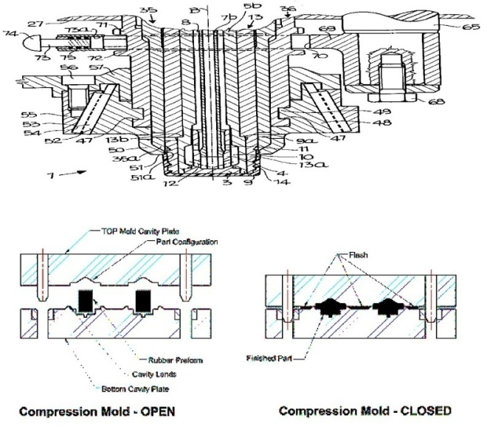

**ii) Injection moulding:**

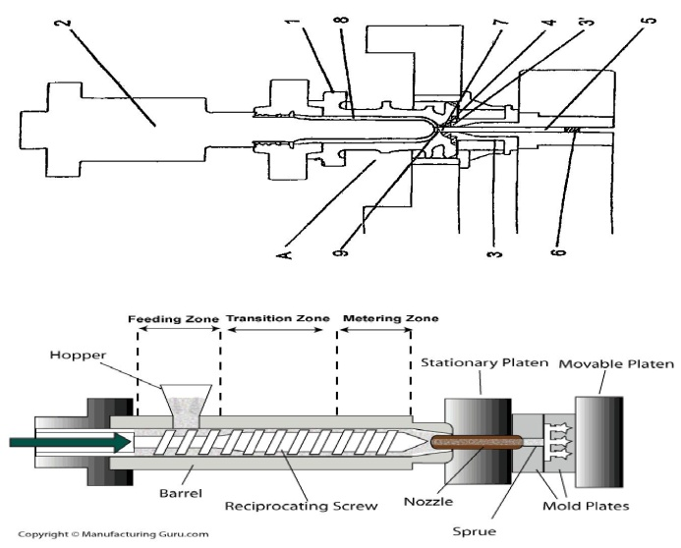 In this method, the moulding plastic powder is fed into a heated cylinder from where it is injected at a controlled rate into the tightly locked mould by means of a screw arrangement or by a piston plunger. The mould is kept cold to allow the hot plastic to cure and become rigid. When the materials have been cured sufficiently, half of the mould is opened to allow the injection of the finished article without any deformation, etc. Heating is done by oil or electricity.

**Differences between compression and injection moulding techniques:**

|  |  |  |
| --- | --- | --- |
|  | Compression Moulding | Injection Moulding |
| 1. | The plastic ingredient in proper proportions are filled in between the two half portions of the mould. These portions are moved relative to each other and by applying heat and pressure, the part or plastic can be manufactured | In this, the heated plastic is injected into the mould cavity from where it is cooled and taken out. |
| 2. | It is applicable to both thermosetting and thermoplastic resins | It is applicable to thermoplastic resins |
| 3. | Moulding is often simpler | Moulding is somewhat complicated compared to compression moulding |
| 4. | It is less expensive | It is expensive |
| 5. | Require more operation time | Require less operation time |
| 6. | Less production time | High production rate |
| 7. | There is no limiatation to design of articles to be moulded | There is limitation to the design of articles to be moulded |
| 8. | High moulding cost | Less moulding cost |

**PREPERATION , PROPERITIES AND APPLICATIONS OF PVC AND BAKELITE**

**PVC :** Poly Vinyl Chloride is obtained by heating a water emulsion of vinyl chloride in presence of a small amount

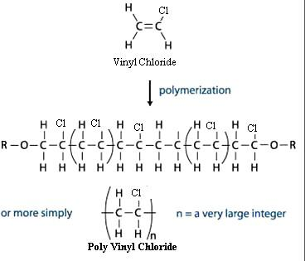 of benzoyl peroxide or hydrogen peroxide in an auto clave under pressure.

Vinyl chloride, so needed is generally prepared by treating acetylene at 1 to 1.5 atmospheres with

chloride at 600C to 800C in the presence of metal chloride as catalyst.

CH = CH + HCl CH2 = CH Cl

Acetylene Vinyl chloride

**Properties**: It occurs as a colourless rigid material.

It is having high density and low softening point.

It is resistant to light, atmospheric oxygen, inorganic acids and alkalis.

It is most widely used synthetic plastic.

**Uses:** It is mainly used as cable insulation, leather cloth, packing and toys.

It is used for manufacturing of film, sheet and floor covering.

PVC pipes are used for carrying corrosive chemicals in petrochemical factories

**Bakelite:** It is prepared by condensing phenol with formaldehyde in presence of acidic/alkaline catalyst.

The initial reaction results in the formation of O- and P- hydroxyl methyl/phenol which reacts to form

linear polymer. During modeling hexamethylene tetramine is added, which converts to insoluble solid of cross-linked structure Bakalite.

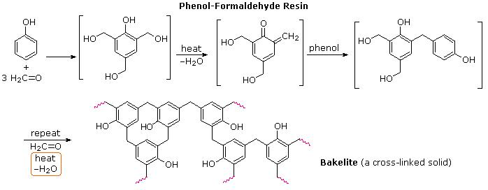

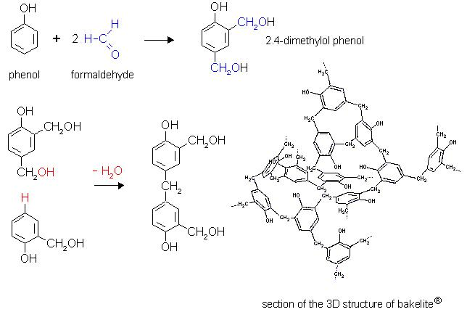

**Applications**: It is used for making electric insulator parts like switches, plugs, switch boardsetc. For

making moulded articles like telephone parts cabinet of radio and television.

**FIBRES:**

**Properties of Textile Fiber:**   
To be a textile fiber it has some properties. The [properties of textile fiber](http://textilelearner.blogspot.com/2011/07/textile-fiber-properties-of-textile.html) are given below:   
Normally properties of textile fiber are three types   
A) [**Physical Properties**](http://textilelearner.blogspot.com/2011/05/physical-properties-of-cotton-fiber-end_846.html) B) [**Mechanical Properties**](http://www.textilelearner.blogspot.com/2011/07/mechanical-properties-of-textile-fibers.html) C) [**Chemical Properties**](http://textilelearner.blogspot.com/2011/07/textile-fiber-properties-of-textile.html)   
  
**A) Physical Properties**   
1. Length   
2. Fineness   
3. [**Crimp**](http://textilelearner.blogspot.com/2012/01/crimp-percentage-determination-of-crimp.html)   
4. Maturity   
5. Lusture   
6. Softness   
7. Resiliency   
8. Work of rupture   
9. Density   
10. Appearance   
11. Flexibility   
12. Toughness   
13. Elorgation   
**B)Mechanical Properties**   
1. Strength   
2. Elasticity   
3. Extensibility   
4. Rigidity   
**C) Chemical Properties**   
1. Solubility in aqueous salt   
2. Solubility in organic salt

**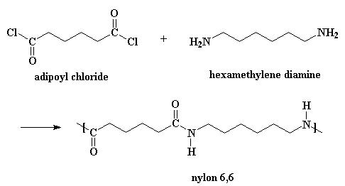 Nylon-6,6**: It is prepared by Hexamethylene diamine and Adipic acid are polymerized in 1:1 ratio. **Properties**: This is linear polymer not resistant to alkali and mineral acids.Oxidising agents like hydrogen peroxide, potassium permanganate etc. are able to degrade the fibres.

**Applications:** Nylon-6,6 is mainly used for moulding purposes for gear bearings and makingcar tyres, used

for fibres etc.

This is mainly used in manufacture of tyre cord. Other uses include manufacture of carpets, rope, fibre cloth etc.

**POLYESTER** Terylene is a polyester fibre made from ethylene glycol and terephthalicacid. Terephtalic acid required for the manufacture of Terylene is produced by the catalytic atmospheric oxidation of p-xylene.

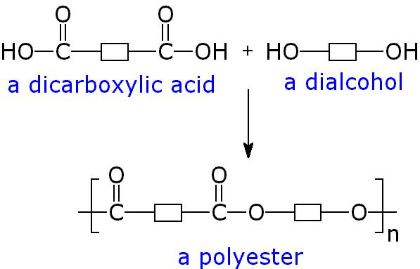

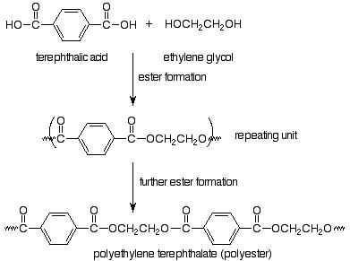

**Properties:** This occurs as a colourless rigid substance. This is highly resistant to mineral andorganic acids

but is less resistant to alkalis. This is hydrophobic in nature. This has high melting point due to presence of aromatic ring.

**Uses:** It is mostly used for making synthetic fibres. It can be blended with wool, cotton forbetter use and wrinkle resistance. Other application of polyethylene terephthalate film is in electrical insulation.

**FIBREREINFORCED PLASTICS**

THE fobre reinforced plastics composites constitute more than 90% ( by weight ) of the composites used in various industries . the advantages of using polymer in structural composites is the ease of fabrication of complex structural shapes it can be manufactured.

Preparation frp are produed by suitably bonding a fibre material with a resin matrix and curing them under oressure and heat. The main reinforcing agents used in FRP composites are glass , graphite, alumina, carbon, boron , etc.

The reinforcement material can be different forms such as sort fibres, continuous filaments or woven fabrics.

The resin matrix commonly uswede in FRP are polyesters , epoxy,phenolic, silicon,and polyamide polymer resins

Characteristics or properities of FRP

1. It possess superior properities like higher yield strength, fracture strength and fatigue life.
2. Since fibre prevents slip and crack propagation , the mechanical properities of FRp gets increased.
3. It possess high corrosion resistance and heat resistance property.

## example polymer and reinforcement combinations

|  |  |  |
| --- | --- | --- |
| **Reinforcing material**[**[2]**](https://en.wikipedia.org/wiki/Fibre-reinforced_plastic#cite_note-Gunter-2) | **Most common matrix materials** | **Properties improved** |
| Glass fibres | [UP](https://en.wikipedia.org/wiki/Unsaturated_polyester), [EP](https://en.wikipedia.org/wiki/Epoxide), [PA](https://en.wikipedia.org/wiki/Polyamide), [PC](https://en.wikipedia.org/wiki/Polycarbonate), [POM](https://en.wikipedia.org/wiki/Polyoxymethylene), [PP](https://en.wikipedia.org/wiki/Polypropene), [PBT](https://en.wikipedia.org/wiki/Polybutylene_terephthalate), [VE](https://en.wikipedia.org/wiki/Vinyl_ester) | Strength, elasticity, heat resistance |
| Wood fibres | [PE](https://en.wikipedia.org/wiki/Polythene), PP, [ABS](https://en.wikipedia.org/wiki/Acrylonitrile_butadiene_styrene), [HDPE](https://en.wikipedia.org/wiki/High-density_polyethene), [PLA](https://en.wikipedia.org/wiki/Polylactic_acid) | Flexural strength, tensile modulus, tensile strength |
| Carbon and aramid fibres | EP, UP, VE, PA | Elasticity, tensile strength, compression strength, electrical strength. |
| Inorganic particulates | Semicrystalline thermoplastics, UP | Isotropic shrinkage, abrasion, compression strength |

## Applications

### Carbon-fibre-reinforced polymers

Main article: [Carbon-fibre-reinforced polymer](https://en.wikipedia.org/wiki/Carbon-fibre-reinforced_polymer)

Rudder of Airbus A310

Advantages over a traditional rudder made from sheet aluminium are:

* + 25% reduction in weight
  + 95% reduction in components by combining parts and forms into simpler moulded parts.
  + Overall reduction in production and operational costs, economy of parts results in lower production costs and the weight savings create fuel savings that lower the operational costs of flying the aeroplane.

### Glass-fibre-reinforced polymers

Engine intake manifolds are made from glass-fibre-reinforced PA 66.

* Advantages this has over cast aluminium manifolds are:
  + Up to a 60% reduction in weight
  + Improved surface quality and aerodynamics
  + Reduction in components by combining parts and forms into simpler moulded shapes.

Automotive gas and clutch pedals made from glass-fibre-reinforced PA 66 (DWP 12–13)

Advantages over stamped aluminium are:

* + Pedals can be moulded as single units combining both pedals and mechanical linkages simplifying the production and operation of the design.
  + Fibres can be oriented to reinforce against specific stresses, increasing the durability and safety.

Aluminium windows, doors and facades get thermally insulated by using thermal insulation plastics made of glass fibre reinforced polyamide. In 1977 Ensinger GmbH produced first insulation profile for window systems.

**Natural Rubber:** Rubbers also known as Elastomers, they are high polymers, whichhave elastic properties in excess of 300%. Natural rubbers consist of basic material latex, which is a dispersion of isoprene. During the treatment, these isoprene molecules polymerize to form, long-coiled chains of cis-polyisoprene. Natural rubber is made from the saps of a wide range of plants like Hevea brasillians and guayule. Latex: is a milky white fluid that oozes out from the plant Hevea brasillians when a cut is made on the steam of the plant. The latex is diluted with water. Then acetic or formic acid is added [1kg of acid per 200kgs of latex] to prepare coagulum. This is processed to give wither crepe rubber or smoked rubber.

**Vulcanization:**Vulcanization discovered by Charles Goodyear in 1839.

It consists of heating the raw rubber at 100 – 1400C with sulphur. The combine chemically at the double bonds of different rubber spring and provides cross-linking between the chains. This cross- linking during vulcanization brings about a stiffening of the rubber by anchoring and consequently preventing intermolecular movement of rubber springs. The amount of sulphur added determines the extent of stiffness of vulcanized rubber. For example, ordinary rubber (say for battery case) may contain as much as 30% sulphur.

Advantages of vulcanization:

The tensile strength increase.

1. Vulcanized rubber has excellent resilience.
2. It has boarder useful temperature range (-40 to 1000C)
3. It has better resistance to moisture, oxidation and abrasion.
4. It is resistance to organic solvents like CCl4, Benzene petrol etc.
5. It has only slight thickness.
6. 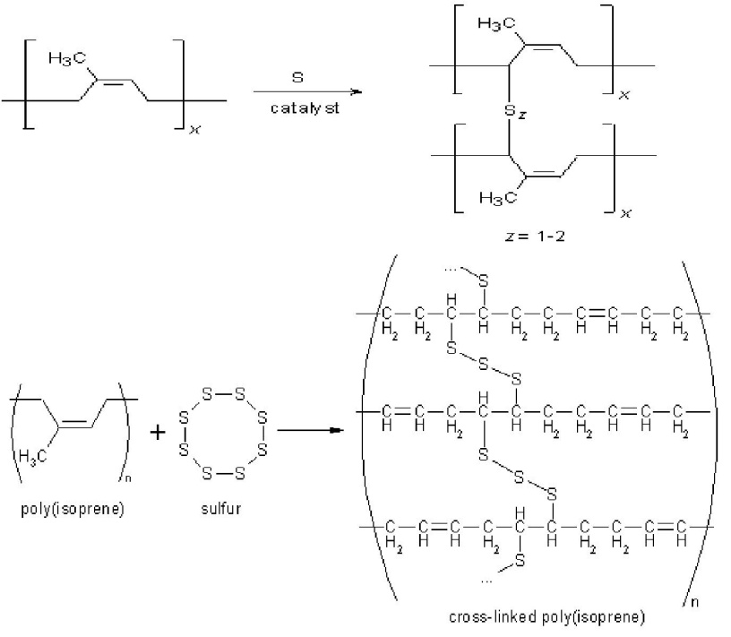It has low elasticity

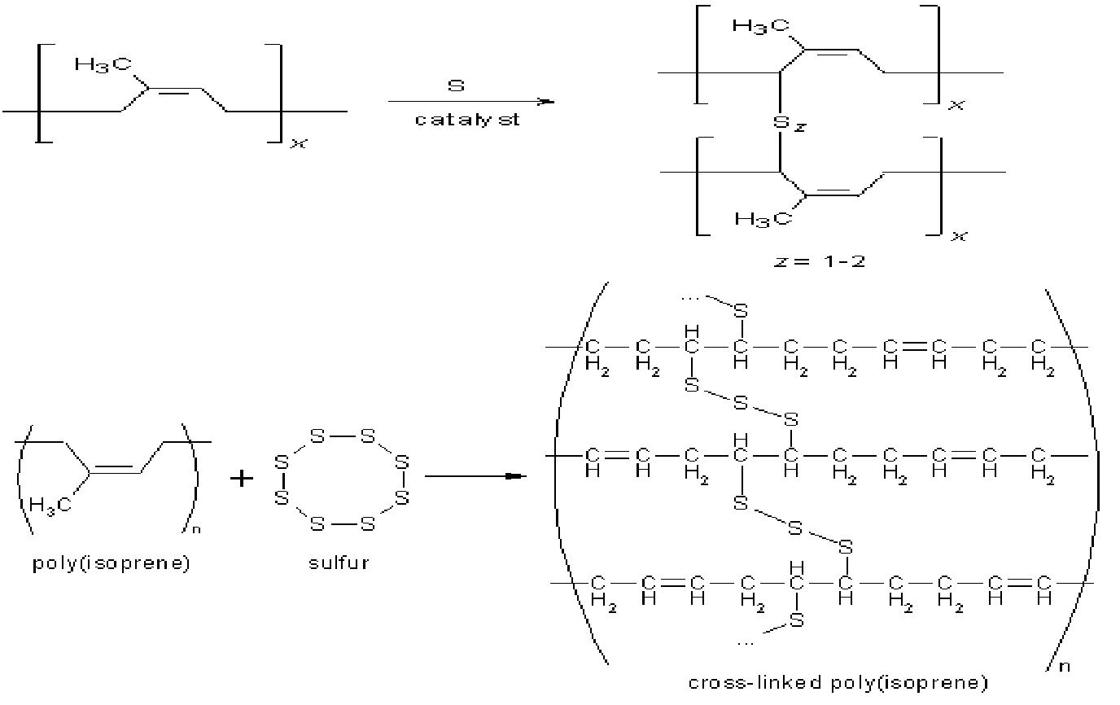

**Copmounding of rubber:-** **1. Elastomer system**

• One or more elastomers for characteristics  
• Elastomer for improved processing

1. **Filler System**
2. • Reinforcing filler  
   • Semi and non-reinforcing fillers  
   • Plasticizers

**3. Protectants**

• Antioxidents  
• Antiozonants  
• Inhibitors/promoters

**4. Process Aids**

• Mixing Aids  
• Molding Aids

**5. Cure System**

• Vulcanizing Agents  
• Activators  
• Accelerators  
• Scorch Retarders

**ELASTOMERS**

**Buna – S or STYRENE RUBBER:**

Buna-S rubber is probably the most important type of synthetic rubber, which is produced by

copolymerization of butadiene (about 75% by weight) and styrene (25% by weight).

nCH2 = CH – CH = CH2 + n CH2 = CH –Ph 🡪(-H2C -CH = CH –CH --CH2 –CH – Ph-)n-

1,3-butadiene (75%) Styrene(25%)

**Properties:** Styrene rubber resembles natural rubber in processing characteristics as well asquality of finished products It possesses high abrasion-resistance, high load-bearing capacity and resilience. However, it gets readily oxidized, especially in presence of traces of ozone present in the atmosphere. Moreover, it swells in oils and solvents. It can be vulcanized in the same way as natural rubber either by sulphur or sulphur monochloride (S2Cl2). However, It requires less sulphur, but more accelerators for vulcanization

**Uses**: Mainly used for the manufacture of motor tyres. Other uses of these elastomers are floortiles,

shoe soles, gaskets, foot-wear components, wire and cable insulations, carpet backing, adhesives, tank-linings, etc.

BUTYL RUBBER:- butyl rubber is a copolymer of isobutylene and a small amount of isoprene

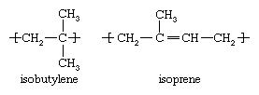 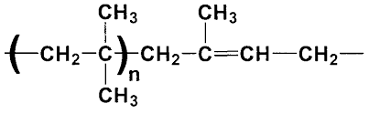

### Properties

* Copolymer of isobutylene and a small amount of isoprene
* Vulcanized
* Impermeable to most common gasses
* High damping capabilities

### Advantages

* Flexibility
* Air tight and gas impermeable (a property unique to butyl rubbers)
* Low glass transition temperature
* Good ozone resistance
* Displays high damping at ambient temperatures
* Good weathering, heat, and chemical resistance
* Good vibration damper
* Biocompatible
* Age resistance

### Applications utilizing these materials

* Sealant for rubber roof repair
* Tubeless tire liners
* Inner tubes
* Stoppers for glass bottles, medicine bottles, and pharmaceuticals
* Used in sealants and adhesives
* Butyl O Rings
* Pond Liners
* Tank Liners

**THIOKOL RUBBER**

This also called as polysulphide rubber (or Gr-P). It can be prepared by the condensation polymerization of sodium polysulphide (Na2Sx) and ethylene dichloride.

S S

| |

Cl – CH2 - CH2 – Cl + Na – S – S – Na + Cl – CH2 - CH2- Cl

Ethylene dichloride Sodium polysulphide Ethylene dichloride

S S

| |

-CH2 – CH2 – S – S – CH2 – CH2-

Thiokol

It is used for the -

1. Manufacture of oils hoses, chemically resistant tubing and engine gaskets;
2. Diaphragms and seals in contact with solvents and
3. Printing rolls,
4. Containers for transporting solvents and
5. Solid propellant fuels for rockets, etc.

**Conducting Polymers :**

Most polymeric materials are poor conductor of electricity, because of the non – availability of large number of free electrons in the conduction process.

“ The polymeric materials, which possess electrical conductivities on par with metallic conductors, are called conducting polymers”

Conductivities as high as 1.510-1 ohm-1 m-1 have been attained in these polymeric materials. On a volume basis, this value is equal to one fourth of the conductivity of copper (or) is twice its conductivity on the basis of weight. Electrical conductivity of some polymers are given below.

|  |  |  |
| --- | --- | --- |
|  | **Polymers** | **Electrical conductivity (ohm-1 m-1** |
| 1 | Phenol formaldehyde | 10-9 – 10-10 |
| 2 | Poly – methyl methacrylate | < 10 -12 |
| 3 | Nylon – 6,6 | 10-12 – 10-13 |
| 4 | Polystyrene | < 10-14 |
| 5 | Polyethylene | 10-15-10-17 |
| 6 | Polytetrafluoro ethylene | <10-17 |

**Different types of conducting polymers are discussed below:**

1. Intrinsically conducting polymer (ICP) (or) Conjugated – Electrons conducting polymer
2. Doped conducting polymer
3. Extrinsically conducting polymer
4. Coordination conducting polymer (inorganic polymer)

(1) **Intrinsically conducting polymer (ICP) or Conjugated – Electrons conducting polymer**

The polymers which conduct electricity are called conducting polymers. The conduction of the polymers is may be due to the presence of double bonds in the structure (Intrinsic Conducting Polymers) or due to the presence of externally added ingredients in them (Extrinsic Conducting Polymers).

Intrinsic conducting polymers are classified into two types.

1. Conducting polymers having conjugation:

These polymers have conjugated double bonds in the backbone and possess their conductivity due to pi-electrons.

The orbitals of conjugated electrons overlap the entire backbone of the polymer and result in the formation of valence bands and conduction bands, which were separated by a significant Fermi energy gap. The electrical conductivity will takes place only after thermal or activation of the electrons, which give them sufficient energy to jump the gap and reach into conduction band.



**Ex:**

Polymerization of acetylene over Zeigler Natta catalysts will give polyacetylene, which is predominantly in *cis-*form. On rising the temperature of the film gives more stable *trans*-form.







1. Doped conducting polymers:

The conducting polymers having pi-electrons in their backbone can be easily oxidized or reduced because of their low ionization potential and high electron affinities. Hence their conductance can be increased by the introduction of a +ve charge or –ve charge on backbone by oxidation or reduction.

If the conductivity increased by the oxidation process by adding some alkali metal ion or electron acceptor, then it is said to be “p-doping”. If the conductivity is increased by reduction process by adding an electron donor is called “n-doping”.

* **Oxidation process (p-doping)**:

In this process, -electrons are removed from conjugated double bonds and positive hole or radical cation is created. The radical cation is called ‘polaron’ which stabilizes itself by polarizing the medium. The polarons are mobile and this delocalization is responsible for the conduction of current in the polymers. The p-doping is generally brought by adding Lewis acids (such as FeCl3), iodine, bromine arsenic pentafluoride (AsF5) etc.

Ex: polyacetylene





Doping of polyacetylene:













**Reduction process (n-doping):**

In this type of doping some electrons are introduced into the polymer by reducing agent like sodium naphthalide[**Na+(C10H8)-]**or by adding Lewis base (electron donor). Formation of polaron, bipolaron takes place in two steps, followed by recombination of radicals, which yields two charge carriers on the polyacetylene chain, which are responsible for the conduction as shown below.





The n-doping in less common, because on earth, atmosphere is oxygen rich, which creates an oxidizing environment. An electron rich ‘n-doped’ polymer will react immediately with oxygen and converts into the neutral state by re-oxidizing.

Polyaniline

It can be prepared by the reaction of aniline with ammonium persulfate in aq. HCl.



Poly aniline is a conjugated polymer and in reactive. Polyaniline is considered as an organic metal.Poly aniline is transparent in thin layers. In conducting state it will be in green colour. It turns red under reducing conditions and blue under oxidizing or basic conditions. Poly aniline is a stable conducting polymer. It has wide range of conductivity (10-11–105 S/cm). It can be synthesized chemically (or) electrochemically as a blue powder or film.

Emeraldine salt is the most stable form of polyaniline. It is also known as “Synthetic metal”, because it possess metallic conductivity, metallic lusture and metallic sound.

-

**(3) Extrinsically conducting polymers :**

Extrinsically conducting polymers are those polymers whose conductivity is due to the presence of “externally” added ingradient in them. These are of the following two types.

(a) **Conductive element filled polymer :** It is a resin or polymer filled with conducting elements such as carbon black, metallic fibres, metal acids, etc. In this, the polymer acts as the binder to hold the conducting elements together in the solid entity.

(b) **Blended conducting polymer :** It is the product obtained by blending a conventional polymer with a conducting polymer either by physical or chemically change.

**(4) Coordination conducting polymer :**  (inorganic Polymer)

It is a charge transfer complex containing polymer obtained by combining a metal atom with a polydentate ligand.

**Application :** Conducting polymers are finding increased use because they are light weight, easy to process and have good mechanical properties. Some of the important applications of conducting polymers are :

(A) In rechargeable light weight batteries based on perchlorate doped polyacetylene – lithium system. These are about 10 times, lighter than conventional lead storage batteries. Such batteries are sufficiently flexible to fit a variety of designed configuration.

(b) In optically display devices based on polythiophene. When the structure is electrically based, the optical density of the film changes, i.e., colour changes. Such electrochromic systems produce coloured displays with faster switching time and better viewing than conventional liquid crystal display devices. (LCD)

(C) in wiring in aircrafts and aerospace components

(D) in telecommunication systems

(F) in antistatic coatings for clothing.

**Bio degradable polymers** are a specific type of [polymer](https://en.wikipedia.org/wiki/Polymer) that [breaks down](https://en.wikipedia.org/wiki/Chemical_decomposition) after its intended purpose to result in natural byproducts such as gases ([CO2](https://en.wikipedia.org/wiki/Carbon_dioxide), [N2)](https://en.wikipedia.org/wiki/Nitrogen), [water](https://en.wikipedia.org/wiki/Water), [biomass](https://en.wikipedia.org/wiki/Biomass), and inorganic salts.[[1]](https://en.wikipedia.org/wiki/Biodegradable_polymer#cite_note-ESN-pdf-1)[[2]](https://en.wikipedia.org/wiki/Biodegradable_polymer#cite_note-HoBP-2) These polymers are found both naturally and [synthetically](https://en.wikipedia.org/wiki/Chemical_synthesis) made, and largely consist of [ester](https://en.wikipedia.org/wiki/Ester), [amide](https://en.wikipedia.org/wiki/Amide), and [ether](https://en.wikipedia.org/wiki/Ether) functional groups. Their properties and breakdown mechanism are determined by their exact structure. These polymers are often synthesized by [condensation reactions](https://en.wikipedia.org/wiki/Condensation_reaction), [ring opening polymerization](https://en.wikipedia.org/wiki/Ring_opening_polymerization), and [metal catalysts](https://en.wikipedia.org/wiki/Catalysis).

POLY LACTIC ACID : Condensation of lactic acid into dimeric lactide followed by ring-opening polymerization of to form poly(lactic acid); b) Direct condensation of lactic acid,

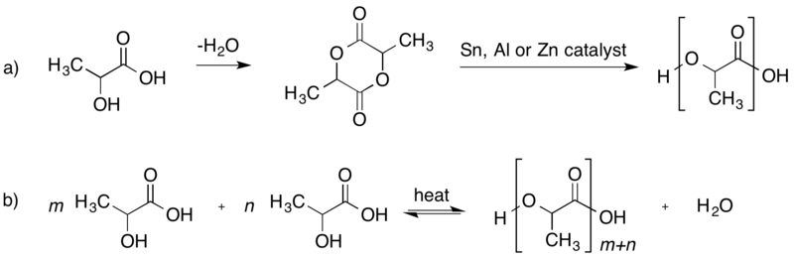

PROPERITIES:- 1.PLA posess good bio- compatibility ,processibility, hogh strength

2.D- isomer of PLA is crystallinity and L \_ isomer is amorphous.

3. biodegradation of D – isomer is slower than L – isomer

Applications

1. PLA is used for making medical implants like screws, pins , anchors etc.
2. It is used in a number of biomedical applications like drug delivery devices and dialysis media
3. It is used in the preparation of bioplastics fot packing food and disposable table ware.
4. It is used for making compostable packing materials , food packing etc.

POLY VINYL ALCOHOL:-

PVA is water soluble biodegradable polymer produced from starch. It can be hydrolysed to glucose by micro organisms and then metabolized to CO2 and H2O.

Biodegradable PVA is synthesized by heating vinyl acetate in presence of acetyle chloride as catalyst.

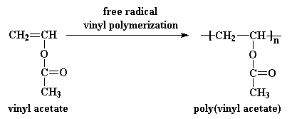

PROPERTIES :-

1. it is a colorless, transparent material
2. it is water soluble
3. it is harmless , if taken orally.
4. the biodegradability can be improved easily by introducing starch molecule into the backbone of pva
5. it possess good mechanical properities.

APPLICATIONS

1. PVA is used in food industry as a packing materials and food storage.
2. It is used for bonding papers and mailing compost bags
3. It is used for making records, chewing gums.

**UNIT IV**

**FUELS AND COMBUSTION**

Energy is a part of life. Better energy sources are status symbol of a country. Fuels are mainly the energy sources for the industry and domestic purposes. For many years to come, the greatest portion of the world’s power will come from the combustion of fuels.

Fuel is a combustible substance, containing carbon as main constituent, which on proper burning gives large amount of heat, which can be used economically for domestic and industrial purposes.

Ex: Wood, Charcoal, Coal, Kerosene, petrol, Diesel, Producer gas, Oil gas etc… are some of the fuels.

The combustion is a quick, high temperature oxidation of fuels, converting carbon to CO2 and hydrogen to water with the evolution of heat and light. During the process of combustion of a fuel (like coal) the atoms of carbon, hydrogen, etc. combine with oxygen with the simultaneous liberation of heat at a rapid rate. This energy is liberated due to the “rearrangement of valancy electrons”, in these atoms, resulting in the formation of new compounds (like CO2, H2O etc.). These new compounds have less energy (or heat content) in them and, therefore, the energy (or heat) released during the combustion process is the difference in the energy of the reactants (C, H and O etc; of fuel) and that of the products formed.

Fuel + O2 Energy + Products

The main source of fuels is coal and petroleum oils, the amounts of which are dwindling day –by –day. These are stored fuels available in earth’s crust and are, generally called “fossil fuels.

Now a day’s different type of fuels are available

Fuels

|  |
| --- |
|  |

Bio fuels fossil fuels nuclear fuels

[biomass (soild) bio gas (liquid) [petroleum products](Liquid) [92U 235,]

U=uranium

Pu= plutonium

**Classification of fuels:-**

Classification of fuels is based on two factors.

1. The way it is obtained (natural or artificial)
2. Physical state of the fuel (solid, liquid, gas).

**Based on above said factors, fuels are classified into 2 types**

1. **Natural fuels (or primary fuel):-**

Some fuels are found in nature and are used in the some form are called natural fuels, or primary fuels.

Ex:-wood, coal and natural gas.

1. **Artificial fuel (secondary fuel):-**

Some of the fuels that are derived from other fuels (primary) are called artificial or secondary fuels.

Ex:- petrol and charcoal. Fuel

Natural (primary) fuel Artificial(secondary) fuel

Solid liquid Gas Solid liquid Gas

**Comparison of solid, liquid and gaseous fuels :-**

|  |  |  |
| --- | --- | --- |
| **Solid** | **Liquid** | **Gas** |
| Cheap and easily available | Costly and available only in the Arabic countries and obtained from mines | More costly except natural gas |
| As it does not burn spontaneously , its storage transportation and use is easy | Transportation easy and storage needs care | Transportation is easy but storage is risky |
| Fire hazards are least | More risky | More risky |
| Slow combustion | Quick combustion | Very fast combustion |
| Ash content is more | No ash content | No ash content |
| Causes more pollution | Less pollution | Least pollution |
| Low calorific value | Higher calorific value | Highest calorific value |
| More oxygen is required for combustion | Less O2 is required for combustion | Least O2 is required for combustion |
| It cannot be used in vehicles as fuel | Mainly used in vehicles as fuel | Also used as fuel for vehicles |

**Characteristics of a good fuel:-**

1.It should be dry and should have less, moisture content, dry fuel increases its calorific value.

1. It should be cheap, poor people cannot afford costlier fuel.
2. It should be easily transportable ,otherwise cost of fuel will increase
3. It must have high calorific value .
4. It must have less ash after combustion. In case more ash, the fuel gives less heat.
5. It must have moderate temperature; low burning (or) ignition temperature can cause fire accident.
6. It should not burn spontaneously to avoid fire hazards.
7. It should not give poisonous gases after combustion
8. Its handling should be easy.
9. The combustion of a good fuel should not be explosive.

**SOLID FUELS: - (COAL)**

**WOOD:-** Wood is obtained from forests. Freshly cut wood contains 25 to 50% moisture, which is reduced to about 15% on air-drying. The average composition of wood on dry moisture-free-basis is: Carbon = 55%, Hydrogen = 6%; Oxygen = 43%, ash = 1%. The calorific value of air-dried-wood is about 3,500 to 4,500 kcal/kg.

**COAL: -** Because of the environmental hazards, the trees were buried inside the earth. By the temperature, pressure and bacterial actions, they were converted into a brown-black solid named coal, in thousands of years.

Temperature / Pressure

Wood ------ --- Coal

Bacterial action

The process of conversion of wood into coal is called “Coalification”. Depending upon the percentage of carbon, hydrogen, moisture and calorific value, four different types of coals exist. It is called “Ranking of coal”

**Wood 🡪 Peat 🡪 Lignite 🡪 Bituminous coal 🡪 Anthracite**

**This progressive transformation of wood to anthracite results in :**

1. Decrease in the moisture content.
2. Decrease in hydrogen, oxygen, nitrogen and sulphur contents, with a corresponding rise in carbon content.
3. Decrease in volatile matter content.
4. Increase in the calorific value.
5. Increase in hardness.
6. **Peat: -** Peat is brown fibrous jelly-like mass. It is regarded as the first stage in the coalification of wood. Peat is mostly dug by manual labor. It is uneconomical fuel, since it may contain as much as 80-90% water, but on air-drying (after 1 to 2 months drying), it burns freely. The average composition of air-dried peat is C = 57%, H = 6%, O = 35%, ash content = 2.5-6%.

Its calorific value is about 5,400 kcal / kg.

1. **Lignites : - (Brown Coals)**

These are soft, brown colored variety of lowest rank coals, which consist of vegetable matter decomposed more than that in peat. It consists of 20-60% of moisture and on air-drying; it breaks up into small pieces. Air-dried Lignite contains, C = 60-70%, O = 20%.

The calorific value is about 6,500 – 7,100 kcal / kg.

1. **Bituminous Coals : - (Common Coals):**

These are pitch-black to dark-grey coals, which usually soil hands. They show a laminated structure of alternate very bright and dull layers. The common bituminous coals are sub-classified on the basis of carbon content.

1. **suub-bituminous Coals: -**

These are black in color and more homogeneous and smooth in appearance. Carbon content varies from 75% to 83 % and oxygen from 10% to 20%. The calorific value is about 7000 – 7500 kcal /kg.

1. **Bituminous coals:-** These can show a typically banded appearance and carbon content ranges from 78-90% their calorific value is 8,000-8,500 kcal/kg. Coal of this class is used in the large quantities in industries for making metallurgical coke, coal gas and for steam raising and domestic heating.
2. **Semi- bituminous coals:-** These included varieties of bituminous coals that are rich in carbon (90-95%) and have low volatile matter.

Their calorific value is about 8500-8600Kcal/Kg.

1. **Anthracite: -** It is a class of highest rank coal, containing highest percentage of carbon (92-98%) and has lowest volatile matter and moisture content they are hardest of all kinds of coals, quite dense and lustrous in appearance. Their calorific value is about 8,650-8,700 kcal/kg and ash content is very small (about 3%),

Change in the average composition from wood to anthracite,

|  |  |  |  |  |  |  |
| --- | --- | --- | --- | --- | --- | --- |
| **Fuel** | **Moisture of air-dried sample at 40’c(%)** | **C** | **H** | **N** | **O** | **CALORIFIC VALUE** |
| Wood | 25% | 50 | 6 | 0.5 | 43.5 | 3500 - 4500 |
| Peat | 25% | 57 | 5.7 | 2 | 35.3 | 4125 - 5400 |
| Lignite | 20% | 67 | 5 | 1.5 | 26.5 | 6500 - 7100 |
| S.B.coal | 11% | 77 | 5 | 1.8 | 16.2 | 7000 - 7500 |
| B.coal | 4% | 83 | 5 | 2 | 10 | 8000 - 8500 |
| Semi.B.C | 1% | 90 | 4.5 | 1.5 | 4 | 8500 - 8600 |
| Anthracite | 1.5% | 93.3 | 3.0 | 0.7 | 3.0 | 8650 - 8700 |

**Analysis of Coal**:-

The analysis of coal is helpful in its ranking. The assessment of the quality of coal is carried out by these two types of analysis.

1. Proximate Analysis
2. Ultimate Analysis
3. **Proximate Analysis :-** In this analysis, the percentage of carbon is indirectly determined. This analysis includes percentage of moisture, % of volatile substance, % of ash content and % of carbon.
4. **Moisture:-** A known mass of finely powdered coal is taken in a crucible. It is heated up to 1100C in an electric hot air-oven. The crucible allowed to remain in oven for 1 hour and then taken out, cooled in a desiccator and weighed. Loss in weight is reported as moisture.

% of moisture = Loss in weight x 100

Weight of Coal taken

1. **Volatile matter: -** The above sample is taken and heated at 9500C in an electric furnace in the absence of air for 7 minutes. It is then cooled to room temperature and weighed. The loss of weight is reported as volatile matter and is removed from coal at 9500C.

% of volatile matter = Loss in weight due to removal of volatile matter X 100

Weight of Coal taken

1. **Ash Content: - In** this analysis, the above coal, free from moisture and volatile matter, is heated in a crucible at about 7000c in the presence of air. It undergoes combustion and results in the formation of ash. Crucible is cooled to room temperature and weighed. The weight of ash is then determined.

% of ash == weight of ash formed X 100

Weight of Coal taken

1. **Carbon: -** Since main component of coal is carbon, it can be determined by subtracting the sum of percentage of moisture , volatile substance and ash content from 100.

% of Carbon = 100 – (% of moisture + % of volatile matter + % of ash)

**Importance or Significance of Proximate Analysis:-**

Proximate analysis provides following valuable information’s in assessing the quality of coal.

**Moisture: -** High moisture content in the fuel reduces the calorific values and increases the transport costs; the better is the quality of a fuel.

**Volatile matter: -** A coal containing high volatile matter burns with long flame, high smoke and low calorific value, volatile matter also influences the design of furnace since the higher the volatile matter, larger is the combustion space required.

**Ash:-** It is a useless, non- combustible matter, which reduces the calorific value of coal, ash content also increases the cost of transportation, handling and storage and disposal. It determines the quality of coal .Hence the lesser the percentage of ash, the better is the quality of coal.

**Carbon:-** The higher the fixed carbon in a coal, the greater is its calorific value.

**2. ULTIMATE ANALYSIS**:-

This analysis includes percentage of C, H, O, S, N and ash content in coal.

1. **Carbon and hydrogen determination :-**

A known weight (1-2gr) of coal is taken and burnt in an apparatus. The carbon change to CO2 and hydrogen changes to H2O. The vapors of CO2 and H2O are then passed through KOH and CaCl2. The CO2 is absorbed by KOH in the tube while H2O is absorbed by CaCl2, because of the absorption, the weight of KOH and CaCl2 increases, which is measured

C+O2 Ignition CO2 (44)

H2 +  O2 Ignition H2O (18)

2 KOH +CO2 K2 CO3 +H2O

CaCl2 + 7 H2O CaCl2. 7H2O (hydrated calcium chloride)

Percentage of carbon =     100

Percentage of carbon =     100

**Significance: -** The higher the percentage of carbon and hydrogen, the better is the quality of coal and higher its calorific value. Percentage of carbon helps in assessing the rank of coal.

**b) Nitrogen determination:-** The estimation of nitrogen is done by Kjeldahl’s method

(i) About 1 gr of accurately weight powdered coal is heated with conc. H2 SO4 along with K2SO4 .

(ii) When clear solution is obtained (i.e., when whole nitrogen is converted into ammonium sulphate) it is treated with excess of NaOH to liberate ammonia.

(iii) The ammonia thus produced is distilled over and absorbed in a known volume of standard H2SO4 solution.

(IV) The volume of unused H2SO4 acid is then determined by back titration with standard NaOH solution [un used H2SO4 means unreacted H2SO4]

Percentage of Nitrogen =

**Significance :-** Nitrogen does not have any calorific value. It has no significance, thus, a good quality coal should have very little nitrogen content.

**© Sulphur determination: -** A known amount of coal is burnt completely in a bomb calorimeter in a current of oxygen, by which sulphur present in coal is oxidized to sulphates. The ash from the bomb calorimeter is extracted with dil.HCl the acid extract is then treated with BaCl2 solution to precipitate sulphate as BaSO4 which is filtered, washed, dried and heated to constant weight.

Percentage of sulphur =

[Atomic weight of S=32; molecular wt of BaSO4  = 233]

**Significance:-** (a) sulphur increases calorific value . (b) The product of combustion SO2, SO3 have corrosive effect on equipment, and cause air pollution.

(d) **Oxygen determination**: - The % of oxygen is determined by subtracting the sum of percentage of C, H, S, N and ash from 100.

Percentage of oxygen = 100 – [percentage of C+H+N+S+ash]

**Significance: -** Oxygen content decreases the calorific value of coal. High oxygen – content coals are characterized by high inherent moisture, low calorific value. Increases in 1% oxygen content decrease the calorific value by about 1.7% and hence, oxygen is undesirable. Thus, a good quality coal should have low percentage of oxygen.

**LIQUID FUEL :- ( PETROLEUM)**

Petroleum is one of the best primary liquid fuels. It is also known as crude oil. Petrol, diesel, kerosene are main liquid fuels. They are secondary liquid fuels derived from petroleum. These fuels are used for domestic works, auto vehicles and power generation.

The word meaning of petroleum is ‘rock oil’ (petra = rock; oleum = oil; petroleum is dark brown viscous liquid. Petroleum is a mineral found deep in earth’s crust. It is a mixture of number of hydrocarbons (paraffin’s highly active compounds along with traces of compounds of heavy metals like Fe,Co,Ni,V.

Composition of petroleum is given as: [paraffins = alkanes olivines = alkenes]

C= 80-87.1%, H = 11.1 – 15.0% S = 0.1 – 3.5%, O = 0.1 – 0.9%, N = 0.4 – 0.9%

**Origin of petroleum: -** There are two theories to explain the origin of petroleum

**Carbide theory :-** [Inorganic theory (or) Mendeleev’s Theory ]

Metals inside the earth react with carbon and form metal carbides these carbides are converted to hydrocarbons in the presence of moisture. This theory was unable to explain the presence of nitrogen, sulfur and optical active compounds found in petroleum. This is also called Inorganic or Mendeleev’s theory.

(II)**Engler’s theory (or) Organic theory**: - According to this theory organic matters, animals, vegetation and marine animals were dead and accumulated in sea. There they were decomposed under high temperature and pressure by anaerobic bacteria to give a dark viscous liquid called petroleum. This theory is better accepted.

**Classification of crude oil:- (or) petroleum**  There are three types of petroleum.

**(III)Paraffinic base type crude oil :-** It has main saturated hydrocarbons Cn H2n+2 (n=1 to 35) i.e., CH4  to C35 H72  along with naphthalene and aromatics. Hydro carbons from C18 H38 to C35 H72  are solids, called waxes. [Saturated hydrocarbons means alkanes;whose G. formula is **Cn H2n+2]**

1. **Asphaltic – base type crude oil:-[asphaltic]**

It has mainly naphthalene, cyclo paraffin’s with quantity of aromatic and saturated hydrocarbons (alkanes (or) paraffins )

1. **Mixed base type crude oil:-** This type of crude oil is a mixture of above two, paraffinic base type and asphaltic type.

**Refining of crude oil:-**  The crude oils is separated into various useful fractions by fractional distillation and finally converted into desired specific products the process is called refining of crude oil, and the plants set up for the purpose, are called the oil refineries. The process of refining involves the following steps.

**Step 1:- [Separation of water(cottrell’s process)]**

The crude oil from the oil well is an extremely stable emulsion of oil and salt water. The process of freeing oil from water consists in allowing the crude to flow between two highly charged electrodes. The colloidal water is separated from oil in the form of big droplets.

**Step 2 :- [Removal of harmful sulfur compounds].**

The crude oil is treated with copper oxide (Cu2O) which gives black precipitate of copper sulfide which can be removed by filtration.

**Step 3:- [fractional distillation]**

Crude oil obtained after step 1 and step 2, is then heated at about 4000 c in an iron retort, where by all volatile constituents except the residue (asphalt or petroleum coke) are evaporated. The hot vapors are then passed up a “fractionating column” which is a tall cylindrical tower containing a number of horizontal stainless steel trays, at short distances. Each tray is provided with small chimney, covered with a loose cap. As the vapor go up, they become gradually cooler and fractional condensation takes place at different heights of column. Higher boiling fraction condenses first, while the lower boiling fractions turn – by- turn.

**2**

**CRACKING:-**  Cracking is a process of conversion of bigger hydrocarbon molecules into smaller hydrocarbons of lower molecular weights.

Eg:- C10H22 cracking C5 H12 + C5 H10

(decane) (n- pentane) (pentene)

Saturated unsaturated

Hydrocarbon Hydrocarbon

B.P = 360 C

Of all the fractions obtained by fractionation of petroleum, gasoline has the largest, demand as a motor fuel, but the yield of these fractions is only 20% of the crude oil. Also the quality of so – called “straight – run” gasoline is not high. It has to be properly blended. Moreover, there is a surplus of heavier petroleum fractions.

To overcome these difficulties, the middle oil and heavy oil are cracked to get petrol. The petrol made by cracking has for better characteristics than “straight-run” petrol.

The process oil cracking is mainly of two types.

1. Thermal cracking
2. Catalytic cracking

**(b) Moving – bed catalytic cracking:-** The solid catalyst is very finely powered, so that it behaves almost as a fluid, which can be circulated in gas stream. The vapors of cracking stock (gas oil, heavy oil, etc.) mixed with fluidized catalytic is forced up into a large reactor ‘bed’ in which cracking of the heavier into lighter molecules occurs. Near the top of the reactor, there is a centrifugal separator (cyclone), which allows only the cracked oil vapors to pass onto the “fractionating column”, but retains all the catalyst powder in the reactor itself. The catalyst powder gradually becomes heavier, due to coating with carbon, and settles to the bottom, from where it is forced by an air blast to regenerator (maintained at 6000c ).

In regenerator, carbon is burnt and the regenerated catalyst then flows through a stand pipe for mixing with fresh batch of incoming cracking oil. At the top of the regenerator, there is a separator which permits only gases (CO2 etc.) to pass out but holds back catalyst particles.

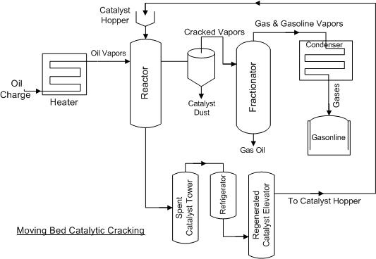

**KNOCKING**

In internal combustions, a mixture of gasoline vapour and air is used as a fuel. After the initiation of the combustion reaction by spark in the cylinder, the flame should spread rapidly and smoothly through the gaseous mixture, there by the expanding gas drives the piston down the cylinder.

The efficiency of an engine is directly related with compression ratio (CR), “The ratio of the gaseous volume in the cylinder at the end of the suction stroke to the volume at the end of the compression – stroke of the piston, is known as compression ratio”. More CR value better will be engine. CR depends upon the type of constituents in gasoline”

“In certain circumstances (due to the presence of some constituents in the gasoline used), the ratio of oxidation becomes so great that the last portion of the fuel air mixture gets ignited instantaneously (immediately), producing an explosive violence, known as knocking”. Knocking decreases the efficiency of engine.

The tendency of knocking is based on the chemical structure of hydrocarbons.

**Straight- chain paraffins > branched – chain paraffins> olefins > cyclo paraffins > aromatics**

In the above order, the knocking of fuel constituents decreases and anti – knocking increases from left to right.

The anti –knocking value of fuel can be increases by adding tetra – ethyl lead (TEL) --- [(C2H5)4 Pb ].

**Octane number (or) Octane Rating:-** Knocking of fuel (gasoline), can be measured in terms of octane number (or) octane rating, it has been found that n-heptane knocks very badly hence , its anti – knock value has arbitrarily been given “zero” on the other hand, isooctane (2,2,4- trimmethyl pentane) gives very little knocking so its anti – knock value has been given as “100”.

“Octane number of a gasoline (or any other internal combustion engine fuel) is the percentage of isooctane in a mixture of isooctane and n- heptane, which matches the fuel under test in knocking characteristics”. In this way, an ’80- octane” fuel is one which has the same combustion characteristics as a 80:20 mixtures of isooctane & n- heptane.

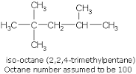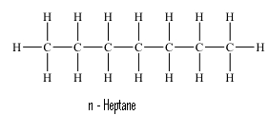

**cetane number**

Diesel knock can be defined as the rattling sound produced due to ignition –lag i.e. the delay in the ignition of the fuel

it can be defined as the percentage of hexadecane in a mixture of hexadecane and 2- methyl naphthalene whose diesel knock matches with the diesel knock of the test sample under examination

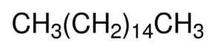 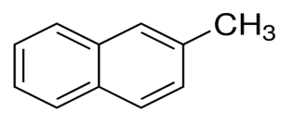

n-hexa decane 2- methyl naphthalene

The order is n-alkanes > naphthalenes > alkenes > Branched alkanes > aromatics

**Synthetic petrol:- (Gasoline)**

Petrol is mainly obtained from crude oil but can also be obtained by synthetic process. Two synthetic processes are given here viz;

1. Fischer – Tropsch process

**Fischer – Tropsch process:-**

The process was developed by German scientist F.Fischer and H.Tropsch in 1923.

Water gas (CO +H2O) is produced by passing steam over heated coke and is mixed with hydrogen. The gas is purified by passing through Fe2O3 (to remove H2S) and then into a mixture of Fe2O3+Na2CO3 (to remove organic sulfur compounds). The purified gas is compressed to 5-30 atmosphere and then led through a convertor consisting of a mixture of 100 parts cobalt, 5 parts thoria, 8 parts MgO and 200 parts keiselguhr earth, maintained at about 2000-3000c A mixture of saturated and unsaturated hydrocarbons result.

n CO + (2n+1) H2 CnH2n+2 + nH2O

n CO+2nH2 CnH2n +n H2O crude oil

n CO +(2n+1)H2 CnH2n+2 + n H2O

CO+H2O CO2 + H2

The reaction is exothermic, so out coming hot gaseous mixture is led to a cooler, where a liquid resembling crude oil is obtained. The crude oil thus obtained is then fractionated to yield gasoline and high boiling heavy oil. The heavy oil is reused for cracking to get more gasoline.

All the above reactions take place at 30 atm pressure and 200-3000C temperature. The gasoline formed by this process has loud anti knock value.

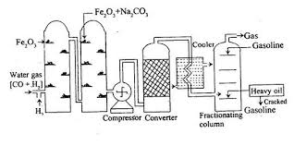

**GASEOUS FUELS:-** Natural gas is the primary gaseous fuel. A variety of secondary fuel are obtained from coal or petroleum’s. They include coal gas, produces gas, water gas derived from coal. LPG   
(liquid petroleum gas) and CNG (compressed natural gas) are derived from natural gas and oil gas is formed by cracking of kerosene oil [producer gas -- mixture of CO+ N2 water gas--- mixture of CO+H2O].

**Natural gas:**- Natural gas is obtained from oil wells dug in the oil bearing regions. When natural gas occurs along with lower hydrocarbon like CH4,C2H6, it is called “wet gas” the wet gas is treated to remove propane, propene, butane, butene, which are used as LPG [ CH4 – methane, C2H6 ]

On the other hand when the gas is associated with higher hydrocarbon along with CH4, is called “dry gas”. Before use, the natural gas is purified to remove objectionable ingredients such as water, dust grit, H2S, CO2, N2 and heavier liquefiable hydrocarbons (propane, propene, butane, butene, etc.).

The approximate composition of natural gas is :

CH4 = 70-90%; C2H6= 5-10%; H2 = 3%; CO+CO2 = rest

The calorific value varies from 12.000 – 14,000 kcal/m3

**Uses of Natural gas:-**

1. It is excellent domestic fuel and can be conveyed over very large distances in pipelines.
2. It has recently been used in the manufacture of a number of chemicals by synthetic processes.
3. It is also used as raw material for the manufacture of carbon black and hydrogen.
4. A synthetic protein (used as animal feed) is obtained by microbiological fermentation of methane (which is main constituent of Natural gas).

**Compressed natural gas:- ( CNG)**

CNG is natural gas compressed to a high pressure of about 1,000 atmospheres. A steel cylinder containing 15kg of CNG contains about 2 104L or 20 m3 of natural gas at 1 atmospheric pressure. CNG is now being used as a substitute for petrol and diesel, since it is comparatively much less pollution causing fuel. During its combustion, no sulphur and nitrogen gases are evolved. Moreover, no carbon particles are ejected. Hence it is a better fuel then petrol or dieset for automobiles. However initial cost of engine designed to use CNG as a fuel is comparatively higher then that of engine designed to use petrol or diesel. In Delhi is is mandatory for all buses, taxis and auto to use CNG as fuel.

**Advantages of CNG:-**

1. Due to higher temperature of ignition, CNG is better fuel than petrol and diesels and hence it is a much safer fuel.
2. Operating cost of CNG is less.
3. It releases least pollutants like CO and unburnt hydrocarbons.
4. The conversion of gasoline operated automobiles into CNG operated vehicle is very easy.
5. It underges regular combustion.
6. No. anticnocking agent is requird as it has high octane number.

**Liquid petroleum gas:-** (LPG) [butylenes/ butane/propylene/ propene]

LPG is obtained from natural gas a byproduct in refineries during cracking of heavy petroleum products. The main constituents of LPG are n-butane, isobutene, butylenes and propane, with little or no propylene and ethane. LPG is supplied under pressure in containers under the trade name like Indane, Bharat gas, HP gas ,etc.

**Advantage of LPG:-**

1. It has high calorific value 27800 kcal/m3. The calorific value of LPG is roughly 3 times higher than that of natural gas and 7 times that of coal gas.
2. It gives less CO and least unburnt hydrocarbon. So it cause least pollution.
3. It gives moderate heat which is very good for cooking.
4. Its strong, simple and is colourless.
5. It has tendency to mix with air easily.
6. It on burning gives no toxic gases though it is highly toxic.
7. It neither gives smoke nor ash content.
8. It is cheaper than gasoline and hence used as fuel into auto vehicles.
9. Needs little for maintenance purpose.

**COMBUSTION**

Combustion is an exothermic chemical reaction, which is accompanied by development of heat and light at a rapid rate ,so, that temperature rises considerably. For example, combustion of carbon in O2.

C (S) + O2 (g) CO2 (g) + 97 Kcal

For proper combustion, the substance must be brought to its kindling (or) ignition temperature; which may be defined as the minimum temperature at which the substance ignites and burns without further addition of heat from outside.

**CALORIFIC VALUE :-**

The calorific value of any fuel is a very important property. It measures the heat produced by the fuel. Higher the calorific value better will be the fuel.

It is defined as “the amount of heat produced by the combustion of unit mass or unit volume of a fuel”.

The calorific value is measured in several units of heat; they are calorie, kilocalorie, British thermal unit (B.T.U) and centigrade thermal units (CTU) or Centigrade Heat Unit (CHU). Relationship amoung all the above units of heat is given below.

1 kcal = 1000 cal = 3.968 BTU = 2.2 CHU (or) CTU

Joule is also a unit of heat or energy.

1 Cal = 4.18 Joule.

There are two types of calorific values of a fuel

1. High Calorific Value ( HCV) or Gross Calorific Value (GCV)
2. Low Calorific Value (LCV) or Net Calorific Value (NCV)

**High Calorific Value ( HCV) or Gross Calorific Value (GCV) :-**

It is defined as “the total amount of heat produced, when unit mass or unit volume of the fuel has been burnt completely and the products of combustion have been cooled to room temperature.”

Usually, all fuels contain some hydrogen and when the calorific value of hydrogen – containing fuel is determined experimentally the hydrogen is converted into steam. If the products of combustion are condensed to the room temperature, the latent heat of condensation of steam also gets included in the measured heat, which is then called HCV or GCV.

**2 .Low calorific value (or) net calorific value :-[ LVC (or)NCV]**

It is defined as the net heat produced, when unit mass or unit volume of the fuel is burnt completely and the products are permitted to escape.

In actual use of any fuel, the water vapor and moisture, etc, are not condensed and escape as such along with hot combustion gases. Hence a lesser amount of heat is available

**Relationship between HCV and LCV :-**

H2 +  O2 H2O

If hydrogen is present in a fuel, the above –mentioned chemical reaction will takes place and 2g of hydrogen will produce 18g of H2O (or) 1g of hydrogen will produce 9g of H2O. if x g hydrogen is present in a fuel, it will produce 9x gr of water [ because 1 part by mass of hydrogen produces 9 parts by mass of water ]; and 9x gr of water vapour that will release 9x  2 cal/g heat on cooling,  
[cal/g is the latent heat of water vapour].

So ,

LCV=HCV – latent heat of water vapour formed (or)

LCV= HCV- 9 X L

Further,

HCV=LCV + 9L [ in case hydrogen is Y%, the above relation will be;

|  |
| --- |
| HCV= LCV+ 0.09 h  587, LCV=HCV-0.09H  587 |

X=

mass of hydrogen ;L= latent heat of water vapour, the latent heat of steam is

587 kcal/kg (or) 1,060 B.Th.u/lb of water vapour at R.temp.(room temp)

It is generally expressed in calorie/gram (cal/g) or kilo calorie/gram kilo

(kcal/kg) or British thermal unit/lb (BTU/lb) in case of solid or liquid fuel.

In case of gaseous fuels, the unit used is kilo calorie /cubic metre (K cal/m3)

or but/cubic feet (BTC/ft3).

**UNIT V**

**CEMENT ,REFRACTORIES, LUBRICANTS AND COMPOSITES**

**CEMENT:** Concrete is the widely used non-metallic material in construction of buildings, dams, bridges, highways, runways etc. The essential bonding material which binds sand and rock when mixed with water, in concrete is cement.

**Cement:**- Cement is greenish heavy powder which find its importance as a building material, which posseses adhesive and cohesive properties to bind rigid masses like stones, bricks, building blocks etc. Cements are hydraulic in nature i.e it possesses the property of setting and hardening in the presence of water.

**Composition of Portaland cement** A good sample of Portland cement has the composition of

calcium oxide or lime (CaO) -60-70% , (Ca(OH)2 ---H2O--Cao)

Silica (SiO2) – 20-24%

Alumina (Al2O3)-5-75%

Magnesia (MgO) – 2-3%

Ferric Oxide (Fe2O3) -1-25%

Sulphur Trioxide (SO3)-1-105%

Sodium oxide(Na2O) -1%

Potassium oxide(K2O)-1%

**Manufacture of Portland Cement**

The manufacture of cement involves the following steps:

1. Mixing of Raw Materials

A mixture of finely ground lime stone and clay(3:1) is made into slurry with water by two process3es

a)Dry Process b) Wet Process

**Dry process** :- The dry produces a fine ground powder. This process is employed if the limestoneand clay are hard . in this process, initially limestone is crushed into pieces and then it is mixed with clay in proportion of 3:1. This mixture is pulverized to a fine powder and is stored in storage bins (silos) and later on it is introduced into the upper end of the Rotary kiln

**Wet Process**: the wet process takes place in the presence of water aned usually results in a slurry formation. This process is preferred if limestone and clay are soft.

In this process the clay is washed with water in washmills to remove any foreign material, organic material etc powdered limestone is then mixed with clay paste in a proper proportion (3:1). This mix is then finely grounded and homogenized to form a slurry containing about 40% of water. This is also stored in the storage bins and can be fed in the rotary kiln when necessary.

Burning the mixture in Rotary kiln:

The slurry of raw materials is fed to roatary kiln, which consist of an inclined rotator

cylinder 150-200 feet along and 10feet in diameter lined with fire bricks

The kiln rotates at the rate of 1 revolution per minute. Due to rotary motion of the kiln, the mixture of raw material enters from the upper to the lower end while the burning fuel (Pulverized coal, oil, or natural gas) and air induced from lower end of the kiln.

A temperature of about 1500-1700C is produced stepwise process.

1. At 750 °C moisture is removed
2. At 1000°C the limestone is completely decomposed to CaO
3. At 1500-1700°C the mistu8re is partly fused

Chemical reactions taking place at various zones of the rotary kiln are

**Drying Zone**: The temp in the zone raises to 750°C, moisture present in the slurry is evaporated and

the clay is broken into

Al2O3.2SiO2.Fe2O3.2H2O------🡪 Al2O3 + 2SiO2+Fe2O3+2H2O

**Calcination Zone** :- This zone is located in the middle portion of the kiln where the temperature is of the order of 1000°C. In this zone the lime stone is completely decomposed into the CaO (Quick lime)

Ca(OH)2------🡪CaO

CaCO3--------🡪 CaO+CO2

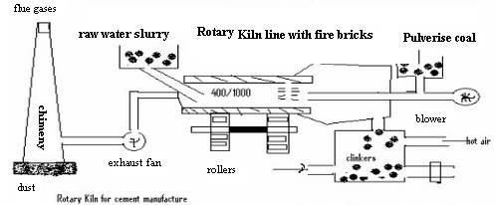

Reaction zone or clinkering zone :- The temperature in this zone is about 1600°C, the mixture is partly melted and chemical combination s between lime alumina, silica, ferric oxide occurs. In this zone lime and clay react with each other forming aluminates and silicates.

2CaO+SiO2---🡪 2Cao.SiO2 Dicalcium silicate

3CaO+SiO2-----3CaO.SiO2 Tricalcium silicate

3CaO+Al2O3-----3CaO.Al2O3 Tricalcium Aluminate

4CaO+Al2O3+Fe2O3----- 4CaO.Al2O3 Fe2O3 Tetra calcium alumino ferrite

The resulting product called clinker is allowed to cool in a cooler

Mixing of clinkers of cement with Gypsum:

The clinkers are then mixed with 3% gypsum to reduce the rate of setting. The fast setting constituent Al2O3 of the clinker reacts with gypsum to form calcium sulfo aluminate

3CaO.Al2O3 3(CaSO4.2H2O) + H2O------3Cao.Al2O3.CaSO4.2H2O + 6H2O

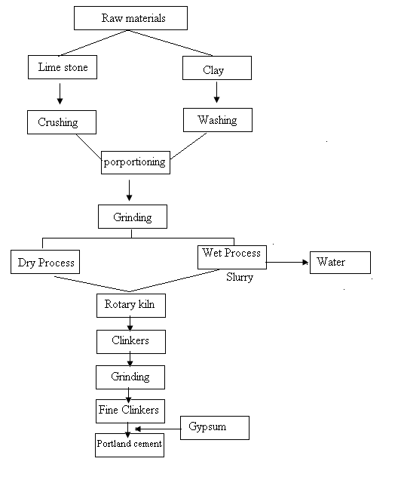**Setting and Hardening of Portland Cement**:-

Cement is mixed with water to produce a plastic cement paste, which slowly loses its plasticity and becomes a stiff and ultimately a rocky mass is obtained. This process is known as setting. After hydration, anhydrated compounds become hydrated, which have less solubility. Hence they are precipitated as insoluble gels or crystals. These have ability to surround sand, crushed stones, other inert materials and bind they very strongly.

The physical changes occurring in the setting and hardening of cement may be summarized in a flow chart as follows

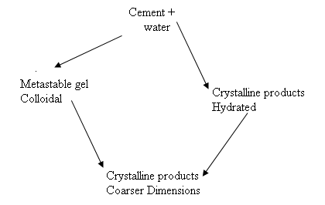

Diagram of Setting & Hardening of Cement

Reactions involved in setting and hardening of cement

The basic chemical compouns in th Portland cement are

|  |  |  |
| --- | --- | --- |
| Name | Chemical Formula | Abbreviation |
| Tricalcium silicate | 3CaO.SiO2 | C3S |
| Dicalcium silicate | 2CaO.SiO2 | C2S |
| Tricalcium Aluminate | 3CaO.Al2O3 | C3A |
| Tetracalcium Alumino Ferrite | 4CaO.Al2O3. Fe2O3 | C4AF |

The behavior of the cement can be altered by modifying the relative percentage of these

compounds.

When cement is mixed with water the paste becomes quite rigid within a short time

which is known as initial set. This due to C3A which hydrate rapidly as as follows

3CaO.Al2O3 + 6H2O -🡪3CaO.Al2O3.6H2O (crystals)

These crystals prevent the hydration reaction of other constitutional compounds forming behavior over them. In order to retard this flash set gypsum is added during the pulverization of cement clinkers. Gypsum retards the dissolution of C3A by interacting with it forming insoluble complex of sulfoaluminate.

3CaO.Al2O3 +xH2O+Y CaSO4.2H2O-🡪3CaO.Al2O3.YCaSO4.ZH2O

The tetra calcium alumino ferrite (C4AF) then reacts with water forming both gels and crystalline compounds as follows

4CaO.Al2O3.Fe2O3 + 7H2O-🡪 3CaO.Al2O3.6H2O +CaO.Fe2O3.H2O

These gels shrink with passage of time and leave some capillaries for the water to come in contact with C3S and C2S to undergo further hydration and hydrolysis reactions.

Final setting and hardening of cement paste is due to the formation of tobermonite gel plus crystallization of Ca(OH)2 and hydration tricalcium aluminate

2CaO.SiO2 + XH2O 🡪 2CaO.SiO2. XH2O

2(3CaO.SiO2) + 6H2O🡪 3CaO.SiO2.3H2O + tobermonite gel + 3Ca(OH)2

During the setting and hardening of portland cement, some amount of heat is liberated due to hydration and hydrolysis reactions. The heat of hydration of the different constitutional compounds are in the following order

C3A > C3S > C4AF > C2S

878 502 418 251 KJ/Kg

**SPECIAL CEMENTS**

**WHITE EMENT:** White Portland cement is made from raw materials containing little or no iron or manganese, the substances that give conventional cement its gray color. So the secret of the White cement is raw material. Apart from that only whitest chalk is used together with light colored sand in production of white cement

. White cement production needs usually 40% higher energy than the normal grey cement and this contributes to the high price of white cement. The difference between ordinary cement and while cements are thus as follows: The amount of chromium, manganese, iron compounds is significantly less in white cement in comparison to gray cement Production of white cement consumes significantly more energy in comparison to gray cement

**WATER PROOF CEMENT :**this cement makes the concrete impervious to water and resist absorption of water. This type of cement is prepared by adding water proofing agents like calcium stearate, aliminium stearate, gypsum and tannic acid to Portland cement during grinding and powdering process.

**HIGH ALUMINA CEMENT:** high alumina cements are made by fusing Bauxite and lime stone mixture at 1500 – 1600o C in rotary kiln and the resulting mass is subjected to grinding , they contain

CaO – 35 – 40% : Al2O3 – 35 – 55% ; FeO + Fe2O3 – 5 – 15% ; SiO2 – 5 – 10 %

Setting time is similar to Portland cement but hardening is very rapid , full strength is obtained in 1 day and the strength is retained even at high temperatures, it also has superior resistance to chemicals.

**ACID RESISTANT CEMENT;** they are produced by mixing finely ground quartize with silicon in suitable proportions . sodium silicon fluoride , or ethyl acetate are used as setting agents , silica gel gets precipitates on drying it becomes very porous and permeable to liquids . hence it should be always kept wet to prevent shrinking of gel

**REFRACTORY**

Any substance that is difficult to fuse is a refractory. A refractory is a material which does not melt easily, because its fusion temperature is very high. Therefore refractories are inorganic materials which can withstand high temperatures as well as abrasive and corrosive action of molten metals, slags and gases without suffering deformation in shape.

Refractories are available in different shape and sizes as bricks, crucibles and tubes, granules, castable and cements.

**Classification of Refractories:**

Refractories are classified on the basis of there chemical properties, constituents substances and fusion temperature into the following catagories:

1. On the basis of fusion temperature ranges they are classified as:-

a)Normal refractory ; Fusion temperature= 1580-1780°C, Eg :- Fire clay

b)High Refractory; fusion temperature = 1780-2000°C, Eg:- Chromite

c) Super Refractory; Fusion temperature = >2000°C, Eg:- Zircon

2) On the basis of Chemical composition they are classified as

a) Acid Refractory: These refractories consist of acidic materials like alumina(Al2O3) and Silica(SiO2). These refractory materials are resistant to acid slags and readily attacked by basic slags(like CaO, MgO etc).

eg:-Alumina, Silica and Fire clay refractories

b)Basic Refractory: These refractories consist of basic materials like CaO, MgO etc and are resistant basic slags. Basic refractories find extensive use in some steel making open hearth furnaces. Eg: Magnesite and dolomite bricks.

3) Neutral Refractories : Neutral refractories are refractories of Neutral materials like Carbon, chromite (FeO CrO2), Zirconia( ZrO) etc.

Characteristics of Refractory Materials:-

* A good refractory material should have softening temperature much higher than operating temperature.
* Refractories should be chemically inert under the condition where in they are employed that is they should not react with corrosive agents like acidic or basic molten slags, Hot gases etc.
* The refractoriness should be high for a good refractory.
* They should posses low permeability
* The refractories should not crack at operating temperature
* They should be able to withstand the overlaying load of structure, at operating temperature.
* They should posses good physical, chemical and mechanical properties.

**Criteria for good refractories:**

**Refractoriness:-** Refractoriness is ability of the refractory to withstand high temperature. Refractoriness is generally measured by softening temperature of the refractory material.

**Measurement of Refractoriness:**

The Refractoriness are measured in terms of pyrometeric cone equivalents (PCE). Pyrometeric Cones of same dimensions which are made of different mixtures of refractory material that can soften at a different temperatures or placed along the sample cone. The standard cones have particular number with known softening point .

Sample cone along the with standard cones are heated under standard conditions of 10°C per minute. The pyrometric equivalent value of the sample cone or test cone is taken as the number of the standard cone which softens along with the sample cone whose softening point is known. If the sample cone soften earlier than one standard cone but later than the next one, then the PCE value of the sample cone is taken as average softening point values of the two standard cones. A good refractory should have high refractoriness.

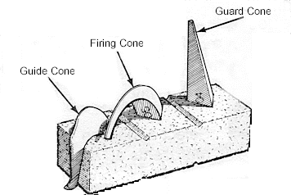

**Refractoriness Under Load:** The load bearing capacity of Refractoriness can be measured by means of R.U.L. Test. In R.U.L test a constant load is applied to the sample refractory specimen of rectangular shape and heated at standard rate in a furnace. The temperature at which atleast 10% of the specimen starts to get destroy or deform is taken as R.U.L value. A good refractory should have high R.U.L value.

**Thermal Conductivity**:Most of the furnaces are line inside with refractory material of low thermal conductivity in order to reduce heat losses to the outside environment by radiation.

Refractories which can be used under these circumstances are fire clay and silica, on the other hand in Muffle furnaces, construction of retorts, the heat should be efficiently transmitted and therefore carbon and silicon carbide refractories which are poor insulators can be employed.

**Thermal Expansion**: The construction of the furnace should be designed in such a manner that allowance has to be made for the thermal expansion. A good refractory will generally have less thermal expansion.

**Chemical Inertness**: Refractories should be chemically inert and especially they should not react with the slags furnace gases etc. It is advisable to use acidic refractory lining for acid material or products formed inside the furnaces similarly basic refractory lining for basic raw materials.

**Dimensional Stability:** The dimensional stability of a good refractory should be high. Dimensional stability may be defined as the volume change of the refractory when subjected to high temperature.

**Porosity:** Porosity is the ratio of its porous volume to the bulk volume. Porosity of a refractory has many bad effects along with few advantages also.Due to porosity slags, gases etc. are likely to enter more easily to generate depth and also react with the refractory hence porosity reduces the strength, resistance to abrasion, resistance to corrosion but lower porosity thermal conductivity owing to the absence of air voids and increase resistance to Thermal spalling.

**Thermal Spalling:** It is the property of breaking, cracking, peeling off, of a refractory material so good refractory should be resistant to the thermal spalling.

APPLICATIONS

1.refractories are mostly used for the construction of the lining of the furnaces, tanks, converters, klns, crucibles, ladles etc.

2. they are employed for the manufacture of cement , glass, ceramics , paper, metals ( both ferrous and non ferrous ) etc.

**LUBRICANTS**

In all types of machines the surfaces of moving or sliding or rolling parts rub against each other. This mutual rubbing of one part over the other leads to resistance of movement, which is termed Friction. It reduces the efficiency of the machinery.

*“ A lubricant may be defined as a substance which reduces the friction when introduced between two surfaces and the phenomenon is known as lubrication”*

Criteria of a Good Lubricant

Any substance which shows the process of lubrication must satisfy certain key functions.

They are

The lubricant should keep moving parts apart

The foremost funcition of a lubricant is to reduce friction

It should transfer heat and act as a coolant.

It should prevent rust and corrosion and there by reduces the maintenance and running

cost of the machines.

It carries away contaminates and debris which would other wise damage the surface of the machinery.

It acts as a seal

It should also reduce the loss of energy in the form of heat

As the use of lubricant minimizes the liberation of frictional heat, the expansion of the

metals can be reduced

**Mechanism**

There are 3 types of mechanism by which lubrication takes place. They are

1. Fluid film lubrication or hydrodynamic
2. Boundary lubrication or Thin film lubrication
3. Extreme pressure lubrication

* **Fluid film lubrication**. In this type of lubrication, the moving or sliding surfaces are separated from on e another by a thick film of lubricant (i.e. 1000A in thickness), so that there is no direct contact between them.
* The fluid film lubrication is based on the properties of the lubricant particularly on its viscosity. This lubrication is satisfactorily done by hydrocarbon oils
* The viscosity of hydrocarbon oils increases with increasing molecular weight. But these fractions generally contain small quantity of unsaturated hydrocarbons which get oxidized under operating conditions, forming gums. Hence it is essential that antioxidants (like amino phenols) to be blended with hydrocarbon oils.
* Light machines like sewing machines, watches , clocks delicate and scientific instruments are proved with fluid film lubrication
* Figure

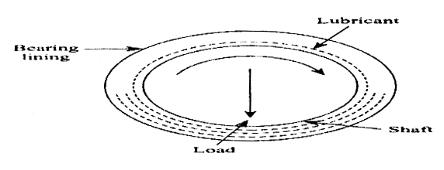

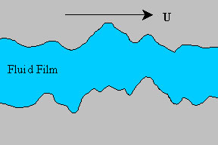

**Fg:-** In a ball bearing, the irregularities of the shaft and bearing surfaces is covered by a thick film of lubricate and do not allow the contact of metallic surfaces with each other as shown in the above figure.

**Boundary lubrication or Thin film lubrication**

* A thin layer of lubricant is adsorbed on the metallic surfaces due to physical or chemical forces. This adsorbed layer helps to avoid a direct metal contact between rubbing surfaces.
* In this type of lubrication, a thin film of lubricant is adsorbed on the surface and held by Vander waal’s forces.

When the lubricant is not viscous enough to generate a film of sufficient thickness for the separation of surfaces under heavy loads friction is reduced by thin film lubrication.

Thin film lubrication is applied when ,

1. The speed is very low

2. The shafts moves from rest position to operation

3. The load is heavy

4. The oil has low viscosity some peaks or asperities may have higher thickness than the film of lubricant which result in wearing and tearing. Hence the chemical or physical forces on some metal surfaces would avoid the direct contact at metals and absorb a thin layer of lubricating oil. The coefficients of friction is reduced due to oiliness. (it is the property by virtue of which oil stick to the surface of machine parts even at high temp and heavy loads).

* The conditions of the lubricant which ought to be satisfied for boundary lubricant are :-
* Long hydrocarbons chains
* Polar groups to promote wetting or spreading over the surface
* High viscosity index
* Good oiliness
* Low pour point and oxidation
* Active functional groups which can form chemical bonds with the metals or other surfaces
* Resistance to heat etc

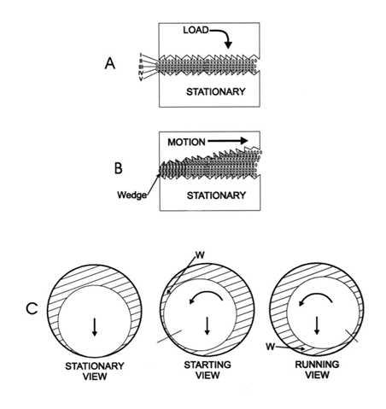Fig:

**Extreme pressure Lubrication**:- Normally under heavy load and high speed operating conditions, a special type of lubricants called high pressure lubricants are to be employed in order to withstand the high temperature generated due to frictional heat.

Chlorinated esters, sulphurized oils and tricresyl phosphate are examples of such additive. These additives react with metallic surfaces, at prevailing high temperature, to form metallic chlorides, sulphides or phosphides, in the form of durable films. These films can with stand very high loads and high temperatures (because of high melting points). Hence they serve as good lubricant under extreme pressure and extreme temperature conditions.

Extreme pressure additives are used in wire drawing of titanium, in cutting fluids in

machining of tough metals and for hypoid gears used in rear axle drive of cars.

**Properties of Lubricants**.

**Viscosity** :- Viscosity is the property of fluid that determines its resistance to flow it is an indicator of low ability of a lubricating oil i.e. the lower the viscosity, greater the flow ability.

The unit of viscosity is poise or Newton /sec/m2

**Coefficient of viscosity (η)** may be defined as the force per unit area required to maintain a unit velocity gradient between two parallel layers.

A good lubricating oil must have moderate viscosity. If the viscosity of the lubrication oil is high due to excessive friction movement of the machine is restricted. On the other hand if the lubrication oil is having low viscosity, the film cannot be maintained under heavy load or pressure.

**Flash and Fire points:**

Flash points is the lowest temperature upto which the oil lubricant is heated to produce sufficient vapours that ignite for a moment or produce a flash when a test flame is brought near it.

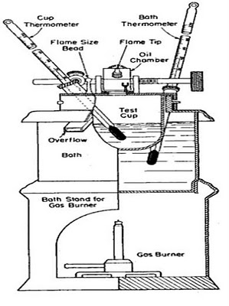Fire point is the lowest temperature upto which the oil lubricant is heated to produce sufficient vapours that burn continuously at least for 5 seconds when a test flame is brought near it. Generally the fire point is 5 to 40C higher than the flash point. A good lubricant should have high fire and flash point so that it can with stand higher working temperatures.

The flash and fire point are determined experimentally by using pensky Martens apparatus. The apparatus consists of a small cup with 5cm diametr and 5.5cm height which is closed at the top except in few places where gaps are provided for inserting the thermometer, stirrer and introducing flame. A shutter which can be moved on the top of the container by lever mechanism and can be used to open the lid for introducing the test flame. The container is filled upto the standard mark with the lubricating oil. The container is gradually heated using burner. For every 1C rise, the test flame is introduced by opening the lid with the removal of shutter. The temperature at which the introduced test flame produces flash is noted as the flash point. Similarly the temperature at which the introduced test flame produces fire at least for 5 seconds is noted as fire points.

**Cloud and Pour points:**

The temp at which the lubricating oil becomes cloudy or hazy on cooling is known as the cloud point. The temperature at which the lubricating oil ceases to flow on cooling is known as the pour point. Machines working at low temperature lubricants with low cloud and pour point are preferred.

For the determination of cloud and pourpoint, the pour point apparatus used is shown below:-

The apparatus consist of a flat bottomed glass tube containing the lubricating oil at a standard height. This is placed inside an air jacket flat bottomed bigger glass tube. In the centre of the main glass tube a thermometer is introduced for noting the temp of the lubricating oil. The test tube along with the outer air jacket testtube are placed inside a beaker containing a ice and salt(CaCl2). The middle test tube containing lubricating oil is withdrawn from the ice mixture and outer jacket for every 1C fall of temperature and noted for any change in state. The temperature at which cloudiness is noticed is recorded as the cloud point. Similarly after some time the temperature at which the lubricating oil solidfy and resist to flow is recorded as the pour point.

**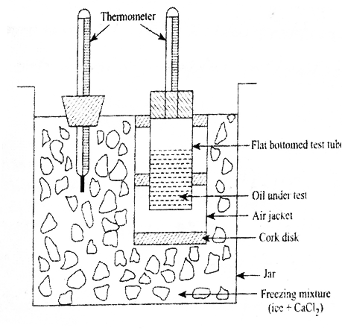**

**COMPOSITES:**

**Introduction composite** material (also called a composition material or shortened to **composite** which is the common name) is a material made from two or more constituent materials with significantly different physical or chemical properties that, when combined, produce a material with characteristics different from the individual .

**Classification of Composites**

Composite materials are commonly classified at following two distinct levels:

•The first level of classification is usually made with respect to the matrix constituent.

The major composite classes include Organic Matrix Composites (OMCs), Metal Matrix Composites (MMCs) and Ceramic Matrix Composites (CMCs). The term organic matrix composite is generally assumed to include two classes of composites, namely Polymer Matrix Composites (PMCs) and carbon matrixcomposites commonly referred to as carbon-

carbon composites.

•

The second level of classification refers to the reinforcement form – fibre Reinforced composites, laminar composites and particulate composites . Fiber Reinforced composites (FRP) can be further divided into those containing discontinuous or continuous fibers.

•

Fibre Reinforced Composites are composed of fibers embedded in matrix material. Such a composite is considered to be a discontinuous fiber or short fiber composite if its properties vary with fibre length. On the other hand, when the length of the fiber is such that any further increase in length does not further increase, the elastic modulus of the composite, the composite is considered to be continuous fiber reinforced. Fibers are small in diameter and when pushed axially, they bend easily although they have very good tensile properties. These fibers must be supported to keep individual fibers from bending and buckling.

•

Laminar Composites are composed of layers of materials held together by matrix. Sandwich structures fall under this category.

•

Particulate Composites are composed of particles distributed or embedded in a matrix body. The particles may be flakes or in powder form. Concrete and wood particle boards are examples of this category.

**Constituents of composites**

Composites generally consists of two phases

Matrix and dispersed phase

The surface forming the common boundary between these two phases is known as interphase.

**1.matrix phase :**IT is the continuous body constitute that encloses the composite and gives it its bulk form

It may be metal, ceramic, or polymer Composites using these matrixes is known as metal Matrix Composites(MMC), ceramic Matrix Composites(CMC) and polymer Matrix Composites(PMC)

Functions of matrix phase:-

i) it binds the dispersed phase together through its cohesive and adhesive forces

ii)it acts as a medium for transmission and distribution of applied load to the dispersed phase.

iii) it protects the dispersed phase from chemical actionand keep in proper position and orientation so as to carry the intended load

1. It prevents propagation of brittle cracks by virtue of its plasticity and softness.

**2.DISPERSED PHASE:** it is structural constituentthat determines the internal structure of a composite.they mat be fibres, particles, whiskers , or flakes.

**fibres:-**it is a long and thin filament of any polymer , metal or ceramic .

they have high strength and stiffness.

Ex:- glass fibres, carbon fibres , aramid fibres, boron fibres etc.

1. Glass fibres:these are very popular reinforcement materials because they are

Readily available, low cost, easy to draw, high specific strength, of 136 kNm and specific stiffness 2.9kNm , and can be mixed with polymer matrix to develop chemical inert ness

1. Carbon fibres: eg; cellulose and poly acrylonitrilein

They are used as reinforcing material with epoxy or polyester resins to form composites ,which have hgh specific strength high modulus , stiffness,resistant to moisture,acids, bases and a no.of solvents

1. Aramid fibres: eg: aromatic polyamides such as Kevlar, Nomex etc

They are high modulus and tensile strength, stability at high temperatures and retention of mechanical properities in wide range of temperature i.e.-2000C to 2000C., excellent toughness and impact resistance,

**PARTICULATES:** these are small pieces of hard solid metallic or non metallic materials. They following changes to matrix

* Increase in surface hardness
* Improvisation of wear and abrasion resistance
* Changes in thermal and electrical conductives
* Increase in strength
* Reduction in cost

FLAKES:these are thin solids having a two dimensional geometry e.g., mica flakes

they impart equal strength in a plane compare to fibres, where reinforcement is unidirectional.

Packing of flakes is more efficient than those of fibres and spherical particulates.

WHISKERS: these are thin strong filaments or fibres

Ex: graphite, silicon carbide, sapphire , silicon nitride, and aluminium oxide.

They possess high elastic modulus, high degree of crystalline perfection and high strength.

\*Because of their high cost and difficulty in incorporation in matrix their uses are limited

**Advantages of composites**:

High resistance tofatigue and corrosiondegradation

.

•High ‘strength or stiffness to weight’ ratio. As enumerated above, weight savings are significant ranging from 25-45% of the weight of conventional metallic designs.

•

Due to greaterreliability, there are fewer inspections and structural repairs.

•

Directional tailoring capabilitiesto meet the design requirements. The fibre pattern can be laid in a manner that will tailor the structure to efficiently sustain the applied loads.

•

Fibre to fibre redundant load path.

•

Improved dent resistance is normally achieved. Composite panels do not sustain damage as easily as thin gage sheet metals

•

It is easier to achieve smooth aerodynamic profilesfor drag reduction. Complex double-curvature parts with a smooth surface finish can be made in one manufacturing operation. .

•

High resistance to impact damage.

•

Thermoplastics have rapid process cycles, making them attractive for high volume commercial applications that traditionally have been the domain of sheet metals. Moreover, thermoplastics can also be reformed.

•

Like metals, thermoplastics have indefinite shelf life.

•

Composites are dimensionally stablei.e. they havelow thermal conductivity and low coefficient of thermal expansion. Composite materials can be tailo

red to comply with a broad range of thermal expansion design requirements and to minimise thermal stresses.

•

The improvedweatherabilityof composites in a marine environment as well as theircorrosion resistance and durability reduce the down time for maintenance.

•

Close tolerances can be achieved without machining.

•

Material is reduced because composite parts and structures are frequently built toshape rather than machined to the requiredconfiguration, as is common with metals.

•

Excellent heat sink properties of composites, especially Carbon-Carbon, combined with their lightweight have extended their use for aircraft brakes.

•

Improved friction and wear properties.

•

The ability to tailor the basic material properties of a Laminate has allowed newapproaches to the design of aeroelastic flight structure

**Applications of composites**

|  |  |  |  |
| --- | --- | --- | --- |
| **Cooking** Dishwasher Refrigerator Small Appliances Laundry  Ice Machines | **Construction** Entry Doors Garage Doors Architecture Countertops Waste Water Treatment | **Sanitary/Plumbing** Faucets Sinks Drains Showers Bathtubs | **Energy** Wind Turbine Fuel Cells Solar Panels Pumps |
| **Forward Lighting** Headlamps Reflections | **HVAC** Drain Pans Blower Housing Wall Sleeves Control Panels Recreational Vehicles | **Lighting** Class 1/ DV2 Light Housing In ground Explosion Proof Reflectors | **Marine** Engine Covers Personal Watercraft Boat Access Covers Electrical Buyers Motor Housing |
| [**Electrical Distribution**](http://www.mar-bal.com/wp-content/uploads/2013/08/Mar-Bal-Electrical-Application-112012.pdf) Circuit Breakers Motor Control Centers Generators Switchgear Busway Control Cabinets Cross Arms | **Transportation** Resisters Drive Motors Controls Valve Covers Oil Pans Air Suspensions |

**PREVIOUS QUESTION PAPERS**