LECTURE NOTES
ON
DATA STUCTURES
III B-Tech I Semester(JNTUH-R13)



COMPUTER SCIENCE & ENGINEERING
CMR ENGINEERING COLLEGE
KANDLAKOYA (V), MEDCHAL (M), R.R.DIST.

Syllabus

JAWAHARLAL NEHRU TECHNOLOGICAL UNIVERSITY H YDERABAD
II Year B.Tech. CSE-I Sem L T/P/D C
4 -/-/- 4
DATA STRUCTURES
UNIT- I
Basic concepts- Algorithm Specification-Introduction, Recursive algorithms, Data Abstraction Performance
analysis- time complexity and space complexity, Asymptotic Notation-Big O, Omega and Theta notations,
Introduction to Linear and Non Linear data structures.
Singly Linked Lists-Operations-Insertion, Deletion, Concatenating singly linked lists, Circularly linked lists-
Operations for Circularly linked lists, Doubly Linked Lists- Operations- Insertion, Deletion.
Representation of single, two dimensional arrays, sparse matrices-array and linked representations.

UNIT- II
Stack ADT, definition, operations, array and linked implementations in C, applications-infix to postfix conversion,Postfix expression evaluation, recursion implementation, Queue ADT, definition and operations ,array and linked Implementations in C, Circular queues-Insertion and deletion operations, Deque (Double ended queue)ADT, array and linked implementations in C.

UNIT- III
Trees – Terminology, Representation of Trees, Binary tree ADT, Properties of Binary Trees, Binary Tree Representations-array and linked representations, Binary Tree traversals, Threaded binary trees, Max Priority Queue ADT-implementation-Max Heap-Definition, Insertion into a Max Heap, Deletion from a Max Heap. Graphs – Introduction, Definition, Terminology, Graph ADT, Graph Representations- Adjacency matrix, Adjacency lists, Graph traversals- DFS and BFS.

UNIT- IV
Searching- Linear Search, Binary Search, Static Hashing-Introduction, hash tables, hash functions, Overflow Handling. Sorting-Insertion Sort, Selection Sort, Radix Sort, Quick sort, Heap Sort, Comparison of Sorting methods.

UNIT- V

Search Trees-Binary Search Trees, Definition, Operations- Searching, Insertion and Deletion, AVL Trees- Definition and Examples, Insertion into an AVL Tree ,B-Trees, Definition, B-Tree of order m, operations-Insertion and Searching, Introduction to Red-Black and Splay Trees(Elementary treatment-only Definitions and Examples),Comparison of Search Trees.
Pattern matching algorithm- The Knuth-Morris-Pratt algorithm, Tries (examples only).

TEXT BOOKS:
1. Fundamentals of Data structures in C, 2nd Edition, E.Horowitz, S.Sahni and Susan
Anderson-Freed, Universities Press.
2. Data structures A Programming Approach with C, D.S.Kushwaha and A.K.Misra, PHI.

REFERENCE BOOKS:
1. Data structures: A Pseudocode Approach with C, 2nd edition, R.F.Gilberg And B.A.Forouzan, Cengage
Learning.
2. Data structures and Algorithm Analysis in C, 2nd edition, M.A.Weiss, Pearson.
3. Data Structures using C, A.M.Tanenbaum,Y. Langsam, M.J.Augenstein, Pearson.
4. Data structures and Program Design in C, 2nd edition, R.Kruse, C.L.Tondo and B.Leung,Pearson.
5. Data Structures and Algorithms made easy in JAVA, 2nd Edition, Narsimha Karumanchi, CareerMonk
Publications.
6. Data Structures using C, R.Thareja, Oxford University Press.
7. Data Structures, S.Lipscutz,Schaum’s Outlines, TMH.
8. Data structures using C, A.K.Sharma, 2nd edition, Pearson..
9. Data Structures using C &C++, R.Shukla, Wiley India.
10. Classic Data Structures, D.Samanta, 2nd edition, PHI.
11. Advanced Data structures, Peter Brass, Cambridge.

13 Lecture Schedule with methodology
SNo | Period No | Unit No | Date | Topic to be covered in One lecture | Reg/Additional | Teaching aids used LCD/OHP/  BB | Remarks
1 | 1 | I |  | Introduction to subject | Reg | BB
2 | 2 |  |  | Basic Concepts Algorithm specification-Introduction | Reg | BB
3 | 3 |  |  | Recursive Algorithms | Reg | BB
4 | 4 |  |  | Data Abstraction | Reg | BB
5 | 5 |  |  | Performance analysis -space complexity | Reg | BB,OHP
6 | 6 |  |  | Time comlexity using -variable count | Reg | BB,OHP
7 | 7 |  |  | Time complexity using- step count table | Reg | BB OHP
8 | 8 |  |  | Asymptotic notations | Reg | BB OHP
9 | 9 |  |  | Linear and nonlinear data structures | Reg | BB,OHP
10 | 10 |  |  | Singly linked list operations- insertion, deletion | Reg | BB OHP
11 | 11 |  |  | Concatenation of lists | Reg | BB OHP
12 | 12 |  |  | Circular linked list all operations | Reg | BB OHP
13 | 13 |  |  | Doubly linked list operations- insertion,deletion | Reg | BB OHP
14 | 14 |  |  | Representation of Single, two dimensional arrays | Reg | BB OHP
15 | 15 |  |  | Sparse matrices array representation | Reg& Add | BB,OHP
16 | 16 |  |  | Sparse matrices linked representation | Reg | BB OHP
17 | 1 | II |  | Stack Definition , ADT | Reg | BB,OHP
18 | 2 |  |  | Stack- Array implementation | Reg& Add | BB,OHP
19 | 3 |  |  | Stack Linked representation | Reg | BB,OHP
20 | 4 |  |  | Applications- infix to postfix conversion | Reg | BB,OHP
21 | 5 |  |  | Postfix Expression Evaluation | Reg | BB,OHP
22 | 6 |  |  | Queue ADT- Definition and operations | Reg | BB,OHP
23 | 7 |  |  | Queue implementation -Array and linked lists | Reg | BB,OHP
24 | 8 |  |  | Circular Queues -all operations using arrays | Reg | BB,OHP
25 | 9 |  |  | Circular Queues- all operations using linked list | Reg | BB,OHP
26 | 10 |  |  | Double Ended Queue(Deque)- all operations using arrays | Reg | BB,OHP
27 | 11 |  |  | Deque all operations using linked list | Reg | BB,OHP
28 | 1 | III |  | Trees- Treminology, Representatin of Trees, Binary Tree ADT | Reg | BB,OHP
29 | 2 |  |  | Properties of Binary Trees, Array representation | Reg | BB,OHP
30 | 3 |  |  | Linked List Representatin of Binary Tree | Reg | BB,OHP
31 | 4 |  |  | Binary Tree traversals- Recursive | Reg | BB,OHP
32 | 5 |  |  | Non- Recursive Binary Tree Traversals | Reg | BB,OHP
33 | 6 |  |  | Threaded Binary Trees- Threads, Inorder Traversaland insertion into threaded binary tree | Reg | BB,OHP
34 | 7 |  |  | Max priority Queue- ADT, Definition, insertion into a Max Heap | Reg | BB,OHP
35 | 8 |  |  | Deletion from a Max Heap | Reg | BB,OHP
36 | 9 |  |  | Graphs- Introduction, Definition, Terminology | Reg | BB,OHP
37 | 10 |  |  | Graph Representaions- Adjacency Matrix  Adjacency Lists | Reg | BB,OHP
38 | 11 |  |  | Graph Traversals-DFS and BFS | Reg | BB,OHP
39 | 1 | IV |  | Searching- Linear Search & Binary Search | Reg | BB,OHP
40 | 2 |  |  | Static Hashing- Introduction, Hash Tables | Reg | BB,OHP
41 | 3 |  |  | Hash functions- Division, Mid-Square, Folding, Digit Analysis, converting Keys to Integers | Reg | BB,OHP
42 | 4 |  |  | Overflow Handling- open Addressing, Chaining | Reg | BB,OHP
43 | 5 |  |  | Sorting-Motivation, Insertion Sort | Reg | BB,OHP
44 | 6 |  |  | Selection Sort | Reg | BB,OHP
45 | 7 |  |  | Radix Sort | Reg | BB,OHP
46 | 8 |  |  | Quick sort | Reg | BB,OHP
47 | 9 |  |  | Heap sort | Reg | BB,OHP
48 | 10 |  |  | Comparison of sorting techniques | Reg | BB,OHP
49 | 1 | V |  | Search Trees- Binary Search Trees( search and insert) | Reg | BB,OHP
50 | 2 |  |  | Deletion from a BST | Reg | BB,OHP
51 | 3 |  |  | AVL Trees- Definition and Examples | Reg | BB,OHP
52 | 4 |  |  | Insertion and Deletion from an AVL Tree | Reg | BB,OHP
53 | 5 |  |  | B- Trees- Definition, B-Tree of order m | Reg | BB,OHP
54 | 6 |  |  | B-Trees- Searching, Insertion and Deletion | Reg | BB,OHP
55 | 7 |  |  | Red- Black Trees- Definition and Examples | Reg | BB,OHP
56 | 8 |  |  | Splay Trees- Definition and Examples | Reg | BB,OHP
57 | 9 |  |  | Pattern matching algorithms- Brute Force Approach | Reg | BB,OHP
58 | 10 |  |  | Knuth- Morris- Pratt Algortihm | Reg | BB,OHP
59 | 11 |  |  | Example on KMP Pattern Match | Reg | BB,OHP
60 | 12 |  |  | Tries- Examples and definitions | Reg | BB,OHP

14. Lecture Notes
UNIT I
Definition
An algorithm is a finite set of instructions that accomplishes a particular task.
Criteria
  - input
  - output
  - definiteness: clear and unambiguous
  - finiteness: terminate after a finite number of steps
  - effectiveness: instruction is basic enough to be carried out

Data Type
A data type is a collection of objects and a set of operations that act on those objects.

Abstract Data Type
An abstract data type(ADT) is a data type that is organized in such a way that the specification of the objects and the operations on the objects is separated from the representation of the objects and the implementation of the operations
Specificatin vs Implementation
Operation specification
  - function name
  - the types of arguments
  - the type of the results
Implementation independent
*Structure 1.1:Abstract data type Natural_Number
structure Natural_Number is
objects: an ordered subrange of the integers starting at zero and ending
at the maximum integer (INT_MAX) on the computer
functions:
for all x, y ∈ Nat_Number; TRUE, FALSE ∈ Boolean
and where +, -, <, and == are the usual integer operations.
Nat_No Zero ( ) ::= 0
Boolean Is_Zero(x) ::= if (x) return FALSE
else return TRUE
Nat_No Add(x, y) ::= if ((x+y) <= INT_MAX) return x+y
else return INT_MAX
Boolean Equal(x,y) ::= if (x== y) return TRUE
else return FALSE
Nat_No Successor(x) ::= if (x == INT_MAX) return x
else return x+1
Nat_No Subtract(x,y) ::= if (x<y) return 0
else return x-y
end Natural_Number
Space Complexity
S(P)=C+S_{P}(I)
Fixed Space Requirements (C)
Independent of the characteristics of the inputs and outputs
  - instruction space
  - space for simple variables, fixed-size structured variable, constants
Variable Space Requirements (S_{P}(I))
depend on the instance characteristic I
  - number, size, values of inputs and outputs associated with I
  - recursive stack space, formal parameters, local variables, return address

*Program 1.1: Simple arithmetic function
float abc(float a, float b, float c)
{
return a + b + b * c + (a + b - c) / (a + b) + 4.00;
}
S_{abc}(I) = 0
*Program 1.2: Iterative function for summing a list of numbers
float sum(float list[ ], int n)
{
float tempsum = 0;
int i;
for (i = 0; i<n; i++)
tempsum += list [i];
return tempsum;
}
S_{sum}(I) = 0
Recall: pass the address of the first element of the array & pass by value
*Program 1.3: Recursive function for summing a list of numbers
float rsum(float list[ ], int n)
{
if (n) return rsum(list, n-1) + list[n-1];
return 0;
}
S_{sum}(I)=S_{sum}(n)=6n
*Figure 1.1: Space needed for one recursive call of Program 1.3

Time Complexity
T(P)=C+T_{P}(I)
Compile time (C)
independent of instance characteristics
T_{P}(n)=c_{a}ADD(n)+c_{s}SUB(n)+c_{l}LDA(n)+c_{st}STA(n)
run (execution) time T_{P}
Definition
A program step is a syntactically or semantically meaningful program segment whose execution time is independent of the instance characteristics.
Example
  - abc = a + b + b * c + (a + b - c) / (a + b) + 4.0
  - abc = a + b + c
Regard as the same unit machine independent

Methods to compute the step count
1.Introduce variable count into programs
2.Tabular method
  - Determine the total number of steps contributed by each statement
step per execution × frequency
  - add up the contribution of all statements
Iterative summing of a list of numbers
*Program 1.4: Program 1.2 with count statements
float sum(float list[ ], int n)
{
float tempsum = 0; count++; /* for assignment */
int i;
for (i = 0; i < n; i++) {
count++; /*for the for loop */
tempsum += list[i]; count++; /* for assignment */
}
count++; /* last execution of for */
return tempsum;
count++; /* for return */
}
2n + 3 steps
*Program 1.5: Simplified version of Program 1.4
float sum(float list[ ], int n)
{
float tempsum = 0;
int i;
for (i = 0; i < n; i++)
count += 2;
count += 3;
return 0;
}
2n + 3 steps

Recursive summing of a list of numbers
*Program 1.6: Program 1.4 with count statements added
float rsum(float list[ ], int n)
{
count++; /*for if conditional */
if (n) {
count++; /* for return and rsum invocation */
return rsum(list, n-1) + list[n-1];
}
count++;
return list[0];
} 2n+2

Matrix addition
*Program 1.7: Matrix addition
void add( int a[ ] [MAX_SIZE], int b[ ] [MAX_SIZE],
int c [ ] [MAX_SIZE], int rows, int cols)
{
int i, j;
for (i = 0; i < rows; i++)
for (j= 0; j < cols; j++)
c[i][j] = a[i][j] +b[i][j];
}

*Program 1.8: Matrix addition with count statements
void add(int a[ ][MAX_SIZE], int b[ ][MAX_SIZE],
int c[ ][MAX_SIZE], int row, int cols )
{
int i, j;
for (i = 0; i < rows; i++){
count++; /* for i for loop */
for (j = 0; j < cols; j++) {
count++; /* for j for loop */
c[i][j] = a[i][j] + b[i][j];
count++; /* for assignment statement */
}
count++; /* last time of j for loop */
}
count++; /* last time of i for loop */
}
*Program 1.9: Simplification of Program 1.7
void add(int a[ ][MAX_SIZE], int b [ ][MAX_SIZE],
int c[ ][MAX_SIZE], int rows, int cols)
{
int i, j;
for( i = 0; i < rows; i++) {
for (j = 0; j < cols; j++)
count += 2;
count += 2;
}
count++;
}
2rows × cols + 2rows +1

Tabular Method
Figure 1.2: Step count table for Program 1.2
Iterative function to sum a list of numbers

Recursive Function to sum of a list of numbers
*Figure 1.3: Step count table for recursive summing function

Matrix Addition
Step count table for matrix addition


Definition
f(n) = O(g(n)) iff there exist positive constants c and n₀ such that f(n) ≤ cg(n) for all n, n ≥ n₀.
Examples
  - 3n+2=O(n) /* 3n+2≤4n for n≥2 */
  - 3n+3=O(n) /* 3n+3≤4n for n≥3 */
  - 100n+6=O(n) /* 100n+6≤101n for n≥10 */
  - 10n²+4n+2=O(n²) /* 10n²+4n+2≤11n² for n≥5 */
  - 6*2^{n}+n²=O(2^{n}) /* 6*2^{n}+n² ≤7*2^{n} for n≥4 */

- Complexity of c₁n²+c₂n and c₃n
  - for sufficiently large of value, c₃n is faster than c₁n²+c₂n
  - for small values of n, either could be faster
    - c₁=1, c₂=2, c₃=100 --> c₁n²+c₂n ≤ c₃n for n ≤ 98
    - c₁=1, c₂=2, c₃=1000 --> c₁n²+c₂n ≤ c₃n for n ≤ 998
  - break even point
    - no matter what the values of c1, c2, and c3, the n beyond which c₃n is always faster than c₁n²+c₂n

Figure 1.4:Function values 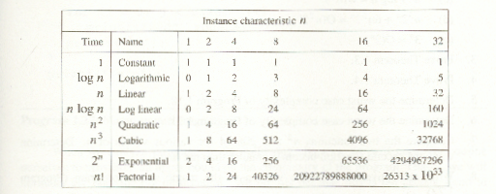

SINGLY LINKED LISTS

Linked list
An ordered sequence of nodes with links
The nodes do not reside in sequential locations
The locations of the nodes may change on different runs

Usual way to draw a linked list

create a linked list of words

typedef struct list_node *list_pointer;
typedef struct list_node {
char data [4];
list_pointer link;
};
Creation
list_pointer ptr =NULL;
Testing
#define IS_EMPTY(ptr) (!(ptr))
Allocation
ptr=(list_pointer) malloc (sizeof(list_node));
e -> name -> (*e).name
strcpy(ptr -> data, “bat”);
ptr -> link = NULL;

Referencing the fields of a node

typedef struct list_node *list_pointer;
typedef struct list_node {
int data;
list_pointer link;
};
list_pointer ptr =NULL
list_pointer create2( )
{
/* create a linked list with two nodes */
list_pointer first, second;
first = (list_pointer) malloc(sizeof(list_node));
second = ( list_pointer) malloc(sizeof(list_node));
second -> link = NULL;
second -> data = 20;
first -> data = 10;
first ->link = second;
return first;
}

Insert mat after cat

- Get a node that is currently unused ; let its address be paddr.
- Set the data field of this node to mat.
- Set paddr’s link field to point to the address found in the link field of the node containing cat.
- Set the link field of the node containing cat to point to paddr.

Insert a node after a specific node
#define IS_FULL(p) (!(p))
void insert(list_pointer *ptr, list_pointer node)
{
/* insert a new node with data = 50 into the list ptr after node */
list_pointer temp;
temp = (list_pointer) malloc(sizeof(list_node));
if (IS_FULL(temp)) //if, temp==NULL
{
fprintf(stderr, “The memory is full\n”);
exit (1);
}
temp->data = 50;
if (*ptr) { // nonempty list
temp->link =node ->link;
node->link = temp;
}
else { // empty list
temp->link = NULL;
*ptr =temp;
}
}

List Deletion

- Before b) After deletion

Delete other than first node

void delete(list_pointer *ptr, list_pointer trail,
list_pointer node)
{
/* delete node from the list, trail is the preceding node
ptr is the head of the list */
if (trail)
trail->link = node->link;
else
*ptr = (*ptr) ->link;
free(node);
}
Print out a list (traverse a list)
void print_list(list_pointer ptr)
{
printf(“The list ocntains: “);
for ( ; ptr; ptr = ptr->link)
printf(“%4d”, ptr->data);
printf(“\n”);
}
Circular Linked Lists

A Circular Linked List is a special type of Linked List
It supports traversing from the end of the list to the beginning by making the last node point back to the head of the list
A Rear pointer is often used instead of a Head pointer

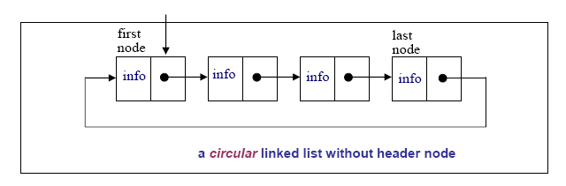

MOTIVATION
Circular linked lists are usually sorted
Circular linked lists are useful for playing video and sound files in “looping” mode
They are also a stepping stone to implementing graphs, an important topic in comp171.

Definition
#include <stdio.h>
using namespace std;
struct Node{
int data;
Node* next;
};
typedef Node* NodePtr;

Circular Linked List Operations
insertNode(NodePtr& Rear, int item)
//add new node to ordered circular linked list
deleteNode(NodePtr& Rear, int item)
//remove a node from circular linked list
print(NodePtr Rear)
//print the Circular Linked List once

Traverse The List
void print(NodePtr Rear){
NodePtr Cur;
if(Rear != NULL){
Cur = Rear->next;
do{
cout << Cur->data << " ";
Cur = Cur->next;
}while(Cur != Rear->next);
cout << endl;
}
}

Insert Node
- Insert into an empty list

NotePtr New = new Node;
New->data = 10;
Rear = New;
Rear->next = Rear;
- Insert to head of a Circular Linked List
New->next = Cur; // same as: New->next = Rear->next;
Prev->next = New; // same as: Rear->next = New;
- Insert to middle of a Circular Linked List between Pre and Cur
New->next = Cur;
Prev->next = New;
Insert to end of a Circular Linked List
New->next = Cur; // same as: New->next = Rear->next;
Prev->next = New; // same as: Rear->next = New;
Rear = New;
void insertNode(NodePtr& Rear, int item){
NodePtr New, Cur, Prev;
New = new Node;
New->data = item;
if(Rear == NULL){ // insert into empty list
Rear = New;
Rear->next = Rear;
return;
}
Prev = Rear;
Cur = Rear->next;
do{ // find Prev and Cur
if(item <= Cur->data)
break;
Prev = Cur;
Cur = Cur->next;
}while(Cur != Rear->next);
New->next = Cur; // revise pointers
Prev->next = New;
if(item > Rear->data) //revise Rear pointer if adding to end
Rear = New;
}

- Delete a node from a single-node Circular Linked List
Rear = NULL;
delete Cur;
- Delete the head node from a Circular Linked List
Prev->next = Cur->next; // same as: Rear->next = Cur->next
- Delete a middle node Cur from a Circular Linked List
Prev->next = Cur->next;
delete Cur;
DelPrev->next = Cur->next; // same as: Rear->next;
delete Cur;
Rear = Prev;
void deleteNode(NodePtr& Rear, int item){
NodePtr Cur, Prev;
if(Rear == NULL){
cout << "Trying to delete empty list" << endl;
return;
}
Prev = Rear;
Cur = Rear->next;
do{ // find Prev and Cur
if(item <= Cur->data) break;
Prev = Cur;
Cur = Cur->next;
}while(Cur != Rear->next);
if(Cur->data != item){ // data does not exist
cout << "Data Not Found" << endl;
return;
}
if(Cur == Prev){ // delete single-node list
Rear = NULL;
delete Cur;
return;
}
if(Cur == Rear) // revise Rear pointer if deleting end
Rear = Prev;
Prev->next = Cur->next; // revise pointers
delete Cur;
}

void main(){
NodePtr Rear = NULL;

insertNode(Rear, 3);
insertNode(Rear, 1);
insertNode(Rear, 7);
insertNode(Rear, 5);
insertNode(Rear, 8);
print(Rear);
deleteNode(Rear, 1);
deleteNode(Rear, 3);
deleteNode(Rear, 8);
print(Rear);
insertNode(Rear, 1);
insertNode(Rear, 8);
print(Rear);
}

Result is:
1 3 5 7 8
5 7
1 5 7 8

Doubly Linked List
Move in forward and backward direction.
Singly linked list (in one direction only)
How to get the preceding node during deletion or insertion?
Using 2 pointers
Node in doubly linked list
left link field (llink)
data field (item)
right link field (rlink)
typedef struct node *node_pointer;
typedef struct node {
node_pointer llink;
element item;
node_pointer rlink;
}

Empty doubly linked circular list with head node

Insertion into an empty doubly linked circular list
INSERT
void dinsert(node_pointer node, node_pointer newnode)
{
(1) newnode->llink = node;
(2) newnode->rlink = node->rlink;
(3) node->rlink->llink = newnode;
(4) node->rlink = newnode;
}

DELETE
void ddelete(node_pointer node, node_pointer deleted)
{
if (node==deleted)
printf(“Deletion of head node not permitted.\n”);
else {
(1) deleted->llink->rlink= deleted->rlink;
(2) deleted->rlink->llink= deleted->llink;
free(deleted);
}
}

ARRAYS
Array: a set of index and value
a collection of data of the same type data structure
For each index, there is a value associated with that index
representation (possible)
implemented by using consecutive memory.
Array A(i)=a_{i} i∈Integers

Structure Array is
objects: A set of pairs <index, value> where for each value of index
there is a value from the set item. Index is a finite ordered set of one or
more dimensions, for example, {0, … , n-1} for one dimension,
{(0,0),(0,1),(0,2),(1,0),(1,1),(1,2),(2,0),(2,1),(2,2)} for two dimensions,
etc.
Functions:
for all A ∈ Array, i ∈ index, x ∈ item, j, size ∈ integer
Array Create(j, list) ::= return an array of j dimensions where list is a
j-tuple whose ith element is the size of the
ith dimension. Items are undefined.
Item Retrieve(A, i) ::= if (i ∈ index) return the item associated with
index value i in array A
else return error
Array Store(A, i, x) ::= if (i in index)
return an array that is identical to array
A except the new pair <i, x> has been
inserted else return error
end Array
Abstract Data Type Array
Arrays in C
int list[5], *plist[5];
list[5]: five integers
list[0], list[1], list[2], list[3], list[4]
*plist[5]: five pointers to integers
plist[0], plist[1], plist[2], plist[3], plist[4]
implementation of 1-D array
list[0] base address = α
list[1] α + 1*sizeof(int)
list[2] α + 2*sizeof(int)
list[3] α + 3*sizeof(int)
list[4] α + 4*size(int)
Compare int *list1 and int list2[5] in C.
Same: list1 and list2 are pointers.
Difference: list2 reserves five locations.
Notations:
list2 - a pointer to list2[0]
(list2 + i) - a pointer to list2[i] (&list2[i])
*(list2 + i) - list2[i]

Example: 1-dimension array addressing
int one[] = {0, 1, 2, 3, 4};
Goal: print out address and value
void print1(int *ptr, int rows)
{
/* print out a one-dimensional array using a pointer */
int i;
printf(“Address Contents\n”);
for (i=0; i < rows; i++)
printf(“%8u%5d\n”, ptr+i, *(ptr+i));
printf(“\n”);
}

- A[-3..2, -1..6, 2..7, 0..5] each of its elements occupies three memory spaces starting from 123
Find the address of the element A[0,1,2,3]
- In row major order (2) In column major order

The Sparse Matrix Abstract Data Type
Matrix
  - Examples of matrix
- Sparse matrix
  - Many zero items
- Representation of matrix
  - A[][], standard representation
  - Sparse matrix, store non-zero item only

Structure Sparse_Matrix is
objects: a set of triples, <row, column, value>, where row
and column are integers and form a unique combination, and
value comes from the set item.
functions:
for all a, b ∈ Sparse_Matrix, x item, i, j, max_col,
max_row index
Sparse_Marix Create(max_row, max_col) ::=
return a Sparse_matrix that can hold up to
max_items = max _row max_col and
whose maximum row size is max_row and
whose maximum column size is max_col.
Sparse_Matrix Transpose(a) ::=
return the matrix produced by interchanging
the row and column value of every triple.
Sparse_Matrix Add(a, b) ::=
if the dimensions of a and b are the same
return the matrix produced by adding
corresponding items, namely those with
identical row and column values.
else return error
Sparse_Matrix Multiply(a, b) ::=
if number of columns in a equals number of
rows in b
return the matrix d produced by multiplying
a by b according to the formula: d [i] [j] =
(a[i][k]•b[k][j]) where d (i, j) is the (i,j)th
element
else return error.
Abstract data type Sparse-Matrix
(1) Represented by a two-dimensional array.
Sparse matrix wastes space.
(2) Each element is characterized by <row, col, value>.

Sparse matrix and its transpose stored as triples

Sparse_matrix Create(max_row, max_col) ::=
#define MAX_TERMS 101 /* maximum number of terms +1*/
typedef struct {
int col;
int row;
int value;
} term;
term a[MAX_TERMS]
Transpose a Matrix

(1) for each row i
take element <i, j, value> and store it
in element <j, i, value> of the transpose.

difficulty: where to put <j, i, value>
(0, 0, 15) ====> (0, 0, 15)
(0, 3, 22) ====> (3, 0, 22)
(0, 5, -15) ====> (5, 0, -15)
(1, 1, 11) ====> (1, 1, 11)
Move elements down very often.
(2) For all elements in column j,
place element <i, j, value> in element <j, i, value>

void transpose (term a[], term b[])
/* b is set to the transpose of a */
{
int n, i, j, currentb;
n = a[0].value; /* total number of elements */
b[0].row = a[0].col; /* rows in b = columns in a */
b[0].col = a[0].row; /*columns in b = rows in a */
b[0].value = n;
if (n > 0) { /*non zero matrix */
currentb = 1;
for (i = 0; i < a[0].col; i++)
/* transpose by columns in a */
for( j = 1; j <= n; j++)
/* find elements from the current column */
if (a[j].col == i) {
/* element is in current column, add it to b */
if (n > 0) { /*non zero matrix */
currentb = 1;
for (i = 0; i < a[0].col; i++)
/* transpose by columns in a */
for( j = 1; j <= n; j++)
/* find elements from the current column */
if (a[j].col == i) {
/* element is in current column, add it to b */
b[currentb].row = a[j].col;
b[currentb].col = a[j].row;
b[currentb].value = a[j].value;
currentb++
}
}
} O(columns*elements)

Discussion: compared with 2-D array representation
O(columns*elements) vs. O(columns*rows)
elements --> columns * rows when nonsparse
O(columns*columns*rows)
Problem: Scan the array “columns” times.
Solution:
Determine the number of elements in each column of the original matrix.
==>
Determine the starting positions of each row in the transpose matrix.
[0] [1] [2] [3] [4] [5]
row_terms = 2 1 2 2 0 1
starting_pos = 1 3 4 6 8 8

void fast_transpose(term a[ ], term b[ ])
{
/* the transpose of a is placed in b */
int row_terms[MAX_COL], starting_pos[MAX_COL];
int i, j, num_cols = a[0].col, num_terms = a[0].value;
b[0].row = num_cols; b[0].col = a[0].row;
b[0].value = num_terms;
if (num_terms > 0){ /*nonzero matrix*/
for (i = 0; i < num_cols; i++)
row_terms[i] = 0;
for (i = 1; i <= num_terms; i++)
row_term [a[i].col]++
starting_pos[0] = 1;
for (i =1; i < num_cols; i++)
starting_pos[i]=starting_pos[i-1] +row_terms [i-1];
for (i=1; i <= num_terms, i++) {
j = starting_pos[a[i].col]++;
b[j].row = a[i].col;
b[j].col = a[i].row;
b[j].value = a[i].value;
}
}
}
Fast transpose of a sparse matrix
Compared with 2-D array representation
O(columns+elements) vs. O(columns*rows)
elements --> columns * rows
O(columns+elements) --> O(columns*rows)
Cost: Additional row_terms and starting_pos arrays are required.
Let the two arrays row_terms and starting_pos be shared.

 | space | time
2D array | O(rows * cols) | O(rows * cols)
Transpose | O(elements) | O(cols * elmnts)
Fast Transpose | O(elmnts+MAX_COL) | O(cols + elmnts)

Sparse Matrix Multiplication
Definition: [D]_{m*p}=[A]_{m*n}* [B]_{n*p}
Procedure: Fix a row of A and find all elements in column j
of B for j=0, 1, …, p-1.
Alternative 1. Scan all of B to find all elements in j.
Alternative 2. Compute the transpose of B.
(Put all column elements consecutively)

void mmult (term a[ ], term b[ ], term d[ ] )
/* multiply two sparse matrices */
{
int i, j, column, totalb = b[].value, totald = 0;
int rows_a = a[0].row, cols_a = a[0].col,
totala = a[0].value; int cols_b = b[0].col,
int row_begin = 1, row = a[1].row, sum =0;
int new_b[MAX_TERMS][3];
if (cols_a != b[0].row){
fprintf (stderr, “Incompatible matrices\n”);
exit (1);
}
fast_transpose(b, new_b);
a[totala+1].row = rows_a;
new_b[totalb+1].row = cols_b;
new_b[totalb+1].col = 0;
for (i = 1; i <= totala; ) {
column = new_b[1].row;
for (j = 1; j <= totalb+1;) {
/* mutiply row of a by column of b */
if (a[i].row != row) {
storesum(d, &totald, row, column, &sum);
i = row_begin;
for (; new_b[j].row == column; j++)
;
column =new_b[j].row
}
else switch (COMPARE (a[i].col, new_b[j].col)) {
case -1: /* go to next term in a */
i++; break;
case 0: /* add terms, go to next term in a and b */
sum += (a[i++].value * new_b[j++].value);
break;
case 1: /* advance to next term in b*/
j++
}
} /* end of for j <= totalb+1 */
for (; a[i].row == row; i++)
;
row_begin = i; row = a[i].row;
} /* end of for i <=totala */
d[0].row = rows_a;
d[0].col = cols_b; d[0].value = totald;
}
Program : Sparse matrix multiplication

UNIT II
STACKS AND QUEUES
Stack (stack: a Last-In-First-Out (LIFO) list )
- Stack
  - An ordered list
  - Insertions and deletions are made at one end, called top
- Illustration

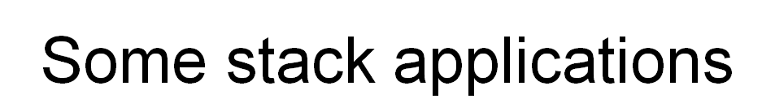
- Implementing recusive call
- Expression evaluation
  - Infix to postfix
  - Postfix evaluation
- Maze problem
- Breadth First Search

an application of stack: stack frame of function call

abstract data type for stack
structure Stack is
objects: a finite ordered list with zero or more elements.
functions:
for all stack ∈ Stack, item ∈ element, max_stack_size
∈ positive integer
Stack CreateS(max_stack_size) ::=
create an empty stack whose maximum size is
max_stack_size
Boolean IsFull(stack, max_stack_size) ::=
if (number of elements in stack == max_stack_size)
return TRUE
else return FALSE
Stack Add(stack, item) ::=
if (IsFull(stack)) stack_full
else insert item into top of stack and return

Boolean IsEmpty(stack) ::=
if(stack == CreateS(max_stack_size))
return TRUE
else return FALSE
Element Delete(stack) ::=
if(IsEmpty(stack)) return
else remove and return the item on the top of the stack
Structure 2.1: Abstract data type Stack
Implementation: using array
Stack CreateS(max_stack_size) ::=
#define MAX_STACK_SIZE 100 /* maximum stack size */
typedef struct {
int key;
/* other fields */
} element;
element stack[MAX_STACK_SIZE];
int top = -1;
Boolean IsEmpty(Stack) ::= top< 0;
Boolean IsFull(Stack) ::= top >= MAX_STACK_SIZE-1;
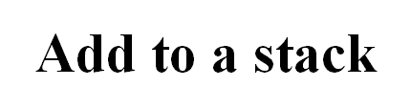
void add(int *top, element item)
{
if (*top >= MAX_STACK_SIZE-1) {
stack_full( );
return;
}
stack[++*top] = item;
}
*program 2.1: Add to a stack
Delete from a stack

element delete(int *top)
{
if (*top == -1)
return stack_empty( ); /* returns and error key */
return stack[(*top)--];
}
*Program 2.2: Delete from a stack
- Queue
  - An ordered list
  - All insertions take place at one end, rear
  - All deletions take place at the opposite end, front
- Illustration
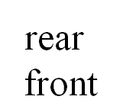

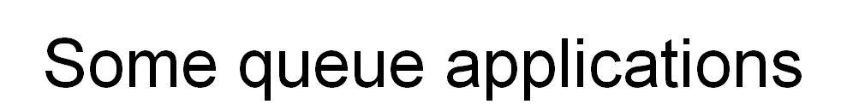
- Job scheduling
- Event list in simulator
- Server and Customs
Application: Job scheduling

Figure 3.2: Insertion and deletion from a sequential queue

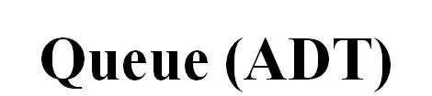
structure Queue is
objects: a finite ordered list with zero or more elements.
functions:
for all queue ∈ Queue, item ∈ element,
max_ queue_ size ∈ positive integer
Queue CreateQ(max_queue_size) ::=
create an empty queue whose maximum size is
max_queue_size
Boolean IsFullQ(queue, max_queue_size) ::=
if(number of elements in queue == max_queue_size)
return TRUE
else return FALSE
Queue AddQ(queue, item) ::=
if (IsFullQ(queue)) queue_full
else insert item at rear of queue and return queue
Boolean IsEmptyQ(queue) ::=
if (queue ==CreateQ(max_queue_size))
return TRUE
else return FALSE
Element DeleteQ(queue) ::=
if (IsEmptyQ(queue)) return
else remove and return the item at front of queue.
*Structure 3.2: Abstract data type Queue
Implementation 1: using array
Queue CreateQ(max_queue_size) ::=
# define MAX_QUEUE_SIZE 100/* Maximum queue size */
typedef struct {
int key;
/* other fields */
} element;
element queue[MAX_QUEUE_SIZE];
int rear = -1;
int front = -1;
Boolean IsEmpty(queue) ::= front == rear
Boolean IsFullQ(queue) ::= rear == MAX_QUEUE_SIZE-1

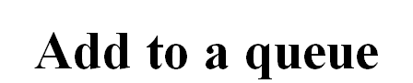
void addq(int *rear, element item)
{
if (*rear == MAX_QUEUE_SIZE_1) {
queue_full( );
return;
}
queue [++*rear] = item;
}
*Program 3.3: Add to a queue

element deleteq(int *front, int rear)
{
if ( *front == rear)
return queue_empty( ); /* return an error key */
return queue [++ *front];
}
*Program 3.4: Delete from a queue
Implementation 2: regard an array as a circular queue
front: one position counterclockwise from the first element
rear: current end

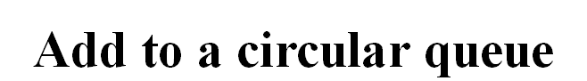

void addq(int front, int *rear, element item)
{
*rear = (*rear +1) % MAX_QUEUE_SIZE;
if (front == *rear) /* reset rear and print error */
return;
}
queue[*rear] = item;
}
*Program 3.5: Add to a circular queue
Delete from a circular queue
element deleteq(int* front, int rear)
{
element item;
if (*front == rear)
return queue_empty( );
/* queue_empty returns an error key */
*front = (*front+1) % MAX_QUEUE_SIZE;
return queue[*front];
}
*Program 3.6: Delete from a circular queue


- Evaluating a complex expression in computer
  - ((rear+1==front)||((rear==MaxQueueSize-1)&&!front))
  - x= a/b- c+ d*e- a*c
- Figuring out the order of operation within any expression
  - A precedence hierarchy within any programming language
  - See Figure 3.12
Evaluation of Expressions (Cont.)

- Ways to write expressions
  - Infix (standard)
  - Prefix
  - Postfix
    - compiler, a parenthesis-free notation
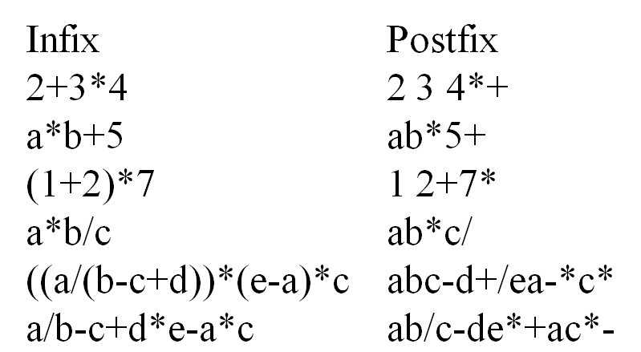
- Left-to-right scan Postfix expression,
  - Stack operands until find an operator,
  - Meet operator, remove correct operands for this operator,
  - Perform the operation,
  - Stack the result
- Remove the answer from the top of stack

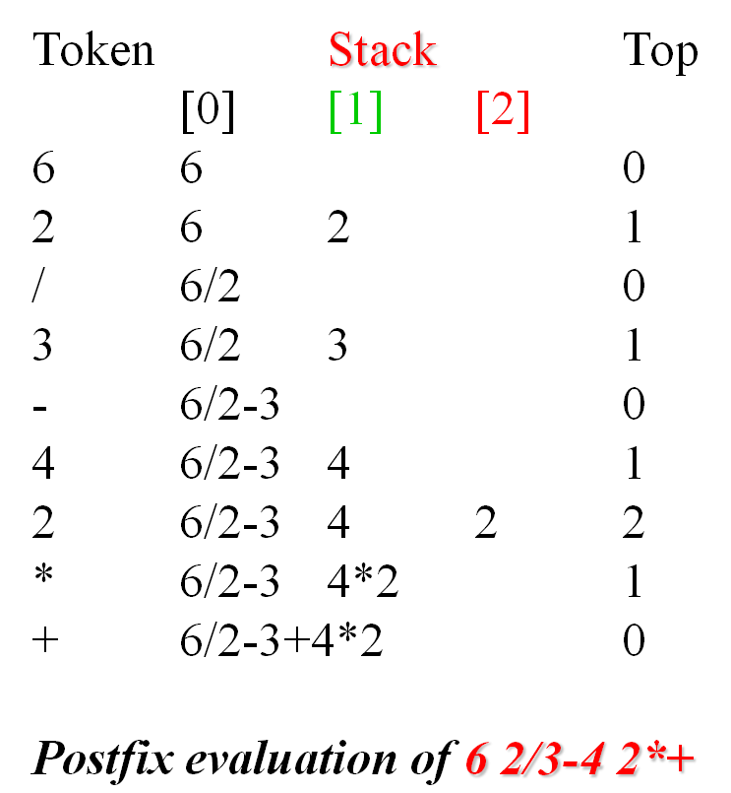
Assumptions:
operators: +, -, *, /, %
operands: single digit integer
#define MAX_STACK_SIZE 100
#define MAX_EXPR_SIZE 100 /* max size of expression */
typedef enum{1paran, rparen, plus, minus, times, divide,
mod, eos, operand} precedence;
int stack[MAX_STACK_SIZE]; /* global stack */
char expr[MAX_EXPR_SIZE]; /* input string
int eval(void)
{
precedence token;
char symbol;
int op1, op2;
int n = 0; /* counter for the expression string */
int top = -1;
token = get_token(&symbol, &n);
while (token != eos) {
if (token == operand)
add(&top, symbol-’0’); /* stack add */
else {
/* remove two operands, perform operation, and
return result to the stack */
op2 = delete(&top); /* stack delete */
op1 = delete(&top);
switch(token) {
case plus: add(&top, op1+op2); break;
case minus: add(&top, op1-op2); break;
case times: add(&top, op1*op2); break;
case divide: add(&top, op1/op2); break;
case mod: add(&top, op1%op2);
}
}
token = get_token (&symbol, &n);
}
return delete(&top); /* return result */
}
*Program 3.7: Fuprecedence get_token(char *symbol, int *n)
{
*symbol =expr[(*n)++];
switch (*symbol) {
case ‘(‘ : return lparen;
case ’)’ : return rparen;
case ‘+’: return plus;
case ‘-’ : return minus;
case ‘/’ : return divide;
case ‘*’ : return times;
case ‘%’ : return mod;
case ‘\0‘ : return eos;
default : return operand;
}
}
*Program 3.8: Function to get a token from the input string (p.123)nction to evaluate a postfix expression


- Method I
  - Fully parenthesize the expression
  - Move all binary operators so that they replace their corresponding right parentheses
  - Delete all parentheses
- Examples:a/b-c+d*e-a*c
  - ((((a/b)-c)+(d*e))-(a*c)), fully parentheses
  - ab/c-de*+ac*-, replace right parentheses and delete all parentheses
- Disadvantage
  - inefficient, two passes
- Method II
  - scan the infix expression left-to-right
  - output operand encountered
  - output operators depending on their precedence, i.e., higher precedence operators first
- Example: a+b*c, simple expression
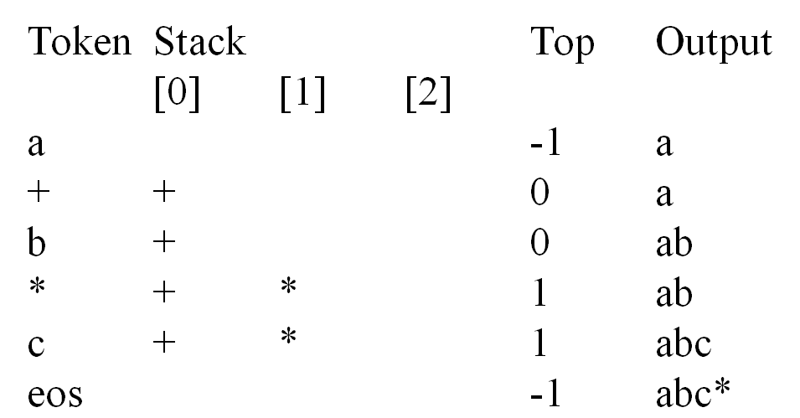

- Example: a*(b+c)*d , parenthesized expression

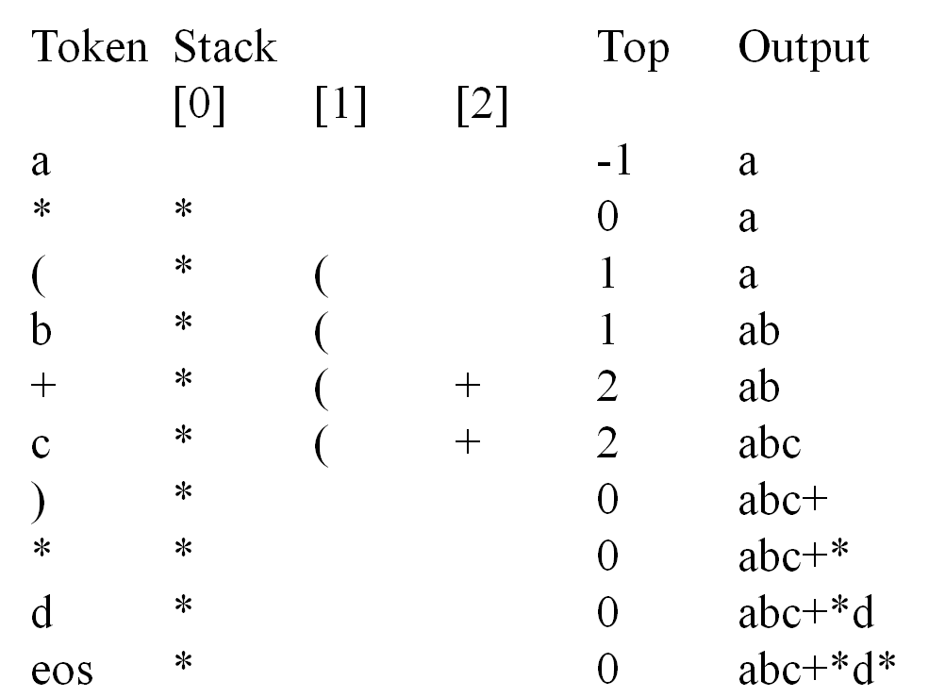

- Last two examples suggests a precedence-based scheme for stacking and unstacking operators
  - isp (in-stack precedence)
  - icp (iprecedence stack[MaxStackSize];
  - /* isp and icp arrays - index is value of precedence
  - lparen, rparen, plus, minus, time divide, mod, eos */
  - static int isp[]= { 0, 19, 12, 12, 13, 13, 13, 0};
  - static int icp[]= {20, 19, 12, 12, 13, 13, 13, 0}n-coming precedence)
void postfix(void)
{
/* output the postfix of the expression. The expression
string, the stack, and top are global */
char symbol;
precedence token;
int n = 0;
int top = 0; /* place eos on stack */
stack[0] = eos;
for (token = get _token(&symbol, &n); token != eos;
token = get_token(&symbol, &n)) {
if (token == operand)
printf (“%c”, symbol);
else if (token == rparen ){
/*unstack tokens until left parenthesis */
while (stack[top] != lparen)
print_token(delete(&top));
delete(&top); /*discard the left parenthesis */
}
else{
/* remove and print symbols whose isp is greater
than or equal to the current token’s icp */
while(isp[stack[top]] >= icp[token] )
print_token(delete(&top));
add(&top, token);
}
}
while ((token = delete(&top)) != eos)
print_token(token);
print(“\n”);
}
*Program 3.9: Function to convert from infix to postfix

UNIT III
Trees

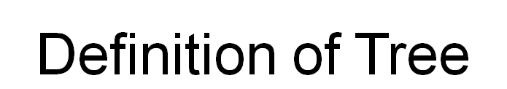
- A tree is a finite set of one or more nodes
such that:
- There is a specially designated node called
the root.
- The remaining nodes are partitioned into n>=0 disjoint sets T1, ..., Tn, where each of these sets is a tree.
- We call T1, ..., Tn the subtrees of the root.

Node, Degree of a node, Leaf (terminal), Nonterminal, Parent, Children, Sibling, Degree of a tree, Ancestor,Level of a node
- Height of a tree The degree of a node is the number of subtrees
of the node
  - The degree of A is 3; the degree of C is 1.
- The node with degree 0 is a leaf or terminal
node.
- A node that has subtrees is the parent of the
roots of the subtrees.
- The roots of these subtrees are the children of
the node.
- Children of the same parent are siblings.
- The ancestors of a node are all the nodes
along the path from the root to the node.


- List Representation
  - ( A ( B ( E ( K, L ), F ), C ( G ), D ( H ( M ), I, J ) ) )
  - The root comes first, followed by a list of sub-trees

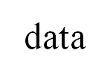

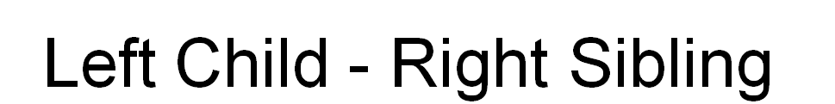

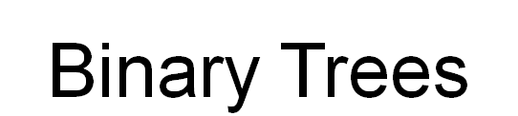
- A binary tree is a finite set of nodes that is either empty or consists of a root and two
disjoint binary trees called the left subtree and the right subtree.
- Any tree can be transformed into binary tree.
  - by left child-right sibling representation
- The left subtree and the right subtree are distinguished.

Binary Tree ADT

structure Binary_Tree(abbreviated BinTree) is objects: a finite set of nodes either empty or
consisting of a root node, left Binary_Tree, and right Binary_Tree.
functions:
for all bt, bt1, bt2 ∈ BinTree, item ∈ element
Bintree Create() ::= creates an empty binary tree
Boolean IsEmpty(bt) ::= if (bt==empty binary tree) return TRUE else return FALSE
BinTree MakeBT(bt1, item, bt2)::= return a binary tree
whose left subtree is bt1, whose right subtree is bt2,
and whose root node contains the data item
Bintree Lchild(bt)::= if (IsEmpty(bt)) return error
else return the left subtree of bt
element Data(bt)::= if (IsEmpty(bt)) return error
else return the data in the root node of bt
Bintree Rchild(bt)::= if (IsEmpty(bt)) return error
else return the right subtree of bt

Samples of Trees
Maximum Number of Nodes in BT
- The maximum number of nodes on level i of a binary tree is 2^{i-1}, i>=1.
- The maximum nubmer of nodes in a binary tree
of depth k is 2^{k}-1, k>=1.

Relations between Number of Leaf Nodes and Nodes of Degree 2
For any nonempty binary tree, T, if n0 is the number of leaf nodes and n2 the number of nodes
of degree 2, then n0=n2+1
proof:
Let n and B denote the total number of nodes & branches in T.
Let n0, n1, n2 represent the nodes with no children, single child, and two children respectively.
n= n0+n1+n2, B+1=n, B=n1+2n2 ==> n1+2n2+1= n,
n1+2n2+1= n0+n1+n2 ==> n0=n2+1

Full BT VS Complete BT
- A full binary tree of depth k is a binary tree of depth k having 2 -1 nodes, k>=0.
- A binary tree with n nodes and depth k is complete iff its nodes correspond to the nodes numbered from 1 to n in the full binary tree of depth k.

Binary Tree Representations
- If a complete binary tree with n nodes (depth =log n + 1) is represented sequentially, then for any node with index i, 1<=i<=n, we have:
  - parent(i) is at i/2 if i!=1. If i=1, i is at the root and has no parent.
  - left_child(i) ia at 2i if 2i<=n. If 2i>n, then i has noleft child.
  - right_child(i) ia at 2i+1 if 2i +1 <=n. If 2i +1 >n, then i has no right child.
- Sequential Representation
Linked Representation
typedef struct node *tree_pointer;
typedef struct node {
int data;
tree_pointer left_child, right_child;
};
Binary Tree Traversals
Let L, V, and R stand for moving left, visiting the node, and moving right.
There are six possible combinations of traversal
LVR, LRV, VLR, VRL, RVL, RLV
Adopt convention that we traverse left before right, only 3 traversals remain
LVR, LRV, VLR
inorder, postorder, preorder
Inorder Traversal (recursive version)
void inorder(tree_pointer ptr)
/* inorder tree traversal */
{
if (ptr) {
inorder(ptr->left_child);
printf(“%d”, ptr->data);
inorder(ptr->right_child);
}
}
Preorder Traversal (recursive version)
void preorder(tree_pointer ptr)
/* preorder tree traversal */
{
if (ptr) {
printf(“%d”, ptr->data);
preorder(ptr->left_child);
preorder(ptr->right_child);
}
}
Postorder Traversal (recursive version)
void postorder(tree_pointer ptr)
/* postorder tree traversal */
{
if (ptr) {
postorder(ptr->left_child);
postorder(ptr->right_child);
printf(“%d”, ptr->data);
}
}
Iterative Inorder Traversal (using stack)
void iter_inorder(tree_pointer node)
{
int top= -1; /* initialize stack */
tree_pointer stack[MAX_STACK_SIZE];
for (;;) {
for (; node; node=node->left_child)
add(&top, node);/* add to stack */
node= delete(&top);
/* delete from stack */
if (!node) break; /* empty stack */
printf(“%d”, node->data);
node = node->right_child;
}
}
Trace Operations of Inorder Traversal

Level Order Traversal (using queue)
void level_order(tree_pointer ptr)
/* level order tree traversal */
{
int front = rear = 0;
tree_pointer queue[MAX_QUEUE_SIZE];
if (!ptr) return; /* empty queue */
addq(front, &rear, ptr);
for (;;) {
ptr = deleteq(&front, rear);
if (ptr) {
printf(“%d”, ptr->data);
if (ptr->left_child)
addq(front, &rear,
ptr->left_child);
if (ptr->right_child)
addq(front, &rear,
ptr->right_child);
}
else break;
}
} Non Recursive Binary Tree Traversals
Nonrecursive Inorder Traversal: General Algorithm
- current = root; //start traversing the binary tree at
// the root node
- while(current is not NULL or stack is nonempty)
if(current is not NULL)
{
push current onto stack;
current = current->llink;
}
else
{
pop stack into current;
visit current; //visit the node
current = current->rlink; //move to the
//right child
}
Nonrecursive Preorder Traversal
1. current = root; //start the traversal at the root node
2. while(current is not NULL or stack is nonempty)
if(current is not NULL)
{
visit current;
push current onto stack;
current = current->llink;
}
else
{
pop stack into current;
current = current->rlink; //prepare to visit
//the right subtree
}
Nonrecursive Postorder Traversal

- current = root; //start traversal at root node
- v = 0;
- if(current is NULL)
the binary tree is empty
- if(current is not NULL)
  - push current into stack;
  - push 1 onto stack;
  - current = current->llink;
  - while(stack is not empty)
if(current is not NULL and v is 0)
{
push current and 1 onto stack;
current = current->llink;
}
else
{
pop stack into current and v;
if(v == 1)
{
push current and 2 onto stack;
current = current->rlink;
v = 0;
}
else
visit current;
}

Threaded Binary Trees
- Two many null pointers in current representation of binary trees n: number of nodes number of non-null links: n-1 total links: 2n null links: 2n-(n-1)=n+1
- Replace these null pointers with some useful “threads”.
- If ptr->left_child is null, replace it with a pointer to the node that would be visited before ptr in an inorder traversal
- If ptr->right_child is null, replace it with a pointer to the node that would be visited after ptr in an inorder traversal

Heap

A max tree is a tree in which the key value in each node is no smaller than the key values in
its children. A max heap is a complete binary tree that is also a max tree.A min tree is a tree in which the key value in each node is no larger than the key values in its children. A min heap is a complete binary tree that is also a min tree.
Operations on heaps
  - creation of an empty heap
  - insertion of a new element into the heap;
  - deletion of the largest element from the heap
\

*Figure 5.25: Sample max heaps
14
12
7
8
10
6
9
6
3
5
30
25
1
2
3
5
6
1
[2]
3
4
[1]
2

Property:
The root of max heap (min heap) contains the largest (smallest).

*Figure 5.26:Sample min heaps
2
7
4
8
10
6
10
20
83
50
11
21
[1]
[2]
[3]
[5]
[6]
[1]
[2]
[3]
[4]
[1]
[2]
[4]

ADT for Max Heap
structure MaxHeap
objects: a complete binary tree of n > 0 elements organized so that
the value in each node is at least as large as those in its children
functions:
for all heap belong to MaxHeap, item belong to Element, n,
max_size belong to integer
MaxHeap Create(max_size)::= create an empty heap that can
hold a maximum of max_size elements
Boolean HeapFull(heap, n)::= if (n==max_size) return TRUE
else return FALSE
MaxHeap Insert(heap, item, n)::= if (!HeapFull(heap,n)) insert
item into heap and return the resulting heap else return error
Boolean HeapEmpty(heap, n)::= if (n>0) return FALSE
else return TRUE
Element Delete(heap,n)::= if (!HeapEmpty(heap,n)) return one
instance of the largest element in the heap
and remove it from the heap
else return error
Application: priority queue
machine service
  - amount of time (min heap)
  - amount of payment (max heap)
factory
  - time tag
Data Structures
unordered linked list
unordered array
sorted linked list
sorted array
heap
Figure 5.27: Priority queue representations

Example of Insertion to Max Heap

initial location of new node
20
15
2
14
10
21
15
20
14
10
2
insert 21 into heap
20
15
5
14
10
2
insert 5 into heap

Insertion into a Max Heap

void insert_max_heap(element item, int *n)
{
int i;
if (HEAP_FULL(*n)) {
fprintf(stderr, “the heap is full.\n”);
exit(1);
}
i = ++(*n);
while ((i!=1)&&(item.key>heap[i/2].key)) {
heap[i] = heap[i/2];
i /= 2;
}
heap[i]= item;
}

Example of Deletion from Max Heap
remove
20
15
2
14
10
10
15
2
14
15
14
2
10
(a) Heap structure
(b) 10 inserted at the root
(c) Finial heap
Deletion from a Max Heap
element delete_max_heap(int *n)
{
int parent, child;
element item, temp;
if (HEAP_EMPTY(*n)) {
fprintf(stderr, “The heap is empty\n”);
exit(1);
}
/* save value of the element with the
highest key */
item = heap[1];
/* use last element in heap to adjust heap */
temp = heap[(*n)--];
parent = 1;
child = 2;
while (child <= *n) {
/* find the larger child of the current
parent */
if ((child < *n)&&
(heap[child].key<heap[child+1].key))
child++;
if (temp.key >= heap[child].key) break;
/* move to the next lower level */
heap[parent] = heap[child];
child *= 2;
}
heap[parent] = temp;
return item;
}
GRAPHS
Definition
A graph, G=(V, E), consists of two sets:
  - a finite set of vertices(V), and
  - a finite, possibly empty set of edges(E)
  - V(G) and E(G) represent the sets of vertices and edges of G, respectively
Undirected graph
  - The pairs of vertices representing any edges is unordered
  - e.g., (v0, v1) and (v1, v0) represent the same edge
Directed graph
  - Each edge as a directed pair of vertices
  - e.g. <v0, v1> represents an edge, v0 is the tail and v1 is the head.

Examples for Graph
0
1
2
3
1
2
0
1
2
3
4
5
6
G1
G2
G3
complete graph
incomplete graph

V(G1)={0,1,2,3} E(G1)={(0,1),(0,2),(0,3),(1,2),(1,3),(2,3)}
V(G2)={0,1,2,3,4,5,6} E(G2)={(0,1),(0,2),(1,3),(1,4),(2,5),(2,6)}
V(G3)={0,1,2} E(G3)={<0,1>,<1,0>,<1,2>}

complete undirected graph: n(n-1)/2 edges
complete directed graph: n(n-1) edges

Complete Graph
A complete graph is a graph that has the
maximum number of edges
  - for undirected graph with n vertices, the maximum number of edges is n(n-1)/2
  - for directed graph with n vertices, the maximum
number of edges is n(n-1)
  - example: G1 is a complete graph

Adjacent and Incident

If (v0, v1) is an edge in an undirected graph,
  - v0 and v1 are adjacent
  - The edge (v0, v1) is incident on vertices v0 and v1
If <v0, v1> is an edge in a directed graph
  - v0 is adjacent to v1, and v1 is adjacent from v0
  - The edge <v0, v1> is incident on v0 and v1

Subgraph and Path

- A subgraph of G is a graph G’ such that V(G’)
is a subset of V(G) and E(G’) is a subset of E(G)
- A path from vertex vp to vertex vq in a graph G,
is a sequence of vertices, vp, vi1, vi2, ..., vin, vq,
such that (vp, vi1), (vi1, vi2), ..., (vin, vq) are edges
in an undirected graph
- The length of a path is the number of edges on it

Figure 6.4: subgraphs of G1 and G3
0
0
1
2
3
1
2
0
1
2
3
(i) (ii) (iii) (iv)
(a) Some of the subgraph of G₁
0
0
1
0
1
2
0
1
2
(i) (ii) (iii) (iv)
(b) Some of the subgraph of G₃
單一
0
1
2
3
G1
0
1
2
G3
Simple Path and Style
- A simple path is a path in which all vertices, except possibly the first and the last, are distinct
- A cycle is a simple path in which the first and the last vertices are the same
- In an undirected graph G, two vertices, v0 and v1, are connected if there is a path in G from v0 to v1
- An undirected graph is connected if, for every pair of distinct vertices vi, vj, there is a path
from vi to vj

Connected Component

- A connected component of an undirected graph
is a maximal connected subgraph.
- A tree is a graph that is connected and acyclic.
- A directed graph is strongly connected if there
is a directed path from vi to vj and also
from vj to vi.
- A strongly connected component is a maximal subgraph that is strongly connected

Degree
- The degree of a vertex is the number of edges incident to that vertex
- For directed graph,
  - the in-degree of a vertex v is the number of edges
that have v as the head
  - the out-degree of a vertex v is the number of edges
that have v as the tail
  - if di is the degree of a vertex i in a graph G with n vertices and e edges, the number of edges is

degree
0
1
2
3
4
5
6
G1
G2
3
2
3
3
1
1
1
1
directed graph
in-degree
out-degree
0
1
2
in:1, out: 1
in: 1, out: 2
in: 1, out: 0
0
1
2
3
3
3
3
ADT for Graph

structure Graph is
objects: a nonempty set of vertices and a set of undirected edges, where each
edge is a pair of vertices
functions: for all graph ∈ Graph, v, v1 and v2 ∈ Vertices
Graph Create()::=return an empty graph
Graph InsertVertex(graph, v)::= return a graph with v inserted. v has no
incident edge.
Graph InsertEdge(graph, v1,v2)::= return a graph with new edge
between v1 and v2
Graph DeleteVertex(graph, v)::= return a graph in which v and all edges
incident to it are removed
Graph DeleteEdge(graph, v1, v2)::=return a graph in which the edge (v1, v2)
is removed
Boolean IsEmpty(graph)::= if (graph==empty graph) return TRUE
else return FALSE
List Adjacent(graph,v)::= return a list of all vertices that are adjacent to v

0
1
2
3
4
6
5
7
G4
0
1
2
3
G1
2
1
0
G3

Graph Representations
Adjacency Matrix
- Let G=(V,E) be a graph with n vertices.
- The adjacency matrix of G is a two-dimensional
n by n array, say adj_mat
- If the edge (vi, vj) is in E(G), adj_mat[i][j]=1
- If there is no such edge in E(G), adj_mat[i][j]=0
- The adjacency matrix for an undirected graph is symmetric; the adjacency matrix for a digraph
need not be symmetric
Examples for Adjacency Matrix
G1
G2
0
1
2
3
0
1
2
1
0
2
3
4
5
6
7

symmetric
undirected: n²/2
directed: n²
Merits of Adjacency Matrix
- From the adjacency matrix, to determine the connection of vertices is easy
- The degree of a vertex is
- For a digraph, the row sum is the out_degree, while the column sum is the in_degree

Adjacency lists
- linked list
#define MAX_VERTICES 50
1
2
0
2
1
0
G3
typedef struct node *node_ptr;
typedef struct node {
int vertex;
node_ptr link;
0
1
2
3
G1
3
1
2
2
3
0
1
3
0
2
1
0
} node;
node_ptr graph[MAX_VERTICES];
int n = 0; /* number of nodes

Adjacency lists, by array
2
1
0
G3
1
2
0

Some Graph Operations
- Traversal
Given G=(V,E) and vertex v, find all w∈V, such that w connects v.
  - Depth First Search (DFS) preorder tree traversal
  - Breadth First Search (BFS) level order tree traversal
- Connected Components
- Spanning Trees
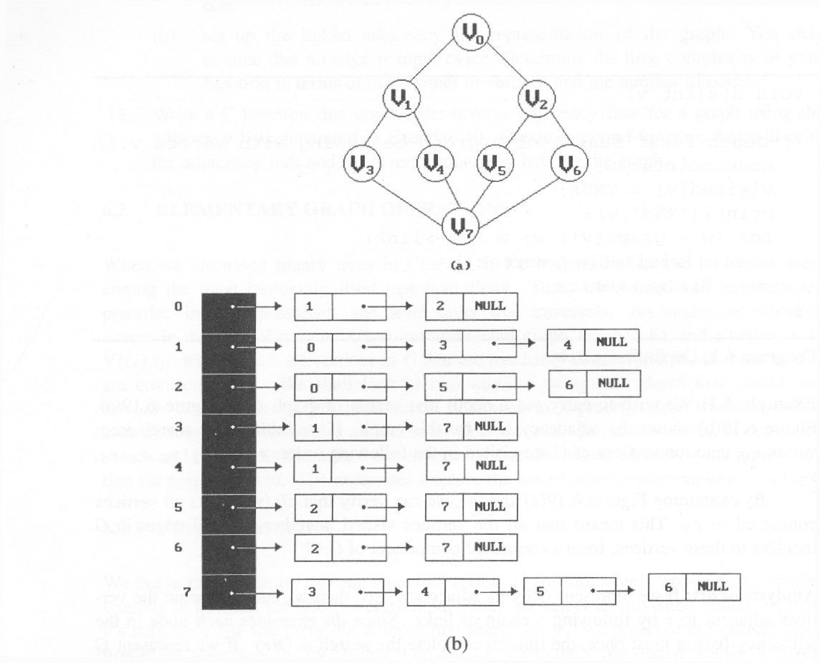
Depth First Search
#define FALSE 0
#define TRUE 1
short int visited[MAX_VERTICES];
void dfs(int v)
{
node_pointer w;
visited[v]= TRUE;
printf(“%5d”, v);
for (w=graph[v]; w; w=w->link)
if (!visited[w->vertex])
dfs(w->vertex);
}
Data structure: a) adjacency list: O(e) b) adjacency matrix: O(n2)

Breadth-First Search
typedef struct queue *queue_ptr;
typedef struct queue {
int vertex;
queue_ptr link;
};
void addq(queue_ptr *, queue_ptr *, int);
Int deleteq(queue_ptr);

void bfs(int v) {
node_ptr w;
queue_ptr front, rear;
front=rear=NULL;
printf(“%5d”,v);
visited[v]=TRUE;
addq(&front, &rear, v);
while(front) {
v = deleteq(&front);
for(w=graph[v]; w; w=w->link)
if(!visited[w->vertex]) {
printf(“%5d”, w->vertex);
addq(&front, &rear, w->vertex);
visited[w->vertex] = TRUE;
}
}
}
}

UNIT-IV

Sequential Search(Linear search)

Example
44, 55, 12, 42, 94, 18, 06, 67
unsuccessful search
  - n+1
successful search

# define MAX-SIZE 1000/* maximum size of list plus one */
typedef struct {
int key;
/* other fields */
} element;
element list[MAX_SIZE];

*Program 4.1:Sequential search
int seqsearch( int list[ ], int searchnum, int n )
{
/*search an array, list, that has n numbers. Return i, if list[i]=searchnum. Return -1, if searchnum is not in the list */
int i;
list[n]=searchnum; sentinel
for (i=0; list[i] != searchnum; i++)
;
return (( i<n) ? i : -1);
}

Binary Search
*Program 4.2: Binary search
int binsearch(element list[ ], int searchnum, int n)
{
/* search list [0], ..., list[n-1]*/
int left = 0, right = n-1, middle;
while (left <= right) {
middle = (left+ right)/2;
switch (COMPARE(list[middle].key, searchnum)) {
case -1: left = middle +1;
break;
case 0: return middle;
case 1:right = middle - 1;
}
}
return -1;
}
O(log2n)

*Figure 4.1:Decision tree for binary search

56
[7]
17
[2]
58
[8]
26
[3]
4
[0]
48
[6]
90
[10]
15
[1]
30
[4]
46
[5]
82
[9]
95
[11]

4, 15, 17, 26, 30, 46, 48, 56, 58, 82, 90, 95

- The Symbol Table
Abstract Data Type
dictionary

- symbol table in computer science
- application
1)spelling checker
2)thesarus
3)data dictionary in database
application
4)symbol tables generated by
loader, assembler, and compiler
- The Symbol Table
Abstract Data Type
operations on symbol table

1)determine if a particular name is
in the table
2)retrieve the attributes of that name
3)modify the attributes of that name
4)insert a new name and its attribute
5)delete a name and its attributes

use hashing
- very good expected performance: O(1)
- Static Hashing

hash function
α
x
f(x) = α
···
···
hash table
- Hash Table
hash tables
- store the identifiers in a fixed
size table called a hash table
0
0
1
2
···
s-1
1
b-1
···
2
b buckets, and s slots in each bucket
- Hash Table
Def)
- identifier density of a hash table:
n/T where
n: number of identifiers in table
T: total number of possible
identifiers

- loading density or loading factor
of a hash table:
a = n/(s·b) where
s: number of slots in each bucket
b: number of bucket
- Hash Table
- two identifiers i1 and i2 are synonyms with respect to f, if f(i1) = f(i2) where i1 ¹ i2

- an overflow occurs when we hash a new identifier, i, into a full bucket

- a collision occurs when we hash two nonidentical identifiers into the same bucket

- collisions and overflows occur simultaneously iff bucket size is 1

- Hash Table
Example) hash table ht with b=26, s=2, n=10
hash function f
- 1st character of identifier

Identifiers
acos
define
float
exp
char
atan
ceil
floor
clock
ctime
hash table with 26 bucket and two slots per bucket

Hash Function
requirements for a hash function
- easy to compute
- minimizes the number of collision (but, we can not avoid collisions)

uniform hash function
- for randomly chosen x from the identifier space, P[f(x)=i] = 1/b, for all buckets i
- a random x has an equal chance of hashing into any of the b buckets

mid-square
- middle of square hash function- frequently used in symbol table applications

hash function fm
1)squaring the identifier
2)obtain the bucket address by using an appropriate number of bits from the middle of the square
3)if we use r bits, 2r buckets are necessary

division(modular)
- use the modulus(%) operator

fD(x) = x % M
where M: table size
- range of bucket address: 0 ~ M-1
- the choice of M is critical
- choose M as a prime number such that M does not divide rk±a for small k and a
- choose M such that it has no prime divisors less than 20
folding
1)shift folding
ex) identifier x = 12320324111220

123
203
241
112
20
123
203
241
112
20
699
x₁
x₂
x₃
x₄
x₅
2)folding at the boundaries

→ 123 + 302 + 241 + 211 + 20 = 897
digit analysis
- used in case all the identifiers are known in advance
- examine the digits of each identifier
- delete those digits that have skewed distributions
- select the digit positions to be used to calculate the hash address

- Overflow Handling
linear open addressing

1) linear probing

- when overflow occurs, linear search for the empty slot in the hash table using circular rotation

linear probing
- represent hash table as a
one-dimensional array

#define MAX_CHAR 10
/* max number of characters in an identifier */
#define TABLE_SIZE 13
/* max table size = prime number*/
typedef struct {
char key[MAX_CHAR];
/* other filed */
} element;
element hash_table[TABLE_SIZE];

initialize the table
- allow overflows and collisions to
be detected
- all slots to empty(null) string

void init_table(element ht[]) {
int i;
for (i = 0; i < TABLE_SIZE; i++) {
ht[i].key[0] = NULL;
}
initialization of a hash table
to insert an element, transform a key
into a number and calculate hash
address

int transform(char *key) {
/* simple additive approach to create a natural
number that is within the integer range */
int number = 0;
while (*key)
number += *key++;
return number;
}

int hash(char *key) {
/* calculate hash address */
return(transform(key) % TABLE_SIZE);
}
creation of a hash function
insert element into the hash table
- find another bucket if the new
element is hashed into a full
bucket: linear probing

Example) b = 13, s = 1

[0]
function
[1]
[2]
for
[3]
do
[4]
while
[5]
[6]
[7]
[8]
[9]
else
[10]
[11]
[12]
if
hash table with linear probing
(13 buckets, 1 slot/bucket)
4 cases in insertion process
examine the hash table buckets- ht[(f(x)+j) % TABLE_SIZE], where
0 £ j £ TABLE_SIZE1)the bucket contains x
- simply report a duplicate identifier
- update information in the other fields of the element
2)the bucket contains the empty string
- bucket is empty, and insert the new element into it

3)the bucket contains a nonempty string other than x
- proceed to examine the next bucket
4)return to the home bucket ht[f(x)](j = TABLE_SIZE)
- the home bucket is being examined for the second time and all remaining buckets have been examined
- report an error condition and exit

void linear_insert(element item, element ht[]) {
/* insert the key into the table using the linear
probing technique, exit the function if the table
is full */
int i, hash_value;
hash_value = hash(item.key);
i = hash_value;
while (strlen(ht[i].key)) {
if (!strcmp(ht[i].key, item.key)) {
fprintf(stderr, ”duplicate entry\n”);
exit(1);
}
i = (i + 1) % TABLE_SIZE;
if (i == hash_value) {
fprintf(stderr,”the table is full\n”);
exit(1);
}
}
ht[i] = item;
}
linear insert into a hash table
characteristics of linear probing to
resolve overflow
- identifiers tend to cluster together
- increases the search time

Ex) enter the C built-in functions into
a 26-bucket hash table in the order
“acos, atoi, char, define, exp,
ceil, cos, float, atol, floor,
ctime”

- b = 26, s = 1

hash table with linear probing(26 buckets, 1 slot/bucket)

cluster of identifiers in linear probing
- tend to merge as more identifiers is entered into the table
- bigger cluster

solutions
- quadratic probing
- random probing
- rehashing
2) quadratic probing

- examine the hash table buckets
ht[f(x)],
ht[(f(x) + i2) % b],
ht[(f(x) - i2) % b],

for 0 £ i £ (b-1)/2,
where
b: number of buckets in the table

- reduce the average number of probes
3) rehashing
- use a series of hashing functions
f1, f2, ··· , fb
- bucket fi(x) is examined for
i = 1, 2, ··· , b
chaning
defect of linear probing
- comparison of identifiers with different hash values

maintain list of identifiers
- one list per one bucket
- each list has all the synonyms
- requires a head node for each chain

link
link
data(key)
list(linked list)
Bucket (head n\\noden))node)

#define MAX_CHAR 10
#define TABLE_SIZE 13
#define IS_FULL(ptr) (!(ptr))
typedef struct {
char key[MAX_CHAR];
/* other fields */
} element;

typedef struct list *list_ptr;
typedef struct list {
element item;
list_ptr link;
}
list_ptr hash_table[TABLE_SIZE];
void chain_insert(element item, list_ptr ht[]) {
int hash_value = hash(item.key);
list_ptr ptr, trail = NULL;
list_ptr lead = ht[hash_value];
for (; lead; trail=lead, lead = lead->link)
if (!strcmp(lead->item.key, item.key)) {
fprintf(stderr,”the key is in the table\n”);
exit(1);
}
}
ptr = (list_ptr)malloc(sizeof(list));
if (IS_FULL(ptr)) {
fprintf(stderr,“the memory is full\n”);
exit(1);
}
ptr->item = item;
ptr->link = NULL;
if (trail) trail->link = ptr;
else ht[hash_value] = ptr;
}
chain insert into a hash table

- hash chains
acos
[0]
[1]
[2]
[3]
[4]
[5]
[6]
···
[25]
atoi
atol
char
ceil
cos
define
exp
float
floor
ctime

List Verification
- Compare lists to verify that they are identical or identify the discrepancies.
- example
  - international revenue service (e.g., employee vs. employer)
- complexities
  - random order: O(mn)
  - ordered list:
O(tsort(n)+tsort(m)+m+n)

*Program 4.3: verifying using a sequential search
void verify1(element list1[], element list2[ ], int n, int m)
/* compare two unordered lists list1 and list2 */
{
int i, j;
int marked[MAX_SIZE];
for(i = 0; i<m; i++)
marked[i] = FALSE;
for (i=0; i<n; i++)
if ((j = seqsearch(list2, m, list1[i].key)) < 0)
printf(“%d is not in list 2\n “, list1[i].key);
else
/* check each of the other fields from list1[i] and list2[j], and print out any discrepancies */
marked[j] = TRUE;
for ( i=0; i<m; i++)
if (!marked[i])
printf(“%d is not in list1\n”, list2[i]key);
}
*Program 4.4:Fast verification of two lists
void verify2(element list1[ ], element list2 [ ], int n, int m)
/* Same task as verify1, but list1 and list2 are sorted */
{
int i, j;
sort(list1, n);
sort(list2, m);
i = j = 0;
while (i < n && j < m)
if (list1[i].key < list2[j].key) {
printf (“%d is not in list 2 \n”, list1[i].key);
i++;
}
else if (list1[i].key == list2[j].key) {
/* compare list1[i] and list2[j] on each of the other field
and report any discrepancies */
i++; j++;
}
else {
printf(“%d is not in list 1\n”, list2[j].key);
j++;
}
for(; i < n; i++)
printf (“%d is not in list 2\n”, list1[i].key);
for(; j < m; j++)
printf(“%d is not in list 1\n”, list2[j].key);
}

Sorting Problem
Definition
  - given (R0, R1, …, Rn-1), where Ri = key + data
find a permutation σ, such that Kσ(i-1) ≤ Kσ(i), 0<i<n-1
sorted
  - Kσ(i-1) ≤ Kσ(i), 0<i<n-1
stable
  - if i < j and Ki = Kj then Ri precedes Rj in the sorted list
internal sort vs. external sort
criteria
  - # of key comparisons
  - # of data movements

Insertion Sort

void insertion_sort(element list[], int n)
{
int i, j;
element next;
for (i=1; i<n; i++) {
next= list[i];
for (j=i-1; j>=0&&next.key<list[j].key;
j--)
list[j+1] = list[j];
list[j+1] = next;
}
}
O(n)
worse case

i 0 1 2 3 4
- 5 4 3 2 1
1 4 5 3 2 1
2 3 4 5 2 1
3 2 3 4 5 1
4 1 2 3 4 5
best case

i 0 1 2 3 4
- 2 3 4 5 1
1 2 3 4 5 1
2 2 3 4 5 1
3 2 3 4 5 1
4 1 2 3 4 5
left out of order (LOO)
Ri is LOO if Ri < max{Rj}
0≤j<i

k: # of records LOO
Computing time: O((k+1)n)
44 55 12 42 94 18 06 67
*
*
*
*
*

Radix Sort

Sort by keys
K⁰, K¹, …, K^{r-1}
Most significant key
Least significant key
R₀, R₁, …, R_{n-1} are said to be sorted w.r.t. K₀, K₁, …, K_{r-1} iff

0≤i<n-1
Most significant digit first: sort on K⁰, then K¹….

Least significant digit first: sort on K^{r-1}, then K^{r-2}…

Figure 4.5: Arrangement of cards after first pass of an MSD sort

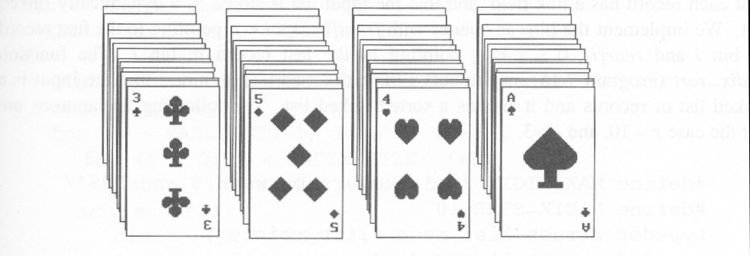
Suits: ♣ < ♦ < ♥ < ♠
Face values: 2 < 3 < 4 < … < J < Q < K < A
(1) MSD sort first, e.g., bin sort, four bins ♣ ♦ ♥ ♠
LSD sort second, e.g., insertion sort

(2) LSD sort first, e.g., bin sort, 13 bins
2, 3, 4, …, 10, J, Q, K, A
MSD sort, e.g., bin sort four bins ♣ ♦ ♥ ♠

Figure : Arrangement of cards after first pass of LSD sort

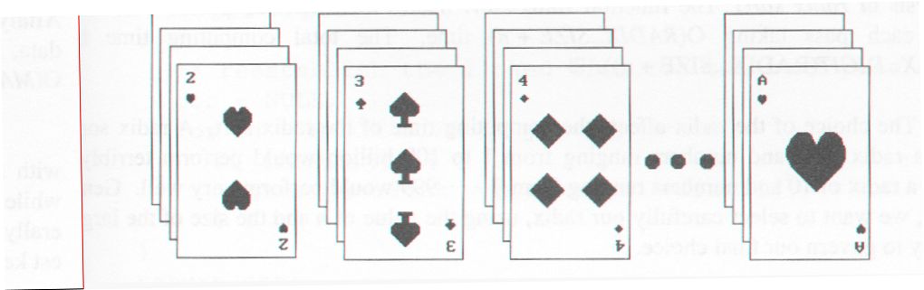
RADIX SORT
0 ≤ K ≤ 999
(K⁰, K¹, K²)
MSD
LSD
0-9
0-9
0-9
radix 10 sort
radix 2 sort

Example for LSD Radix Sort

271, 93, 33, 984, 55, 306, 208, 179, 859, 9 After the first pass

306
208
9
null
null
null
33
null
null
55
859
null
null
271
179
null
984
null
93
null
rear[0]
rear[1]
rear[2]
rear[3]
rear[4]
rear[5]
rear[6]
rear[7]
rear[8]
rear[9]
front[0]
front[1]
front[2]
front[3]
front[4]
front[5]
front[6]
front[7]
front[8]
front[9]
306, 208, 9, 33, 55, 859, 271, 179, 984, 93 (second pass)

306
null
null
null
859
null
984
null
rear[0]
rear[1]
rear[2]
rear[3]
rear[4]
rear[5]
rear[6]
rear[7]
rear[8]
rear[9]
front[1]
front[2]
front[3]
front[4]
front[5]
front[6]
front[7]
front[8]
front[9]
179
null
208
271
null
null
null

9, 33, 55, 93, 179, 208, 271, 306, 859, 984 (third pass)

Data Structures for LSD Radix Sort

An LSD radix r sort,
R0, R1, ..., Rn-1 have the keys that are d-tuples
(x0, x1, ..., xd-1)
#define MAX_DIGIT 3
#define RADIX_SIZE 10
typedef struct list_node *list_pointer;
typedef struct list_node {
int key[MAX_DIGIT];
list_pointer link;
}

LSD Radix Sort
list_pointer radix_sort(list_pointer ptr)
{
list_pointer front[RADIX_SIZE],
rear[RADIX_SIZE];
int i, j, digit;
for (i=MAX_DIGIT-1; i>=0; i--) {
for (j=0; j<RADIX_SIZE; j++)
front[j]=read[j]=NULL;
while (ptr) {
digit=ptr->key[I];
if (!front[digit]) front[digit]=ptr;
else rear[digit]->link=ptr;
rear[digit]=ptr;
ptr=ptr->link;
}
/* reestablish the linked list for the next pass */
ptr= NULL;
for (j=RADIX_SIZE-1; j>=0; j++)
if (front[j]) {
rear[j]->link=ptr;
ptr=front[j];
}
}

return ptr;
}
Comparison
n < 20: insertion sort

20 ≤ n < 45: quick sort

n ≥ 45: merge sort

hybrid method: merge sort + quick sort
merge sort + insertion sort

Quick Sort (C.A.R. Hoare)

Given (R0, R1, …, Rn-1)
Ki: pivot key
if Ki is placed in S(i),
then Kj ≤ Ks(i) for j < S(i),
Kj ≥ Ks(i) for j > S(i).
R0, …, RS(i)-1, RS(i), RS(i)+1, …, RS(n-1)

Example for Quick Sort

void quicksort(element list[], int left, int right)
{
int pivot, i, j;
element temp;
if (left < right) {
i = left; j = right+1;
pivot = list[left].key;
do {
do i++; while (list[i].key < pivot);
do j--; while (list[j].key > pivot);
if (i < j) SWAP(list[i], list[j], temp);
} while (i < j);
SWAP(list[left], list[j], temp);
quicksort(list, left, j-1);
quicksort(list, j+1, right);
}
}

Analysis for Quick Sort
Assume that each time a record is positioned, the list is divided into the rough same size of two parts.
Position a list with n element needs O(n)
T(n) is the time taken to sort n elements
T(n)<=cn+2T(n/2) for some c
<=cn+2(cn/2+2T(n/4))
...
<=cnlog n+nT(1)=O(nlog n)
Time and Space for Quick Sort
Space complexity:
Average case and best case: O(log n)
Worst case: O(n)
Time complexity:
Average case and best case: O(n log n)
Worst case: O(n )

Heap Sort
Figure 4.2: Array interpreted as a binary tree

1 2 3 4 5 6 7 8 9 10

26 5 77 1 61 11 59 15 48 19

26
[1]
5
[2]
77
[3]
1
[4]
61
[5]
11
[6]
59
[7]
15
[8]
48
[9]
19
[10]

*Figure 4.3: Max heap following first for loop of heapsort

77
[1]
61
[2]
59
[3]
48
[4]
19
[5]
11
[6]
26
[7]
15
[8]
1
[9]
5
[10]
initial heap

Figure 4.4: Heap sort example

61
[1]
48
[2]
59
[3]
15
[4]
19
[5]
11
[6]
26
[7]
5
[8]
1
[9]
77
[10]
59
[1]
48
[2]
26
[3]
15
[4]
19
[5]
11
[6]
1
[7]
5
[8]
61
[9]
77
[10]
(a)

48
[1]
19
[2]
26
[3]
15
[4]
5
[5]
11
[6]
1
[7]
59
[8]
61
[9]
77
[10]
26
[1]
19
[2]
11
[3]
15
[4]
5
[5]
1
[6]
48
[7]
59
[8]
61
[9]
77
[10]
(c)
(d)
59
61
59
48

Heap Sort
void adjust(element list[], int root, int n)
{
int child, rootkey; element temp;
temp=list[root]; rootkey=list[root].key;
child=2*root;
while (child <= n) {
if ((child < n) &&
(list[child].key < list[child+1].key))
child++;
if (rootkey > list[child].key) break;
else {
list[child/2] = list[child];
child *= 2;
}
}
list[child/2] = temp;
} void heapsort(element list[], int n)
{
int i, j;
element temp;
for (i=n/2; i>0; i--) adjust(list, i, n);
for (i=n-1; i>0; i--) {
SWAP(list[1], list[i+1], temp);
adjust(list, 1, i);
}
}

UNITY –V

B-Trees: Balanced Tree Data Structures

Introduction
Tree structures support various basic dynamic set operations including Search, Predecessor, Successor, Minimum, Maximum, Insert, and Delete in time proportional to the height of the tree. Ideally, a tree will be balanced and the height will be log n where n is the number of nodes in the tree. To ensure that the height of the tree is as small as possible and therefore provide the best running time, a balanced tree structure like a red-black tree, AVL tree, or b-tree must be used.
When working with large sets of data, it is often not possible or desirable to maintain the entire structure in primary storage (RAM). Instead, a relatively small portion of the data structure is maintained in primary storage, and additional data is read from secondary storage as needed. Unfortunately, a magnetic disk, the most common form of secondary storage, is significantly slower than random access memory (RAM). In fact, the system often spends more time retrieving data than actually processing data.
B-trees are balanced trees that are optimized for situations when part or all of the tree must be maintained in secondary storage such as a magnetic disk. Since disk accesses are expensive (time consuming) operations, a b-tree tries to minimize the number of disk accesses. For example, a b-tree with a height of 2 and a branching factor of 1001 can store over one billion keys but requires at most two disk accesses to search for any node (Cormen 384).

The Structure of B-Trees
Unlike a binary-tree, each node of a b-tree may have a variable number of keys and children. The keys are stored in non-decreasing order. Each key has an associated child that is the root of a subtree containing all nodes with keys less than or equal to the key but greater than the preceeding key. A node also has an additional rightmost child that is the root for a subtree containing all keys greater than any keys in the node.
A b-tree has a minumum number of allowable children for each node known as the minimization factor. If t is this minimization factor, every node must have at least t - 1 keys. Under certain circumstances, the root node is allowed to violate this property by having fewer than t - 1 keys. Every node may have at most 2t - 1 keys or, equivalently, 2t children.
Since each node tends to have a large branching factor (a large number of children), it is typically neccessary to traverse relatively few nodes before locating the desired key. If access to each node requires a disk access, then a b-tree will minimize the number of disk accesses required. The minimzation factor is usually chosen so that the total size of each node corresponds to a multiple of the block size of the underlying storage device. This choice simplifies and optimizes disk access. Consequently, a b-tree is an ideal data structure for situations where all data cannot reside in primary storage and accesses to secondary storage are comparatively expensive (or time consuming).

Height of B-Trees
For n greater than or equal to one, the height of an n-key b-tree T of height h with a minimum degree t greater than or equal to 2,
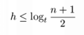
The worst case height is O(log n). Since the "branchiness" of a b-tree can be large compared to many other balanced tree structures, the base of the logarithm tends to be large; therefore, the number of nodes visited during a search tends to be smaller than required by other tree structures. Although this does not affect the asymptotic worst case height, b-trees tend to have smaller heights than other trees with the same asymptotic height.

Operations on B-Trees
The algorithms for the search, create, and insert operations are shown below. Note that these algorithms are single pass; in other words, they do not traverse back up the tree. Since b-trees strive to minimize disk accesses and the nodes are usually stored on disk, this single-pass approach will reduce the number of node visits and thus the number of disk accesses. Simpler double-pass approaches that move back up the tree to fix violations are possible.
Since all nodes are assumed to be stored in secondary storage (disk) rather than primary storage (memory), all references to a given node be be preceeded by a read operation denoted by Disk-Read. Similarly, once a node is modified and it is no longer needed, it must be written out to secondary storage with a write operation denoted by Disk-Write. The algorithms below assume that all nodes referenced in parameters have already had a corresponding Disk-Read operation. New nodes are created and assigned storage with the Allocate-Node call. The implementation details of the Disk-Read, Disk-Write, and Allocate-Node functions are operating system and implementation dependent.

B-Tree-Search(x, k)
i <- 1
while i <= n[x] and k > key_{i}[x]
do i <- i + 1
if i <= n[x] and k = key_{i}[x]
then return (x, i)
if leaf[x]
then return NIL
else Disk-Read(c_{i}[x])
return B-Tree-Search(c_{i}[x], k)
The search operation on a b-tree is analogous to a search on a binary tree. Instead of choosing between a left and a right child as in a binary tree, a b-tree search must make an n-way choice. The correct child is chosen by performing a linear search of the values in the node. After finding the value greater than or equal to the desired value, the child pointer to the immediate left of that value is followed. If all values are less than the desired value, the rightmost child pointer is followed. Of course, the search can be terminated as soon as the desired node is found. Since the running time of the search operation depends upon the height of the tree, B-Tree-Search is O(log_{t} n).

B-Tree-Create(T)
x <- Allocate-Node()
leaf[x] <- TRUE
n[x] <- 0
Disk-Write(x)
root[T] <- x
The B-Tree-Create operation creates an empty b-tree by allocating a new root node that has no keys and is a leaf node. Only the root node is permitted to have these properties; all other nodes must meet the criteria outlined previously. The B-Tree-Create operation runs in time O(1).

B-Tree-Split-Child(x, i, y)
z <- Allocate-Node()
leaf[z] <- leaf[y]
n[z] <- t - 1
for j <- 1 to t - 1
do key_{j}[z] <- key_{j+t}[y]
if not leaf[y]
then for j <- 1 to t
do c_{j}[z] <- c_{j+t}[y]
n[y] <- t - 1
for j <- n[x] + 1 downto i + 1
do c_{j+1}[x] <- c_{j}[x]
c_{i+1} <- z
for j <- n[x] downto i
do key_{j+1}[x] <- key_{j}[x]
key_{i}[x] <- key_{t}[y]
n[x] <- n[x] + 1
Disk-Write(y)
Disk-Write(z)
Disk-Write(x)
If is node becomes "too full," it is necessary to perform a split operation. The split operation moves the median key of node x into its parent y where x is the i^{th} child of y. A new node, z, is allocated, and all keys in x right of the median key are moved to z. The keys left of the median key remain in the original node x. The new node, z, becomes the child immediately to the right of the median key that was moved to the parent y, and the original node, x, becomes the child immediately to the left of the median key that was moved into the parent y.
The split operation transforms a full node with 2t - 1 keys into two nodes with t - 1 keys each. Note that one key is moved into the parent node. The B-Tree-Split-Child algorithm will run in time O(t) where t is constant.

B-Tree-Insert(T, k)

r <- root[T]
if n[r] = 2t - 1
then s <- Allocate-Node()
root[T] <- s
leaf[s] <- FALSE
n[s] <- 0
c₁ <- r
B-Tree-Split-Child(s, 1, r)
B-Tree-Insert-Nonfull(s, k)
else B-Tree-Insert-Nonfull(r, k)

B-Tree-Insert-Nonfull(x, k)

i <- n[x]
if leaf[x]
then while i >= 1 and k < key_{i}[x]
do key_{i+1}[x] <- key_{i}[x]
i <- i - 1
key_{i+1}[x] <- k
n[x] <- n[x] + 1
Disk-Write(x)
else while i >= and k < key_{i}[x]
do i <- i - 1
i <- i + 1
Disk-Read(c_{i}[x])
if n[c_{i}[x]] = 2t - 1
then B-Tree-Split-Child(x, i, c_{i}[x])
if k > key_{i}[x]
then i <- i + 1
B-Tree-Insert-Nonfull(c_{i}[x], k)
To perform an insertion on a b-tree, the appropriate node for the key must be located using an algorithm similiar to B-Tree-Search. Next, the key must be inserted into the node. If the node is not full prior to the insertion, no special action is required; however, if the node is full, the node must be split to make room for the new key. Since splitting the node results in moving one key to the parent node, the parent node must not be full or another split operation is required. This process may repeat all the way up to the root and may require splitting the root node. This approach requires two passes. The first pass locates the node where the key should be inserted; the second pass performs any required splits on the ancestor nodes.
Since each access to a node may correspond to a costly disk access, it is desirable to avoid the second pass by ensuring that the parent node is never full. To accomplish this, the presented algorithm splits any full nodes encountered while descending the tree. Although this approach may result in unecessary split operations, it guarantees that the parent never needs to be split and eliminates the need for a second pass up the tree. Since a split runs in linear time, it has little effect on the O(t log_{t} n) running time of B-Tree-Insert.
Splitting the root node is handled as a special case since a new root must be created to contain the median key of the old root. Observe that a b-tree will grow from the top.

B-Tree-Delete
Deletion of a key from a b-tree is possible; however, special care must be taken to ensure that the properties of a b-tree are maintained. Several cases must be considered. If the deletion reduces the number of keys in a node below the minimum degree of the tree, this violation must be corrected by combining several nodes and possibly reducing the height of the tree. If the key has children, the children must be rearranged.
Examples Sample B-Tree

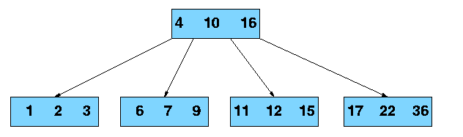

Searching a B-Tree for Key 21
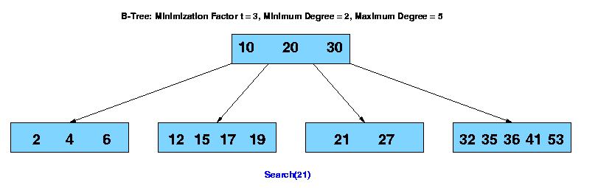

AVL TREES

Binary search tree
time complexity
- average case: O(log2n)
- worst case: O(n)

maintain the binary search tree as a complete binary tree
- minimize the average and maximum search time
- average and worst case: O(log2n)
- a significant increase in the time required to add new element
Jan
Mar
Feb
Apr
May
June
Sept
Oct
Nov
July
Aug
Dec
binary search tree obtained for the months of the year

Jan
Mar
Feb
Apr
May
June
Sept
Oct
Nov
July
Aug
Dec

a balanced tree for the months of the year

Jan
Mar
Feb
Apr
May
June
Sept
Oct
Nov
July
Aug
Dec
degenerate binary search tree

AVL Trees
- balanced binary trees
- average and worst case: O(log2n)

Def) height balanced binary tree
- an empty binary tree is height balanced
- if T is a nonempty binary tree with TL and TR as its left and right subtrees
- T is height balanced iff
1) TL and TR are height balanced, and
2) |hL - hR| £ 1 where hL and hR are height of TL and TR, respectively

Def) balance factor, BF(T), of node T
in a binary tree
- hL - hR where hL and hR are heights of left and right subtree of T
- for any node T in an AVL tree, BF(T) = -1, 0, or 1

Mar
0
Mar
-1
May
0
Nov
0
May
-1
Mar
-2
Nov
0
May
0
Mar
0
(a) insert March
(b) insert May
(c) insert November
RR
rotation
Insertion
Example
May
+1
Mar
+1
Nov
0
Aug
0
(d) insert August
LL
rotation
Apr
0
Aug
+1
Mar
+2
May
+2
Nov
0
May
+1
Nov
0
Aug
0
Mar
0
Apr
0
(e) insert April

May
+2
Aug
-1
May
0
Mar
+1
Apr
0
Jan
0
Mar
0
Aug
0
May
-1
Jan
0
Apr
0
Nov
0
Mar
+1
May
-1
Aug
-1
Apr
0
Jan
+1
Nov
0
Dec
0
(f) insert January
LR
rotation

Dec
0
July
0
Mar
+1
May
-1
Aug
-1
Apr
0
Jan
0
Nov
0
(h) insert July
Mar
+1
May
-1
Apr
0
Nov
0
Dec
0
Jan
0
July
0
Aug
+1
Feb
0
RL
rotation
(i) insert February
four kinds of rotations to rebalance
- LL, LR, RR, RL
- LL and RR are symmetric
- LR and RL are symmetric
Let Y: new inserted node, and
A: the nearest ancestor of Y, whose balance factor becomes ±2
LL: Y is inserted in the left subtree of the left subtree of A
LR: Y is inserted in the right subtree of the left subtree of A
RR: Y is inserted in the right subtree
of the right subtree of ARL: Y is inserted in the left subtree of the right subtree of A
- height of the subtrees which are not involved in the rotation remain unchanged

Red-Black Trees

- Balanced” binary search trees guarantee an O(lgn) running time
- Red-black-tree
  - Binary search tree with an additional attribute for its nodes: color which can be red or black
  - Constrains the way nodes can be colored on any path from the root to a leaf:

Ensures that no path is more than twice as long as any other path ⇒ the tree is balanced

- For convenience we use a sentinel NIL[T] to represent all the NIL nodes at the leafs
  - NIL[T] has the same fields as an ordinary node
  - Color[NIL[T]] = BLACK
  - The other fields may be set to arbitrary values
Red-Black-Trees Properties

- Every node is either red or black
- The root is black
- Every leaf (NIL) is black
- If a node is red, then both its children are black
  - No two consecutive red nodes on a simple path from the root to a leaf
- For each node, all paths from that node to descendant leaves contain the same number of black nodes

Black-Height of a Node

- Height of a node: the number of edges in the longest path to a leaf
- Black-height of a node x: bh(x) is the number of black nodes (including NIL) on the path from x to a leaf,
not counting x

Overview: Most important property of
Red-Black-Trees
A red-black tree with n internal nodes
has height at most 2lg(n + 1)
Need to prove two claims first …Any node x with height h(x) has bh(x) ≥ h(x)/2
Proof
By property 4, at most h/2 red nodes on the path from the node to a leaf
Hence at least h/2 are black
SPLAY TREES

- Splay trees are tree structures that:
  - Are not perfectly balanced all the time
  - Data most recently accessed is near the root. (principle of locality; 80-20 “rule”)
- The procedure:
  - After node X is accessed, perform “splaying” operations to bring X to the root of the tree.
  - Do this in a way that leaves the tree more balanced as a whole

- Let X be a non-root node with ≥ 2 ancestors.
  - P is its parent node.
  - G is its grandparent node.

Zig-Zig and Zig-Zag

Splay Tree Operations

In this unit pattern matching, is the act of checking some sequence of tokens for the presence of the constituents of some pattern .Uses of pattern matching include outputting the locations of a pattern within a token sequence, to output some component of the matched pattern, and to substitute the matching pattern with some other token sequence (I.e., search and replace).

Contents:
1. Pattern matching algorithms
2. Standard Tries, Compressed Tries, Suffix tries.

Brute Force algorithm

Main features
- no preprocessing phase;
- constant extra space needed;
- always shifts the window by exactly 1 position to the right;
- comparisons can be done in any order;
- searching phase in O(mn) time complexity;
- 2n expected text characters comparisons.
Description
The brute force algorithm consists in checking, at all positions in the text between 0 and n-m, whether an occurrence of the pattern starts there or not. Then, after each attempt, it shifts the pattern by exactly one position to the right.
The brute force algorithm requires no preprocessing phase, and a constant extra space in addition to the pattern and the text. During the searching phase the text character comparisons can be done in any order. The time complexity of this searching phase is O(mn) (when searching for a^{m-1}b in a^{n} for instance). The expected number of text character comparisons is 2n.

Boyer-Moore algorithm

Main features
- performs the comparisons from right to left;
- preprocessing phase in O(m+) time and space complexity;
- searching phase in O(mn) time complexity;
- 3n text character comparisons in the worst case when searching for a non periodic pattern;
- O(n / m) best performance.
Description
The Boyer-Moore algorithm is considered as the most efficient string-matching algorithm in usual applications. A simplified version of it or the entire algorithm is often implemented in text editors for the «search» and «substitute» commands.
The algorithm scans the characters of the pattern from right to left beginning with the rightmost one. In case of a mismatch (or a complete match of the whole pattern) it uses two precomputed functions to shift the window to the right. These two shift functions are called the good-suffix shift (also called matching shift and the bad-character shift (also called the occurrence shift).
Assume that a mismatch occurs between the character x[i]=a of the pattern and the character y[i+j]=b of the text during an attempt at position j.
Then, x[i+1 .. m-1]=y[i+j+1 .. j+m-1]=u and x[i] y[i+j]. The good-suffix shift consists in aligning the segment y[i+j+1 .. j+m-1]=x[i+1 .. m-1] with its rightmost occurrence in x that is preceded by a character different from x[i] (see figure ).
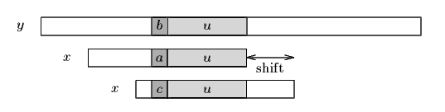
Figure . The good-suffix shift, u re-occurs preceded by a character c different from a.
If there exists no such segment, the shift consists in aligning the longest suffix v of y[i+j+1 .. j+m-1] with a matching prefix of x (see figure).
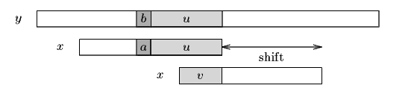
Figure . The good-suffix shift, only a suffix of u re-occurs in x.
The bad-character shift consists in aligning the text character y[i+j] with its rightmost occurrence in x[0 .. m-2]. (see figure)
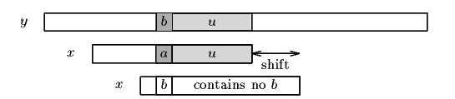
Figure . The bad-character shift, a occurs in x.
If y[i+j] does not occur in the pattern x, no occurrence of x in y can include y[i+j], and the left end of the window is aligned with the character immediately after y[i+j], namely y[i+j+1] (see figure).
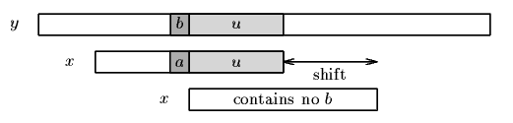
Figure . The bad-character shift, b does not occur in x.
Note that the bad-character shift can be negative, thus for shifting the window, the Boyer-Moore algorithm applies the maximum between the the good-suffix shift and bad-character shift. More formally the two shift functions are defined as follows.
The good-suffix shift function is stored in a table bmGs of size m+1.
Let us define two conditions:
Cs(i, s): for each k such that i < k < m, s k or x[k-s]=x[k] and

Co(i, s): if s <i then x[i-s] x[i]
Then, for 0 i < m: bmGs[i+1]=min{s>0 : Cs(i, s) and Co(i, s) hold}
and we define bmGs[0] as the length of the period of x. The computation of the table bmGs use a table suff defined as follows: for 1 i < m, suff[i]=max{k : x[i-k+1 .. i]=x[m-k .. m-1]}
The bad-character shift function is stored in a table bmBc of size . For c in : bmBc[c] = min{i : 1 i <m-1 and x[m-1-i]=c} if c occurs in x, m otherwise.
Tables bmBc and bmGs can be precomputed in time O(m+) before the searching phase and require an extra-space in O(m+). The searching phase time complexity is quadratic but at most 3n text character comparisons are performed when searching for a non periodic pattern. On large alphabets (relatively to the length of the pattern) the algorithm is extremely fast. When searching for a^{m-1}b in b^{n} the algorithm makes only O(n / m) comparisons, which is the absolute minimum for any string-matching algorithm in the model where the pattern only is preprocessed.

Knuth-Morris-Pratt string matching

The problem: given a (short) pattern and a (long) text, both strings, determine whether the pattern appears somewhere in the text. Last time we saw how to do this with finite automata. This time we'll go through the Knuth-Morris-Pratt (KMP) algorithm, which can be thought of as an efficient way to build these automata. I also have some working C++ source code which might help you understand the algorithm better.
First let's look at a naive solution.
suppose the text is in an array: char T[n]
and the pattern is in another array: char P[m].
One simple method is just to try each possible position the pattern could appear in the text.

Naive string matching:
for (i=0; T[i] != '\0'; i++)
{
for (j=0; T[i+j] != '\0' && P[j] != '\0' && T[i+j]==P[j]; j++) ;
if (P[j] == '\0') found a match
}
There are two nested loops; the inner one takes O(m) iterations and the outer one takes O(n) iterations so the total time is the product, O(mn). This is slow; we'd like to speed it up.
In practice this works pretty well -- not usually as bad as this O(mn) worst case analysis. This is because the inner loop usually finds a mismatch quickly and move on to the next position without going through all m steps. But this method still can take O(mn) for some inputs. In one bad example, all characters in T[] are "a"s, and P[] is all "a"'s except for one "b" at the end. Then it takes m comparisons each time to discover that you don't have a match, so mn overall.
Here's a more typical example. Each row represents an iteration of the outer loop, with each character in the row representing the result of a comparison (X if the comparison was unequal). Suppose we're looking for pattern "nano" in text "banananobano".
0 1 2 3 4 5 6 7 8 9 10 11
T: b a n a n a n o b a n o

i=0: X
i=1: X
i=2: n a n X
i=3: X
i=4: n a n o
i=5: X
i=6: n X
i=7: X
i=8: X
i=9: n X
i=10: X
Some of these comparisons are wasted work! For instance, after iteration i=2, we know from the comparisons we've done that T[3]="a", so there is no point comparing it to "n" in iteration i=3. And we also know that T[4]="n", so there is no point making the same comparison in iteration i=4.

Skipping outer iterations
The Knuth-Morris-Pratt idea is, in this sort of situation, after you've invested a lot of work making comparisons in the inner loop of the code, you know a lot about what's in the text. Specifically, if you've found a partial match of j characters starting at position i, you know what's in positions T[i]...T[i+j-1].
You can use this knowledge to save work in two ways. First, you can skip some iterations for which no match is possible. Try overlapping the partial match you've found with the new match you want to find:
i=2: n a n
i=3: n a n o
Here the two placements of the pattern conflict with each other -- we know from the i=2 iteration that T[3] and T[4] are "a" and "n", so they can't be the "n" and "a" that the i=3 iteration is looking for. We can keep skipping positions until we find one that doesn't conflict:
i=2: n a n
i=4: n a n o
Here the two "n"'s coincide. Define the overlap of two strings x and y to be the longest word that's a suffix of x and a prefix of y. Here the overlap of "nan" and "nano" is just "n". (We don't allow the overlap to be all of x or y, so it's not "nan"). In general the value of i we want to skip to is the one corresponding to the largest overlap with the current partial match:
String matching with skipped iterations:
i=0;
while (i<n)
{
for (j=0; T[i+j] != '\0' && P[j] != '\0' && T[i+j]==P[j]; j++) ;
if (P[j] == '\0') found a match;
i = i + max(1, j-overlap(P[0..j-1],P[0..m]));
}

Skipping inner iterations

The other optimization that can be done is to skip some iterations in the inner loop. Let's look at the same example, in which we skipped from i=2 to i=4:
i=2: n a n
i=4: n a n o
In this example, the "n" that overlaps has already been tested by the i=2 iteration. There's no need to test it again in the i=4 iteration. In general, if we have a nontrivial overlap with the last partial match, we can avoid testing a number of characters equal to the length of the overlap.
Standard Tries
•The standard trie for a set of strings S is an ordered tree such that:
-each node but the root is labeled with a character
-the children of a node are alphabetically ordered
-the paths from the external nodes to the root yield the strings of S

Example: standard trie for the set of strings
S = { bear, bell, bid, bull, buy, sell, stock, stop }

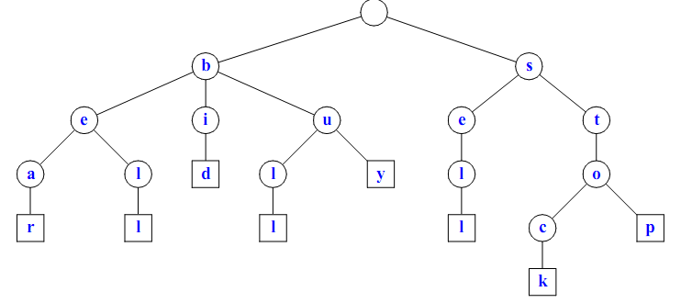

A standard trie uses O(n) space. Operations (ﬁnd, insert, remove) take time O(dm) each, where:
-n = total size of the strings in S,
-m =size of the string parameter of the operation
-d =alphabet size,
Applications of Tries
•A standardtrie supports the following operations on a preprocessed text in time O(m), where m = |X|
- wordmatching:ﬁnd the ﬁrst occurrence of word X in the text
- preﬁx matching: ﬁnd the ﬁrst occurrence of the longest preﬁx of word X in the text
•Each operation is performed by tracing a path in the trie starting at the root
Compressed Tries
•Trie with nodes of degree at least 2
•Obtained from standard trie by compressing chains of redundant nodes

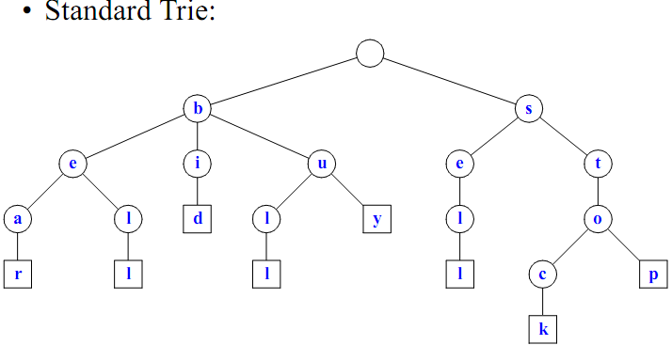
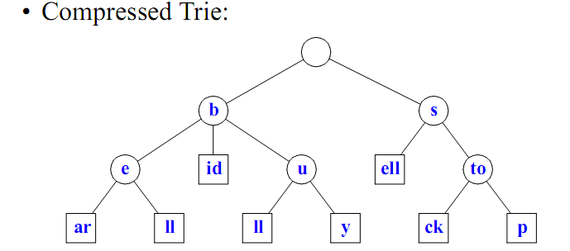

Sufﬁx Tries
•A sufﬁx trie is a compressed trie for all the sufﬁxes of a text
Example
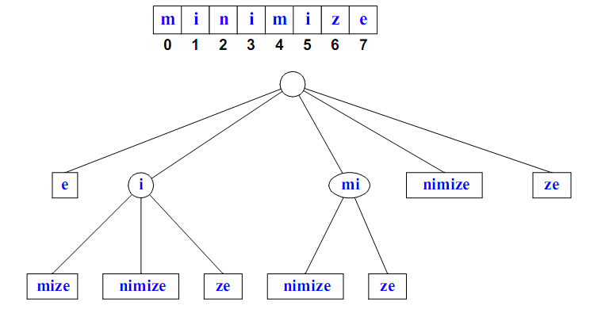

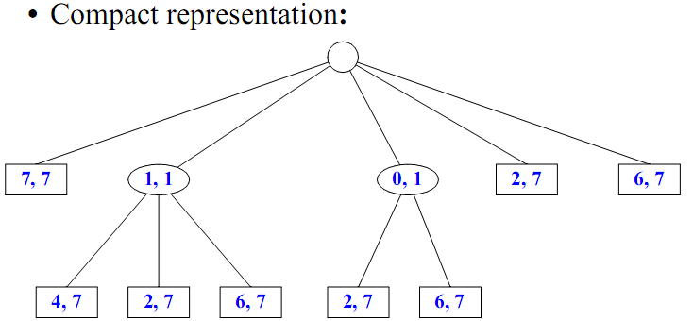

Properties of Sufﬁx Tries
•The sufﬁxtrie foratextXofsize n from an alphabet of size d -stores all the n(n−1)/2 sufﬁxes of X in O(n) space
-supports arbitrary patternmatching and preﬁx matching queries in O(dm) time, where m is the length of the pattern -can be constructed in O(dn) time
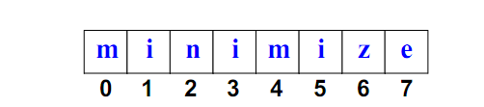
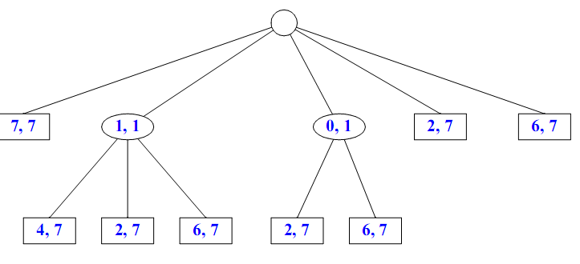

15 Additional Topics
  - Addition and Multiplication of Polynomials.
  - B+ Tree.
  - Brute –Force Approach in Pattern Matching.
16University Question papers(attached as separate file)
17 Question Bank

Unit – 1

Objective Questions
Q.1 The complexity of multiplying two matrices of order m*n and n*p is
(A) mnp (B) mp
(C) mn (D) np

Q.2 Merging 4 sorted files containing 50, 10, 25 and 15 records will take____time
(A) O (100) (B) O (200)
(C) O (175) (D) O (125)

Q.3 Consider a linked list of n elements. What is the time taken to insert an element after an element pointed by some pointer?
(A) O (1) (B) O (log2 n)
(C) O (n) (D) O (n log2 n)

Q.4 The smallest element of an array’s index is called its
(A) lower bound. (B) upper bound.
(C) range. (D) extraction.

Q.5 In a circular linked list
(A) components are all linked together in some sequential manner.
(B) there is no beginning and no end.
(C) components are arranged hierarchically.
(D) forward and backward traversal within the list is permitted.

Q.6 The minimum number of multiplications and additions required to evaluate the polynomial
P = 4x3+3x2-15x+45 is
(A) 6 & 3 (B) 4 & 2
(C) 3 & 3 (D) 8 & 3

Q.7 In a linked list with n nodes, the time taken to insert an element after an element pointed by
some pointer is
(A) 0 (1) (B) 0 (log n)
(C) 0 (n) (D) 0 (n 1og n)

Q.8 What data structure would you mostly likely see in a nonrecursive implementation of a recursive algorithm?
(A) Stack (B) Linked list
(C) Queue (D) Trees

Q.9 Let the following circular queue can accommodate maximum six elements with the
following data
front = 2 rear = 4
queue = _______; L, M, N, ___, ___
What will happen after ADD O operation takes place?
(A) front = 2 rear = 5
queue = ______; L, M, N, O, ___
(B) front = 3 rear = 5
queue = L, M, N, O, ___
(C) front = 3 rear = 4
queue = ______; L, M, N, O, ___
(D) front = 2 rear = 4
queue = L, M, N, O, ___

Q.10 A linear collection of data elements where the linear node is given by means of pointer is
called
(A) linked list (B) node list
(C) primitive list (D) None of these

Q.11 Representation of data structure in memory is known as:
(A) recursive (B) abstract data type
(C) storage structure (D) file structure

Q.12 If the address of A[1][1] and A[2][1] are 1000 and 1010 respectively and each element occupies 2 bytes then the array has been stored in _________ order.
(A) row major (B) column major
(C) matix major (D) none of these

Q.13 An adjacency matrix representation of a graph cannot contain information of :
(A) nodes (B) edges
(C) direction of edges (D) parallel edges

Q.14 Time complexities of three algorithms are given. Which should execute the slowest for large values of N?
(A) ( 1 2 ) O N (B) O(N)
(C) O(log N) (D) None of these

Q.15 How does an array differ from an ordinary variable?

Q.16 Which of the following operations is performed more efficiently by doubly linked list than by singly linked list?
(A) Deleting a node whose location in given
(B) Searching of an unsorted list for a given item
(C) Inverting a node after the node with given location
(D) Traversing a list to process each node

Q.17 The extra key inserted at the end of the array is called a,
(A) End key. (B) Stop key.
(C) Sentinel. (D) Transposition.

Q.18 The time required to delete a node x from a doubly linked list having n nodes is
(A) O (n) (B) O (log n)
(C) O (1) (D) O (n log n)

Part A

Q.1 Which sorting algorithm is easily adaptable to singly linked lists? Explain
your answer.
Q 2. Determine the frequency counts for all statements in the following program
segment.
for (i=1; i <= n; i ++)
for (j = 1; j <= i; j++)
for (k =1; k <= j; k++)
y ++;

Q 3 . Write an algorithm to count number of nodes in the circular linked list.

Q 4. Write an algorithm to insert a node in between any two nodes in a linked list
Q.5 What is the difference between a grounded header link list and a circular header
link list?
Q 6. A linear array A is given with lower bound as 1. If address of A[25] is 375 and
A[30] is 390, then find address of A[16].
Q7. Write an algorithm to insert a node p at the end of a linked list.
Q8. Write an algorithm that counts number of nodes in a linked list.
Q9. Write an algorithm to add an element at the end of circular linked list.
Q10. Delete a given node from a doubly linked list.

Part B
Q.1 Explain an efficient way of storing a sparse matrix in memory. Write a
module to find the transpose of a sparse matrix stored in this way.
Q.2 Two linked lists contain information of the same type in ascending order.
Write a module to merge them to a single linked list that is sorted.
Q.3 An, array, A contains n unique integers from the range x to y (x and y
inclusive where n=y-x). That is, there is one member that is not in A. Design
an O(n) time algorithm for finding that number.
Q.4 Bubble sort algorithm is inefficient because it continues execution even after
an array is sorted by performing unnecessary comparisons. Therefore, the
number of comparisons in the best and worst cases are the same. Modify the
algorithm in such a fashion that it will not make the next pass when the array
is already sorted.
Q.5 What do you mean by complexity of an algorithm? Explain the meaning of
worst case analysis and best case analysis with an example.
Q.6 Explain the method to calculate the address of an element in an array. A
25*4 matrix array DATA is stored in memory in ‘row-major order’. If base
address is 200 and ω = 4 words per memory cell. Calculate the address of
DATA [12, 3] .
Q.7 Write an algorithm to insert a node in the beginning of the linked list.
Q.8 Why do we use asymptotic notation in the study of algorithm? Describe
commonly used asymptotic notations and give their significance.
Q.9 What is a linear array? Explain how two dimensional arrays are represented in
memory.
Q.10 Write a complete programme in C to create a single linked list. Write
functions to do the following operations
(i) Insert a new node at the end
(ii) Delete the first node
Q.11 Define a sparse matrices. Explain the representation of a 4X4 matrix using
linked list.
Q.12 Write a procedure to reverse a singly linked list.

Q 13. Define a sparse matrix. Explain different types of sparse matrices? Show how a
triangular array is stored in memory. Evaluate the method to calculate address of
any element ajk of a matrix stored in memory.

Q 14. Show the linked representation of the following two polynomials.

Build a procedure for adding two polynomials stored in linked lists. Verify
steps of your procedure for the above two polynomials.

Q 15. What is a sparse matrix? How is it stored in the memory of a computer? Write a
function to find the transpose of a sparse matrix using this representation.

Q 16. Write an algorithm for finding solution to the Towers of Hanoi problem. Explain
the working of your algorithm (with 4 disks) with diagrams.

Q 17. Suppose we have divided n elements in to m sorted lists. Explain how to
produce a single sorted list of all n elements in time O (n log m )?

Q.18 Define the term array. How are two-dimensional arrays represented in
memory? Explain how address of an element is calculated in a two
dimensional array.
Q.19 What is an algorithm? What are the characteristics of a good algorithm?
Q.20 How do you find the complexity of an algorithm? What is the relation
between the time and space complexities of an algorithm? Justify your answer with an example.

Unit 2
Objective Questions
Q.1 The postfix form of the expression (A+ B)∗(C∗D− E)∗F / G is
(A) AB+ CD∗E − FG /∗∗ (B) AB + CD∗ E − F ∗∗G /
(C) AB + CD∗ E − ∗F ∗G / (D) AB + CDE ∗ − ∗ F ∗G /
Q.2 A linear list of elements in which deletion can be done from one end (front) and insertion
can take place only at the other end (rear) is known as a
(A) queue. (B) stack.
(C) tree. (D) linked list.

Q.3 What is the postfix form of the following prefix expression -A/B*C$DE
(A) ABCDE$*/- (B) A-BCDE$*/-
(C) ABC$ED*/- (D) A-BCDE$*/

Q.4 The data structure required to evaluate a postfix expression is
(A) queue (B) stack
(C) array (D) linked-list

Q.5 The data structure required to check whether an expression contains balanced parenthesis is
(A) Stack (B) Queue
(C) Tree (D) Array

Q.6 The postfix form of A*B+C/D is
(A) *AB/CD+ (B) AB*CD/+
(C) A*BC+/D (D) ABCD+/*
Q.7 What is the postfix form of the following prefix *+ab–cd
(A) ab+cd–* (B) abc+*–
(C) ab+*cd– (D) ab+*cd–

Q.8 A stack is to be implemented using an array. The associated declarations are:
int stack [100];
int top = 0;
Give the statement to perform push operation.
Q.9 Assume that a queue is available for pushing and popping elements. Given an input sequence a, b, c, (c be the first element), give the output sequence of elements if the rightmost element given above is the first to be popped from the queue.

Q.10 A queue is a,
(A) FIFO (First In First Out) list. (B) LIFO (Last In First Out) list.
(C) Ordered array. (D) Linear tree.

Q.11 Which data structure is needed to convert infix notation to postfix notation?
(A) Branch (B) Queue
(C) Tree (D) Stack
Q.12 The prefix form of A-B/ (C * D ^ E) is,
(A) -/*^ACBDE (B) -ABCD*^DE
(C) -A/B*C^DE (D) -A/BC*^DE
Q.13 What is the result of the following operation
Top (Push (S, X))
(A) X (B) null
(C) S (D) None of these.
Q.14 The prefix form of an infix expression p + q − r * t is
(A) + pq − *rt . (B) − +pqr * t .
(C) − +pq * rt . (D) − + * pqrt .

Q.15 Which data structure is used for implementing recursion?
(A) Queue. (B) Stack.
(C) Arrays. (D) List.
Q.16 The equivalent prefix expression for the following infix expression (A+B)-(C+D*E)/F*G is
(A) -+AB*/+C*DEFG (B) /-+AB*+C*DEFG
(C) -/+AB*+CDE*FG (D) -+AB*/+CDE*FG

Q.17 The equivalent prefix expression for the following infix expression (A+B)-(C+D*E)/F*G is
(A) -+AB*/+C*DEFG (B) /-+AB*+C*DEFG
(C) -/+AB*+CDE*FG (D) -+AB*/+CDE*FG

Part A
Q1. Write down any four application of a stack.

Q2. Convert the following infix expression into a postfix expression (Show steps)
(i)A∗(B+ D)/ E − F(G +H/ k)
(ii) (A + B ↑ D)/(E − F)+G
(iii) (a + b)∗ (c + d)/(e + f ) ↑ g .
Q.3 What are stacks? How can stacks be used to check whether an expression is
correctly parenthized or not. For eg(()) is well formed but (() or )()( is not.

Q4. Convert the following Infix expression to Postfix form using a stack:
x + y * z + (p * q + r ) * s, Follow usual precedence rule and assume that the
expression is legal.

Q5. Define a stack. Describe ways to implement stack.

Q6. Can a Queue be represented by circular linked list with only one pointer
pointing to the tail of the queue? Substantiate your answer using an example.

Q7. Convert the following infix expressions to postfix notation
(i) A+((B+C)*(D+E)+F/G)
(ii) A ↑ B ↑ C∗D

Q8. Suggest a way of implementing two stacks in one array such that as long as
space is there in an array, you should be able to add an element in either stack.
Using proposed method, write algorithms for push and pop operations for both
the stacks.

Q9. Write down any four applications of queues.

Part B
Q.1 Reverse the order of elements on a stack S
(i) using two additional stacks.
(ii) using one additional queue.

Q.2 Write an algorithm to evaluate a postfix expression. Execute your algorithm
using the following postfix expression as your input : a b + c d +*f ↑ .
Q.3 What are circular queues? Write down routines for inserting and deleting
elements from a circular queue implemented using arrays.
Q.4 Implement a Queue using a singly linked list L. The operations INSERT and
DELETE should still take O (1) time.
Q.5 Explain how to implement two stacks in one array A[1..n] in such a way that
neither stack overflows unless the total number of elements in both stacks
together is n. The PUSH and POP operations should run in O(1) time.
Q.6 Let P be a pointer to a singly linked list. Show how this list may be used as a
stack. That is, write algorithms to push and pop elements. Specify the value of P
when the stack is empty.
Q.7 Execute your algorithm to convert an infix expression to a post fix expression
with the following infix expression on your input
(m+ n)*(k + p)/(g / b)↑ (a ↑ b / c)
Q.8 A double ended queue is a linear list where additions and deletions can be
performed at either end. Represent a double ended queue using an array to store
elements and write modules for additions and deletions.
Q.9 Devise a representation for a list where insertions and deletions can be made at
either end. Such a structure is called Deque (Double ended queue). Write
functions for inserting and deleting at either end.
Q.10 Execute your algorithm to convert an infix expression to a post fix expression
with the following infix expression as input
Q = [(A + B)/(C + D) ↑ (E / F)]+ (G + H)/ I

Q11. Using array to implement the queue structure, write an algorithm/program to
(i) Insert an element in the queue.
(ii) Delete an element from the queue.

Q12. Write an algorithm to evaluate an expression given in postfix notation. Show the
execution of your algorithm for the following expression.
AB^CD-EF/GH+/+*

Q13. Write an algorithm to convert an infix expression into postfix expression.

Q14. Using stacks, write an algorithm to determine whether the infix expression has
balanced parenthesis or not.

Q15. Implement a stack using linked list. Show both the PUSH and POP operations.

Unit 3
Q1 Let A be an adjacency matrix of a graph G. The th ij entry in the matrix K A , gives
(A) The number of paths of length K from vertex Vi to vertex Vj.
(B) Shortest path of K edges from vertex Vi to vertex Vj.
(C) Length of a Eulerian path from vertex Vi to vertex Vj.
(D) Length of a Hamiltonian cycle from vertex Vi to vertex Vj.
Q.2 If a node having two children is deleted from a binary tree, it is replaced by its
(A) Inorder predecessor (B) Inorder successor
(C) Preorder predecessor (D) None of the above
Q.3 For an undirected graph with n vertices and e edges, the sum of the degree of each vertex is equal to
(A) 2n (B) (2n-1)/2
(C) 2e (D) e2/2

Q.4 A full binary tree with 2n+1 nodes contain
(A) n leaf nodes (B) n non-leaf nodes
(C) n-1 leaf nodes (D) n-1 non-leaf nodes

Q.5 A full binary tree with n leaves contains
(A) n nodes. (B) log n 2 nodes.
(C) 2n –1 nodes. (D) n 2 nodes.
Q.6 An undirected graph G with n vertices and e edges is represented by adjacency list. What is the time required to generate all the connected components?
(A) O (n) (B) O (e)
(C) O (e+n) (D) O ( 2 ) e

Q.7 A graph with n vertices will definitely have a parallel edge or self loop of the total number of edges are
(A) more than n (B) more than n+1
(C) more than (n+1)/2 (D) more than n(n-1)/2

Q.8 The maximum degree of any vertex in a simple graph with n vertices is
(A) n–1 (B) n+1
(C) 2n–1 (D) n

Q.9 The data structure required for Breadth First Traversal on a graph is
(A) queue (B) stack
(C) array (D) tree

Q.10 The number of different directed trees with 3 nodes are
(A) 2 (B) 3
(C) 4 (D) 5

Q.11 One can convert a binary tree into its mirror image by traversing it in
(A) inorder (B) preorder
(C) postorder (D) any order

Q.12 One can convert a binary tree into its mirror image by traversing it in
(A) inorder (B) preorder
(C) postorder (D) any order
Q.13 The number of leaf nodes in a complete binary tree of depth d is
(A) 2d (B) 2d–1+1
(C) 2d+1+1 (D) 2d+1

Q.14 The pre-order and post order traversal of a Binary Tree generates the same output. The tree can have maximum
(A) Three nodes (B) Two nodes
(C) One node (D) Any number of nodes
Q.15 A graph with n vertices will definitely have a parallel edge or self loop if the total number of edges are
(A) greater than n–1 (B) less than n(n–1)
(C) greater than n(n–1)/2 (D) less than n2/2
Q.16 A binary tree of depth “d” is an almost complete binary tree if
(A) Each leaf in the tree is either at level “d” or at level “d–1”
(B) For any node “n” in the tree with a right descendent at level “d” all the left
descendents of “n” that are leaves, are also at level “d”
(C) Both (A) & (B)
(D) None of the above
Q.17 In Breadth First Search of Graph, which of the following data structure is used?
(A) Stack. (B) Queue.
(C) Linked List. (D) None of the above.
Q.18 For an undirected graph G with n vertices and e edges, the sum of the degrees of each vertex is
(A) ne (B) 2n
(C) 2e (D) en

Part A
Q.1 What are expression trees? Represent the following expression using a tree.
Comment on the result that you get when this tree is traversed in Preorder,
Inorder and postorder. (a-b) / ((c*d)+e)
Q.2 Taking a suitable example explains how a general tree can be represented as a
Binary Tree.
Q.3 What are the different ways of representing a graph? Represent the following
graph using those ways.
Q.4 Give the adjacency matrix for the following graph:
Q.5 Create a heap with following list of keys:
8, 20, 9, 4, 15, 10, 7, 22, 3, 12
Q.6 Construct a complete binary tree with depth 3 for this tree which is maintained
in memory using linked representation. Make the adjacency list and adjacency matrix for this tree.

Q7. A Binary tree has 9 nodes. The inorder and preorder traversals of the tree
yields the following sequence of nodes:
Inorder : E A C K F H D B G
Preorder: F A E K C D H G B
Draw the tree. Explain your algorithm.

Q.8 How will you represent a max-heap sequentially? Explain with an example.
Q9. Construct the binary tree for the following sequence of nodes in preorder and
inorder respectively.
Preorder : G, B, Q, A, C, K, F, P, D, E, R, H
Inorder: Q, B, K, C, F, A, G, P, E, D, H, R

Q10. Give the algorithm to construct a binary tree where the yields of preorder and
post order traversal are given.

Q11. Draw a picture of the directed graph specified below:
G = ( V, E)
V(G) = {1, 2, 3, 4, 5, 6}
E(G) = {(1,2), (2, 3), (3, 4), (5,1), (5, 6), (2, 6), (1, 6), (4, 6), (2, 4)}
Obtain the following for the above graph:
(i) Adjacency matrix.
(ii) React ability matrix.

Q.12 Draw a binary tree from its inorder and preorder traversal sequences given as
follows:
Inorder : d b g e h a c n f
Preorder : a b d e g h c f n

Part B
Q.1 Draw the expression tree of the following infix expression. Convert it in to
Prefix and Postfix expressions.
((a + b)+ c * (d + e)+ f )* (g + h)
Q.2 Given a set of input representing the nodes of a binary tree, write a non
recursive algorithm that must be able to output the three traversal orders.

Q.3 How do you rotate a Binary Tree? Explain right and left rotations with the help of
an example.
Q.4 Show the result of running BFS and DFS on the directed graph given below
using vertex 3 as source. Show the status of the data structure used at each
stage.
Q.5 Explain the representations of graph. Represent the given graph using any two
methods
Q.6 Two Binary Trees are similar if they are both empty or if they are both nonempty
and left and right sub trees are similar. Write an algorithm to determine
if two Binary Trees are similar.
Q.7 The degree of a node is the number of children it has. Show that in any binary tree, the
number of leaves are one more than the number of nodes of degree 2
Q.8 Write the non-recursive algorithm to traverse a tree in preorder.
Q.9 Draw the complete undirected graphs on one, two, three, four and five
vertices. Prove that the number of edges in an n vertex complete graph is
n(n-1)/2.
Q.10 Write an algorithm which does depth first search through an un-weighted
connected graph. In an un-weighted graph, would breadth first search or depth
first search or neither find a shortest path tree from some node? Why?

Q.11 Write a non recursive algorithm to traverse a binary tree in inorder.
Q.12 Which are the two standard ways of traversing a graph? Explain them with an
example of each.
Q.13 Consider the following specification of a graph G
V(G) = {1,2,3,4}
E(G) = {(1,2), (1,3), (3,3), (3,4), (4,1)}
(i) Draw an undirected graph.
(ii) Draw its adjacency matrix.
Q.14 Write an algorithm to insert an element to a max-heap that is represented
sequentially.
Q.15 Construct a binary tree whose nodes in inorder and preorder are given as
follows:
Inorder : 10, 15, 17, 18, 20, 25, 30, 35, 38, 40, 50
Preorder: 20, 15, 10, 18, 17, 30, 25, 40, 35, 38, 50
Q.16 Given the following inorder and preorder traversal reconstruct a binary tree
Inorder sequence D, G, B, H, E, A, F, I, C
Preorder sequence A, B, D, G, E, H, C, F, I
Q.17 What is a Binary Tree? What is the maximum number of nodes possible in a
Binary Tree of depth d. Explain the following terms with respect to Binary
trees
(i) Strictly Binary Tree (ii) Complete Binary Tree (iii) Almost
Complete Binary Tree
Q.18 Show the result of running BFS and DFS on a directed graph given below
using vertex 1 as source. Show the status of the data structure used at each
stage.
Q.19 Define adjacency matrix and make the same for the following undirected
graph. (8)
Q.20 Show the linked representation of the above graph.

Q.21 What do you understand by tree traversal? Write a procedure for traversing a
binary tree in preorder and execute it on the following tree.

Q22. Sort the following list using Heap Sort technique, displaying each step.
20, 12, 25 6, 10, 15, 13

Q.23. Give the adjacency matrix and adjacency list of the following graphs.
Q24. Sort the following list using Heap Sort
66, 33, 40, 20, 50, 88, 60, 11, 77, 30, 45, 65.

Q25. What are the two phases in heap sort algorithm? Sort the following data
using heap sort and show all the intermediate steps.
88, 12, 91, 23, 10, 36, 45, 55, 15, 39, 81

Q.29 Draw the complete undirected graphs on one, two, three, four and five
vertices. Prove that the number of edges in an n vertex complete graph is
n(n-1)/2.

Unit 4

Q.1 If h is any hashing function and is used to hash n keys in to a table of size m, where n<=m, the expected number of collisions involving a particular key x is :
(A) less than 1. (B) less than n.
(C) less than m. (D) less than n/2.

Q.2 A technique for direct search is
(A) Binary Search (B) Linear Search
(C) Tree Search (D) Hashing

Q.3 You have to sort a list L consisting of a sorted list followed by a few “random” elements. Which of the following sorting methods would be especially suitable for such a task?
(A) Bubble sort (B) Selection sort
(C) Quick sort (D) Insertion sort

Q.4 The searching technique that takes O (1) time to find a data is
(A) Linear Search (B) Binary Search
(C) Hashing (D) Tree Search

Q.5 In worst case Quick Sort has order
(A) O (n log n) (B) O (n2/2)
(C) O (log n) (D) O (n2/4)
Q.6 A sort which relatively passes through a list to exchange the first element with any element less than it and then repeats with a new first element is called
(A) insertion sort. (B) selection sort.
(C) heap sort. (D) quick sort.

Q.7 Which of the following sorting algorithms does not have a worst case running time of ( 2 ) O n ?
(A) Insertion sort (B) Merge sort
(C) Quick sort (D) Bubble sort

Q.8 The quick sort algorithm exploit _________ design technique
(A) Greedy (B) Dynamic programming
(C) Divide and Conquer (D) Backtracking

Q.9 The complexity of searching an element from a set of n elements using Binary search algorithm is
(A) O(n) (B) O(log n)
(C) O(n2) (D) O(n log n)

Q.10 Which of the following sorting methods would be most suitable for sorting a list which is almost sorted
(A) Bubble Sort (B) Insertion Sort
(C) Selection Sort (D) Quick Sort

Q.11 Quick sort is also known as
(A) merge sort (B) heap sort
(C) bubble sort (D) none of these

Q.12 The goal of hashing is to produce a search that takes
(A) O(1) time (B) O(n2 ) time
(C) O(log n ) time (D) O(n log n ) time

Q.13 The best average behaviour is shown by
(A) Quick Sort (B) Merge Sort
(C) Insertion Sort (D) Heap Sort

Q.14 Which sorting algorithm is best if the list is already sorted? Why?

Q.15 What is the time complexity of Merge sort and Heap sort algorithms?

Q.16 Consider that n elements are to be sorted. What is the worst case time complexity of Bubblesort?
(A) O(1) (B) O(log2n)
(C) O(n) (D) O(n2)

Q.17 A characteristic of the data that binary search uses but the linear search ignores is
the___________.
(A) Order of the elements of the list.
(B) Length of the list.
(C) Maximum value in list.
(D) Type of elements of the list.
Q.18 The worst case of quick sort has order
(A) O(n2) (B) O(n)
(C) O (n log2 n) (D) O (log2 n)

Part A

Q.1 How many key comparisons and assignments an insertion sort makes in its
worst case?
Q.2 What is the best case complexity of quick sort and outline why it is so. How
could its worst case behaviour arise?
Q3. Write an algorithm to sort a given list using Quick sort method. Describe the
behaviour of Quick sort when input is already sorted.

Part B

Q.1 What is quick sort? Sort the following array using quick sort method.
24 56 47 35 10 90 82 31.
Q.2 Sort the following sequence of keys using merge sort.
66, 77, 11, 88, 99, 22, 33, 44, 55.
Q.3 The following values are to be stored in a hash table
25, 42, 96, 101, 102, 162, 197
Describe how the values are hashed by using division method of hashing with
a table size of 7. Use chaining as the method of collision resolution.
Q.4 Describe insertion sort with a proper algorithm. What is the complexity of
insertion sort in the worst case?
Q.5 What do you mean by hashing? Explain any five popular hash functions.
Q.6 Write an algorithm to merge two sorted arrays into a third array. Do not sort
the third array.
Q.7 Define Hashing. How do collisions happen during hashing? Explain the
different techniques resolving of collision.
Q.8 What do you mean by hash clash? Explain in detail any one method to resolve
hash collisions.

Q9. Execute quick algorithm on the following data till two key values are placed in
their position 12,34,45,15,4,11,7,8,5,14,35,89,43,21.

Q 10 Sort the following array of elements using quick sort {3 1 4 1 5 9 2
6 5 3 5 8}

Q.11 Execute your algorithm for two passes using the following list as input:
66, 33, 40, 20, 50, 88, 60, 11, 77, 30, 45, 65
Describe the behaviour of Quick sort when the input is already sorted.

Q12. Write down the algorithm of quick sort.
Q13. Draw the 11 item hash table resulting from hashing the keys: 12, 44, 13, 88,
23, 94, 11, 39, 20, 16 and 5 using the hash function h(i) = (2i+5) mod 11.

Q14. Write an algorithm for selection sort. Describe the behaviours of selection sort
when the input is already sorted.

Q15. Explain Hash Tables, Hash function and Hashing Techniques?

Q16. Define hashing. Describe any two commonly used hash functions. Describe one
method of collision resolution.

Q.17 Compare and contrast various sorting techniques with respect to memory
space and computing time.

Unit 5

Q.1 B Trees are generally
(A) very deep and narrow (B) very wide and shallow
(C) very deep and very wide (D) cannot say

Q.2 If a node in a BST has two children, then its inorder predecessor has
(A) no left child (B) no right child
(C) two children (D) no child
Q.3 A binary tree in which if all its levels except possibly the last, have the maximum number of nodes and all the nodes at the last level appear as far left as possible, is known as
(A) full binary tree. (B) AVL tree.
(C) threaded tree. (D) complete binary tree.

Q.4 A B-tree of minimum degree t can maximum _____ pointers in a node.
(A) t–1 (B) 2t–1
(C) 2t (D) t

Q.5 A BST is traversed in the following order recursively: Right, root, left
The output sequence will be in
(A) Ascending order (B) Descending order
(C) Bitomic sequence (D) No specific order

Q.6 One of the major drawback of B-Tree is the difficulty of traversing the keys sequentially.
Q.8 In order to get the information stored in a Binary Search Tree in the descending order, one should traverse it in which of the following order?
(A) left, root, right (B) root, left, right
(C) right, root, left (D) right, left, root

Part A

Q.1 Define a B-Tree.
Q 2. What is a height balanced tree? Explain how the height is balanced after
addition/deletion of nodes in it?

Q 3. Write an algorithm to test whether a Binary Tree is a Binary Search Tree.

Q.4 What are B-trees? Draw a B-tree of order 3 for the following sequence of
keys. 3,5,11,10,9,8,2,6,12

Part B

Q.1 What is a Binary Search Tree (BST)? Make a BST for the following sequence
of numbers.
45, 36, 76, 23, 89, 115, 98, 39, 41, 56, 69, 48
Traverse the tree in Preorder, Inorder and postorder.
Q.2 Show the result of inserting the keys.
F, S, Q, K, C, L, H, T, V, W, M, R, N , P, A, B, X, Y, D, Z, E in the order to
an empty B-tree of degree-3.
Q.3 Make a BST for the following sequence of numbers.
45,32,90,34,68,72,15,24,30,66,11,50,10 Traverse the BST created in Preorder,
Inorder and Postorder.
Q4. What are B-trees? Construct a B-Tree of order 3 for the following set of
Input data:
69, 19, 43, 16, 25, 40, 132, 100, 145, 7, 15, 18
Q.33 Draw a B-tree of order 3 for the following sequence of keys:
2, 4, 9, 8, 7, 6, 3, 1, 5, 10
Q.5 Explain insertion into a B-tree.

Q6. Write an algorithm to delete a particular node from binary search tree. Trace
your algorithm to delete a node (10) from the given tree.

Q7. What is a Binary Search Tree (BST)? Make a BST for the following sequence
of numbers.
45, 32, 90, 21, 78, 65, 87, 132, 90, 96, 41, 74, 92

Q8. Traverse the Binary Search Tree created above in Preorder, Inorder and Postorder.

Additional Questions

Q.1 Write short notes on any FOUR:-
(i) B Tree.
(ii) Time Complexity, Big O notation.
(iii) Merge Sort.
(iv) Threaded Binary Tree.
(v) Depth First Traversal.
Q.2 Write an algorithm INSERT that takes a pointer to a sorted list and a pointer to
a node and inserts the node into its correct position in the list.
Q. 3Write short notes on the following:
(i) B-tree.
(ii) Abstract data type.

Q.4 Define data type and abstract data type. Comment upon the significance of
both.

Q5 Enumerate various operations possible on ordered lists and arrays. Write
procedures to insert and delete an element in to array.

Q.6 By taking an example show how multidimensional array can be represented in
one dimensional array.

Q.7 Show the various passes of bubble sort on an unsorted list 11, 15, 2, 13, 6

Q.8 Describe the concept of binary search technique? Is it efficient than sequential
search?
Q.9 Prove the hypothesis that “A tree having ‘m’ nodes has exactly (m–1) edges or
branches”.
Q.10 Write a procedure to insert a node into a linked list at a specific position and
draw the same by taking any example?

Q.11 List various problem solving techniques.

Q12. Explain the concept of primitive data structures.

Q13. The system allocates memory for any multidimensional array from a large
single dimensional array. Describe two mapping schemes that helps us to store
a two dimensional metrics in a one-dimensional array.

Q14. Write an algorithm for binary search. What are the conditions under which
sequential search of a list is preferred over binary search?
Q15. Define the following terms:
(i) Abstract data type.
(ii) Column major ordering for arrays.
(iii) Adjacency multilist.
(iv) Game trees.

Q16. Describe various memory allocation strategies.

Q17. How memory is freed using Boundary tag method in the context of Dynamic
memory management?

Q 18. Define a method for keeping two stacks within a single linear array S in such a
way that neither stack overflows until entire array is used and an entire stack is
never shifted to a different location within the array. Write routines for pushing
and poping elements in two stacks.

Q19. Suppose a queue is housed in an array in circular fashion. It is desired to add
new items to the queue. Write down a procedure ENQ to achieve this also
checking whether the queue is full. Write another procedure DQ to delete an
element after checking queue empty status.

Q20. Write short notes on the following:
(i) Threaded binary trees.
(ii) Graph traversal.
(iii) Conversion of forest into tree.
(iv) Doubly linked list.

Q21. Differentiate between system defined data types and Abstract data types with
suitable examples.

Q22. Explain the following:
(i) Complexity of an Algorithm.
(ii) The space-time trade off algorithm.

Q23. Let a binary tree ‘T’ be in memory. Write a procedure to delete all terminal
nodes of the tree.

Q24. Consider the following eight numbers 50, 33, 44, 22, 77, 35, 60 and 40. Display
the construction of the binary by inserting the above numbers in the given order.

Q25. Establish the usage of linked lists for polynomial manipulation.

Q26. Define a linked-list? How are these stored in the memory? Suppose the linked
list in the memory consisting of numerical values. Write a procedure for each of
the following:
(i) To find the maximum MAX of the values in the list.
(ii) To find the average MEAN of the values in the list.
(iii) To find the product PROD of the values in the list.

Q27. Give the binary search algorithm.

Q28. What do you understand by structured programming? Explain.

Q29. Consider the algebraic expression
E = (5x+z) (3a-b)2
(i) Draw the expression tree corresponding to E
(ii) Find the scope of exponential operator i.e. the subtree rooted at the
exponential operator.

Q30. Define an array. How does an array differ from an ordinary variable? How are
arrays represented in the memory?

Q31. Consider an array A[20, 10]. Assume 4 words per memory cell and the base
address of array A is 100. Find the address of A[11, 5] assuming row major
storage.

Q32. Write a recursive function to count the number of nodes in a binary tree.

Q33. Define the following :
(i) AVL tree.
(ii) Thread.
(iii) Heap.
(iv) Binary Search Tree.

Q34. Write an algorithm for searching a key from a sorted list using binary search
technique.

Q35. Define graph, adjacency matrix, adjacency list, hash function, sparse matrix,
reachability matrix.

Q36. Explain various graph traversal schemes and write their merits and demerits.

Q37. Write short notes on the following:
(i) Decision and game trees.
(ii) Polynomial representation and manipulation using linked lists.
(iii) Analysis of algorithm.
(iv) Circular queues.

Q38. What is the smallest value of n such that an algorithm whose running time is
100n2 runs faster than an algorithm whose running time is 2n on the same
machine.

Q39. Let X = (X1, X2, X3,….Xn) and Y= (Y1, Y2, Y3,….Xm) be two linked lists.
Write an algorithm to merge the lists together to obtain the linked list Z such that
Z = (X1, Y1, X2, Y2,….Xm, Ym,Xm+1….Xn) if m<=n or
Z = (X1, Y1,X2,Y2….Xn,Yn,Yn+1….Ym) if m>n.

Q40. Devise a representation for a list where insertions and deletions can be made at
either end. Such a structure is called a Deque (Double ended queue). Write
functions for inserting and deleting at either end.

Q41. Write binary search algorithm and trace to search element 91 in following list:
13 30 62 73 81 88 91
What are the limitations of Binary Search?

Q42. Show the result of running BFS on a complete Binary Tree of depth 3. Show the
status of the data-structure used at each stage.

Q43. Define a linked list with a loop as a linked list in which the tail element points
to one of the list’s elements and not to NULL. Assume that you are given a
linked list L, and two pointers P1, P2 to the head. Write an algorithm that
decides whether the list has a loop without modifying the original list. The
algorithm should run in time O(n) and additional memory O(1), where n is the
number of elements in the list.

Q44 Write an algorithm for checking validity of the input, i.e., the program must
know if the input is disjoint, duplicated and has a loop.
Q.45 Write an algorithm for finding solution to the Tower’s of Hanoi problem.
Explain the working of your algorithm (with 4 disks) with diagrams.

18 Assignment Questions

Unit -1

- Write both a recursive and an iterative c function to compute n!
- The fibonacci numbers are defined as f0=0 f1=1 fi=f1+fi-2 for i>1 write recursive and non recursive function to compute fi
- Write a recursive function to compute a binomial coefficient then transform it into an equivalent non recursive function
- Write a recursive function solving towers Hanoi problem
- Consider an array A[20, 10]. Assume 4 words per memory cell and the base address of array A is 100. Find the address of A[11, 5] assuming row major
storage.
- Obtain the indexing formula for lower right and upper-left triangular matrices using row major and column major , consider the cases of
    - Square matrix of order n*n;
    - Non square matrix of order m*n m<>n

Unit -2

1. Convert the following infix expression into a postfix expression (Show steps)
(i)A∗(B+ D)/ E − F(G +H/ k)
(ii) (A + B ↑ D)/(E − F)+G
(iii) (a + b)∗ (c + d)/(e + f ) ↑ g .
2 After obtaining the postfix expression on the above expressions reverse them into infix expression using corresponding algorithm

Unit 3
- A Binary tree has 9 nodes. The inorder and postorder traversals of the tree
yields the following sequence of nodes:
Inorder : 1 2 3 4 5 6 7 8 9
Postorder: 1 3 5 4 2 8 7 9 6
Draw the tree. Explain your algorithm.

- How will you represent a max-heap sequentially? Explain with an example.
- Construct the binary tree for the following sequence of nodes in preorder and
inorder respectively.
Preorder : G, B, Q, A, C, K, F, P, D, E, R, H
Inorder: Q, B, K, C, F, A, G, P, E, D, H, R

- Give the algorithm to construct a binary tree where the yields of preorder and
post order traversal are given.

- Draw a picture of the directed graph specified below:
G = ( V, E)
V(G) = {1, 2, 3, 4, 5, 6}
E(G) = {(1,2), (2, 3), (3, 4), (5,1), (5, 6), (2, 6), (1, 6), (4, 6), (2, 4)}
Obtain the following for the above graph:
  - Adjacency matrix.
  - React ability matrix.
  - Adjacency List.

Unit 4

- What is quick sort? Sort the following array using quick sort method.
24 56 47 35 10 90 82 31 (7)
- Sort the following sequence of keys using merge sort.
66, 77, 11, 88, 99, 22, 33, 44, 55 (8)
- Apply radix sort ,insertion sort, selection sort techniques on the above data

- The following values are to be stored in a hash table
25, 42, 96, 101, 102, 162, 197
Describe how the values are hashed by using division method of hashing with
a table size of 7. Use chaining as the method of collision resolution. (8)

Unit 5

- What are B-trees? Draw a B-tree of order 3 for the following sequence of
keys. 3,5,11,10,9,8,2,6,12 (6)
- What is a Binary Search Tree (BST)? Make a BST for the following sequence
of numbers.45, 32, 90, 21, 78, 65, 87, 132, 90, 96, 41, 74, 92 (7)
- construct an AVL tree for the following data
    - 30,31,32,23,22,28,24,29,26,27,34,36
    - 50,55,60,15,20,40,20,45,30,70,80

- Write short notes Pattern Matching Algorithms
- Write short notes Tries
- Explain Red –black trees
- Explain Splay trees.

19 Quiz Questions

Unit 1

1) The asymptotic analysis focuses on determining _______terms in the complexity function

2) The data space is needed store_________

3) Consider a linked list of n elements. What is the time taken to insert an element pointer ? [ ]
- O(log2n) B. O(n) C.O(1) D.O(n log2n)

4) Data that consists of a single, non decomposable entity are known [ ]
(A) atomic data (B) array new (C) data structure delete (D) standard type

Unit 2

1) Which of the following operation is used to add an item in a queue [ ]
(A) write() (B) read() (C) pop() (D) push()

2) Queue can be used to implement [ ]
(A) recursion (B) quick sort (C) radix sort (D) depth first search

Unit 3

1. A priority queue can be implemented by [ ]
a) Heap b) BST c) DFS method d) AVL Tree

2. The difference between tree and graph will be [ ]
a) Tree has no cycles, graph can have cycle b) Tree has no parent, graph can have parent
c) Tree has root node, graph has no root node d) Both A and C

3. Which of the following is useful in traversing a given graph by breadth first search [ ]
a) Stack s b) Set c) list d) Queue

4. In a heap_____________________ element will resides at top position.

5. In a max heap the child element should be _____________________ than parent element

6. if a heap represented in the form of list, when a parent element available at “ ith “ element in the list then left, right Childs will be available at __________________________.

7. The post order traversal of a binary tree is DEBFCA. find out the pre order traversal [ ]
A)ABFCDE B)ADBFEC C)ABDECF D)ABDCEF

8. The time to initialize the max heap is _______

9) The data structure that is used to keep the vertices whose adjacent vertices are to be visited in the Depth first traversal___________ [ ]
a) Queue b) stack c) heap d) dictionary.

10) The number of edges incident from a vertex v_{i} called_______ [ ]
a) In degree b) out degree c) pendent d) degree
11) Graph can be represented by [ ]
a) Adjacency matrix b) adjacency list c) queue d) both a & b

12) _________ is the application of Priority queue [ ]
a) Scheduling of jobs in operating system b)text editors
c)spell checking programs d)heap

13) Graph is a collection of __________ and ___________

14) ___________ is required when data being sorted do not fit in to main memory.

15) ______ consists of a set of vertices V and a set of edges E.

16) _______is a complete binary tree in which the value in each node is lesser than those in its children.

17) In an undirected graph, the sum of degrees of all the nodes [ ]
(A) must be even (B) is thrice the number of edges
(C) must be odd (D) need not be even

18) The minimum number of edges in a connected cyclic on n vertices is _____________

19) An n vertex undirected graph with exactly n*(n-1)/2 edges is said to be ______________

Unit 4

1) The order of the binary search algorithm is _______________

2) In hashing by division the hash function has the form_____ [ ]
a)f(k)=K%(d-1) b) f(k)=(K+1)%(d+1) c)f(k)=(k-1)%d d)f(k)=k%d

3) In division hash function , in the hash table of length 11 we can place the value 80 at _____position. [ ]
a)5 b)8 c)3 d)10

4)__________ occurs when there isn't room i n the home bucket for the new pair

5) One of the collision handling method ________

6) A -------------- sort uses the binary tree concept such that any number is larger than all the numbers in the subtree below it is called [ ]
(A) Quick (B) Bubble (C) Heap t (D) All

7) The number of passes required for sorting M records of length N using simple external sorting algorithm is [ ]
(A) [log(N/M)] (B) [log(M/N)] (C) [log(N*M)] (D) [log(N+M)]

8) For merging two sorted lists of sizes m and n into a sorted list of size m+n, requires _ __ _ _ _ _ _ no.of comparisons. [ ]
a) O(m) b) O(n) c) O(m+n) d) O(log(m)+log(n))

9) Sorting is not useful for [ ]
a) report generation b) minimizing the storage needed
c) making searching easier and efficient d) responding to queries easily
10) Merge sort uses_________________ [ ]
a)divide and conquer b)backtracking c)greedy approach d)heuristic approach

11) The average number of comparisons performed by the merge sort algorithm , in merging two sorted listsof length 2 is [ ]
(A) 8/3 (B) 8/5 (C) 11/7 (D) 1/16

Unit 5

1) A binary search tree contains the values - 1,2,3,4,5,6,7,8. The tree is traversed in preorder and the values are printed out. Which of the following sequences is a valid output? [ ]
(A) 5 1 2 3 (B) 1 4 2 6 (C) 1 2 3 4 (D) 5 3 1 2

2) In a binary search tree if the key element is less than the root element then sub tree must be searched in _________________

3) _________________ traversal of a binary search tree traverses visits to the nodes in ascending order of key values.

4). In a BST, parent element should be [ ]
a) <left,>right b) >left, <right c) <left, <right d) >left, >right

5) In a red black tree, a root node is _______________ leaf node is _________ [ ]
a) Black, Red b) Red, Black c) Black, Black d) Red, Red

6) Which of the following is search engine [ ]
a) BST b) AVL tree c) Brute Force Alg d) Splay tree

7) A node in a B-tree consists of set of elements, those should be arranged in [ ]
a) Non-increasing order b) Non-decreasing order c) Both, depends on data d) None

8) In an AVL tree, the heights of left, right sub child are differed by [ ]
a) At most one b) At least one c) One d) Depends on data

9) Suffix Trie search time [ ]
a) O (n+1) b) O (n-1) c) O (m) d) None

10) The order of B-tree indicates [ ]
a) Number of element present in the tree b) Number of element present at certain node
c) Total number of leaf nodes d) None

11) In a BST the left child should be ____________________ than parent element

12) AVL tree is also known as _________________________.

13) A height of BST will be performed by _______________ traversal

14) When an element inserted at left sub tree of left child then ________________ rotation will be performed.

15) The Knuth-Morris-Pratt (KMP) algorithm looks for the pattern in the text in a ____________order

16) A compressed trie as internal nodes of degree al least _____________________.

17) In a binary tree, certain null entries are replaced by special pointers which point to nodes higher in the tree for efficiency. These special pointers are called __________________

18) A binary search tree is constructed with the following keys 20,22,26,21,13,19,18,15,26,28
The above keys are inserted in that order. Then the total keys in the left sub tree and the right sub tree of the tree or respectably. [ ]
a) 5,5 b) 6,4 c) 7,3 d) 4,6

19) The balance factor of a node x in a binary tree is 3. There are 2 nodes in the right sub tree of x. There must be _ _ _ _ _ _ _ _ nodes in the left sub tree of x [ ]
a) 2 b) 0 c) 5 d) 3

20) AVL tree is a _ _ _ _ _ _ _ _ _ binary tree [ ]
a) Complete b) Full c) Height balanced d) Skewed

21) In KMP pattern matching algorithm pre processing is done by an auxillary function known as
a) failure function b) prefix function c) postfix function d) insert function

22) In R0 Rotation the node which is imbalanced will be moving towards [ ]
a) Left sub tree b) Right Subtree c) root d) not moving

23) Which traversal of a binary search tree traverses visits to the nodes in ascending order of key values?
a) In Order b) Pre Order c) Post Order d) Past Order

24) AVL tree was not developed by _ _ _ _ _ _ _ _ _ [ ]
a) Velskii b) Anderson c) Landis d) Adelson
25) B-tree of order 3 is also known as _ _ _ _ _ _ _ _ _ _ [ ]
a) 2-3 tree b) 3-4 tree c) binary tree d) Splay tree

26) In binary search tree, if the element to be inserted is greater than the root node, the element is inserted in ____________

27. The difference between the height of left sub tree & right sub tree is called ________

28. All AVL Trees are basically __________

29. _________ algorithm is recommended for binary strings pattern matching.

30. The permissible balance factors of an AVL trees are _________

31. In B-tree of order m, the root has child nodes___________

32. ___________ traversal technique the node is processed before the children.

33. ________ Tress is designed especially for use on disk.

34. __________________ algorithm is preferred for pattern matching when the length is of short duration.

35 In a B-tree of order ‘m’ all the leaf nodes except the root node should have minimum of ___ non empty children. [ ]
a) [m/2] b) [m] c) [m-1] d) [(m/2)-1]

36 _______ algorithm is recommended for the binary strings pattern matching [ ]
a)Brute force b) Boyer Moore c)KMP d)Morris

37 In LR Rotation the node which is imbalanced is replaced by____________ [ ]
a) root of the left subtree b)root of right subtree
c) left child of right subtree d) right child of left subtree

38 A compressed trie is a kind of standard trie in which internal node has atleast degree of [ ]
a) 3 b) 1 c) 2 d)-1

39) The difference between heights of left subtree and Right subtree is called [ ]
a) Balanced factor b) height difference c) Rank d) Load balance

40) In a AVL Tree LL rotation the node which is imbalanced will move towards__________

41) The search, insert and delete operations on a m-way search tree of height have the complexity as ______

42) __________algorithm is preferred for pattern matching if the size of string is large compared to the length of the pattern.

43) A node with ‘k’ subtrees will have______ elements in B-Tree.

44) _________ is a technique of finding the substring in text which is equal to pattern.

45) __________ is collection of elements that each element has been added a priority.

46) Find the odd one out [ ]
(A)binary tree (B) AVL tree (C) graph (D) queue

47) Which of the following need not be a binary tree [ ]
(A)Search tree (B) Heap (C) AVL-tree (D) B-tree

48) Which of the following traversal techniques lists the nodes of a binary search tree in ascending order
(A) post-order (B) In-order (C) Pre-order (D) No-order

49) In which trie node allows only one character [ ]
(A) standard (B) compressed (C) suffix (D) none

50) A priority queue is an abstract concept like a ____________

51) Merge sort uses_____________ strategy

52) The depth of a complete binary tree with n nodes __________

53) __________ tree is a self-balancing binary search tree

54) A standard trie uses_________________ space

55) A _______________ is a tree-based data structure, stores the large text string as a tree for fast pattern matching.

20 Tutorial problems

UNIT-I
  - Add the following operation to the Natural Number ADT: Predecessor, IsGreater, Multiply, Divide.
  - Create an ADT set: use the standard mathematical definition and include the following operations: Crate, Insert, Remove, IsIn, Union, Intersection and Difference.
  - Show that the following statements are correct
    - 5n²-6n=ϴ(n²) b) 2n²+nlogn= ϴ(n²)
- Show that the following statements are incorrect.
    - 10n²+9=O(n) b) n²logn= ϴ(n²)
- Suppose , an arrayA[-15,…64] is stored in a memory whose starting address is 459. Assume that word size for each element is 2. Then obtain the following
i). How many no. of elements are there in the array A.
ii). If one word of the memory is equal to 2 bytes, then how much memory is required to store the entire array.
iii). What is the location for A[50].
iv). What is the location for 10th element?
v). which element is located at 589.
UNIT-II

  - Transform the following infix expressions into their equivalent postfix expressions
i). A*(B+D)/F-F*(G+H/K)
ii). A^B*C+D/A/(E+F)

UNIT-III
1. Draw the internal memory representations of the binary tree using
a) Sequential and b) Linked Representation.
2. Write the preorder, inorder and post order traversals of the binary tree given in Q.1
3. Draw the binary tree given in Q.1, showing its threaded representation.
4. Suppose that we have the following key values7,16,49,82,5,31,6,2,44
a). Write out the max heap after each value is inserted into the heap.
b). Write the min heap after each value is inserted into the heap.
5. Consider the following specification of a graph G, V(G)={1,2,3,4}
E(G)={(1,2),(1,3),(3,3),(3,4),(4,1)}
a). Draw a picture of the undirected graph.
b). Give its Adjacency Matrix.
c). Give its Adjacency List.
d). Write BFS and DFS Traversals.
UNIT-IV
  - Consider the given unsorted array. Sort this array in ascending order using insertion sort.
76, 67, 36, 55, 23, 14, 6
  - Sort this array using selection sort and show your work in each pass.
7, 23,31,40,56, 78,92
  - Sort 07, 10, 99, 02, 80, 14, 25, 63, 88, 33, 11, 72, 68, 39,21, 50 using Radix Sort.
  - Sort the following numbers using Quick Sort.
3, 1,4,5,9,2,6,10,7,8
- Given the input{4371, 1323,6173,4199,4344,9699,1889} and hash function as
Key%10. Show the results for the following.
      - Open addressing using linear probing.
      - Open addressing using quadratic probing.
      - Open addressing using double hashing.
UNIT-V
  - Construct the AVL Tree for the following data.
  - Explain the steps to build a B-Tree of order 3 for the following data.
  - Explain how Brute- Force algorithm searches for abdf in pattern abdadefg.
  - Apply Knuth-Morris –Pratt algorithm to P=bacaaa and
T=bacbacabcbacbbbacabacbabcbbba
5 . Construct a trie for the set of
keywords={inner,input,in,outer,output,put,outing,tint}

21 Known gaps

Fortunately, no known gaps as it is extension of C Programming in their I Year.

22 Discussion Topics
- Types of Linked Lists
- Sparse matrices representation and manipulation.
- Queues- Circular Queues, Double Ended Queues.
- Non Recursive Binary Tree Traversals.
- Searching Strategies- Linear and Binary Search, Hashing.
- Comparison of Sorting techniques.
- Search Trees.
- Linked list implementation of various Data Structures.
- Pattern Matching Algorithms.

23 References, Journals, websites and E-links

REFERENCE BOOKS:
1. Data structures: A Pseudocode Approach with C, 2nd edition, R.F.Gilberg And B.A.Forouzan, Cengage
Learning.
2. Data structures and Algorithm Analysis in C, 2nd edition, M.A.Weiss, Pearson.
3. Data Structures using C, A.M.Tanenbaum,Y. Langsam, M.J.Augenstein, Pearson.
4. Data structures and Program Design in C, 2nd edition, R.Kruse, C.L.Tondo and B.Leung,Pearson.
5. Data Structures and Algorithms made easy in JAVA, 2nd Edition, Narsimha Karumanchi, CareerMonk
Publications.
6. Data Structures using C, R.Thareja, Oxford University Press.
7. Data Structures, S.Lipscutz,Schaum’s Outlines, TMH.
8. Data structures using C, A.K.Sharma, 2nd edition, Pearson..
9. Data Structures using C &C++, R.Shukla, Wiley India.
10. Classic Data Structures, D.Samanta, 2nd edition, PHI.
11. Advanced Data structures, Peter Brass, Cambridge.

Websites and E-Links:

1. www.cise.ufl.edu/~sahni/fdsc2ed/

- www.csie.ntu.edu.tw/~hsinmu/courses/media/dsa-13spring/horowitz-28-41.pdf
- monet.skku.ac.kr/course-materials/graduate/al/lecture
- iete-elan.ac.in/solQp/soln/DC08-sol.pdf
- www.oupinheonline.com
- www2.kenyon.edu/Depts/Math/Aydin/Teach/Sp04/218/ppt

24 Quality control Sheets

25 Students list(attached)

26 Group wise students list (attached)

