POWER PLANT ENGINEERING
Unit-1

FUEL AND HANDLING EQUIPMENTS
Steam power plant uses fossil fuels to generate steam. The fuel may be in different form such as solid, liquid, pulverized or gaseous. The selection of the type of fuel depends on the availability of fuels and economical conditions. Types of Fuels The important fuels are as follows-
1) Solid fuels
2) Liquid fuels
3) Gaseous fuels

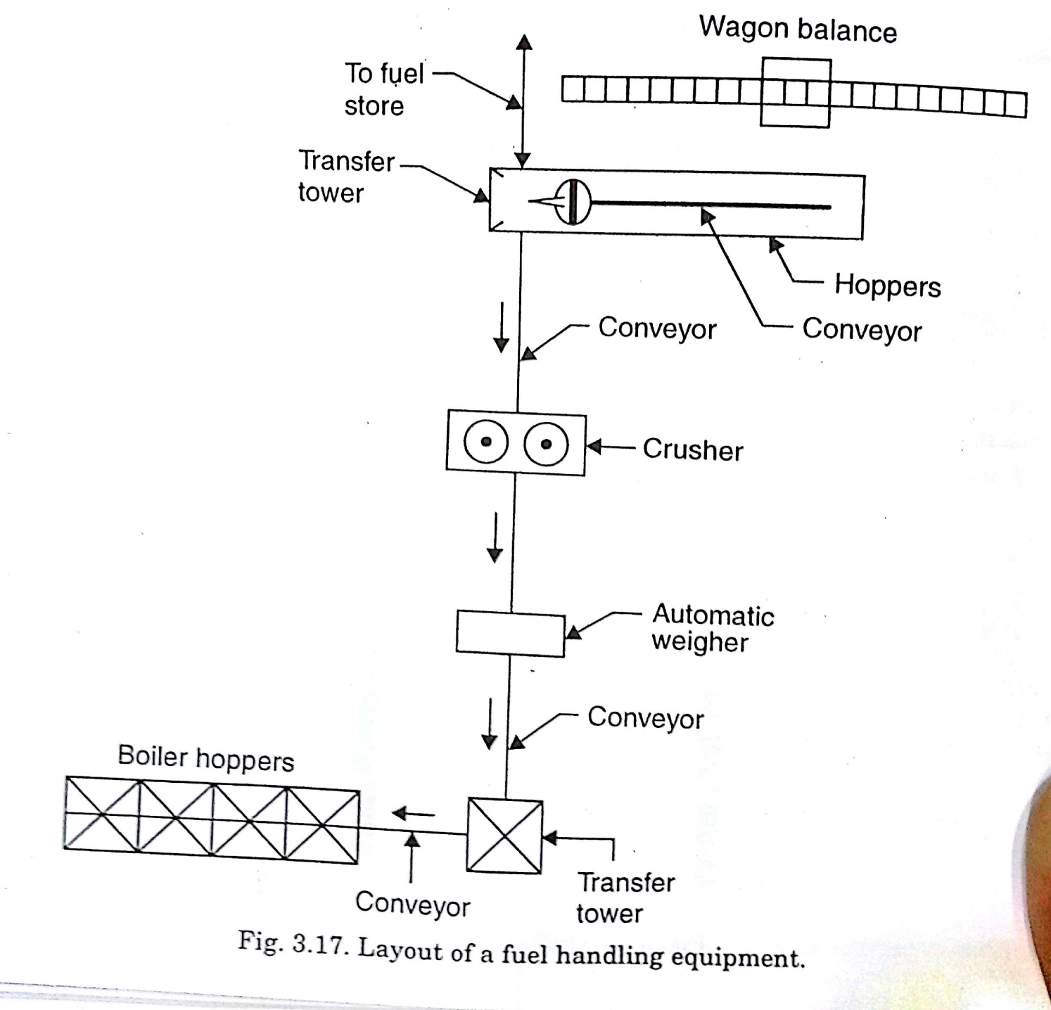

Supply of these fuels to the power plants from various sources is one of the important aspects.
Coal Handling Systems:
.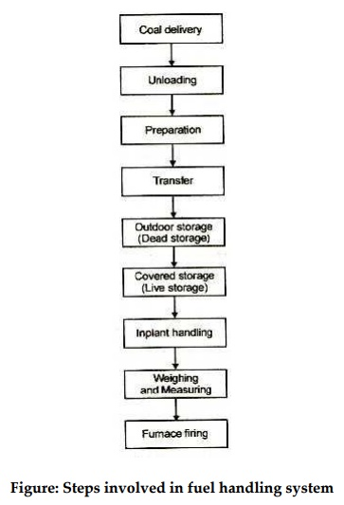
1. Coal Delivery:
From the supply points the coal may be delivered to the power station through rail, road, river and sea.
2.unloading:
Types of coal unload equipment used in the plant depends upon the out plant handling mode as road, rail or ship.
If the coal is delivered by the trucks, there is no need of unloading device as the trucks may dump the coal to the outdoor storage.
If the coal is transported by the sea , the unloading equipment normally used in
- Portable conveyors
- Coal accelerators
- Coal towers
- Unloading bridges
- Self loading boats

3.Preparation:
If the Coal when delivered is in the form of lumps (not in proper size)coal preparation is carried by:
- Breakers
- Crushers
- Sizers
- Dryers
- Magnetic separators.
4.Transfer:
Transfer means the handling of coal between the unloading of the pointand the final storage point from where it is discharged to the firing equipment.The following Equipments are used for transfer of coal:
i) Belt conveyor
ii) Screw conveyor
iii) Vee bucket elevator and conveyor
iv) pivoted bucket conveyor
v) Grab bucket conveyor
vi) flight conveyors(scrapers)
vii) Skip hoists
viii) Mass flow conveyor.
ix) Chutes.

i) Belt conveyor:
Belt conveyors are most commonly used in transportation of coal.
Belt conveyor systems consist of two or more pulleys ( drums). An endless loop of carrying medium and the conveyor belt rotates about them. To move the belt and the material (coal) it carries forward, one or both pulleys are powered. The powered pulley is called “drive pulley,” the unpowered one is known as “idler pulley.” Belt conveyors in general material handling such as those moving boxes along inside a facility form a different class of belt conveyors from those that are used to transport large volumes of resources and agricultural materials.

ii)Screw conveyor:
A screw conveyor or auger conveyor is a mechanism that uses a rotating helical screw blade, called a "flighting", usually within a tube, to move liquid or granular materials.They usually consist of a trough or tube containing either a spiral blade coiled around a shaft, driven at one end and held at the other, or a "shaft less spiral", driven at one end and free at the other..

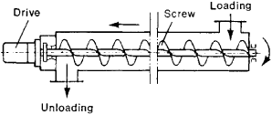
iii)Vee bucket elevator:
Bucket elevator is a type of vertical or inclined transport equipment that efficiently moves
Goods(coal) between floors, vessel or other structure. Elevator is generally powered by electrical
motors that either drive traction cables or counterweight system like a hoist or pump
hydraulic fluid to raise a cylindrical piston like jack. Generally it is preferred for short in
distance compared to belt conveyor. It is more preferable to transport the materials vertically.
(iv) Pivoted bucket conveyor
A type of conveyor using pivoted buckets attached between two endless chains that operate in suitable guides or casing in horizontal, vertical, inclined or a combination of these paths over drive-corner and takeup terminals. The buckets remain in the carrying position until they are tipped or inverted to discharge.
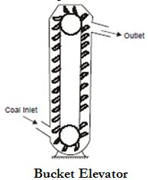

(v) Grab bucket conveyor:
It lifts and transfers coal on a single rail or track from one point to the other. The coal lifted by grab buckets is transferred to overhead bunker or storage. This system requires less power for operation and requires minimum maintenance. The grab bucket conveyor can be used with crane or tower as shown in Fig. 4.6. Although the initial cost of this system is high but operating cost is less.
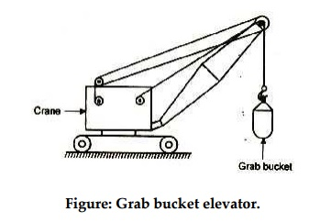
(vi)Flight conveyor.
It consists of one or two strands of chain to which steel scraper or flights are attached. which scrap the coal through a trough having identical shape. This coal is discharged in the bottom of trough. It is low in first cost but has large energy consumption. There is considerable wear. Skip hoist and bucket elevators lift the coal vertically while Belts and flight conveyors move the coal horizontally or on inclines. Fig. shows a flight conveyor. Flight conveyors possess the following
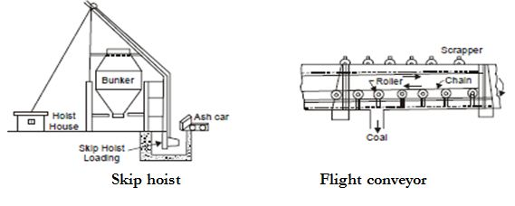
(vi) Skip hoist.
It consists of a vertical or inclined hoist way a bucket or a car guided by a frame and a cable for hoisting the bucket. The bucket is held in upright position. It is simple and compact method of elevating coal or ash. Fig. shows a skip hoist.
- Storage of coal:
It is desirable that sufficient quantity of coal should be stored. Storage of coal gives protection against the interruption of coal supplies when there is delay in transportation of coal or due to strikes in coal mines. Also when the prices are low, the coal can be purchased and stored for future use. The amount of coal to be stored depends on the availability of space for storage, transportation facilities, the amount of coal that will whether away and nearness to coal mines of the power station. Usually coal required for one month operation of power plant is stored in case of power stations situated at longer distance from the collieries whereas coal need for about 15 days is stored in case of power station situated near to collieries. Storage of coal for longer periods is not advantageous because it blocks the capital and results in deterioration of the quality of coal.
The coal received at the power station is stored in dead storage in the form of piles laid directly on the ground. The coal stored has the tendency to whether (to combine with oxygen of air) and during this process coal loss some of its heating value and ignition quality. Due to low oxidation the coal may ignite spontaneously. This is avoided by storing coal in the form of piles which consist of thick and compact layers of coal so that air cannot pass through the coal piles. This will minimize the reaction between coal and oxygen. The other alternative is to allow the air to pass through layers of coal so that air may remove the heat of reaction and avoid burning. In case the coal is to be stored for longer periods the outer surface of piles may be sealed with asphalt or fine coal
6.Implant handling:
It refer to any of the following
(i) Coal handling between the final storage and the firing equipment
(ii)A conveying system to feed coal from any bucker sectio to any firing unit and to move coal from one bucker to another.
(iii)It may mean no more chutes to direct flow into individual firing units and gates or valves to control the flow.
7.Weighing and measuring:
To weigh the quantity of coal following are uesd
(i) Weigh bridge
(ii) Belt Scale
(iii) Weigh lorry
(iv) Automatic scale

Ash handling Equipment:
A huge quantity of ash is produced in central stations, sometimes being as much as 10 to 20% of the total quantity of coal burnt in a day. Hundreds of tonnes of ash may have to be handled every day in large power stations and mechanical devices become indispensable. A station using low grade fuel has to deal with large quantities of ash
Handling of ash includes :
(i) Its removal from the furnace.
(ii) Loading on the conveyers and delivery to the fill or dump from where it can be disposed off by sale or otherwise. Handling of ash is a problem because ash coming out of the furnace is too hot, it is dusty and irritating to handle and is accompanied by some poisonous gas. Ash needs to be quenched before handling due to following reasons :
(i) Quenching reduces corrosion action of the ash.
(ii) It reduces the dust accompanying the ash.
(iii) It reduces temperature of the ash.
(iv) Ash forms clinkers by fusing in large lumps and by quenching clinkers will disintegrate.
Ash Handling Equipment
A good ash handling plant should have the following characteristics :
1. It should have enough capacity to cope with the volume of ash that may be produced in astation.
2. It should be able to handle large clinkers, boiler refuse, soot etc. with little personal attention of the workmen.
3. It should be able to handle hot and wet ash effectively and with good speed.
4. It should be possible to minimize the corrosive or abrasive action of ashes and dust nuisance should not exist.
5. The plant should not cost much.
6. The operation charges should be minimum possible.
7. The operation of the plant should be noiseless as much as possible.
8. The plant should be able to operate effectively under all variable load conditions.
9. In case of addition of units, it should need minimum changes in original layout of plant.
10. The plant should have high rate of handling.
The commonly used equipment for ash handling in large and medium size plants may comprise of:
(i) Bucket elevator
(ii) Bucket conveyor
(iii) Belt conveyor
(iv) Pneumatic conveyor
(v) Hydraulic sluicing equipment
(vi) Trollies or rail cars etc.
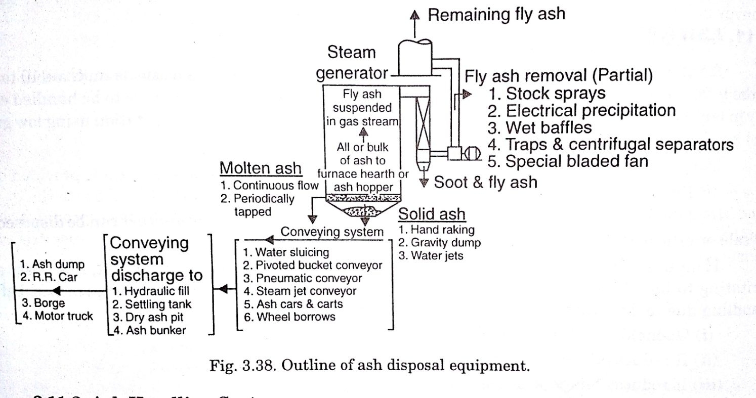
The modern ash-handling systems are mainly classified into four groups:

1. Mechanical Handling System-Belt conveyor is used.
2. Hydraulic Handling System-Water is used to remove ash.
3. Pneumatic Handling System-Air is used to remove ash from furnace
4. Steam Jet Handling System-Steam is used to remove the ash from furnace.

1. Mechanical Handling System.
The mechanical handling system is generally used for low capacity power plants using coal as fuel. The arrangement of the system is shown in Fig. The hot ash coming out of boiler furnace is made to fall over the belt conveyor through a water seal as shown in figure. The cooled ash falls on the belt conveyor and it is carried continuously to the dumping site or overhead bunker. The ash is carried to the dumping site from the ash bunker with the help of trucks.Control valve is opened and closed manually to load the truck. The life of this system is 5 to 10 years. The maximum capacity of this system is limited to 5 tons per hour. The major advantage of this system is low power consumption

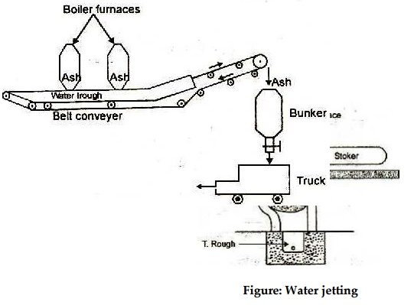
2.Hydraulic Handling System :
Ash from the furnace grate, falls into a system of water possessing high velocity and is carried to the sumps.
It is generally used in large power plants Hydraulic system :
(i). Low Pressure Hydraulic System.
(ii).High Pressure Hydraulic System.

High Velocity Hydraulic AHS : Hoppers below boiler are fitted with nozzles on top (to quench ash) & sides (to drive ash). Cooled ash goes to water channel below, settles & is removed. Water reused.
(i) Low Pressure Hydraulic System.
Ash from furnace grate falls into a low velocity water channel (3 to 5 m/s) and goes to ash sumps. There, ash and water are separated. Water is reused

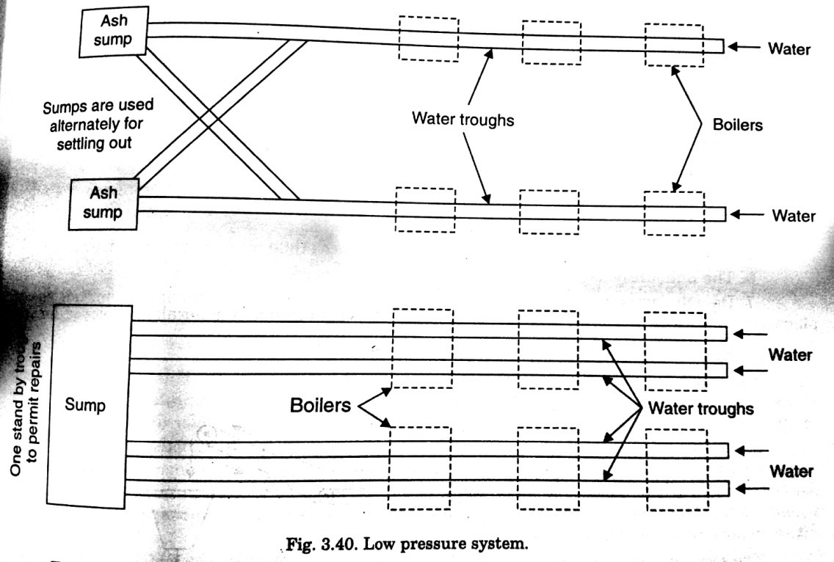

(ii)High Pressure Hydraulic System.
Hoppers below boiler are fitted with nozzles on top (to quench ash) & sides (to drive ash). Cooled ash goes to water channel below, settles & is removed. Water reused.

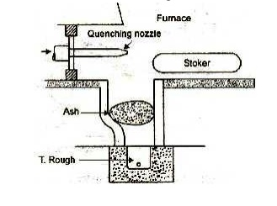
High Pressure Hydraulic System
3.Pneumatic System

In this system ash from the boiler furnace outlet falls into a crusher where a lager ash particles are crushed to small sizes. The ash is then carried by a high velocity air or steam to the point of delivery. Air leaving the ash separator is passed through filter to remove dust etc. So that the exhauster handles clean air which will protect the blades of the exhauster.
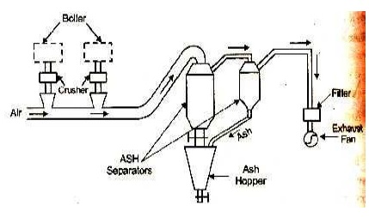
4.Steam Jet steam
Steam at sufficiently high velocity is passed through a pipe and dry solid materials of considerable size are carried along with it. In a high pressure steam jet system a jet of high pressure steam is passed in the direction of ash travel through a conveying pipe in which the ash from the boiler ash hoppers is fed. The ash is deposited in the ash copper.

COMBUSTION PROCESS:

Properties of coal:
- Heating value
- Sulphur content
- Burning characteristics
- Grindability
- Weatherability
- Ash softening temperature

Stoker Firing:
Stoker is a power operated fuel feeding mechanism and grate.
classification of Stoker firing:
The different types of stoker firing work on the following principles.
a) Overfeed stoker
b) Under feed stoker
a) Overfeed stoker:
A fully built up overfeed stoker will have the beds of green coal (raw coal), incandescent coke and ash over the grate. In this the primary air enters the grate from the bottom, which cools the grate while moving up and gets heated as it passes through hot ash bed. The hot air then passes through the bed of incandescent coke, where oxygen reacts with the carbon in the coke to form carbon dioxide, carbon monoxide and hydrogen. Part of carbon dioxide formed reacts with carbon in the fuel to form carbon monoxide.
The gases leaving the bed of incandescent coke consist of nitrogen, carbon dioxide, carbon monoxide, hydrogen and water. To these gases, then an additional air termed the secondary air is supplied from the sides to burn the combustible gases like the carbon monoxide, hydrogen and other volatile matters. The burnt hot gases entering the boiler consist of carbon dioxide, nitrogen, oxygen, and water. It may also contain carbon monoxide, if the combustion is incomplete. The primary and secondary air to the stoker is supplied under pressure with the help of blower.

b) Under feed stoker:
Overfeed stoker firing is the process of combustion in which the unignited fuel or incoming coal is located above ignited fuel bed. The ignited fuel transfer heat to the incoming coal by radiation. Moreover coal is heated convection from hot gases that has been through the combustion. Secondary air is added to perform complete combustion unless steam boiler will produce more smoke because the hot gases contain little oxygen.
These are two types :
(a)Travelling grate stoker
(i)Chain grate type
(ii)Bar grate type
(b)Spreader stoker
(a)Travelling grate stoker:
(i)Chain grate type:
A chain grate stoker consists of an endless chain which forms the support for the fuel bed. The chain is made of cast iron links connected by pins. The chain is held over two sprockets as shown figure, and travels from one end of the furnace to the other end. The sprocket at the front end is driven by an electric motor. The coal is fed at the front end through a hopper which is carried by the chain to the other end, hence into the furnace. The air necessary for the combustion of the fuel is supplied through the air inlets below the traveling grate. The secondary air is supplied through the openings in the top roof as shown in figure.
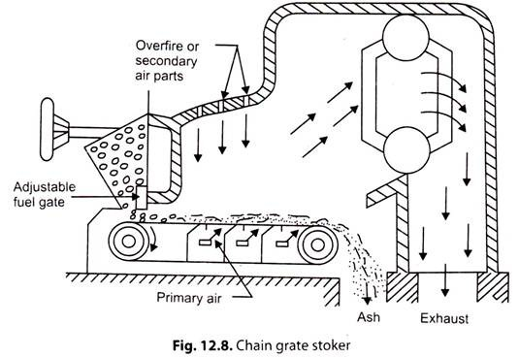

The rate of fuel supplied to the grate and hence the heat to the boiler can be controlled by two means. The first means is to control the depth of the coal bed on the grate by controlling the feed to the hopper. In the second method, the speed of the chain grate can be adjusted to meet the boiler operation requirements. The chain grate stokers are widely used for burning non-caking (that does not form a solid mass while burning), free burning, volatile and high ash content coals.
Advantages of chain grate stokers
1) It is simple in construction and operation.
2) Its initial and maintenance costs very low.
3) It doesn't have ash cleaning problems.
4) Combustion control is simple, by control of feed or chain speed, along with the air supply.
5) Its combustion efficiency is high.
Disadvantages
1) It is suitable only for small capacity plants.
2) Coal losses are high as the un burnt coal may also move with ash.
3) If caking coal is used ash clinker problems may rise.
• In the traveling grate stoker, the chain grate is replaced by grate bars that support the burning fuel.
• Also the grate is inclined towards the inlet of the furnace.
• The fuel movement is accomplished and controlled by vibration of the grate.
• The air supply similar to the chain grate stoker
(b)Spreader or Sprinkler Stoker:
In this type stoker, coal from the hopper is fed on to a rotating feeder which in turn feeds the, to a spreader or sprinkler, and feed according to the requirements. Feeder is a rotating drum fitted with blades on its periphery. Other type of feeders such as reciprocations, endless belts or spiral worms can also be used. The feeder continuously supply the coal on to the spreader, a fast moving drum with blades, which in turn distributes and feeds the coal on to the grate as shown in figure. The fuel feed rate and the supplied to the boiler can be controlled by controlling the feed to the hopper or by controlling the spreader speed.
Fig. shows the schematic arrangement of a spreader stoker. In this type stoker, coal from the hopper is fed on to a rotating feeder which in turn feeds the, to a spreader or sprinkler, and feed according to the requirements. Feeder is a rotating drum fitted with blades on its periphery. Other type of feeders such as reciprocating rams, endless belts or spiral worms can also be used. The feeder continuously supplies the coal on to the spreader, a fast moving drum with blades, which in turn distributes and feeds the coal on to the grate as shown in figure. The fuel feed rate and the supplied to the boiler can be controlled by controlling the feed to the hopper are by controlling the spreader speed.
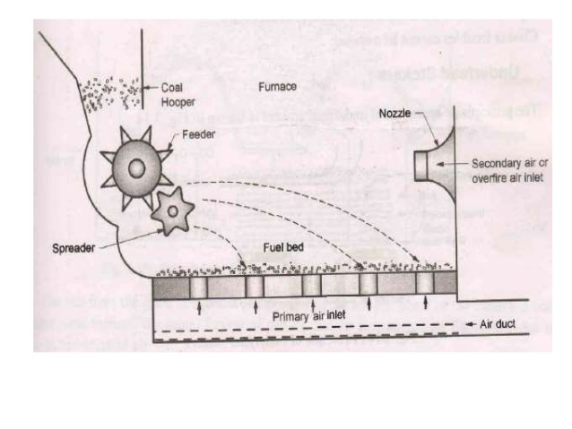
Advantages of spreader stoker:
- Its operation is simple and economical.
- A wide variety of low quality coals can be burnt successfully.
- Preheated air can be used for improving the efficiency of operation.
- The fuel burns rapidly and hence the caking tendency is very low, even with the use of caking coals.
- It can responds quickly to load variations
Disadvantages:
- It is not possible to burn varying sizes of coal and only crushed, sized coal can be used.
- A part of the charge is burnt in suspension and hence fly ash is discharged with flue gases. This necessitates a suitable dust (or fly ash) collector system.
- Un burnt carbon particles may escape through the flues and reduce the combustion efficiency.

RETORT STOKERS:
- Single Retort Stoker:
The principle of construction of a single retort stoker is illustrated in Fig. In this stoker, fuel is burnt on a retort. The fuel is fed through a hopper and pushed on to the retort by a piston ram movement.
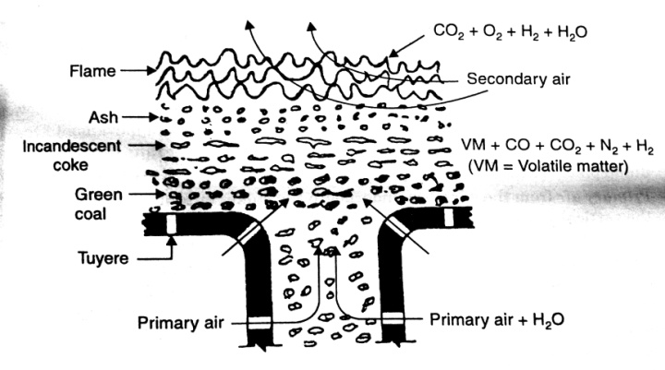

With the feeding from the bottom, gradually the burning coat rises up. Above the green coal an incandescent coke layer is formed, and above which the ash layer is formed. With the continuous feeding of green coal, the ash level rises that is removed by ash raker.

- Multi retort stokers:
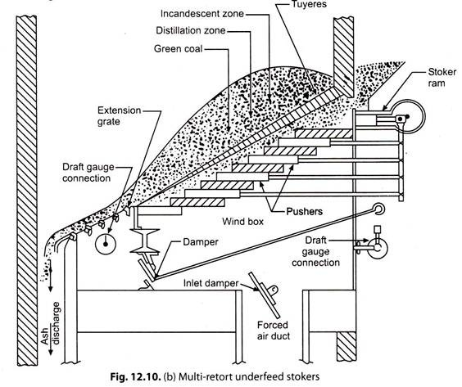

It contains of a series of retorts (5 to 20) with tuyers and pushers. It also consists of a fuel hopper and a coal pusher at the hopper end as shown in figure. The coal fed through the hopper is pushed by the main pusher driven by a ram. The distributing pushers in the retorts push the coal and distribute it to all the retorts. The movement of the fuel bed by the pushers helps in minimizing the clinker formation. The primary air enters the wind box below the retorts, and flows through the retorts. An air damper is provided at the air inlet in the wind box to control the airflow to the furnace. The airflow to the extension grate at its entry is further controlled by another damper, since the extension grate requires small quantity of air with less fuel burning on it. The ash formed from all the retorts falls into the ash pit.
Advantages of multi retort stoker
- Since the combustion rate is high, such a stoker is most suitable for high capacity power plants.
- The combustion efficiency of this stoker is very high.
- As the fuel is pushed off by the pushers, they perform the cleaning action as well.
- Automatic combustion control can be adopted in this stoker.
- This stoker can respond quickly to variations in demand.
Disadvantages
- The operation and maintenance is expensive.
- The initial investment is high.
- Ash clinker problems may arise.
- It needs a larger area for installation and operation.
- Low grade, high ash fuels cannot be burnt successfully.
Pulverized fuel burning system:
In pulverised fuel firing system, the coal is powdered and then charged into the combustion chamber with the help of hot air current. The main purpose of pulverizing coal is to increase the surface area of exposure to the combustion process, which results in faster and efficient combustion. In burning the pulverized coal, the secondary air required for the complete combustion of fuel is supplied separately to the combustion chamber. The resulting turbulence in the combustion chamber helps for uniform mixing of fuel and air. The air required to carry the pulverized coal and dry it before entering the combustion chamber is termed the Priming Air, and the air supplied separately for complete combustion is termed the Secondary Air. Pulverized coal firing systems are universally adopted far large scale power plants.
The choice of pulverized fuel firing system depends upon the size of the boiler unit, type of coal available, cost of coal, type of load (i.e., fluctuating or constant), the load factor and availability of trained personnel. Generally such systems are not economical for small capacity thermal power plants.
Advantages of using pulverised coal:
- A wide variety of low grade fuels (coal) can be used and burnt easily.
- Greater surface area is exposed for combustion and hence combustion is faster and efficient.
- The system is free from clinker and slagging troubles.
- Combustion control is easy, and hence the system gives fast response to load changes.
- Preheated secondary air (up to 350°C) can be used, resulting in rapid flame propagation and faster heat supply to the boiler.
- The pulverizing system can be maintained or repaired without affecting the combustion process.
- It has a very high rate of heat release.
- Banking losses (un burnt fuel with ash) are lower, as compared to stoker firing.
- The boilers can be started from cold very rapidly.
- Usually combustion will be smokeless.

Disadvantages of Pulverised system:
- The capital investment of the system is high as it requires additional equipments (for pulverizing, and handling).
- Its operation and maintenance costs are very high.
- It produces fly-ash/fine dust and needs costly fly-ash removal equipments like electrostatic precipitators.
- The chances of explosion are high as coal burns like a gas.
- The storage of powdered coal requires special attention as it has possibilities of fire hazards.
- Skilled workers are required for safe-operation and maintenance.
- Air pollution takes place by the emission of fine particles of grit and dirt.
- The removal of liquid slag formed from low fusion temperature ash requires special handling equipments.
Pulverised Fuel Burning System
There are two common methods of pulverized fuel burning systems-
1. Unit system
2. Central or Bin system
1. Unit System
In this system, each burner and a pulveriser constitute a unit. It consists of a raw coal bunker, a feeder, pulverizing mill, separator, and the burner. In operation, the raw coal is supplied to the bunker, where it is crushed to the required sizes, the crushed coal is then fed to the pulverizing mill through the feeder at the required rate, depending upon the combustion requirements. Hot gases are passed through the feeder to dry the coal. The dried coal is pulverised in the mill and it is carried to the burner. An induced draft fan is used at the pulverizer to carry the powdered coal to the burner. A separator is provided to separate.

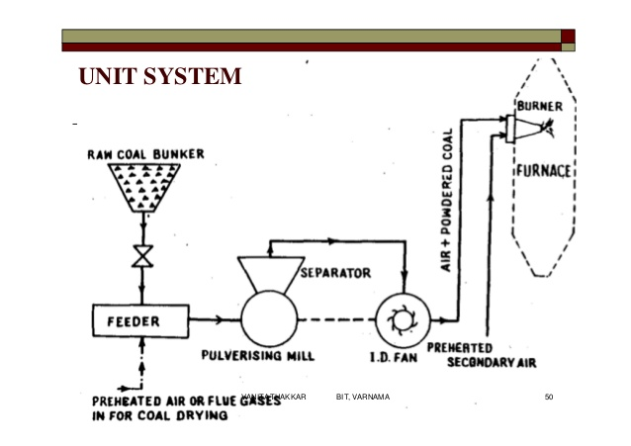

2.Central or Bin System
Fig. shows schematic arrangement and the principle of operation of a central, or bin system for burning pulverised coal. The crushed raw coal is dried using hot air or flue gases and fed to the pulveriser. The pulverised coal from the pulverizing mill is passed to the cyclone separator where over-sized particles are separated and fed back to the mil.

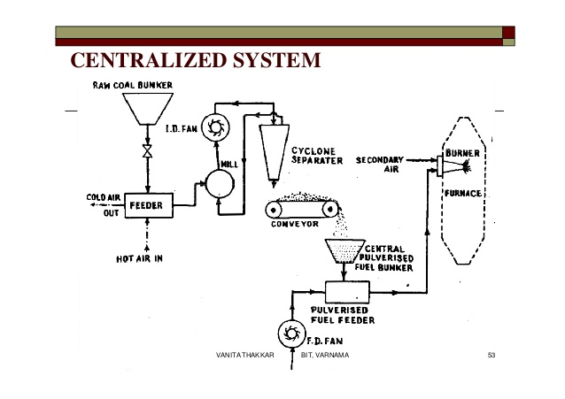
Combustion needs:

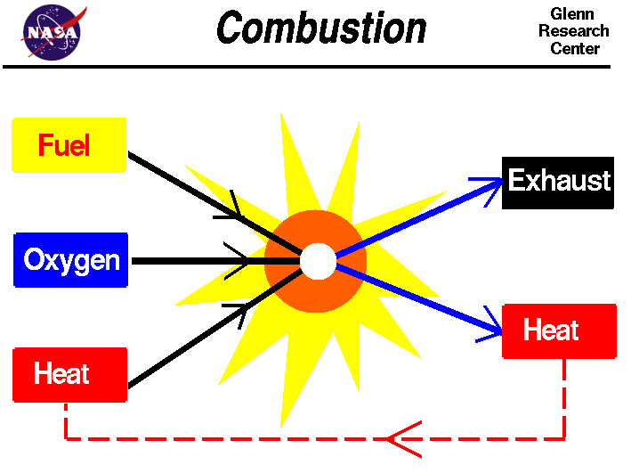
Combustion
It is a chemical process in which a substance reacts rapidly with oxygen and gives off heat. The original substance is called the fuel, and the source of oxygen is called the oxidizer. The fuel can be a solid, liquid, or gas.

Draught system:
The small pressure difference which causes a flow of gas to take place is termed as draught.
Draught can be obtained by use of chimney, fan, steam or air jet or combination of these. When the draught is produced with the help of chimney only, it is known as Natural Draught and when the draught is produced by any other means except chimney it is known as artificial draught.
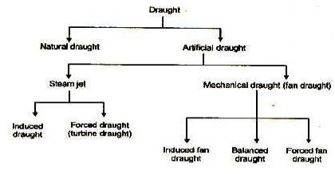

Natural Draught:

Natural draught system employs a tall chimney as shown in figure. The chimney is a vertical tubular masonry structure or reinforced concrete. It is constructed for enclosing a column of exhaust gases to produce the draught. It discharges the gases high enough to prevent air pollution. The draught is produced by this tall chimney due to temperature difference of hot gases in the chimney and cold external air outside the chimney.
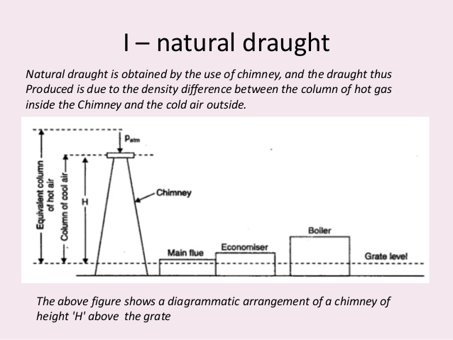
Artificial Draught
It has been seen that the draught produced by chimney is affected by the atmospheric conditions. It has no flexibility, poor efficiency and tall chimney is required. In most of the modern power plants, the draught used must be independence of atmospheric condition, and it must have greater flexibility (control) to take the fluctuating loads on the plant.
Today’srgelasteam power plants requiring 20 thousand tons of steam per hour would be impossible to run without the aid of draft fans. A chimney of an reasonable height would be incapable of developing enough draft to remove the tremendous volume of air and gases (400 × 10 3 m3 to 800 × 103 m3 per minutes). The further advantage of fans is to reduce the height of the chimney needed.
The draught required in actual power plant is sufficiently high (300 mm of water) and to meet high draught requirements, some other system must be used, known as artificial draught. The artificial draught is produced by a fan and it is known as fan (mechanical) draught. Mechanical draught is preferred for central power stations.
Forced Draught
In a forced draught system, a blower is installed near the base of the boiler and air is forced to pass through the furnace, flues, economizer, air-preheater and to the stack.
This draught system is known as positive draught system or forced draught system because the pressure and air is forced to flow through the system.
The arrangement of the system is shown in figure. A stack or chimney is also in this system as shown in figure but its function is to discharge gases high in the atmosphere to prevent the contamination. It is not much significant for producing draught therefore height of the chimney may not be very much.

Induced Draught:
In this system, the blower is located near the base of the chimney instead of near the grate. The air is sucked in the system by reducing the pressure through the system below atmosphere. The induced draught fan sucks the burned gases from the furnace and the pressure inside the furnace is reduced below atmosphere and induces the atmospheric air to flow through the furnace. The action of the induced draught is similar to the action of the chimney. The draught produced is independent of the temperature of the hot gases therefore the gases may be discharged as cold as possible after recovering as much heat as possible in air-preheater and economizer.

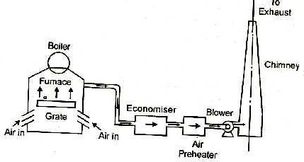
Balanced Draught:
It is always preferable to use a combination of forced draught and induced draught instead of forced or induced draught alone. If the forced draught is used alone, then the furnace cannot be opened either for firing or inspection because the high pressure air inside the furnace will try to blow out suddenly and there is every chance of blowing out the fire completely and furnace stops.
If the induced draught is used alone, then also furnace cannot be opened either for firing or inspection because the cold air will try to rush into the furnace as the pressure inside the furnace is below atmospheric pressure. This reduces the effective draught and dilutes the combustion.

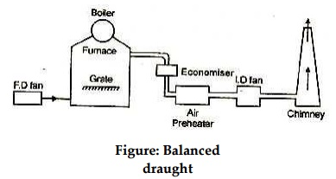
Cyclone furnace:
A cyclone furnace consists of a horizontal cylindrical barrel attached through the side of a boiler furnace. The cyclone barrel is constructed with water cooled, tangential oriented, tube construction. Inside the cyclone barrel are short, densely spaced, pin studs welded to the outside of the tubes. The studs are coated with a refractory material, usually silica or aluminium based, that allows the cyclone to operate at a high enough temperature to keep the slag in a molten state and allow removal through the tap.
Crushed coal and a small amount of primary air enter from the front of the cyclone into the burner. In the main cyclone burner, secondary air is introduced tangentially, causing a circulating gas flow pattern. The products, flue gas and un-combusted fuel, then leave the burner and pass over the boiler tubes. Tertiary air is then released further downstream to complete combustion of the remaining fuel, greatly reducing NOx formation. A layer of molten slag coats the burner and flows through traps at the bottom of the burners, reducing the amount of slag that would otherwise form on the boiler tubes.
Cyclone furnaces were originally designed to take advantage of four things
- Lower fuel preparation time and costs
- Smaller more compact furnaces
- Less fly ash and convective pass slagging
- Flexibility in fuel types

Dust collectors:
A dust collector is a system used to enhance the quality of air released from industrial and commercial processes by collecting dust and other impurities from air or gas.
Designed to handle high-volume dust loads, a dust collector system consists of a blower, dust filter, a filter-cleaning system, and a dust receptacle or dust removal system.
Dust collectors may be of single unit construction, or a collection of devices used to separate particulate matter from the process air.They are often used as an air pollution control device to maintain or improve air quality.
Types of dust collecting systems
I.Mechanical dust collectors:
(i) Wet types(scrubbers)
(a) Spray type
(b) Packed type
(c) Impingment type
(ii) Dry type
(a) Gravitational Separators
(b) Cyclone separator
- Electrical dust collectors
(i) Rod type
(ii) Plate type

- Mechanical dust collectors:
(i) Wet scrubber:
Wet Scrubbers are air pollution control devices for removing particles and gases from industrial exhaust stream.
It is operated by introducing the dirty gas stream with a scrubbing liquid as water. Then gases are collected in the scrubbing liquid.
Wet scrubbers are usually the most appropriate air pollution-control device for collecting both, particulate and gas in a single system alone.
Features:
- Gives high collection efficiency of solid & gaseous pollutant.
- Provides Maximum pressure drop.
- Fumes are also be absorbed
- Maintenance cost is low
- Complete wetting of the product
- Emission of minimum product through exhaust
- Ability to handle high temperature

Cyclone seperators
Cyclones are mostly used for removing industrials dust from air or process gases. They are the principal type of gas-solid separator
Most common form of particulate removal gas is spun rapidly – heavier particulate matter to collect on outside of separator by centrifugal force, where it is collected and removed.

COOLING TOWER AND HEAR REJECTIONS:
Cooling towers are a very important part of many chemical plants. The primary task of a cooling tower is to reject heat into the atmosphere. They represent a relatively inexpensive and dependable means of removing low-grade heat from cooling water. The make-up water source is used to replenish water lost to evaporation. Hot water from heat exchangers is sent to the cooling tower. The water exits the cooling tower and is sent back to the exchangers or to other units for further cooling.
Cooling Tower Types Cooling towers fall into two main categories:
1.Natural draft
- Mechanical draft.
Natural draft:
Natural draft towers use very large concrete chimneys to introduce air through the media. Due to the large size of these towers, they are generally used for water flow rates above 45,000 m3 /hr. These types of towers are used only by utility power stations.
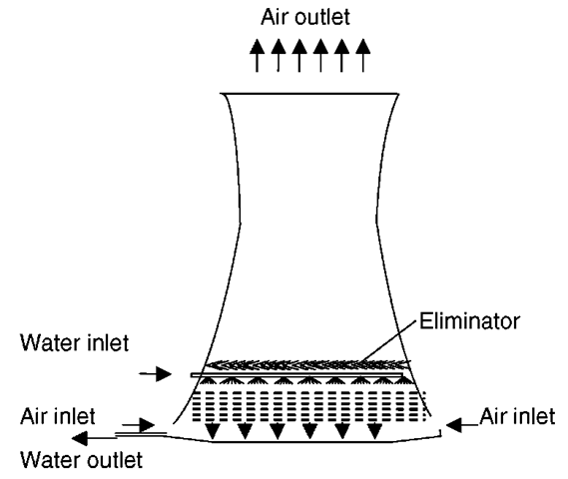

Mechanical Draft Cooling Towers:
The mechanical draft cooling towers are very much similar to that of the natural draft cooling towers. As the name indicates, air is circulated inside the tower mechanically instead of natural circulation. Propeller fans or centrifugal fans may be used.
Advantages of mechanical draft cooling towers over natural draft cooling towers:
- For the same capacity used, the mechanical draft cooling towers are much smaller than the natural draft cooling towers. This is because of the increase in cooling capacity due to increase in volume of the air being forced out by fan.
- Capacity control is possible in mechanical draft cooling tower. By controlling the speed of the fan, the volume of air can be controlled, which in turn controls the capacity.
- The natural draft cooling towers can be located only in open space. As they do not depend upon the atmospheric air, the mechanical draft cooling towers shall be located even inside the building.
Disadvantages of using mechanical draft cooling towers:
- More power is required to run the system,
- Increased running cost due to increase in maintenance of the fans, motors and its associated controls,
According to the location of the fan, they are further classified as:
- Forced draft cooling towers.
- Induced draft cooling towers.

Forced draft cooling towers.

In this system, fan is located near the bottom and on the side. This fan forces the air from bottom to top. An eliminator is used to prevent loss of water droplets along with the forced air.
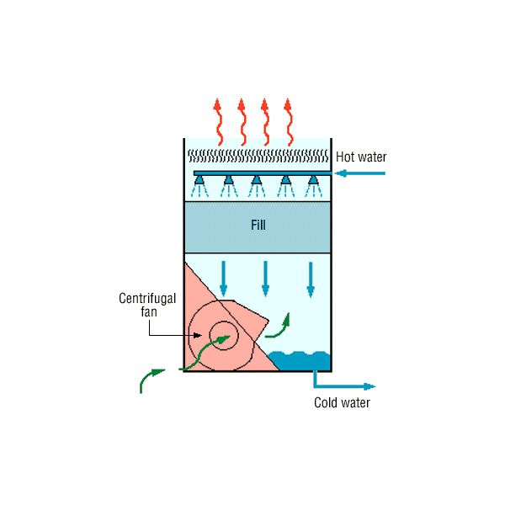
Induced Draft Cooling Towers
In this system, a centrally located fan at the top, takes suction from the tower and discharges it to the atmosphere. The only between the induced draft cooling tower and forced draft cooling tower is that the fan is located at the top in the induced draft cooling tower.
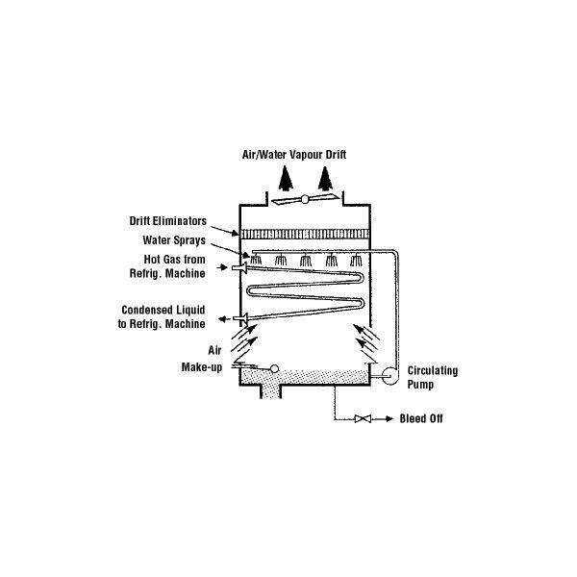

Corrosion and Feed water Treatment
Boiler feedwater is an essential part of boiler operations. The feed water is put into the steam drum from a feed pump. In the steam drum the feed water is then turned into steam from the heat. After the steam is used it is then dumped to the main condenser. From the condenser it is then pumped to the deaerated feed tank. From this tank it then goes back to the steam drum to complete its cycle. The feed water is never open to the atmosphere.
Corrosive compounds, especially O₂ and CO₂ must be removed, usually by use of a deaerator. Residual amounts can be removed chemically, by use of oxygen scavengers. Additionally, feed water is typically alkalized to a pH of 9.0 or higher, to reduce oxidation and to support the formation of a stable layer of magnetite on the water-side surface of the boiler, protecting the material underneath from further corrosion. This is usually done by dosing alkaline agents into the feed water, such as sodium hydroxide (caustic soda) or ammonia. Corrosion in boilers is due to the presence of dissolved oxygen, dissolved carbon dioxide, or dissolved salts.

