

UNIT-1
INTRODUCATION
The field of robotics has its origins in science fiction. The term robot was derived from the English
translation of a fantasy play written in Czechoslovakia around 1920. It took another 40 years before the
modern technology of industrial robotics began. Today. Robots are highly automated mechanical
manipulators controlled by computers. In this chapter. We survey some of the science fiction stories
about robots, and we trace the historical development of robotics technology. Let us begin our chapter by
denning the term robotics and establishing its place in relation to other types of industrial automation.
Robotics:-
Robotics is an applied engineering science that has been referred to as a combination of machine tool
technology and computer science. It includes machine design, production theory, micro electronics, computer programming & artificial intelligence.
OR
"Robotics" is defined as the science of designing and building Robots which are suitable for real life
application in automated manufacturing and other non-manufacturing environments.

Industrial robot:-
The official definition of an industrial robot is provided by the robotics industries association (RIA).
Industrial robot is defined as an automatic, freely programmed, servo-controlled, multi-purpose manipulator to handle various operations of an industry with variable programmed motions.
Automation and robotics:-
Automation and robotics are two closely related technologies. In an industrial context, we can dean
automation as a technology that is concerned with the use of mechanical, electronic, and computer-based systems in the operation and control of production Examples of this technology include transfer lines.
Mechanized assembly machines, feedback control systems (applied to industrial processes), numerically controlled machine tools, and robots. Accordingly, robotics is a form of industrial automation.
Ex:- Robotics, CAD/CAM, FMS, CIMS
Types of Automation:-
Automation is categorized into three types. They are,
1) Fixed Automation
2) Programmable Automation 3) Flexible Automation.

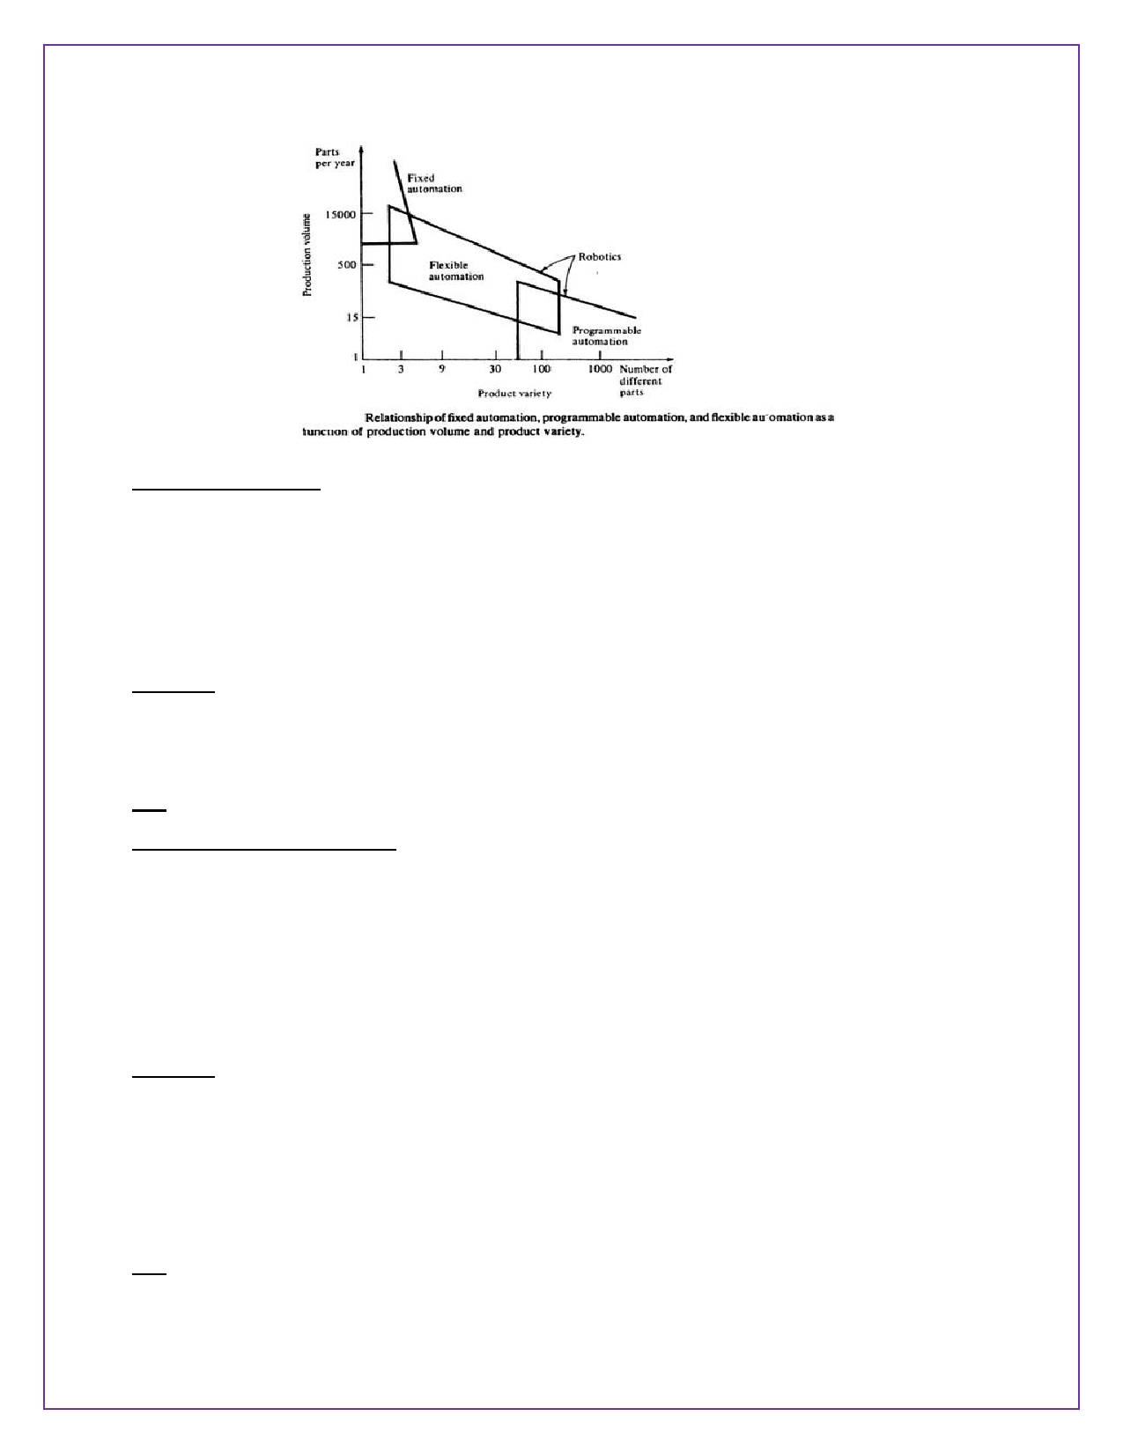

(1) Fixed Automation:-
It is the automation in which the sequence of processing or assembly operations to be carried out are
fixed by the equipment configuration. In fixed automation, the sequence of operations (which are
simple) are integrated in a piece of equipment. Therefore, it is difficult to automate changes in the design
of the product. It is used where high volume of production is required Production rate of fixed
automation is high. In this automation, no new products are processed for a given sequence of assembly operations.
Features:-
i) High volume of production rates,
ii) Relatively inflexible in product variety (no new products are produced). Ex:- Automobile industries … etc. (2) Programmable Automation:-
It is the automation in which the equipment is designed to accommodate various product configurations
in order to change the sequence of operations or assembly operations by means of control program.
Different types of programs can be loaded into the equipment to produce products with new
configurations (i.e., new products). It is employed for batch production of low and medium volumes. For
each new batch of different configured product, a new control program corresponding to the new
product is loaded into the equipment. This automation is relatively economic for small batches of the product.
Features:-
i) High investment in general purpose,
ii) Lower production rates than fixed automation,
iii) Flexibility & Changes in products configuration, iv) More suitable for batch production.
Ex:- Industrial robot, NC machines tools… etc.



(3) Flexible Automation:-
A computer integrated manufacturing system which is an extension of programmable automation is
referred as flexible automation. It is developed to minimize the time loss between the changeover of the batch production from one product to another while reloading. The program to produce new products
and changing the physical setup i.e., it produces different products with no loss of time. This automation is more flexible in interconnecting work stations with material handling and storage system.
Features:-
i) High investment for a custom engineering system.
ii) Medium Production rates
iii) Flexibility to deal with product design variation,
iv) Continuous production of variable mixtures of products.
Ex:- Flexible manufacturing systems (FMS)
Advantages:-
1. High Production rates
2. Lead time decreases
3. Storing capacity decreases
4. Human errors are eliminated. 5. Labour cost is decreases.
Disadvantages:-
1. Initial cost of draw material is very high,
2. Maintenance cost is high,
3. Required high skilled Labour
4. Indirect cost for research development & programming increases.

Reasons for implementation of automated systems in manufacture industries:-
The reasons for the implementation of automated systems in manufacturing industries are as follows,

(i)
(ii)
(iii) (iv) (v)
(vi)
(vii)
To Increase the Productivity Rate of Labour
To Decrease the Cost of Labour
To Minimize the Effect of Shortage of Labour
To Obtain High Quality of Products
A Non-automation nigh Cost is Avoided
To Decrease the Manufacturing Lead Time To upgrade the Safety of Workers.



Need For using robotics in industries:-
Industrial robot plays a significant role in automated manufacturing to perform different kinds of
applications.
1. Robots can be built a performance capability superior to those of human beings. In terms of strength,
size, speed, accuracy…etc.
2. Robots are better than humans to perform simple and repetitive tasks with better quality and
consistence's.
3. Robots do not have the limitations and negative attributes of human works .such as fatigue, need for
rest, diversion of attention…..etc.
4. Robots are used in industries to save the time compared to human beings.
5. Robots are in value poor working conditions
6. Improved working conditions and reduced risks.

CAD/CAM & Robotics:-
CAD/CAM is a term which means computer aided design and computer aided manufacturing. It is the
technology concerned with the use of digital computers to perform certain functions in design &production.
CAD:- CAD can be defined as the use of computer systems to assist in the creation modification, analysis
OR optimization of design.
Cam:- CAM can be defined as the use of computer system to plan, manage & control the operation of a
manufacturing plant, through either direct or in direct computer interface with the plants production resources.
Specifications of robotics:-
1. Axil of motion 2. Work stations
3. Speed
4. Acceleration
5. Pay load capacity
6. Accuracy
7. Repeatability etc…



Overview of Robotics:-
"Robotics" is defined as the science of designing and building Robots which are suitable for real life
application in automated manufacturing and other non-manufacturing environments. It has the
following objectives,
1. To increase productivity 2. Reduce production life
3. Minimize labour requirement
4. Enhanced quality of the products
5. Minimize loss of man hours, on account of accidents. 6. Make reliable and high speed production.

The robots are classified as,
* Programmable/Reprogrammable purpose robots
*Tele-operated, Man controlled robots *Intelligent robots.

Robots are used in manufacturing and assembly units such as,
.:. Spot or arc welding
.:. Parts assembly
.:. Paint spraying .
.:. Material, handling
.:. Loading and unloading

The feature and capabilities of the robots are as follows,
* Intelligence
* Sensor capabilities
* Telepresence
* Mechanical design
* Mobility and navigation
* Universal gripper
* System integration and networking.

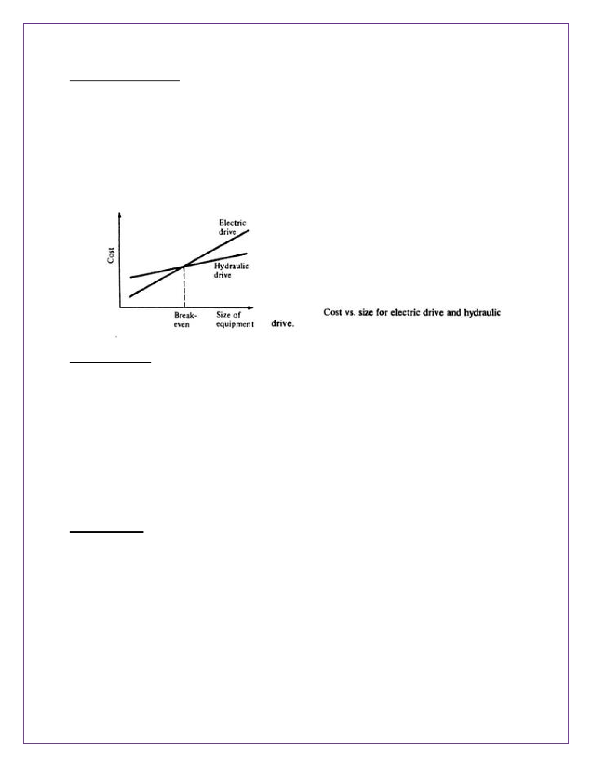

Types of drive systems:-
1. Hydraulic drive
2. Electric drive
3. Pneumatic drive

1. Hydraulic drive:-
Hydraulic drive and electric drive arc the two main types of drives used on more sophisticated robots. Hydraulic drive is generally associated with larger robots, such as the Unimate 2000 series. The usual
advantages of the hydraulic drive system are that it provides the robot with greater speed and strength. The disadvantages of the hydraulic drive system are that it typically adds to the floor space required by the robot, and that a hydraulic system is inclined to leak on which is a nuisance.
This type of system can also be called as non-air powered cylinders. In this system, oil is used as a
working fluid instead of compressed air. Hydraulic system need pump to generate the required pressure and flow rate. This systems are quite complex, costly and requires maintenance.

2. Electric drive:-
Electric drive systems do not generally provide as much speed or power as hydraulic systems. However,
the accuracy and repeatability of electric drive robots are usually better. Consequently, electric robots tend to be smaller. Require less floor space, and their applications tend toward more precise work such as assembly.
In this System, power is developed by an electric current. It required little maintenance and the
operation is noise less.



3. Pneumatic drive:-
Pneumatic drive is generally reserved for smaller robots that possess fewer degrees of freedom (two- to
four-joint motions).
In this system, air is used as a working fluid, hence it is also called air-powered cylinders. Air is
compressed in the cylinder with the aid of pump the compressed air is used to generate the power with required amount of pressure and flow rates.

Applications of robots:-
Present Applications of Robots:- (i) Material transfer applications
(ii) Machine loading and unloading
(iii) Processing operations like,
(a) Spot welding
(b) Continuous arc welding
(c) Spray coating
(d) Drilling, routing, machining operations
(e) Grinding, polishing debarring wire brushing (g) Laser drilling and cutting etc.
(iv) Assembly tasks, assembly cell designs, parts mating. (v) Inspection, automation or test equipment.
Future Applications of Robots:-
The profile of the future robot based on the research activities will include the following,
(i) Intelligence
(ii) Sensor capabilities
(iii) Telepresence
(iv) Mechanical design
(v) Mobility and navigation (walking machines)
(vi) Universal gripper
(vii) Systems and integration and networking (viii) FMS (Flexible Manufacturing Systems)
(Ix) Hazardous and inaccessible non-manufacturing environments

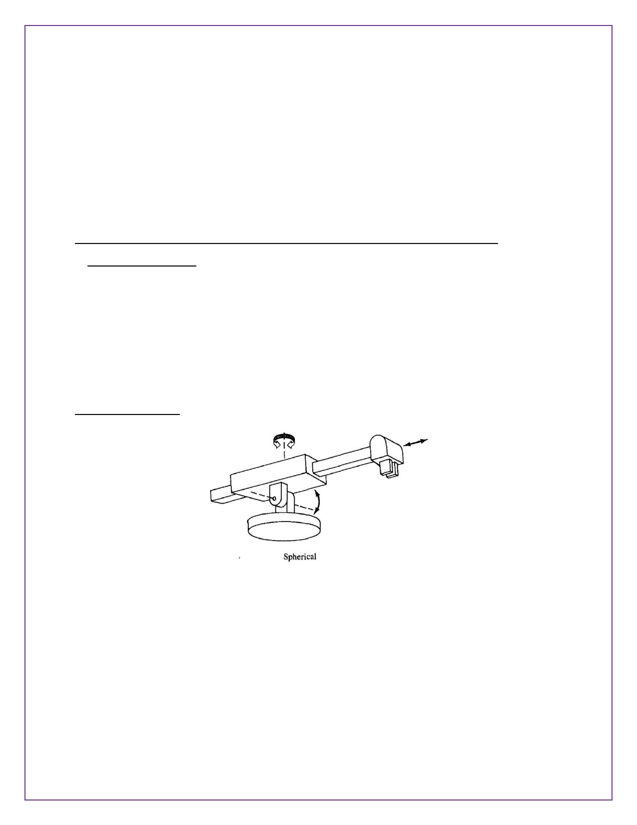

(x) Underground coal mining
(xi) Fire fighting operations
(xii) Robots in space (xiii) Security guards
(xiv) Garbage collection and waste disposal operations
(xv) Household robots
(xvi) Medical care and hospital duties etc.
Classification of Robots (or) Classification by co-ordinate system and control system:-
-> Co-ordinate systems:-
Industrial robots are available in a wide variety of sizes, shapes, and physical configurations. The vast
majority of today's commercially available robots possess one of the basic configurations:
I. Polar configuration
2. Cylindrical configuration
3. Cartesian coordinate configurable
4. Jointed-arm configuration
1. Polar configuration:-

The polar configuration is pictured in part (a) of Fig. It uses a telescoping arm that can be raised or
lowered about a horizontal pivot The pivot is mounted on a mta6ng base These various joints provide
the robot with the capability to move its arm within a spherical space, and hence the name "spherical coordinate" robot is sometimes applied to this type. A number of commercial robots possess the polar configuration.

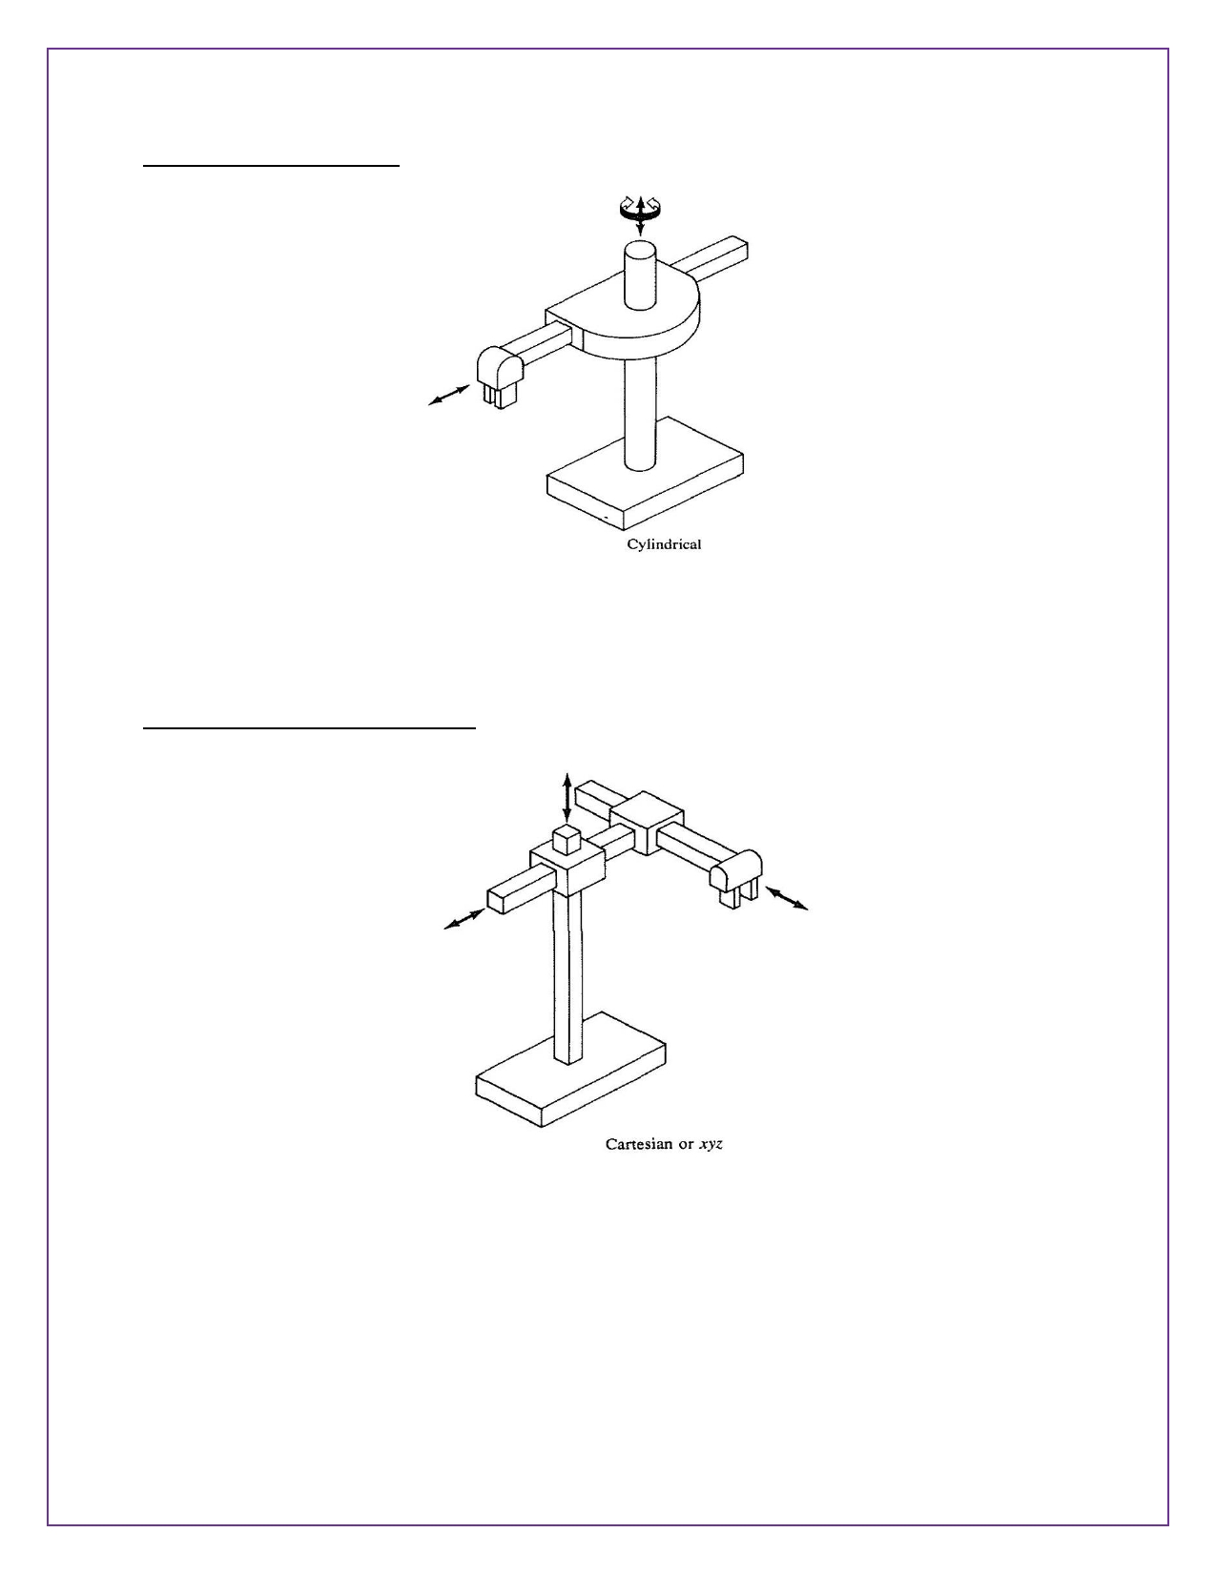

2. Cylindrical configuration:-

The cylindrical configurable, as shown in fig, uses a vertical column and a slide that can be moved up or
down along the column. The robot arm is attached to the slide so that it cm he moved radially with
respect to the column. By routing the column, the robot is capable of achieving a work space that approximation a cylinder.
3. Cartesian coordinate configurable:-

The cartesian coordinate robot, illustrated in part Cc) of Fig, uses three perpendicular slides to construct
the x, y, and z axes. Other names are sometimes applied W this configuration, including xyz robot and
rectilinear robot, By moving the three slides relative to one another, the robot is capable of operating within a rectangular work envelope.

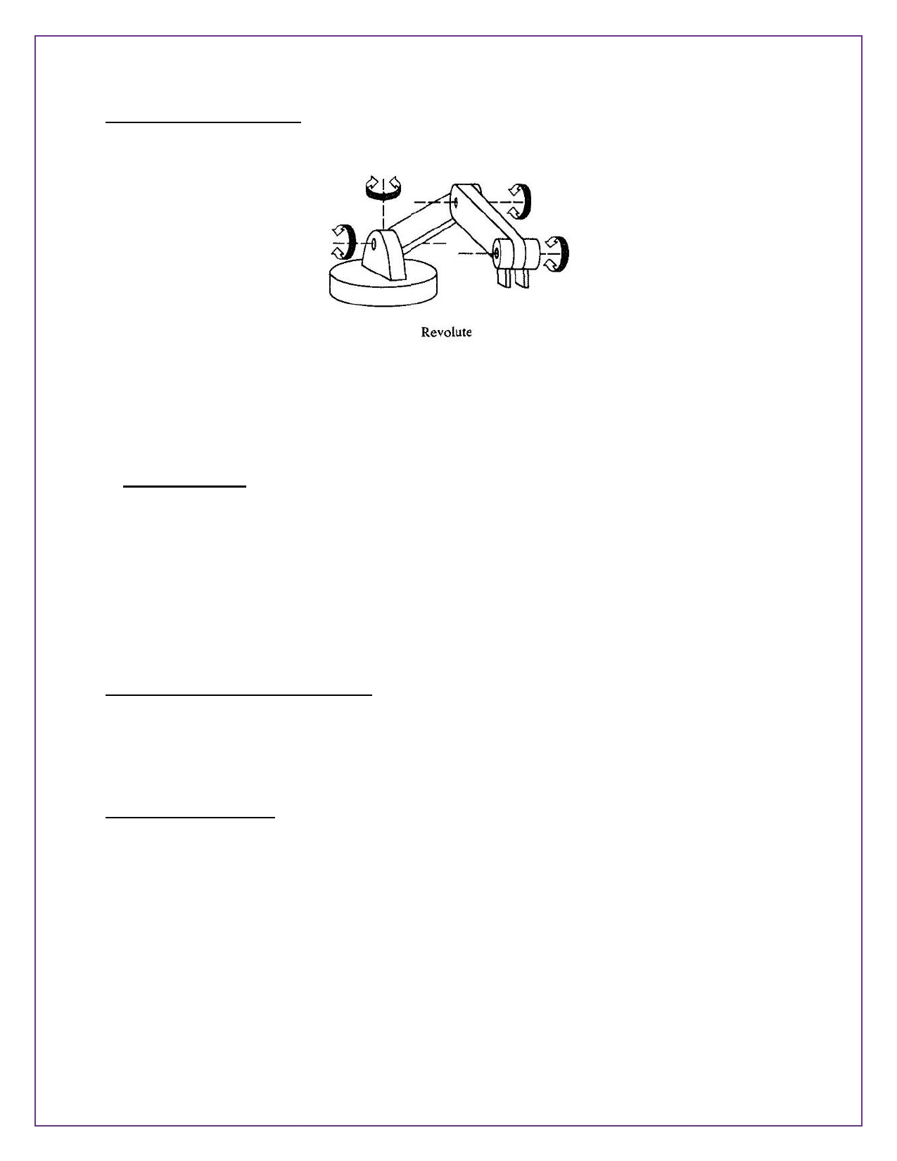

4. Jointed-arm configuration:-

The jointed-arm robot is pictured in Fig. Its configuration is similar to that of the human arm. It consists of two straight components. Corresponding to the human forearm and upper arm, mounted on a vertical
pedestal. These components are connected by two rotary joints corresponding to the shoulder and elbow.
-> Control systems:-
With respect to robotics, the motion control system used to control the movement of the end-effector or
tool.
1. Limited sequence robots (Non-servo)
2. Playback robots with point to point (servo)
3. Play back robots with continuous path control, 4. Intelligent robots.
1. Limited sequence robots (Non-servo):-
1. Limited sequence robots do not give servo controlled to inclined relative positions of the joints, in stead
they are controlled by setting limit switches & are mechanical stops. There is generally no feed back
associated with a limited sequence robot to indicate that the desired position, has been achieved generally thin type of robots involves simple motion as pick & place operations.
2. Point to point motion:-
This type robots are capable of controlling velocity acceleration & path of motion, from the beginning to
the end of the path. It uses complex control programs, PLC's (programmable logic controller's) computers to control the motion.
The point to point control motion robots are capable of performing motion cycle that consists of a series
of desired point location. The robot is tough & recorded, unit.



3. Continuous path motion:-
In this robots are capable of performing motion cycle in which the path followed by the robot in
controlled. The robot move through a series of closely space point which describe the desired path.
Ex:- Spray painting, arc welding & complicate assembly operations.
4. Intelligent robots:-
This type of robots not only programmable motion cycle but also interact with it's environment in a way
that years intelligent. It taken make logical decisions based on sensor data receive from the operation.
There robots are usually programmed using an English like symbolic language not like a computer
programing language.
Precision of movement (or) parameters of robot:-
The preceding discussion of response speed and stability is concerned with the dynamic performance of
the robot. Another measure of performance is precision of the robot's movement. We will define
precision as a function of three features:

1. Spatial resolution
2. Accuracy
3. Repeatability

These terms will be defined with the following assumptions.
(i) The definitions will apply at the robot's wrist end with no hand attached to the wrist.
(ii) The terms apply to the worst case conditions, the conditions under which the robot's precision will
be at its wont. This generally means that the robot's arm is fully extended in the case of a jointed arm or polar configurable.
(iii) Third, our definitions will he developed in the context of a point-to-point robot.
1. Spatial resolution:-
The spatial resolution of a robot is the smallest increment of movement into which the robot can divide
its work volume. Spatial resolution depends on two factors: the system's control resolution and the robot's mechanical inaccuracies. It is easiest to conceptualize these factors in terms of a robot with 1 degree of freedom.

The no of increments =2𝑛
Where n = the number of bits in the control memory.

𝑇𝑜𝑡𝑎𝑙𝑚𝑜𝑚𝑒𝑛𝑡𝑠𝑟𝑎𝑛𝑔𝑒

The control resolution =
𝑇ℎ𝑒𝑛𝑢𝑚𝑏𝑒𝑟𝑜𝑓𝑖𝑛𝑐𝑟𝑒𝑎𝑚𝑒𝑛𝑡𝑠

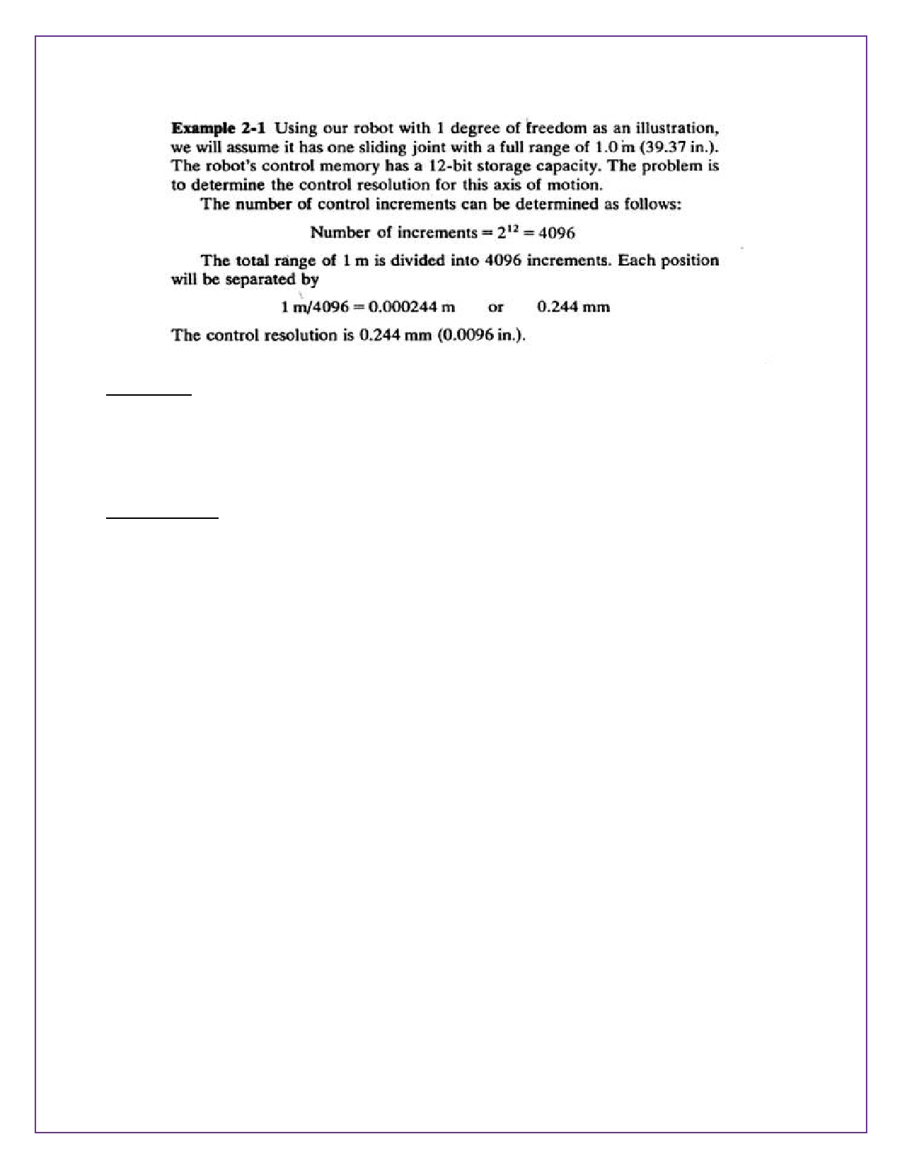

2. Accuracy:-
Accuracy refers to a robot's ability to position its wrist end at a desired target point within the work
volume. The accuracy of a robot can be denned in terms of spatial resolution because the ability to
achieve a given target point depends on how closely the robot can define the control increments for each of its joint motions.
3. Repeatability:-
Repeatability is concerned with the robot's ability to position its wrist or an end effector attached to its
wrist at a point in space is known as repeatability. Repeatability and accuracy refer to two different
aspects of the robot's precision. Accuracy relates to the robot's capacity to be programmed to achieve a given target point. The actual programmed point will probably be different from the target point due to limitations of control resolution Repeatability refers to the robot's ability to return to the programmed point when commanded to do so.

***THE END***

