UNIT-4

- Introduction:
MEASUREMENT OF SPEDD, ACCLERATION AND VIBRATION

Speed is a rate variable defined as the time-rate of motion. Common forms and units of speed measurement include: linear speed expressed in meters per second (m/s), and the angular speed of a rotating machine usually expressed in radians per second (rad/s) or revolutions per minute (rpm).
Measurement of rotational speed has acquired prominence compared to the measurement of linear speed.
Angular measurements are made with a device called tachometer. The dictionary definitions of a tachometer are:
- “an instrument used to measure angular velocity as of shaft, either by registering the number of rotations during the period of contact, or by indicating directly the number of rotations per minutes”
- “an instrument which either continuously indicates the value of rotary speed, or continuously displays a reading of average speed over rapidly operated short intervals of time”
Tachometers may be broadly classified into two categories:
  - Mechanical tachometers and
  - Electrical tachometers.

Mechanical tachometers:

These tachometers employ only mechanical parts and mechanical movements for the measurement of speed.

Revolution counter and timer:
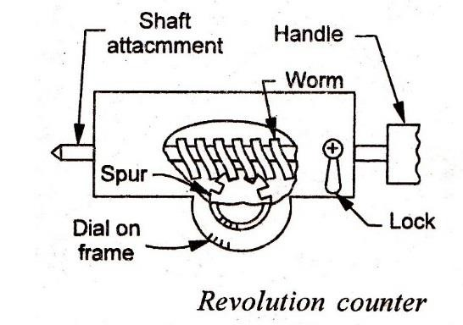
The revolution counter, sometimes called a speed counter, consists of a worm gear which is also the shaft attachment and is driven by the speed source. The worm drives the spur gear which in turn actuates the pointer on a calibrated dial. The pointer indicates the number of revolutions turned by the input shaft in a certain length of time. The unit requires a separate timer to measure the time interval. The revolution counter, thus, gives an average rotational speed rather than an instantaneous rotational speed. Such speed counters are limited to low speed engines which permit reading the counter at definite time intervals. A properly designed and manufactured revolution counter would give a satisfactory speed measure upto 2000-3000 rpm.

Tachoscope:
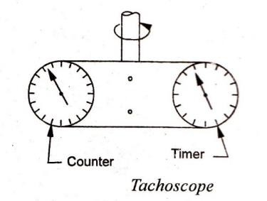
The difficulty of starting a counter and a watch at exactly the same time led to the development of tachoscope, which consists of a revolution counter incorporating a built-in timing device. The two components are integrally mounted, and start simultaneously when the contact point is pressed against the rotating shaft. The instrument runs until the contact point is disengaged from the shaft. The rotational speed is computed from the readings of the counter and timer. Tachoscopes have been used to measure speeds upto 5000 rpm.

Hand speed indicator:
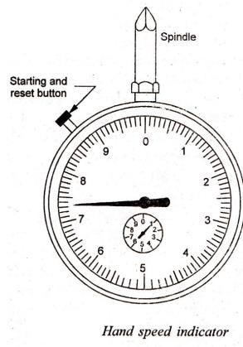
The indicator has an integral stop watch and counter with automatic disconnect. The spindle operates when brought in contact with the shaft, but the counter does not function until the start and wind button is pressed to start the watch and engage the automatic clutch. Depressing of the starting button also serves to wind the starting watch. After a fixed time-interval (usually 3 or 6 seconds), the revolution counter automatically gets disengaged. The instrument indicates the average speed over the short interval, and the dial is designed to indicate the rotational speed directly in rpm. These speed measuring units have an accuracy of about 1% of the full scale and have been used for speeds within the range 20,000 to 30,000 rpm.

Slipping clutch tachometer:

The rotating shaft drives an indicating shaft through at slipping clutch. A pointer attached to the indicator shaft moves over a calibrated scale against the torque of a spring. The pointer position gives a measure of the shaft speed.

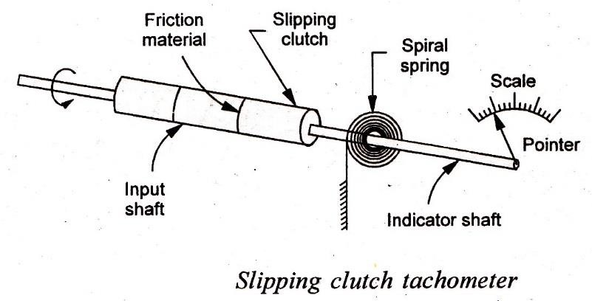

Centrifugal force tachometers:
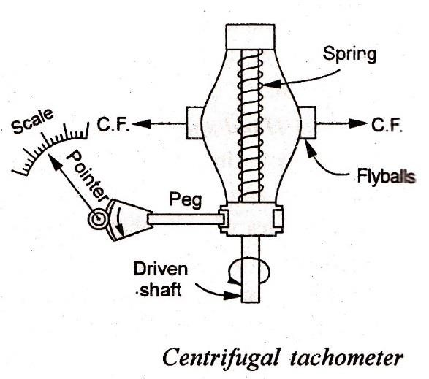
The device operates on the principle that centrifugal force is proportional to the speed of rotation. Two flyballs (small weights) are arranged about a central spindle. Centrifugal force developed by these rotating balls works to compress the spring as a function of rotational speed. A grooved collar or sleeve attached to the free end of the spring then slides on the spindle and its position can be calibrated in terms of the shaft speed. Through a series of linkages, the motion of the sleeve is usually amplified and communicated to the pointer of the instrument to indicate speed. Certain attachments can be mounted onto the spindle to use these tachometers for the measurement of linear speed.

Vibrating reed tachometer:
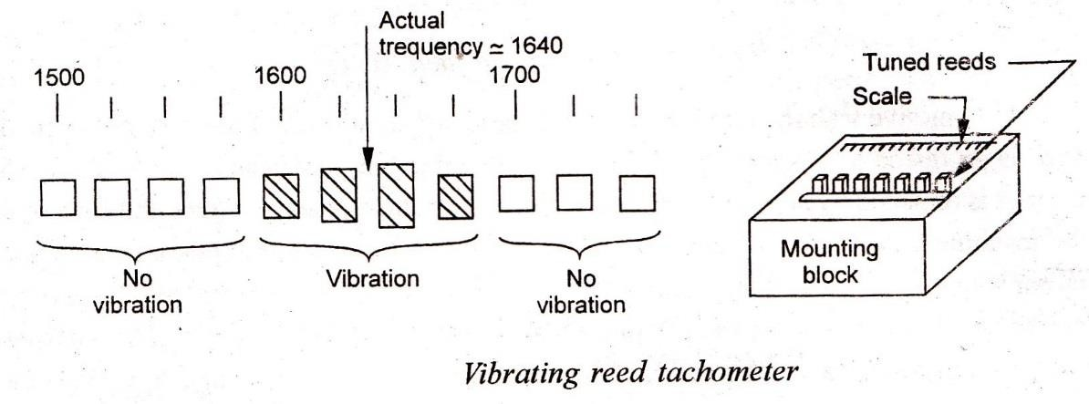
Tachometers of the vibrating reed type utilize the fact that speed and vibration in a body are interrelated. The instrument consists of a set of vertical reeds, each having its own natural frequency of vibration. The reeds are lined up in order of their natural frequency and are fastened to a base plate at one end, with the other end free to vibrate. When the tachometer base plate is placed in mechanical contact with the frame of a rotating machine, a reed tuned to resonance with the machine vibrations responds most frequently. The indicated reed vibration frequency can be calibrated to indicate the speed of the rotating machine.

Electrical tachometers:

An electrical tachometer depends for its indications upon an electrical' signal generated in proportion to the rotational speed of the shaft. Depending on the type of the transducer, electrical tachometers have been constructed in a variety of different designs.

Drug cup tachometer:
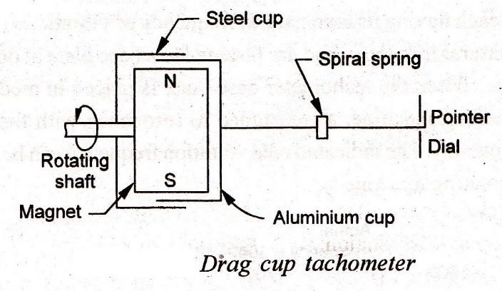
In an eddy current or drag type tachometer, the test shaft rotates a permanent magnet and this induces eddy currents in a drag cup or disc held close to the magnet. The eddy currents produce a torque which rotates the cup against the torque of a spiral spring. The disc tums in the direction of the rotating magnetic field until the torque developed equals that of the spring. A pointer attached to the cup indicates the rotational speed on a calibrated scale. The automobile speedometers operate on this principle and measure the angular speed of the wheels. The rotational measurement is subsequently converted into linear measurement by assuming some average diameter of the wheel, and the scale is directly calibrated in linear speed units.
Eddy current tachometers are used for measuring rotational speeds upto 12,000 rpm with an accuracy of ±3%.

Commutated capacitor tachometer:
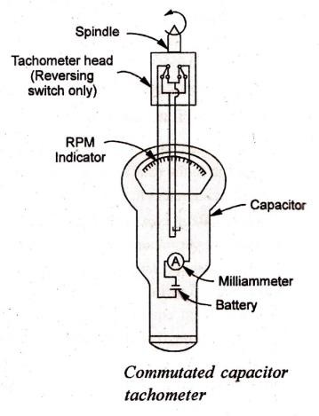
The operation of this tachometer is based on alternately charging and discharging a capacitor. These operations are controlled by the speed of the machine under test. The instrument essentially consists of:
- Tachometer head containing a reversing switch, operated by a spindle which reverses twice with each revolution.

- Indicating unit containing a voltage source, a capacitor, milliammeter and a calibrating circuit. When the switch is closed in one direction, the capacitor gets charged from d-c supply and the current starts flowing through the ammeter. When the spindle operates the reversing switch to close it in opposite direction, capacitor discharges through the ammeter with the current flow direction remaining the same. The instrument is so designed that the indicator responds to the average current. Thus, the indications are proportional to the rate of reversal of contacts, which in turn are proportional to speed of the shaft. The meter scale is graduated to read in rpm rather than in milliamperes. The tachometer is used within the range 200 - 10000 rpm.
- Tachogenerators: These tachometers employ small magnet type d.c or a.c generators which translate the rotational speeds into d.c. or a.c voltage signal. The operating principle of such tachometers is illustrated in Fig. Relative perpendicular motion between a magnetic field and conductor results in voltage generation in the conductor.
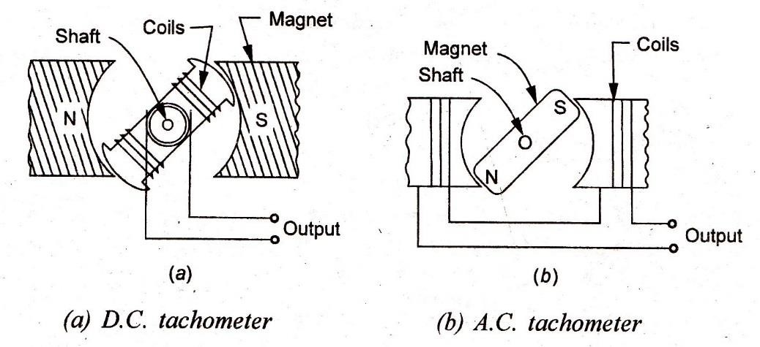
- D. C. tachometergenerator: This is an accurately made dc. generator with a permanent magnet of horse-shoe type. With rotation of the shaft, a pulsating dc. Voltage proportional to the shaft speed is produced, and measured with the help of a moving coil voltmeter having uniform scale and calibrated directly in terms of speed. The tachometer is sensitive to the direction of rotation and thus can be used to indicate this direction by the use of an indicator with its zero point at mid-scale. For greater accuracy, air gap of the magnetic paths must be maintained as uniform as possible. Further, the instrument requires some form of commutation which presents the problem of brush maintenance.
- A.C. tachometer generator: The unit embodies a stator surrounding a rotating permanent magnet. The stator consists of a multiple pole piece (generally four), and the permanent magnet is installed in the shaft whose speed is being measured. When the magnet rotates, an a.c. voltage is induced in the stator coil. The output voltage is rectified and measured with a permanent magnet moving coil instrument. The instrument can also be used to measure a difference in speed of two sources by differentially connecting the stator coils.
Tachogenerators have been successfully employed for continuous measurement of speeds upto 500 rpm with an accuracy of ±1%.

Contactless electrical tachometers:

Tachometers of this type produce pulse from a rotating shaft without any physical contact between the speed transducer and the shaft. This aspect has the distinct advantage in that no load is applied to the machine.

- Inductive pick-up tachometer: The unit consists of a small permanent magnet with a coil round it. This magnetic pick up is placed near a metallic toothed rotor whose speed is to be measured. As the shaft rotates, the teeth pass in front of the pick-up and produce a change in the reluctance of the magnetic circuit. The field expands or collapses and a voltage is induced in the coil. The frequency of the pulses depends upon the number of teeth on the wheel and its speed of rotation. Since the number of teeth is known, the speed of rotation can be determined by measuring the pulse frequency. To accomplish this task, pulse is amplified and squared, and fed into a counter of frequency measuring unit.
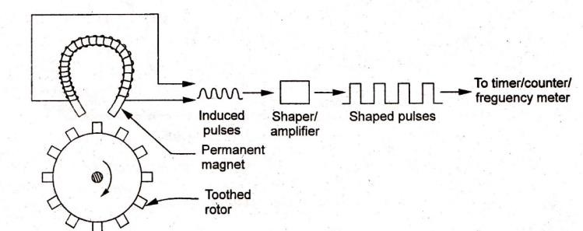
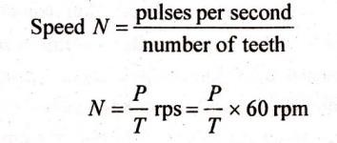

If the rotor has 60 teeth, and if the counter counts the pulses in one second, then me counter will directly display the speed in revolutions per minute.
- Capacitive type pick-up tachometer:
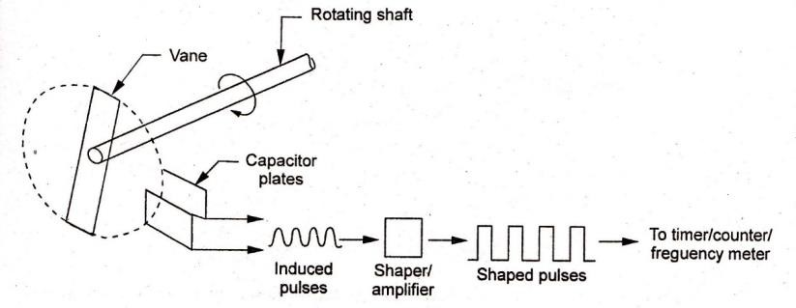
The device consists of a vane attached to one end of the rotating machine shaft. When the shaft rotates between the fixed capacitive plates, there occurs a change in the capacitance. The capacitor forms a part of an oscillator tank so that number of frequency changes per unit of time is a measure of the shaft speed. The pulses thus produced are amplified, and squared, and may then be fed to frequency measuring unit or to a digital counter so as to provide a digital analog of the shaft rotation.
- Photo-electric tachometer: These pick-ups utilize a rotating shaft to intercept a beam of light falling on a photo-electric or photo conductive cell. The shalt has an intermittent reflecting (white) and non- reflecting (black) surface. When a bean) of light hits the reflecting surface on the rotating shaft, light pulses are obtained and the reflected light is focused onto the photo-electric cell. The frequency of light pulses is proportional to the shaft speed, and so will be the frequency of electrical output pulses from the photo-electric cell.

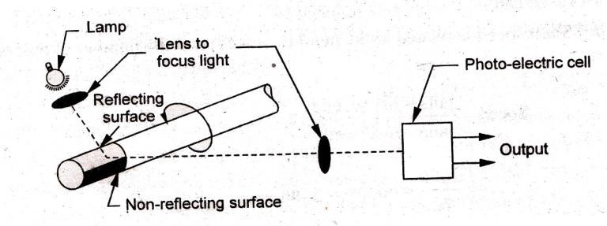

- Stroboscope:
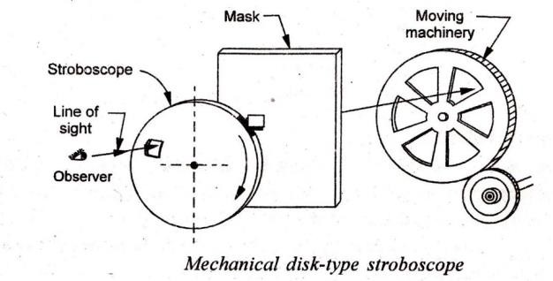

The stroboscope utilises the phenomenon of vision when an object is viewed intermittently. The human sense of vision is so slow to react to light stimuli that it is unable to separate two different light impulses reaching the eye within a very short Period of time (less than 0.1second). A succession of impulses following one another at brief intervals are observed by the eye as a continuous unbroken sequence. A mechanical disk type stroboscope consists essentially of a whirling disk attached to motor whose speed can be varied and measured. A reference mark on the rotating shaft on the shaft appears to be stationary. For this condition, the shaft speed equals that of rotating disk, or some even multiple of this speed and is given by:
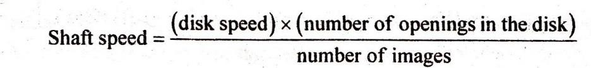

Vibration amplitude and acceleration

Vibration refers to the repeated cyclic oscillations of a system; the oscillatory motions may be simple harmonic (sinusoidal) or complex (non-sinusoidal). The oscillations are caused when acceleration is applied to the machine alternately in two directions
The excessive vibration level in a machine is an indication of the following troubles it can cause:
- Catastrophic failure as a result of stress caused by induced resonance and fatigue
- Excessive wear because of failure to compensate for vibration to which a product is subjected or which is created by the product
- Faulty production
- Incorrect operation of precision equipment and machinery because of failure to compensate for vibration and shock encountered in use

- human discomfort leading to adverse effects such as motion sickness, breathing and speech disturbance, loss of touch of sensitivity etc.
Characteristics and units of vibrations: Vibration is generally characterized by
- The frequency in Hz, or
- The amplitude of the measured parameter which may be displacement, velocity or acceleration. Further, the units of vibration depend on the vibration parameter as follows:
(a) Displacement, measured in m, (b) velocity, measured in m/s and (c) acceleration, measured in m/𝑠2.
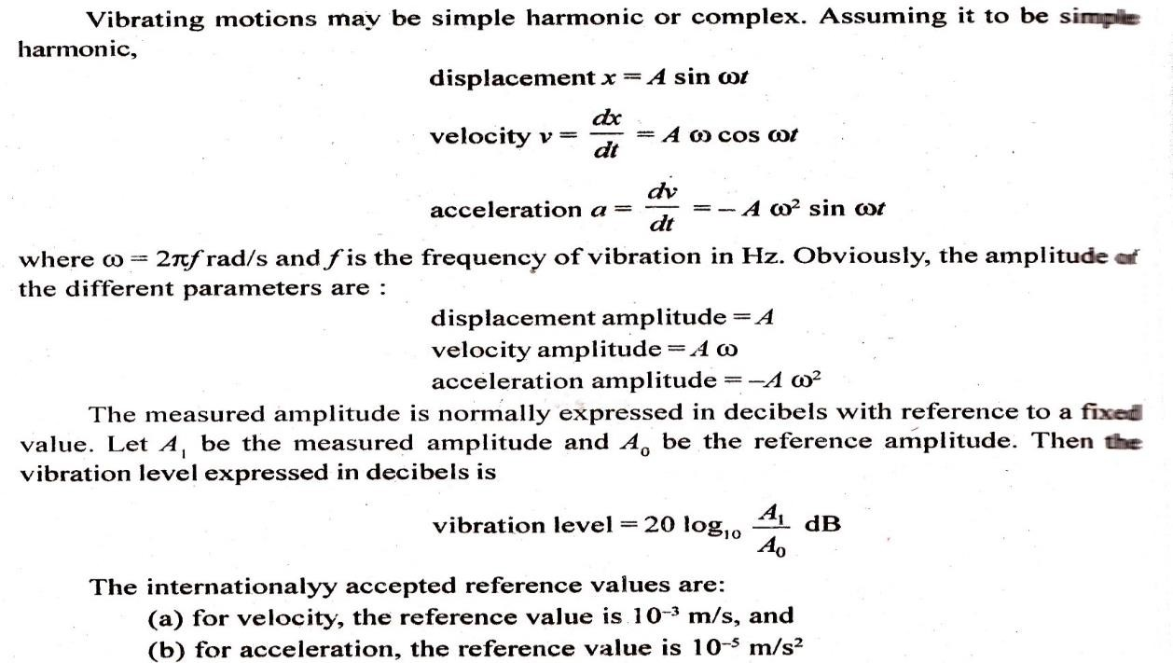

Measurement of acceleration:

There are two types of accelerometers generally used for measurement of acceleration:
(i) Piezo-eletric type, and (ii) seismic type.
(i)Piezo-electric accelerometer: The unit is perhaps the simplest and most commonly used transducer employed for measuring acceleration. The sensor consists of a piezo-electric crystal sandwitched, between two electrodes and has a mass placed on it. The unit is fastened to the base whose acceleration characteristics are to be obtained. The can threaded to the base acts as a 'spring and squeezes the mass against the crystal. Mass exerts a force on the crystal and a certain output voltage is generated. If the base is now accelerated downward, inertial reaction force on the base acts upward against the top of the can. This relieves stress on the crystal. From Newton's second law
force = mass × acceleration

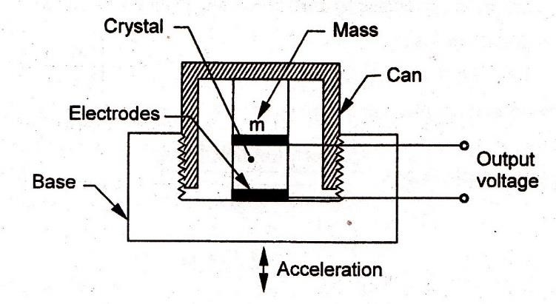

Advantages and limitations

- Rugged and inexpensive device
- High output impedance ’
- High frequency response from 010 Hz to 50 kHz
- High sensitivity varies from 10 to 100 mv/g where g = 9.807 m/𝑠2
- Capability to measure acceleration from a fraction of g to thousands of g
- Somewhat sensitive to changes in temperature
- Subject to hysteresis errors.
Displacement sensing (seismic) accelerometer: In a seismic accelerometer the displacement of a mass resulting from an applied forced is measured and correlated to the acceleration. Fig shows the schematics of a common spring mass damper system which accomplishes this task. The mass is supported by a spring and damper is connected to the housing frame. The frame is rigidly attached to the machine whose acceleration characteristics are to be determined. When an acceleration is imparted by the machine to the housing frame, the mass moves relative to the frame, and this relative displacement between the mass and frame is sensed and indicated by an electrical displacement transducer.
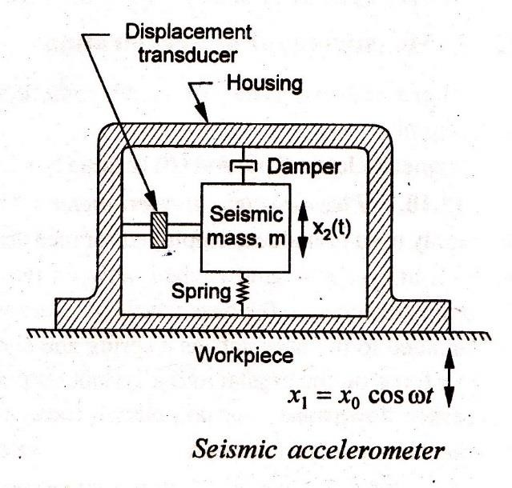

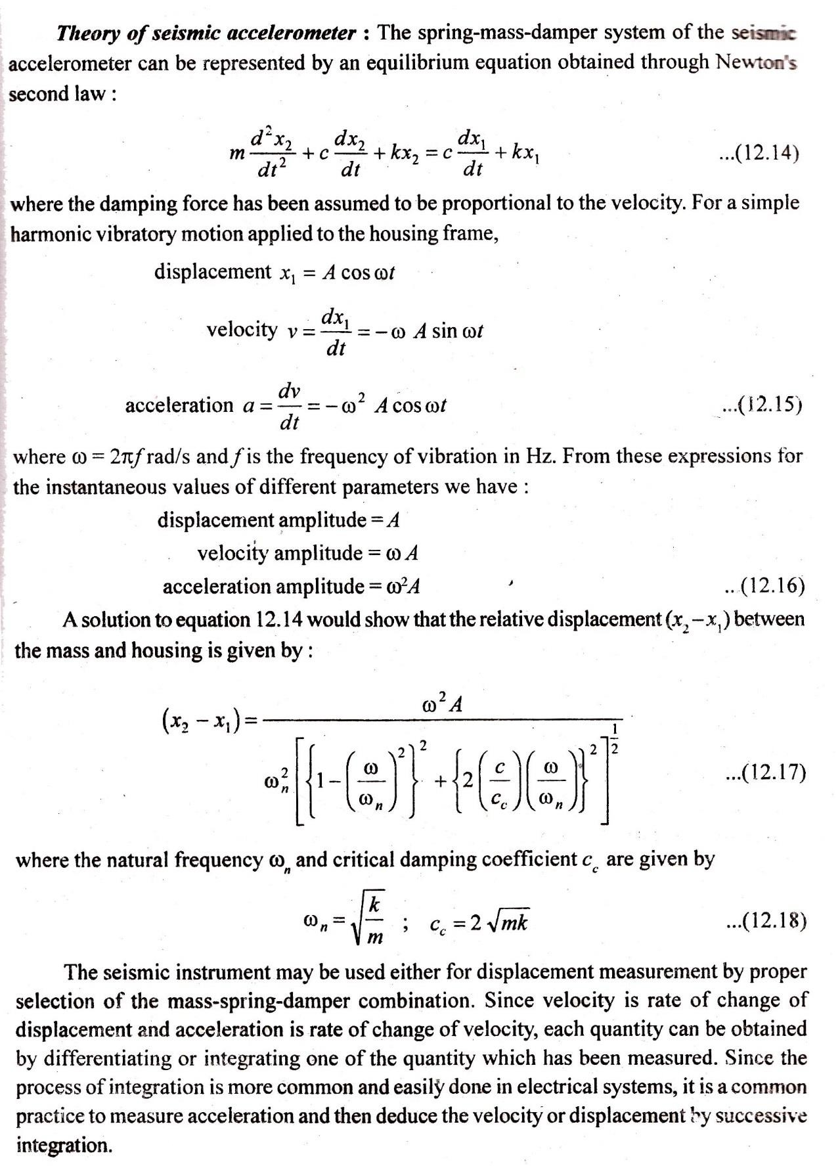

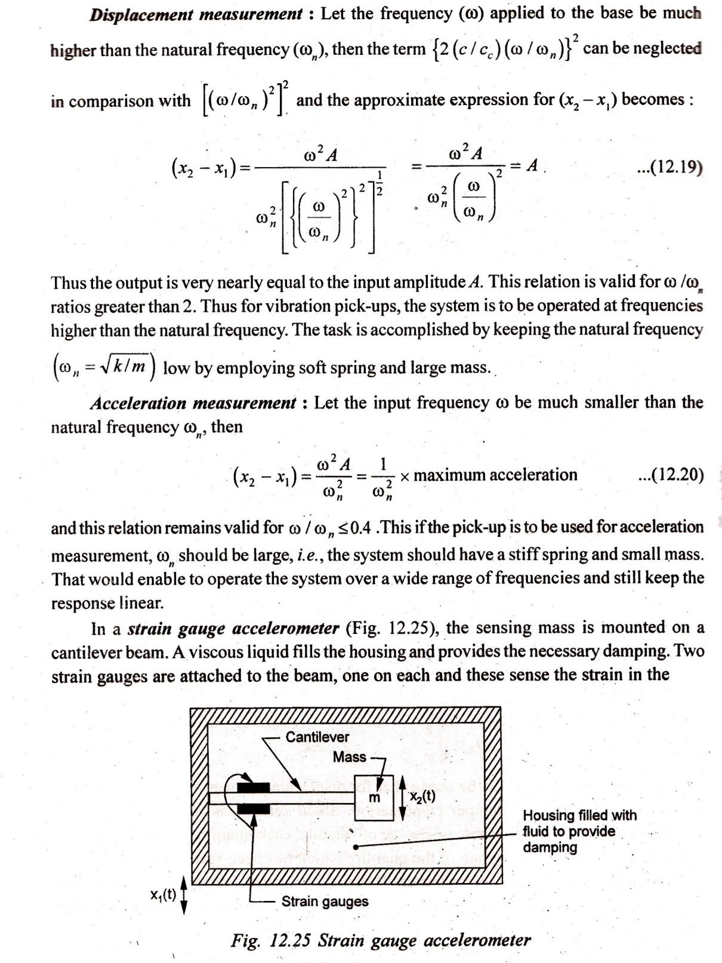

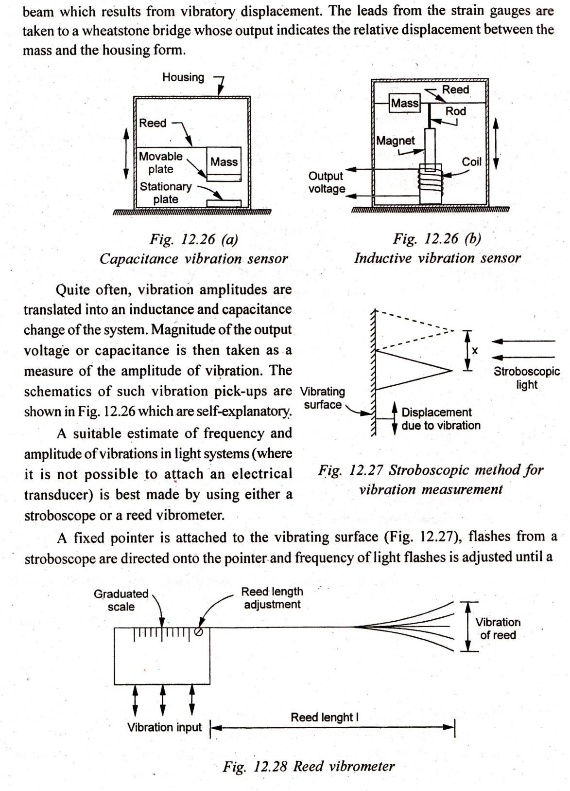

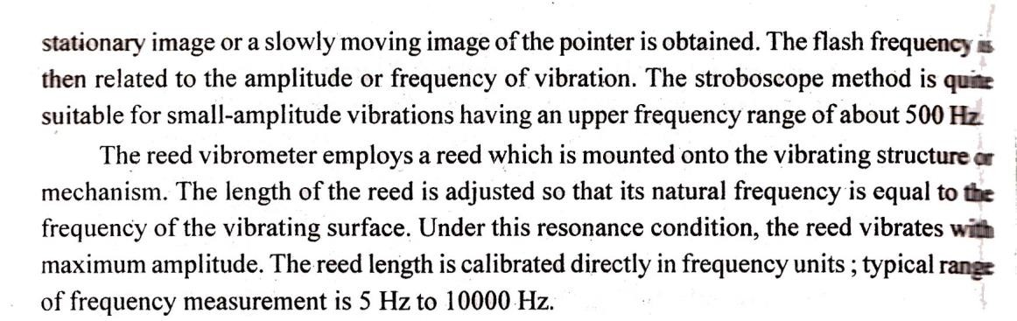

**********THE END**********

